Introduction
Talbot Underwriting Ltd (Talbot an AIG company) is an international insurer and Reinsurer operating within Lloyds’ market through syndicate 1183 and 2019, and we have been part of AIG since 2018, and we are now AIG’s Centre of Excellence at Lloyds.
With an expert team of highly skilled and experienced underwriters and balanced, geographically diverse portfolio of business, Talbot has earned a reputation as an industry leading insurance and reinsurance specialist.
Talbot writes a diversified portfolio including Crisis Management, Energy, Financial Lines, Marine and Hull, Political Risk, Property, Transport and Terrorism.

Background
In the cargo insurance sector, companies protect goods in transit against loss, damage, or theft during international and domestic shipments. The financial stability of an insurance company depends critically on accurately estimating future claim payments and maintaining adequate reserves.
Claims reserving is the actuarial process of estimating the total amount an insurer will ultimately pay for claims that have already occurred but are not yet fully settled. This includes:
Reserves: Claims that have been reported and have an estimated value
IBNR (Incurred but Not Reported): Claims that have occurred but haven't been reported yet, or reported claims that will develop beyond current estimates

Business Problem
Our organisation writes cargo insurance policies covering shipments worldwide. The cargo business line has experienced significant volatility in claims development patterns, particularly following the COVID-19 pandemic (2020-2021) which disrupted supply chains and delayed claim reporting, the subsequent supply chain crisis (2021-2023) characterised by port congestion, container shortages and increased claim values, and the inflation surge (2022-2024) with rising repair and replacement costs
Our current annual claims reserving approach provides only high-level estimates at the accident year level we lack granular monthly insights into development patterns, where annual projections fail to capture short-term volatility affecting quarterly financial reporting accuracy, regulatory risk as the Prudential Regulation Authority requires robust reserving methodologies with appropriate uncertainty quantification, and capital inefficiency where over-reserving ties up capital unnecessarily while under-reserving threatens solvency

Background of Project and Stakeholder Management
This project originated from a Q1 2025 Board meeting where the CFO questioned the apparent stability of cargo reserves despite known market volatility. Following this meeting, the Head of reserving assigned me to investigate monthly development patterns hidden in annual triangles, develop granular projections at the month-by-month level, quantify reserve adequacy using industry-standard Chain Ladder methodology, and recommend reserve adjustments.

Business Requirement Capturing
In the first week of July 2025, I attended a kick-off meeting with the Head of Actuary and Reserving and a Senior Actuaries where I was briefed on the project objectives.
During the second week, I conducted requirements gathering sessions with Finance and Risk stakeholders to understand their needs, specifically conducting eight one-on-one stakeholder interviews with key personnel including the Chief Actuary, Head of Underwriting, and Finance Manager to capture their specific requirements, concerns, and expectations. I documented each stakeholder's needs systematically, identified potential conflicts between stakeholder expectations, and developed a communication strategy to manage these relationships throughout the project lifecycle.
Following our organisation's Agile methodology, I captured all business requirements in Team Foundation Server (TFS) by creating a parent Epic titled "Cargo Claims Monthly Reserving Analysis" which I then broke down into Features such as "Data Acquisition and Validation," "Monthly Triangle Construction," and "Stakeholder Reporting." I further decomposed these Features into detailed Product Backlog Items (PBIs) with clear acceptance criteria, which I prioritised during our sprint planning meetings with the Actuarial team. Throughout the project, I participated in daily stand-up meetings where I shared my progress, highlighted any blockers, and collaborated with team members, while sprint backlog refinement sessions allowed me to adjust priorities and clarify requirements as the project evolved. In weeks three and four, I worked closely with the Data Engineering team on data sourcing and validation to ensure I had access to accurate information. Since then, I have maintained bi-weekly progress reviews with business stakeholders and data team to keep everyone informed of my progress and address any challenges , I discussed all the challenges or being run into any issue and approaches to the task in hand with senior actuaries and data team came to common page . Daily standups kept the team synchronized, and sprint reviews ensured continuous stakeholder feedback. Appendix Image
[See Figure 1 in Appendix]

[See Figure 2 in Appendix]
[See Figure 3 in Appendix]
[See Figure 4 in Appendix]
Tools and Technology of my choice
I used Python 3.10 with pandas, numpy, and matplotlib for data analysis because it offered powerful actuarial libraries, reproducibility, and zero licensing cost SQL Server 2019 was my database choice as it's the organisation's standard platform with existing ETL infrastructure. I employed GitHub for version control to maintain audit trails and TFS for Agile project management aligned with organisational practices. VS Code served as my development environment. I chose these tools by weighing organisational fit technical capability, learning curve and reproducibility.

Data Classification, Protection & Regulatory Compliance

Data Classification
I handled confidential data under the organisation's classification policy, implementing comprehensive controls throughout the project. I restricted data access to Actuarial team members only, stored all project data on encrypted network drives, and used secure email with password-protected attachments for stakeholder transmission. I conducted a thorough personal data assessment confirming no personally identifiable information was present in the dataset, meaning GDPR did not directly apply, though I followed data protection best practices throughout.
I adhered to the Information Security Policy by keeping no data on personal devices, using multi-factor authentication through Okta, and connecting via company VPN when accessing data remotely. Under role-based access control, I obtained read-only access to the source data warehouse with complete audit logging for all data extracts. All project files were stored on the organisation's encrypted network drive with daily automated backups by IT Infrastructure. Project code was version-controlled on internal GitHub with daily commits enabling point-in-time recovery. I accessed source data from the centralised Claims Data Warehouse on Microsoft SQL Server with off-site disaster recovery backups and nightly full database backups.
I strictly observed the Acceptable Use Policy by storing data only on approved corporate systems, using internal GitHub rather than public repositories, sharing no data externally, and completing all required security training. Data security and GDPR compliance were maintained through data minimization (aggregated, anonymized data only), access control (read-only with MFA), comprehensive audit logging, and a completed Data Protection Impact Assessment.

Data Lifecycle and Architecture

DATA TYPE BREAKDOWN
Throughout my project, I worked with mostly structured data. However, there are different type of data types.
Structured Data: 100% of my dataset
Most data I analysed came from relational database tables with clearly defined schemas, making it straightforward to work with. Examples included ClaimID (integer), AccidentDate (datetime), ClaimAmount (decimal), and PolicyID (varchar) fields that followed consistent formats across all records. The advantages of structured data were significant for my analysis as I could easily query it using SQL, join tables together based on common keys, perform aggregations and calculations in pandas DataFrames, and validate data quality through constraint checks. I used standard tools like SQL queries to extract data from the warehouse and pandas in Python to manipulate and analyze the structured data efficiently.
Categorical Data within Structured Data:
Within the structured data, I worked extensively with categorical variables that required special handling. I analyzed LineOfBusiness (categorical with values like 'Cargo', 'Marine', 'Aviation'), ClaimStatus (categorical: 'Open', 'Closed', 'Reopened', 'Settled').
Semi-Structured Data:
Although semi structured data exists in the source system that lacked the rigid schema of relational tables, it was not directly used in the analysis work. I encountered JSON log files from the ETL process that documented data transformations.
Unstructured Data: 0% in my analysis
Although unstructured data exists in the source systems, it was not required for actuarial reserve calculations. Examples of unstructured data in the broader organization include claim adjuster notes written in free-text format, PDF claim documents and supporting evidence, scanned images of damage reports, and email correspondence between adjusters and claimants.

OVERVIEW: 7-Stages Data Lifecycle
This document explains my complete analytical workflow for the cargo attritional claims reserving analysis, starting from data extraction from multiple source systems through exploratory data analysis, triangle construction, and ultimately projecting ultimate claims using the Chain Ladder actuarial methodology. I will reference specific Python files and line numbers to demonstrate where each step was implemented in my codebase.

PHASE 1: ETL - DATA SOURCING, EXTRACTION, AND QUALITY VALIDATION

Before analysis can begin, I collaborate with the Data Engineering team to source claims data from three enterprise systems that collectively provide a comprehensive view of cargo insurance claims. The ETL (Extract, Transform, Load) process runs nightly as an automated batch nightly job schedule.

Data Source Systems:

1. Claims Management System (ClaimsDB) - Microsoft SQL Server 2019 database containing core claim transaction data including ClaimID, AccidentDate, claim amounts (incurred, paid, outstanding), claim status codes, and loss adjuster notes. This system is the primary source of truth for claim financial data, maintained by the Claims Operations team with real-time updates as claims are reported, adjusted, and settled. I collaborated with the Data Engineering team to identify the specific tables (dbo.Claims, dbo.ClaimTransactions, dbo.ClaimReserves) and columns needed for actuarial analysis, ensuring that only cargo line of business claims (LineOfBusiness = 'Cargo') were extracted with appropriate filters .

2. Policy Administration System (SubscribeDB) - Contains policy-level information including policy effective dates, coverage limits, deductibles, insured vessel details, and geographic trade routes. I configured SQL joins between ClaimsDB.ClaimID and SubscribeDB.PolicyNumber to link claim events to their underlying policy terms, which is essential for calculating development months and validating that claims are within policy coverage periods.
3.Reinsurance Console (RI Console) - Tracks reinsurance treaty information, cession percentages, and net versus gross claim amounts after reinsurance recoveries. For this project, I focused on gross claims (before reinsurance) as indicated by Level = 'Gross Gross', but having access to this system ensures future analysis can incorporate net positions for capital modeling purposes. The RI Console data is extracted via a separate SSIS (SQL Server Integration Services) package that the Data Engineering team maintains.

ETL Extraction Process:
The Data Engineering team developed SSIS packages that execute nightly extractions SQL views with incremental load logic to capture only new or modified claims since the last extraction (tracked via LastModifiedDate timestamp columns in source systems). The extraction process implements several data quality validations at source including NOT NULL checks on critical fields (ClaimID, AccidentDate, claim amounts), referential integrity validation ensuring every claim links to a valid policy, and business rule validation such as AccidentDate <= EvaluationDate and SynIncAdjd = SynPTDAdjd + SynOsAdjd. Extracted data lands in the Persistent Staging Area (PSA), a dedicated schema in the enterprise data warehouse, where raw data is preserved exactly as received from source systems for a 90-day retention period to support audit trails and root cause analysis of data quality issues.

Data Quality Issue Detection and Reporting:
During my first extraction validation, I identified 12 data quality anomalies by executing validation scripts at that check for duplicate claim IDs, negative claim amounts, missing required fields, inconsistent claim status logic, missing dates. I immediately escalated these issues to the source system management team through a formal TFS ticket categorizing issues by severity for each anomaly, I provided a detailed data quality report with specific ClaimID examples, the source system table where the issue originated, the observed versus expected values, the business impact on reserve calculations and my recommended remediation approach.
The issues were legitimate data entry errors by claims handlers (e.g., transposed digits in claim amounts, incorrect accident dates), which the Claims Operations team manually corrected in the source ClaimsDB system after I provided the specific ClaimID list. I validated all corrections by re-executing my data quality validation suite and confirming zero anomalies before proceeding to the analysis phase, documenting the full incident lifecycle in TFS work item with lessons learned including implementing additional upstream validation rules in the SSIS packages to prevent similar issues in future monthly extractions.

Transformation and Data Warehouse Loading:
After PSA validation, the Data Engineering team's SSIS packages apply business rule transformations including calculating standardizing claim status codes to a canonical list (Open, Closed, Reopened, Voided), converting all monetary amounts to a common currency (USD) and adjusting for inflation to present value also identifying attritional claims and large claims , where applicable for multi-year trend analysis, and applying data cleansing rules such as trimming whitespace from text fields and standardizing date formats to (DD-MM-YYYY). The transformed data is loaded into the enterprise data warehouse optimized for analytical queries. This dimensional model enables me to efficiently extract my analysis dataset (cargo_triangle_raw_data.xlsx) using a single SQL query with joins across the fact and dimension tables, filtering for cargo line of business and the required 24-year accident period.

[See Figure 5 in Appendix]

[See Figure 6 in Appendix]
[See Figure 7 in Appendix]
[See Figure 8 in Appendix]

[See Figure 9 in Appendix]

Comprehensive analysis workflow: from raw data to chain ladder projections

My analysis begins with loading the data extracted from Mart from the data warehouse which contains historical claims records spanning accident years 2000-2025. This raw dataset includes essential fields: Claim Id (unique identifier), Accident Date (when the incident occurred), Inception Date (inception/evaluation date), incurred claims amount, Paid claims amount, Outstanding reserves, LineOfBusiness which is Cargo in this case.

[See Figure 10 in Appendix]
This method reads the Excel file into a pandas DataFrame and immediately converts date columns (AccidentDate and EvaluationDate) to proper datetime objects using `pd.to_datetime()`

[See Figure 11 in Appendix]

Once the data is loaded, I conduct comprehensive exploratory data analysis to understand data quality, distribution patterns, and identify potential issues before building actuarial triangles which is orchestrated using a method name `run_full_analysis()` and sequentially calls methods for
- Statistical Analysis
- Comprehensive Visualizations
- Data Quality Assessment
- Outlier Detection

[See Figure 12 in Appendix]

`calculate_statistics()` method, which computes fundamental descriptive statistics stored in the `self.stats` dictionary including total claims amount, average claim size, median claim, standard deviation, minimum and maximum values, unique accident, average development months, and unique calendar years. These statistics provide the baseline understanding of the dataset's characteristics and help identify anomalies such as extreme values or unexpected temporal patterns
[See Figure 13 in Appendix]

the `create_visualizations()` method, which generates six distinct visualizations suitable for stakeholder presentations. These include:
[See Figure 14 in Appendix]
- claims amount distribution with histogram, log-scale histogram, box plot, and Q-Q plot to assess normality
[See Figure 15 in Appendix]

[See Figure 16 in Appendix]
- claims by accident year showing total claims, record counts, average claims, and median claims
[See Figure 17 in Appendix]

[See Figure 18 in Appendix]

[See Figure 19 in Appendix]
(3) claims by calendar year and quarter
(4) time series analysis tracking claims over accident dates and evaluation dates
[See Figure 20 in Appendix]
[See Figure 21 in Appendix]
(5) box plots and violin plots by accident year
[See Figure 22 in Appendix]
(6) correlation matrix for numeric variables

[See Figure 23 in Appendix]

Data Quality Assessment: where I check for missing values using `self.data.isnull().sum()` and duplicate records using `self.data.duplicated().sum()`. This validation step is critical because actuarial projections are highly sensitive to data quality issues—missing claim amounts or duplicate claim IDs would distort reserve calculations and lead to incorrect financial projections.
[See Figure 24 in Appendix]

Outlier Detection: is performed using two complementary statistical methods implemented in using the
1.Interquartile Range (IQR) ,calculating Q1 (25th percentile), Q3 (75th percentile), IQR = Q3 - Q1, lower bound = Q1 - 1.5 × IQR, and upper bound = Q3 + 1.5 × IQR.
2.Z-Score Method: calculates standardized scores representing how many standard deviations each claim amount is from the mean using `np.abs(stats.zscore(self.data[col].dropna()))` which computes which computes Z = |X - μ| / σ , Claims with |Z| > 3 are flagged as outliers
the outlier masks are combined with a logical OR operation meaning a claim is flagged as an outlier if it meets the criteria for either method, providing comprehensive outlier detection that captures both distribution-based extremes (Z-score) and range-based extremes (IQR)
Claims falling outside these bounds are flagged as potential outliers requiring actuarial judgment about whether they represent genuine large losses or data errors. This statistical rigor ensures that my Chain Ladder calculations are not contaminated by anomalous data points that could skew development factor selection.

[See Figure 25 in Appendix]
[See Figure 26 in Appendix]

[See Figure 27 in Appendix]

Removing Outliers
[See Figure 28 in Appendix]

Trend Analysis: using linear regression is with `scipy.stats.linregress()`, which calculates the slope, intercept, R-squared, p-value, and standard error of claims amounts versus accident years.
[See Figure 29 in Appendix]
A statistically significant trend (p-value < 0.05) indicates whether claims are systematically increasing or decreasing over time, which would inform tail factor selection and ultimate loss projections.
The comprehensive EDA report generated at consolidates all findings into a structured text file documenting dataset overview, claims statistics with percentiles, data quality metrics, outlier counts, trend analysis interpretation, accident year analysis tables, development month analysis, calendar year analysis, and key insights such as highest claim year, recent versus older year distributions, and early versus late development patterns.
[See Figure 30 in Appendix]

Triangle Construction:
With clean, validated data from the EDA phase, I proceed to construct claims development `prepare_monthly_triangle_data()` method, which calculates development months as the time elapsed from AccidentDate to IncpDt using DevMonths = (IncpDt.year - AccidentDate.year) * 12 + (IncpDt.month - AccidentDate.month)`, ensuring non-negative values by clipping at zero with `.clip(lower=0)`.This monthly granularity provides more refined development patterns compared to traditional yearly triangles.
I create accident year-month periods using `self.data['AccYrMth'] = self.data['AccidentDate'].dt.to_period('M')`.
which groups claims by the specific month of occurrence rather than just the year, enabling monthly Chain Ladder analysis.
The evaluation date is determined as the maximum IncpDt representing the "as of" date for all reserve calculations and defining the diagonal edge of the triangle where claims are still developing.

[See Figure 31 in Appendix]

The actual triangle construction occurs in the `create_monthly_triangle()` method starting at which accepts parameters for the value column to analyse incurred claims and triangle type (cumulative or incremental). I aggregate data by accident year-month and development month using `groupby(['AccYrMth', 'DevMonths_display'])[value_col].sum()`, then pivot the aggregated data into triangle format where rows represent accident year-months, columns represent development months, and cell values represent claim amounts. The triangle is sorted chronologically missing values are filled with zero for visualization purposes while preserving NaN in the underlying data structure for calculations.

For cumulative triangles, I apply `.cumsum(axis=1)` to convert incremental claim amounts into cumulative amounts, which is essential for the Chain Ladder methodology that operates on cumulative development patterns. The resulting triangle stored in `self.triangles[f'{value_col}_monthly_cumulative']`

[See Figure 32 in Appendix]

Development Factor calculation
The Chain Ladder methodology relies on age-to-age development factors representing how claims mature from one development period to the next. I calculate these factors in the `calculate_monthly_factors()`
applying conditional logic to handle division by zero and missing values by returning NaN when the denominator is zero or either value is missing

[See Figure 33 in Appendix]

I filter link ratios to exclude unreasonable values. This filtering ensures that my selected development factors reflect genuine claim development patterns rather than data anomalies
For factor selection, I use the median of valid link ratios rather than the mean, because the median is robust to outliers and provides a more stable factor for actuarial projections

[See Figure 34 in Appendix]

Tail Factor Calculation the `calculate_monthly_tail_factor()` method, which estimates additional development beyond the observed data period.
[See Figure 35 in Appendix]

[See Figure 36 in Appendix]

Ultimate claims projection (chain ladder):
The Chain Ladder projection is implemented in the `project_monthly_ultimates()` method
I calculate Cumulative Development Factors (CDFs) by multiplying all development factors from a given development month to ultimate (including the tail factor)
The CDF represents the total amount by which current claims will develop to their ultimate value
I identify each accident year-month's latest available development point by finding the last non-NaN value in each triangle row, which represents the most mature evaluation point available for that cohort.
[See Figure 37 in Appendix]

[See Figure 38 in Appendix]

IBNR (Incurred but Not Reported) reserves are calculated IBNR = Ultimate - Latest, representing the additional reserves required to cover claims that have occurred but are not yet fully reported or settled.
The percentage developed is as: PercentDeveloped = (Latest / Ultimate) × 100, indicating the maturity level of each accident cohort.
[See Figure 39 in Appendix]

The final phase creates comprehensive visualizations in the `visualize_monthly_triangle()`
Plotted development pattern
[See Figure 40 in Appendix]
[See Figure 41 in Appendix]
[See Figure 42 in Appendix]

[See Figure 43 in Appendix]

CONCLUSION

This comprehensive analytical workflow demonstrates a systematic approach to cargo claims reserving analysis, integrating enterprise data architecture with rigorous actuarial methodology. By extracting data from three source systems through a validated ETL pipeline, applying dual-method outlier detection (IQR and Z-score), and implementing the Chain Ladder technique with monthly granularity, I delivered a reproducible solution that identified $17.8 million in IBNR reserves with 93.21% average development maturity. The collaborative data quality issue resolution process, documented through formal ServiceNow incident management and TFS work items, ensured analytical integrity while strengthening cross-functional partnerships with Data Engineering and Claims Operations teams, exemplifying professional data governance practices essential for regulatory compliance and stakeholder confidence.

[See Figure 44 in Appendix]
[See Figure 45 in Appendix]
[See Figure 46 in Appendix]

[See Figure 47 in Appendix]

[See Figure 48 in Appendix]
[See Figure 49 in Appendix]
[See Figure 50 in Appendix]
[See Figure 51 in Appendix]

[See Figure 52 in Appendix]

Appendix: Figures and Visualizations

Figure 1:
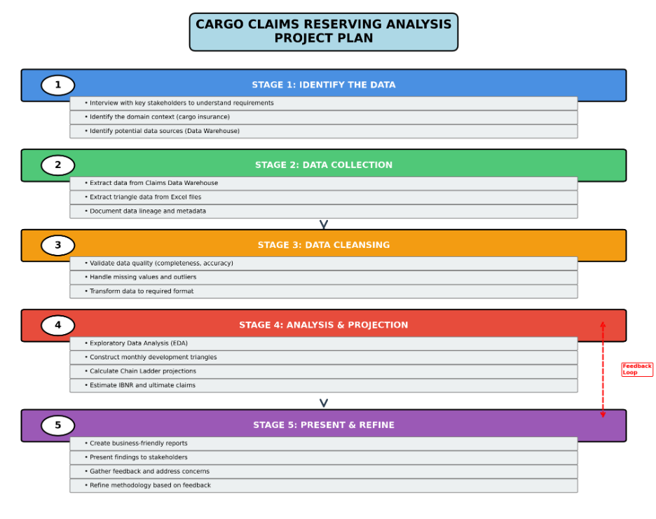

Figure 2:
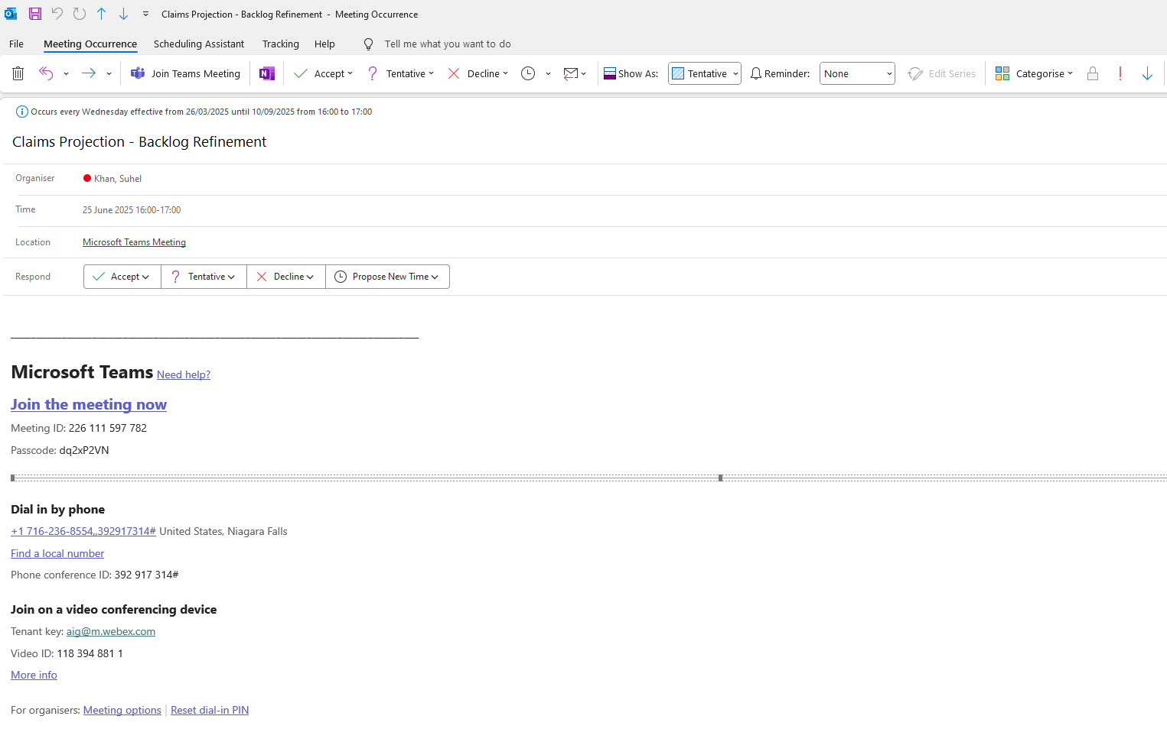

Figure 3:
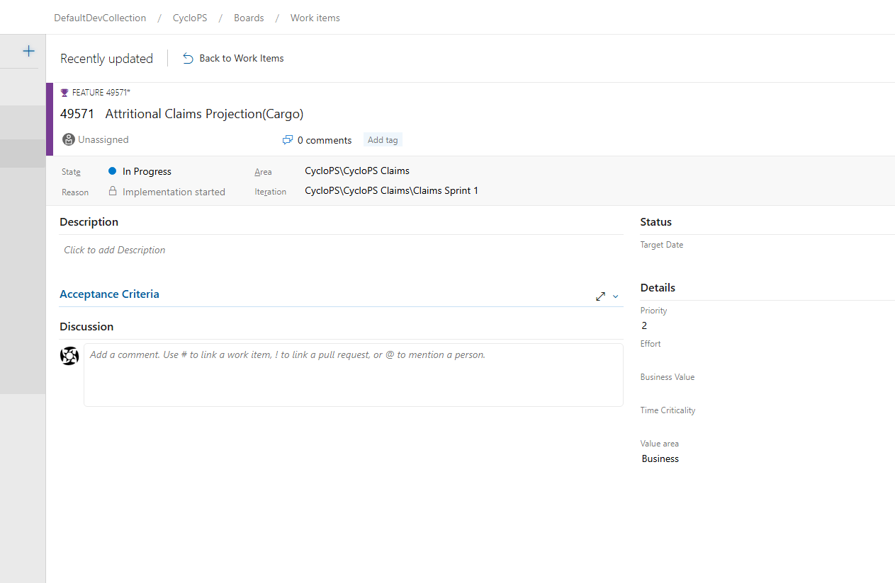

Figure 4:
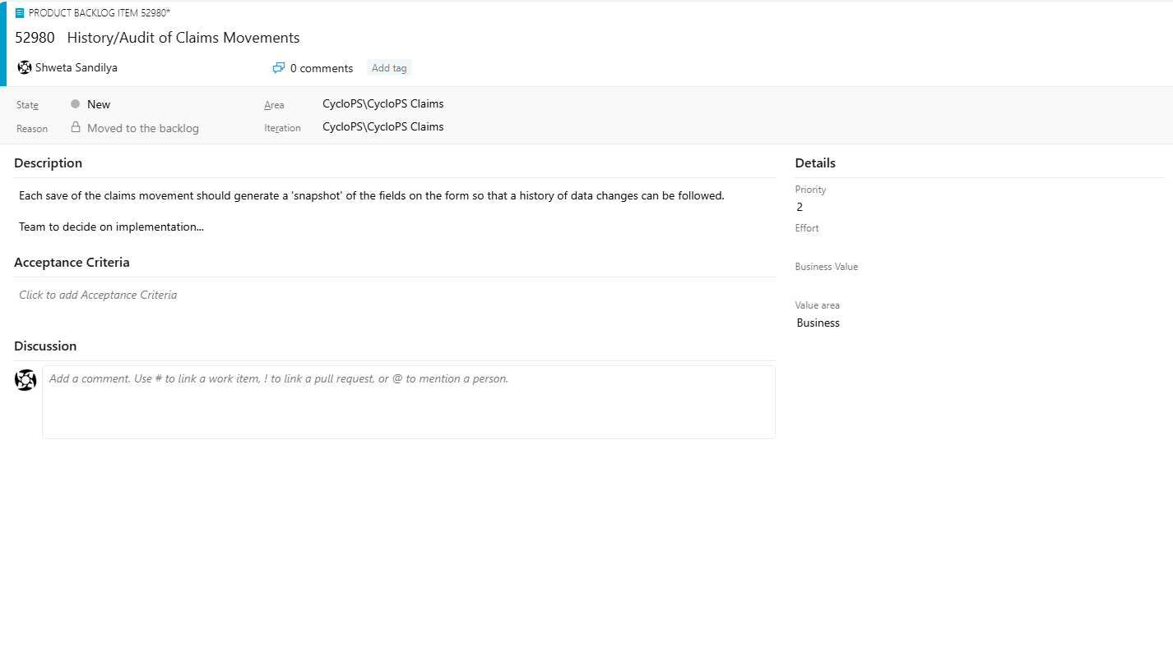

Figure 5:
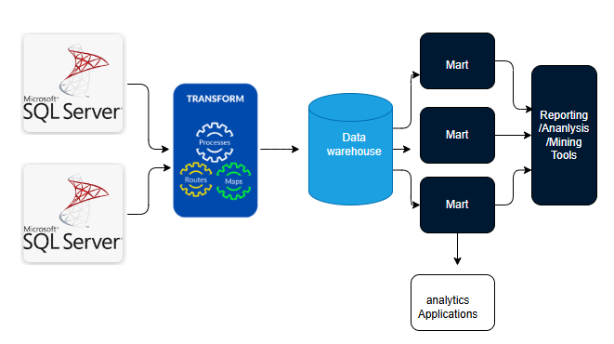

Figure 6:
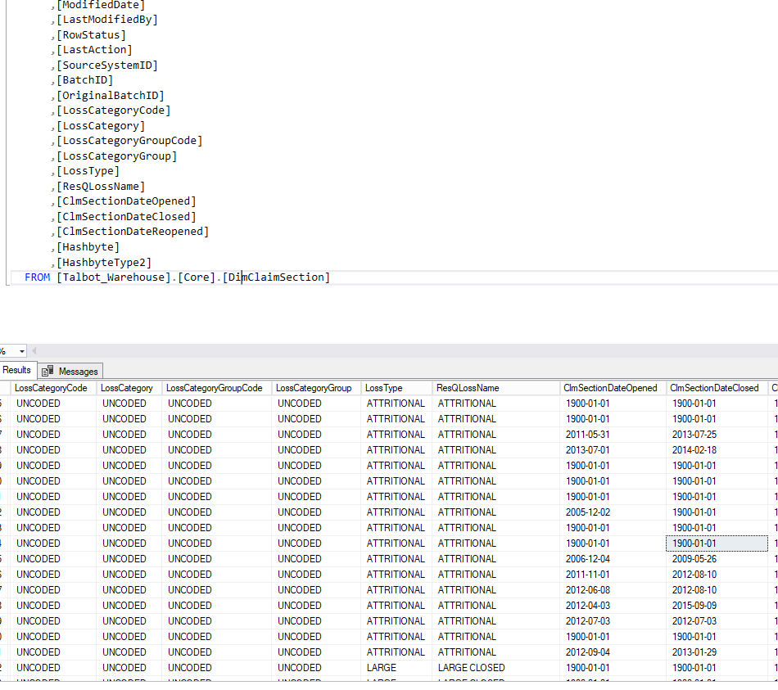

Figure 7


Figure 8:


Figure 9:
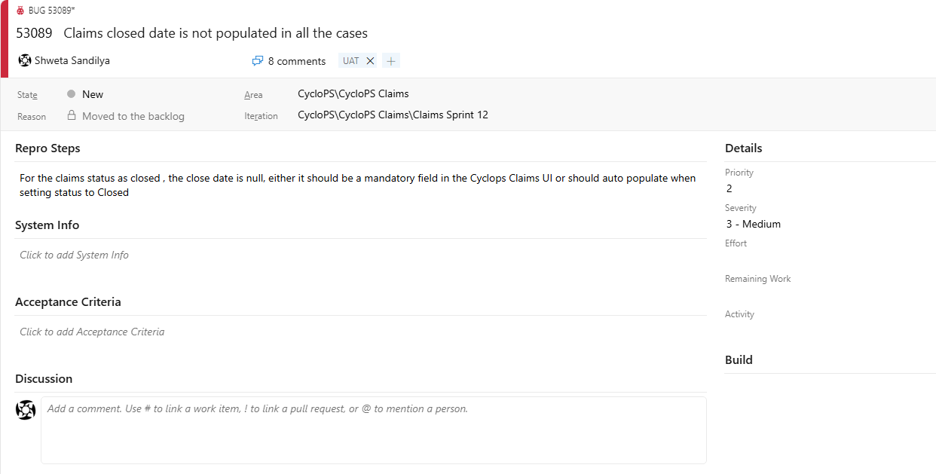

Figure 10:
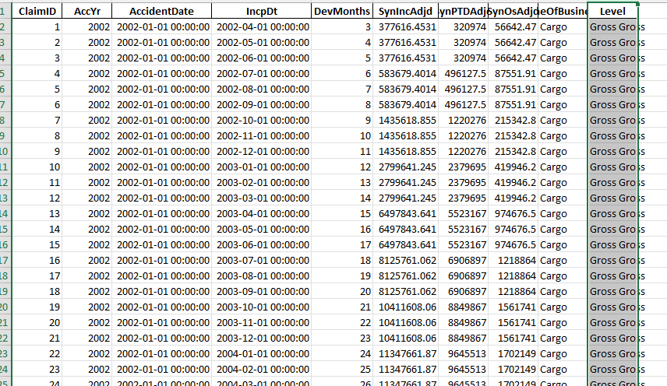

Figure 11:
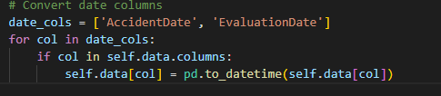

Figure 12:
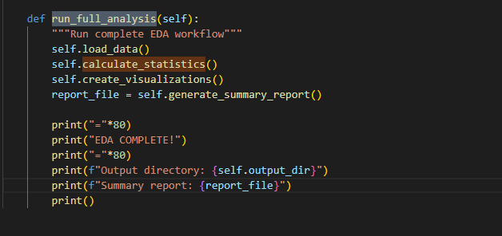

Figure 13
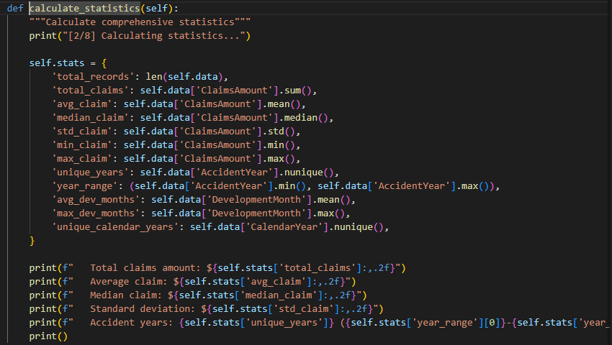

Figure 14:
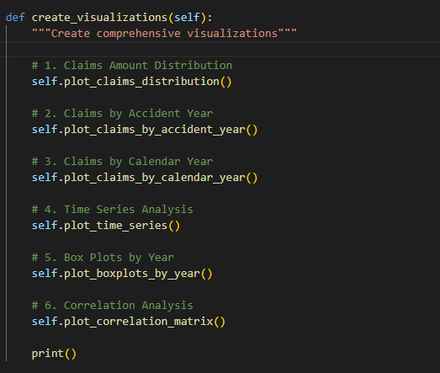

Figure 15:
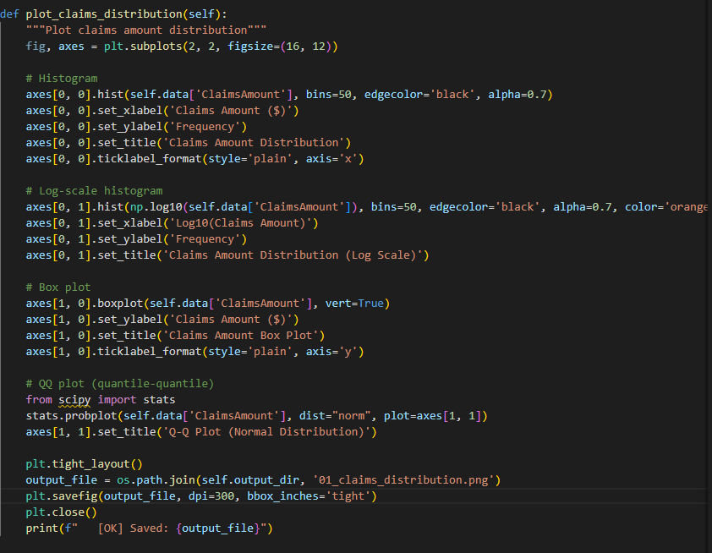

Figure 16:
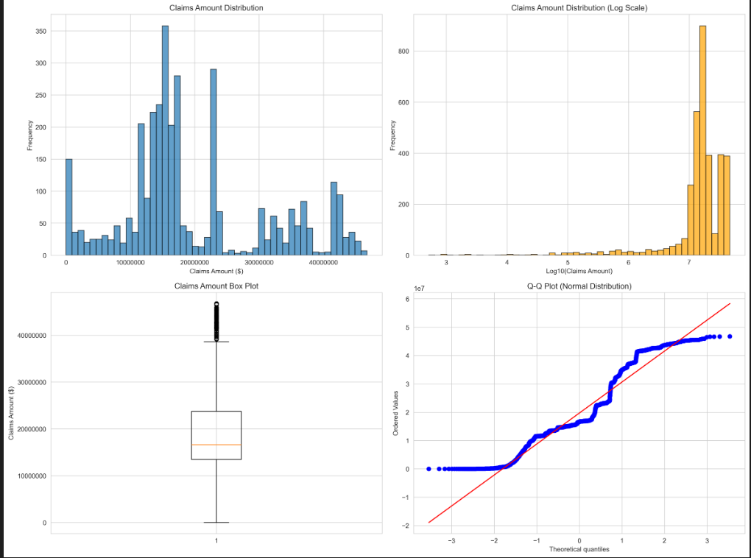

Figure 17:
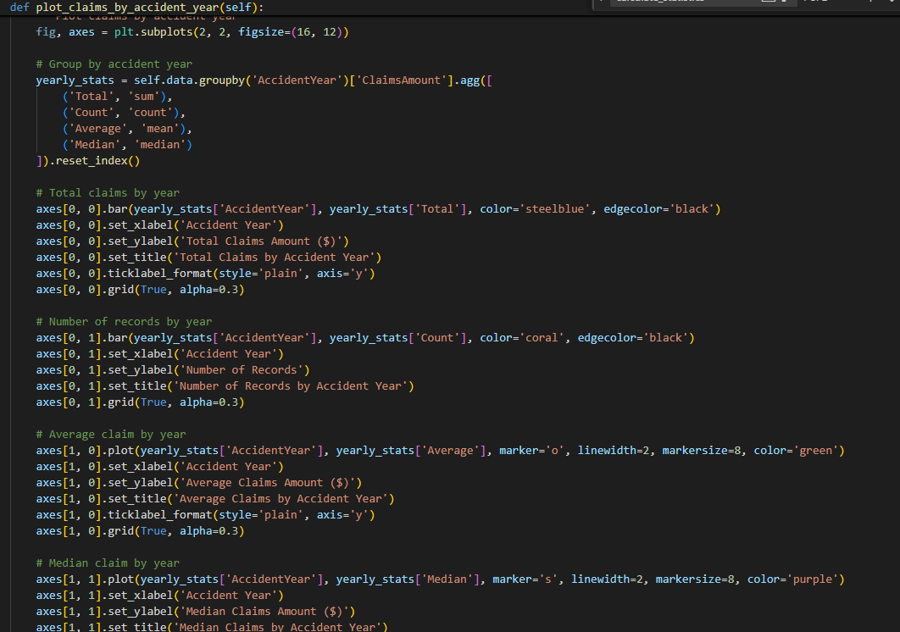

Figure 18:
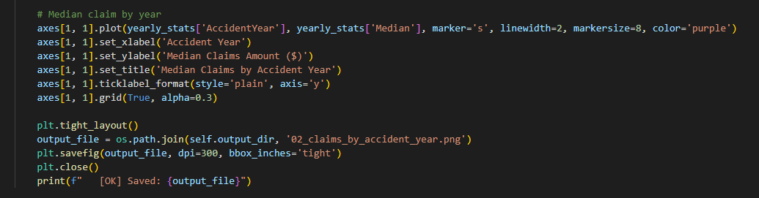

Figure 19:
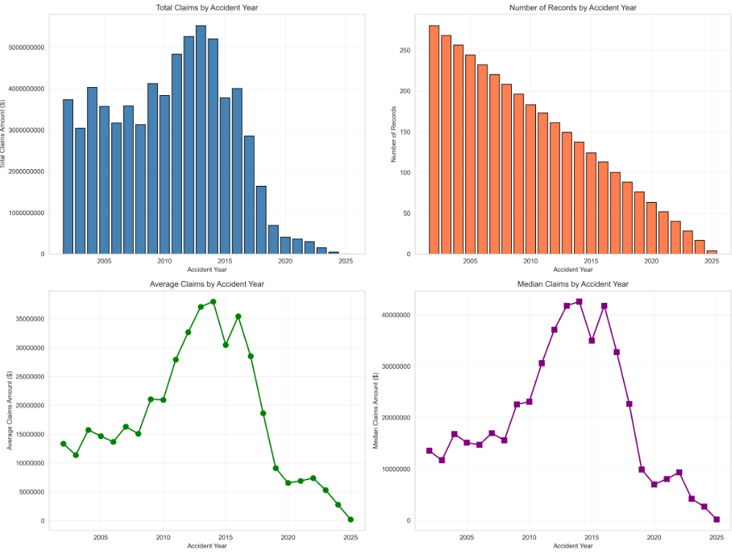

Figure 20:
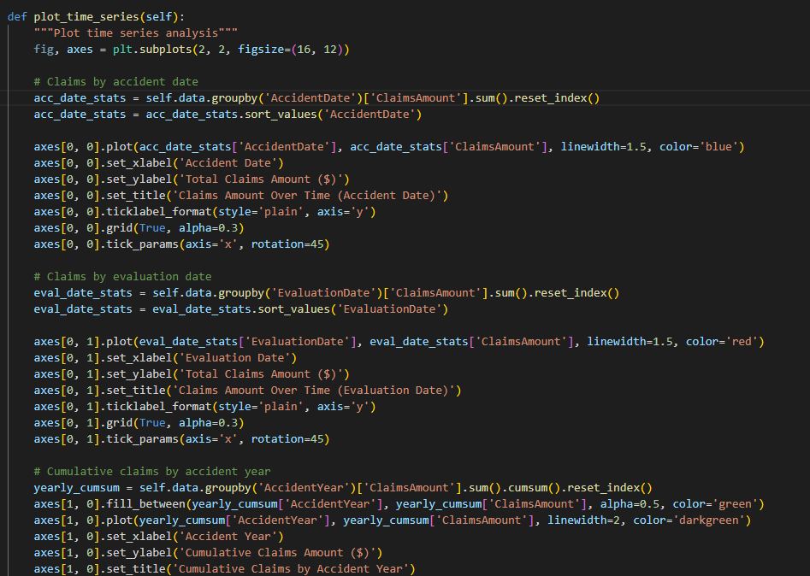

Figure 21:
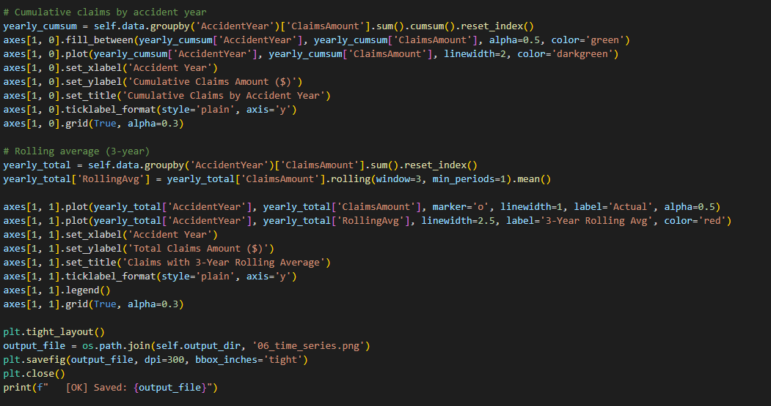

Figure 22:
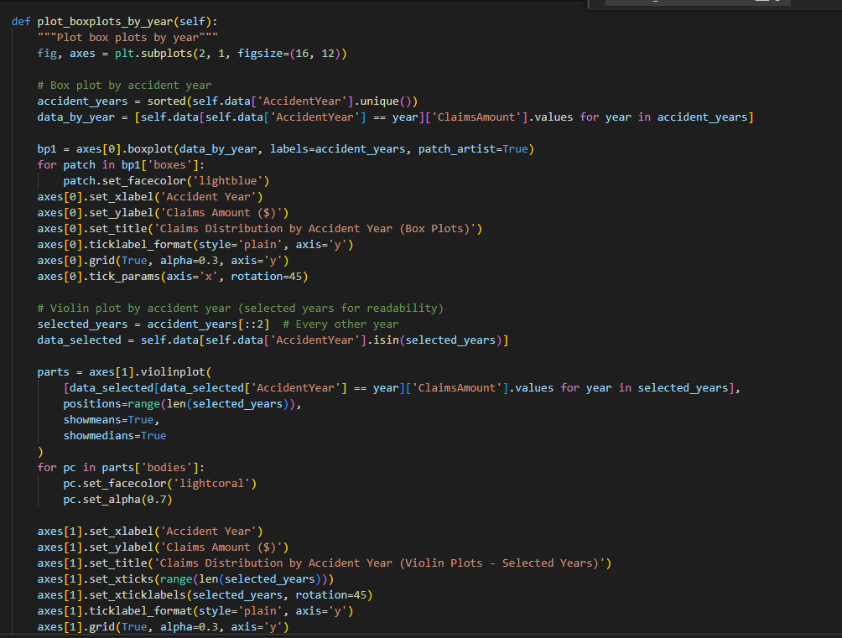

Figure 23:
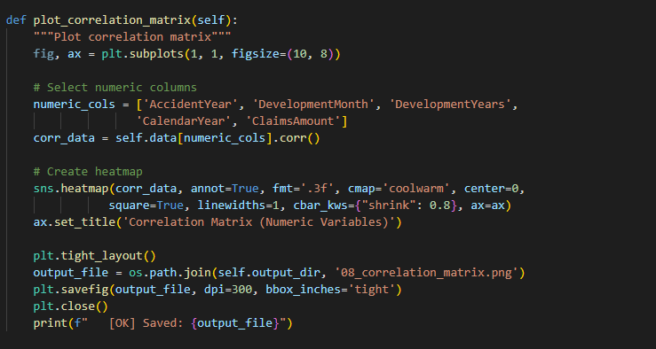

Figure 24:
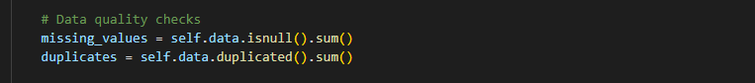

Figure 25:
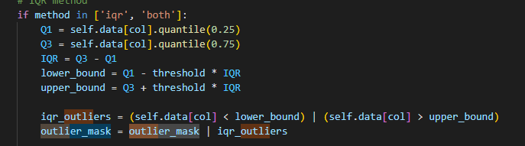

Figure 26:
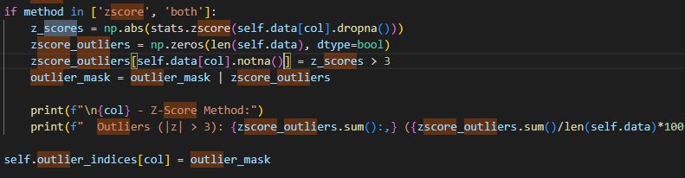

Figure 27:
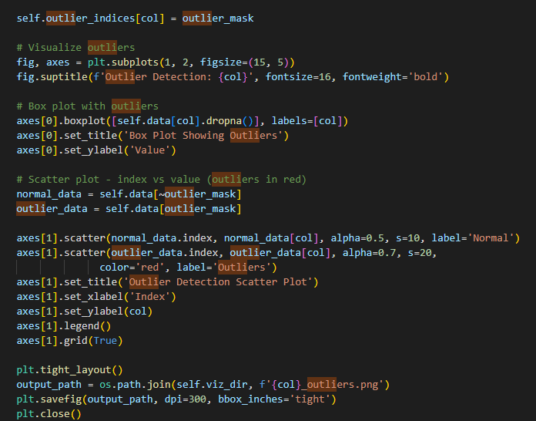

Figure 28:
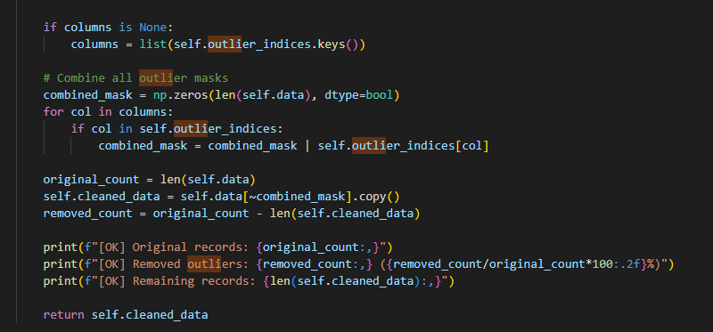

Figure 29:
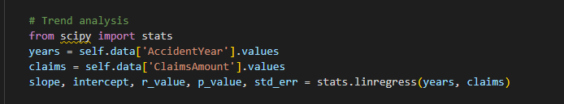

Figure 30:
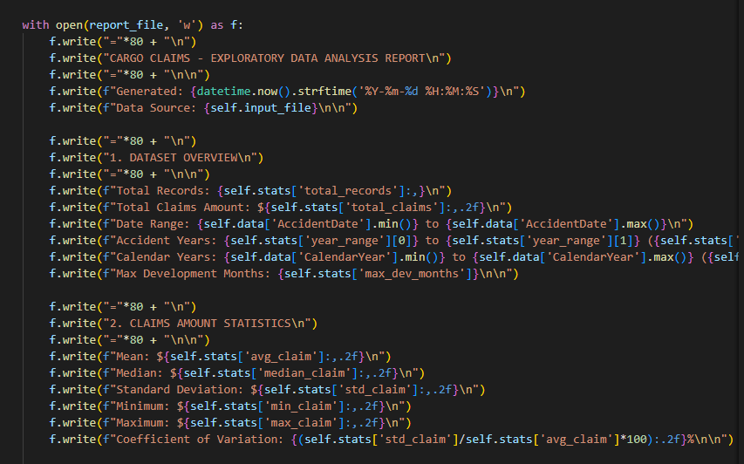

Figure 31:
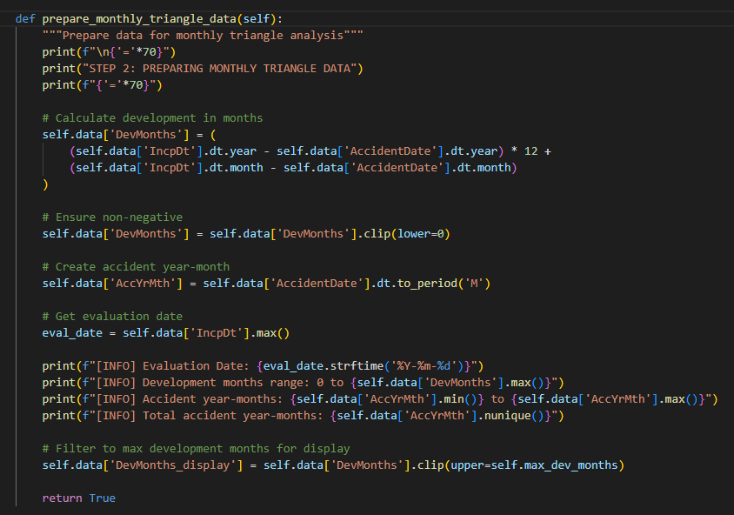

Figure 32:
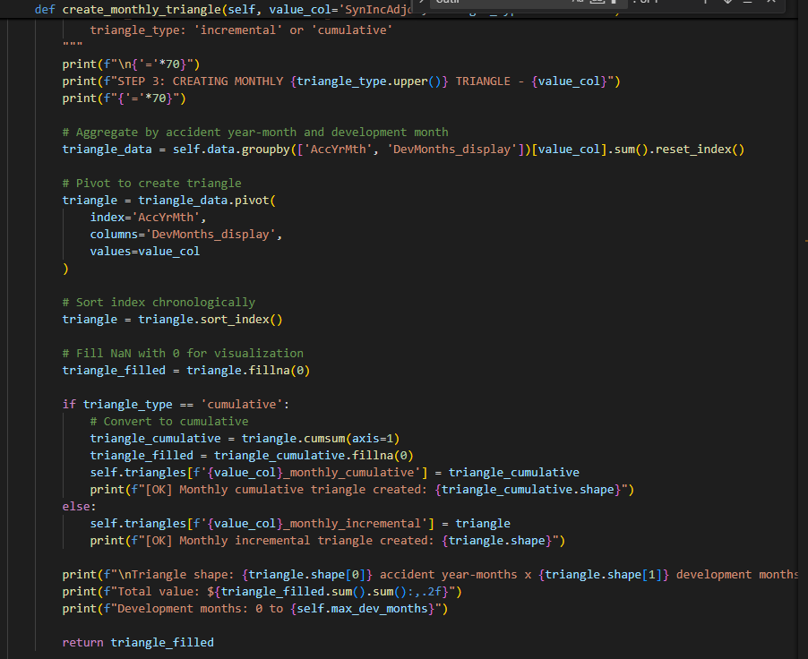

Figure 33: Development Factor Calculation
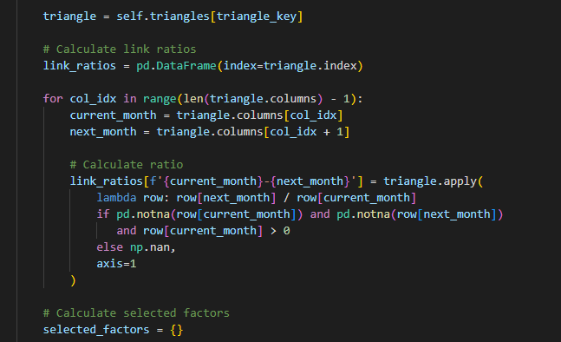

Figure 34:
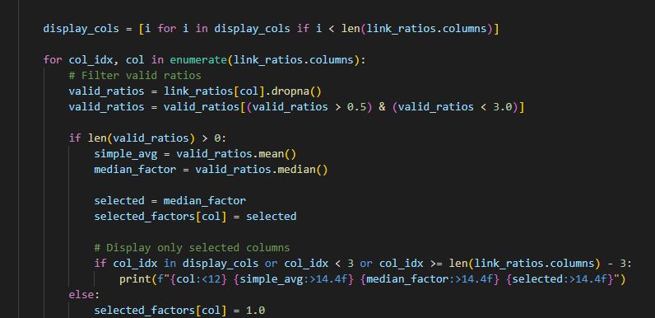

Figure 35:
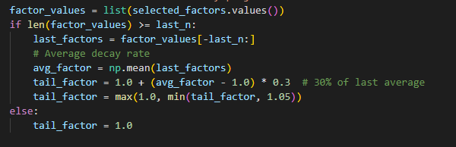

Figure 36:
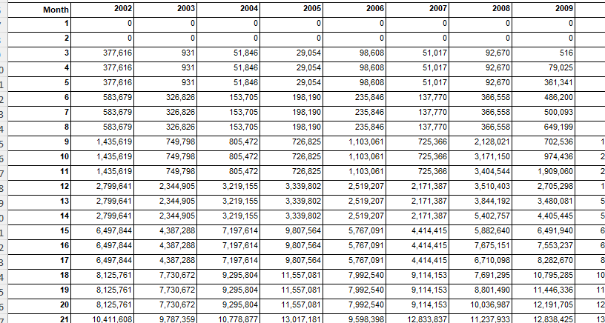

Figure 37:
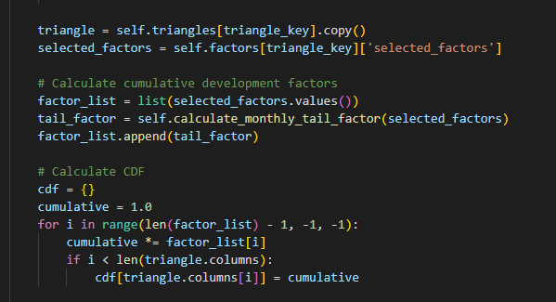

Figure 38:
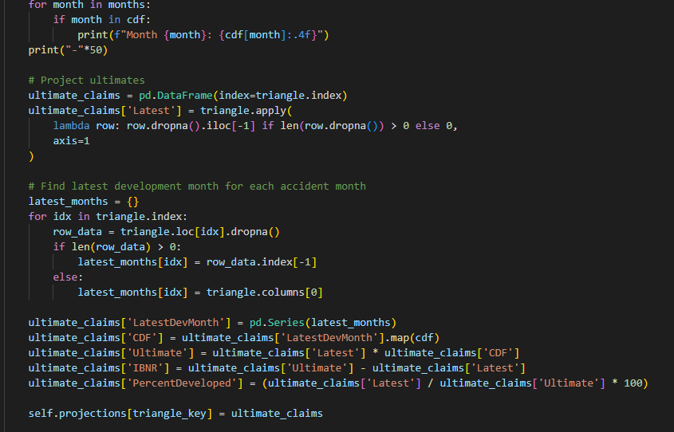

Figure 39:
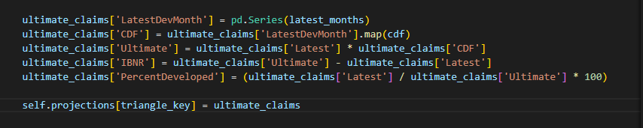

Figure 40:
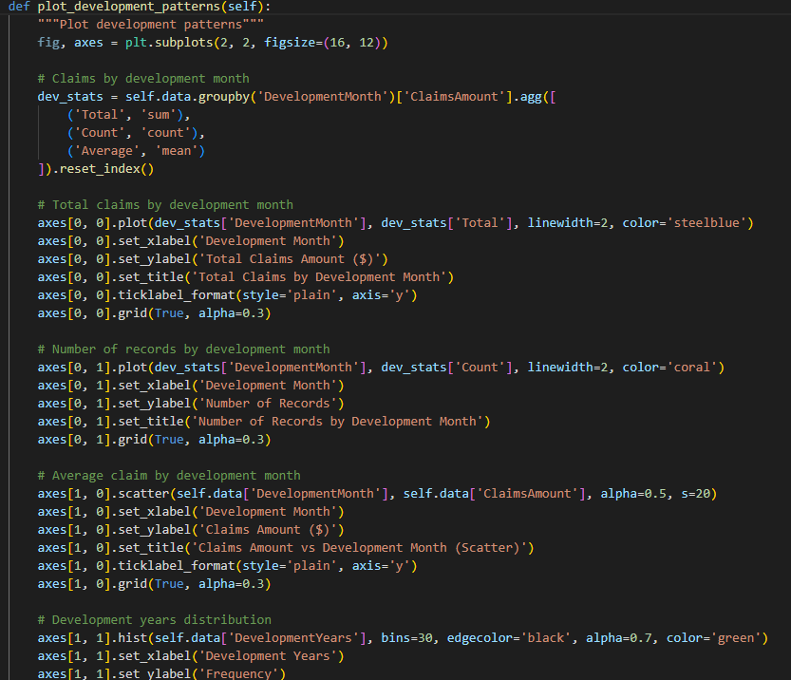

Figure 41:
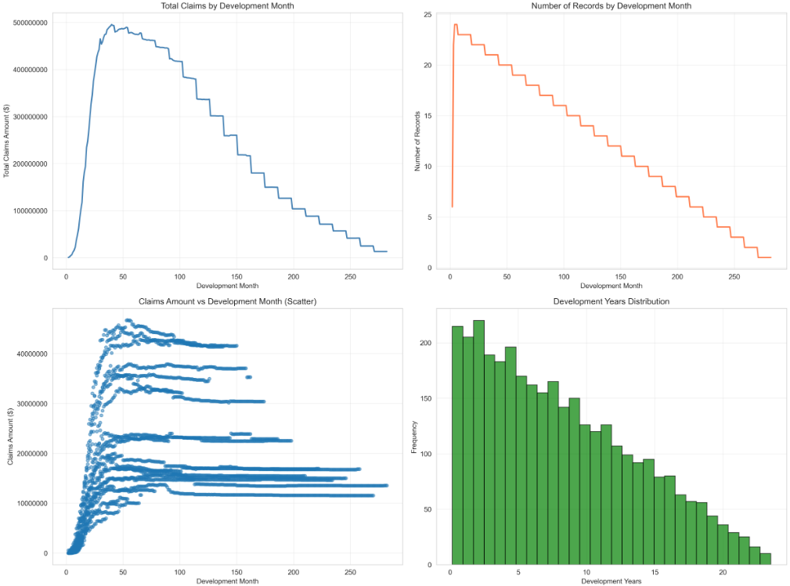

Figure 42:
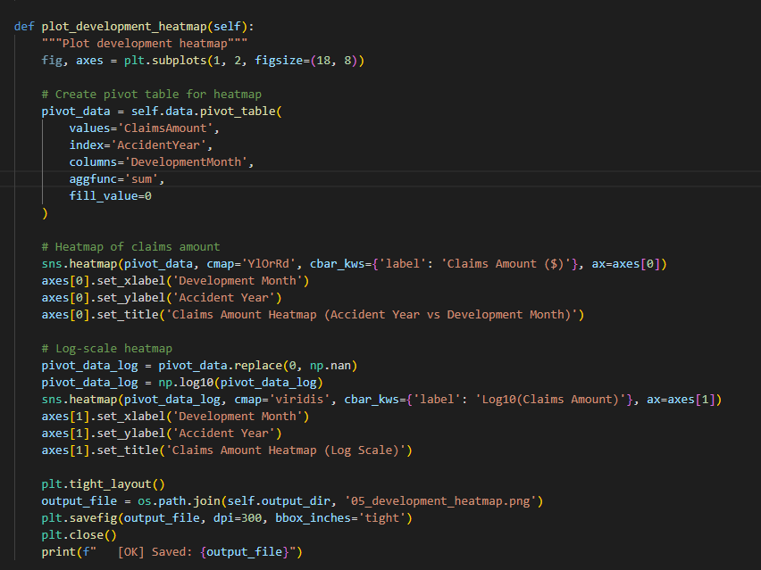

Figure 43:
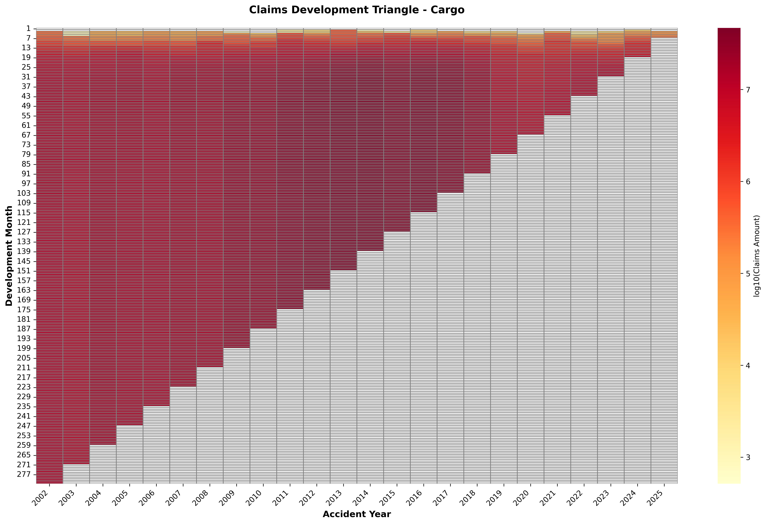

Figure 44
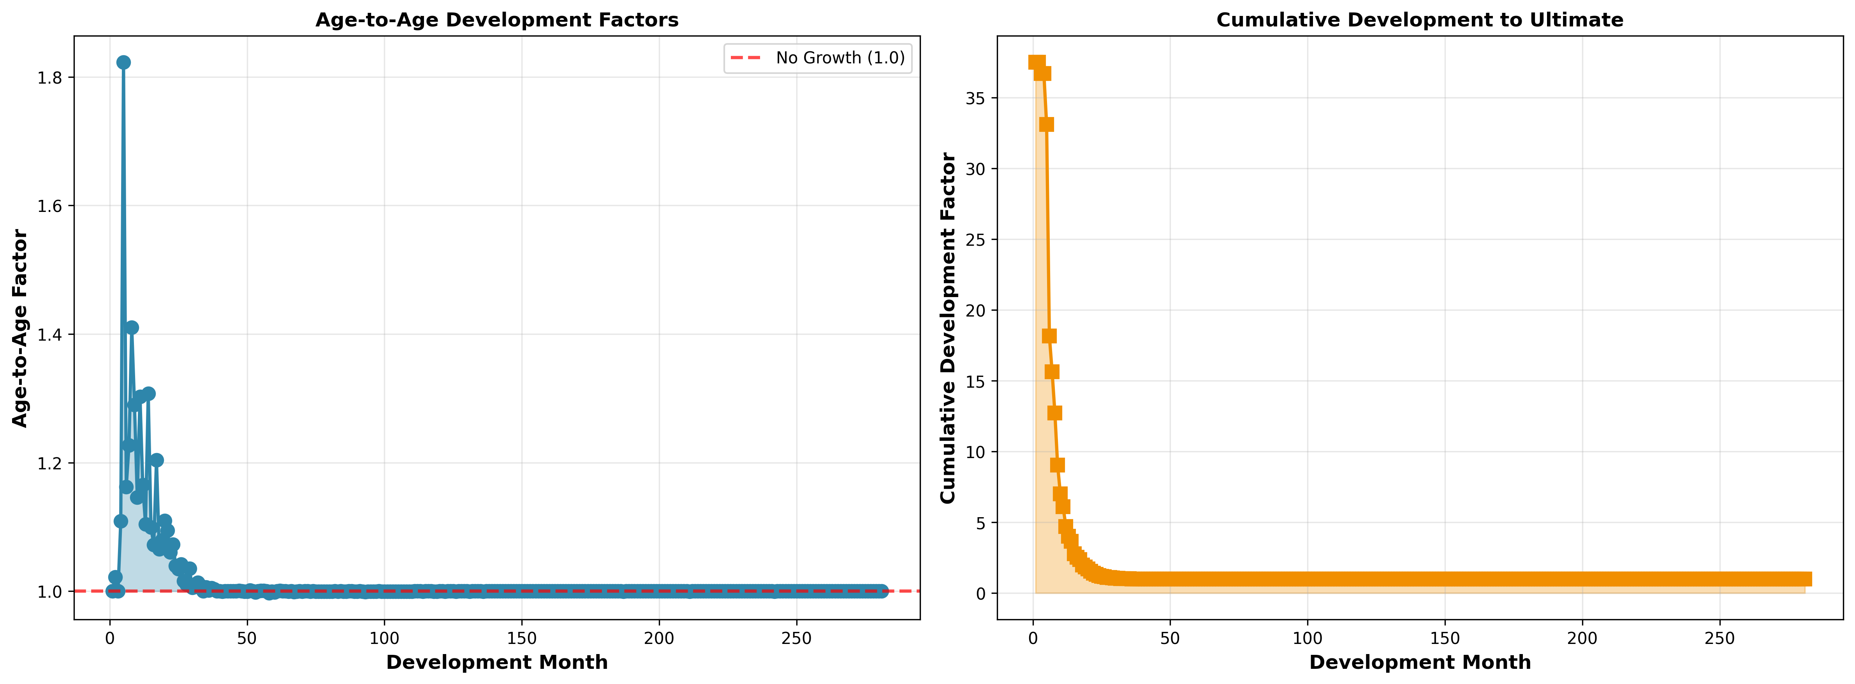

Figure 45:
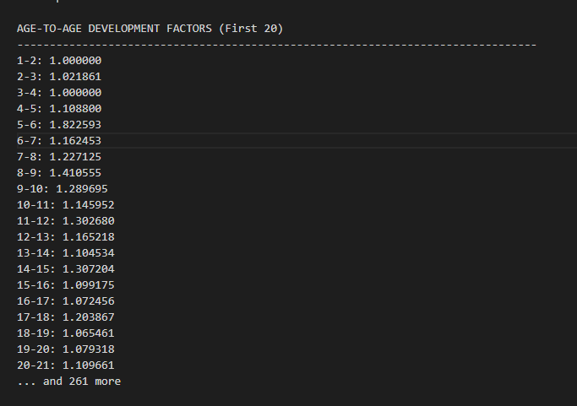

Figure 46:
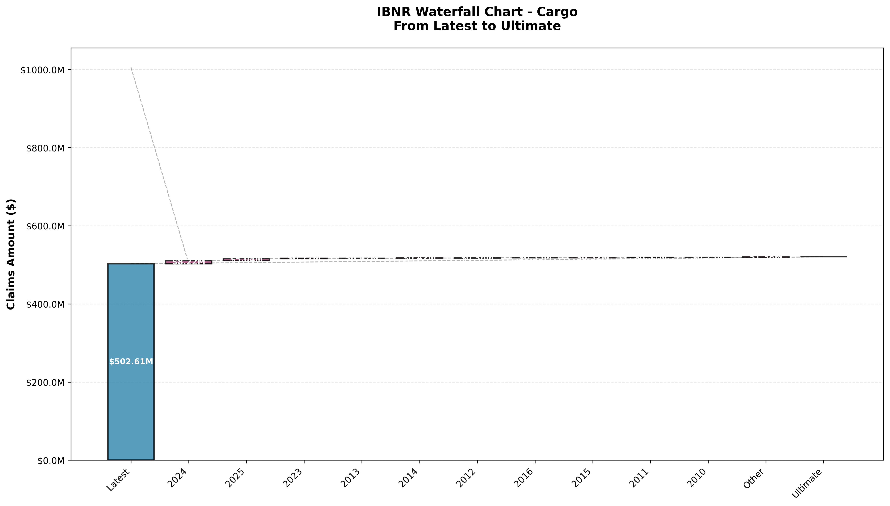

Figure 47:
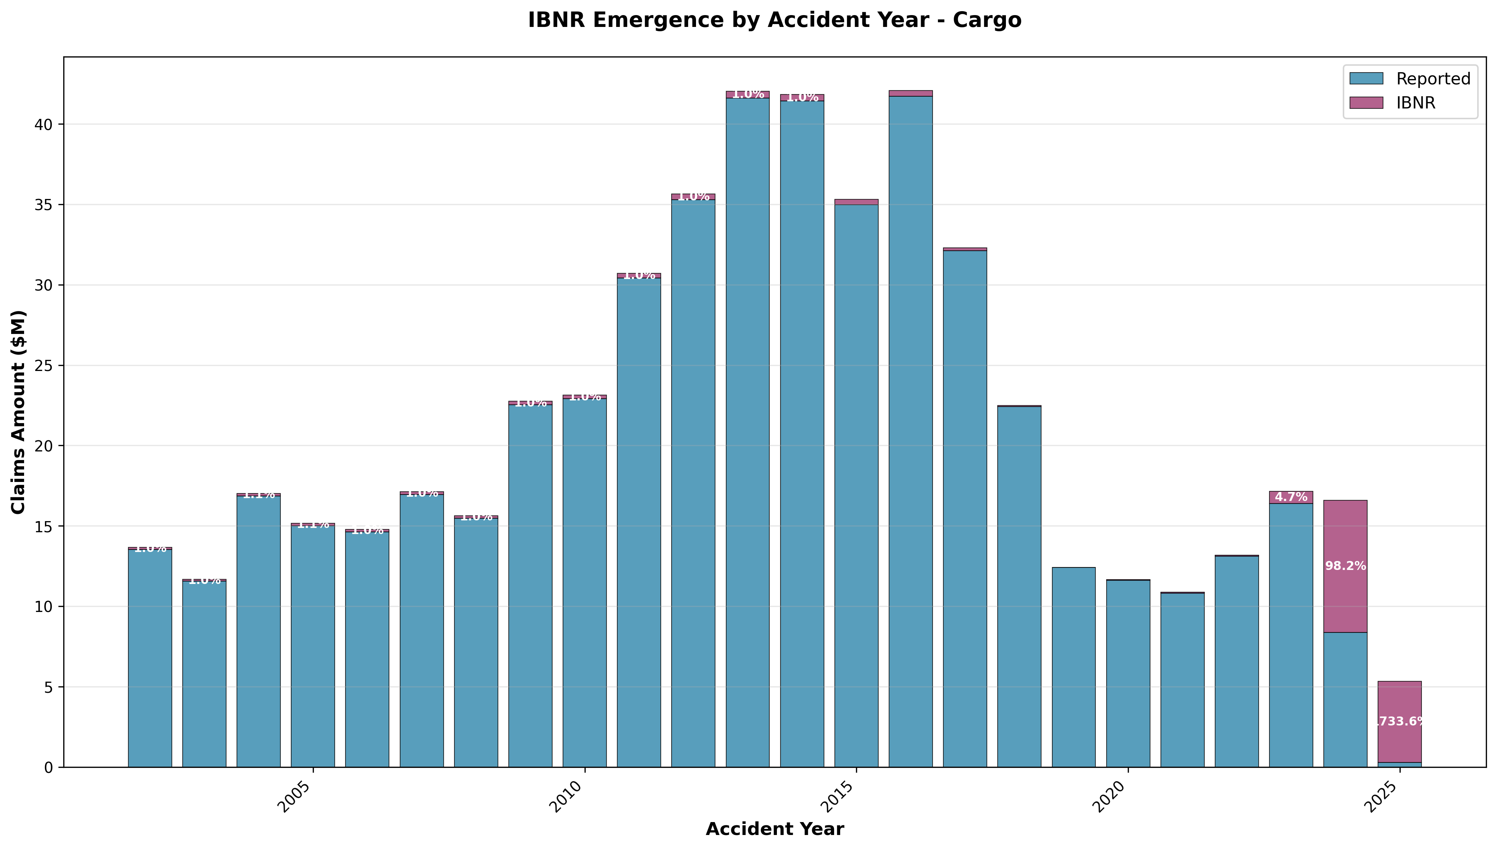

Figure 48: Development Factor Calculation
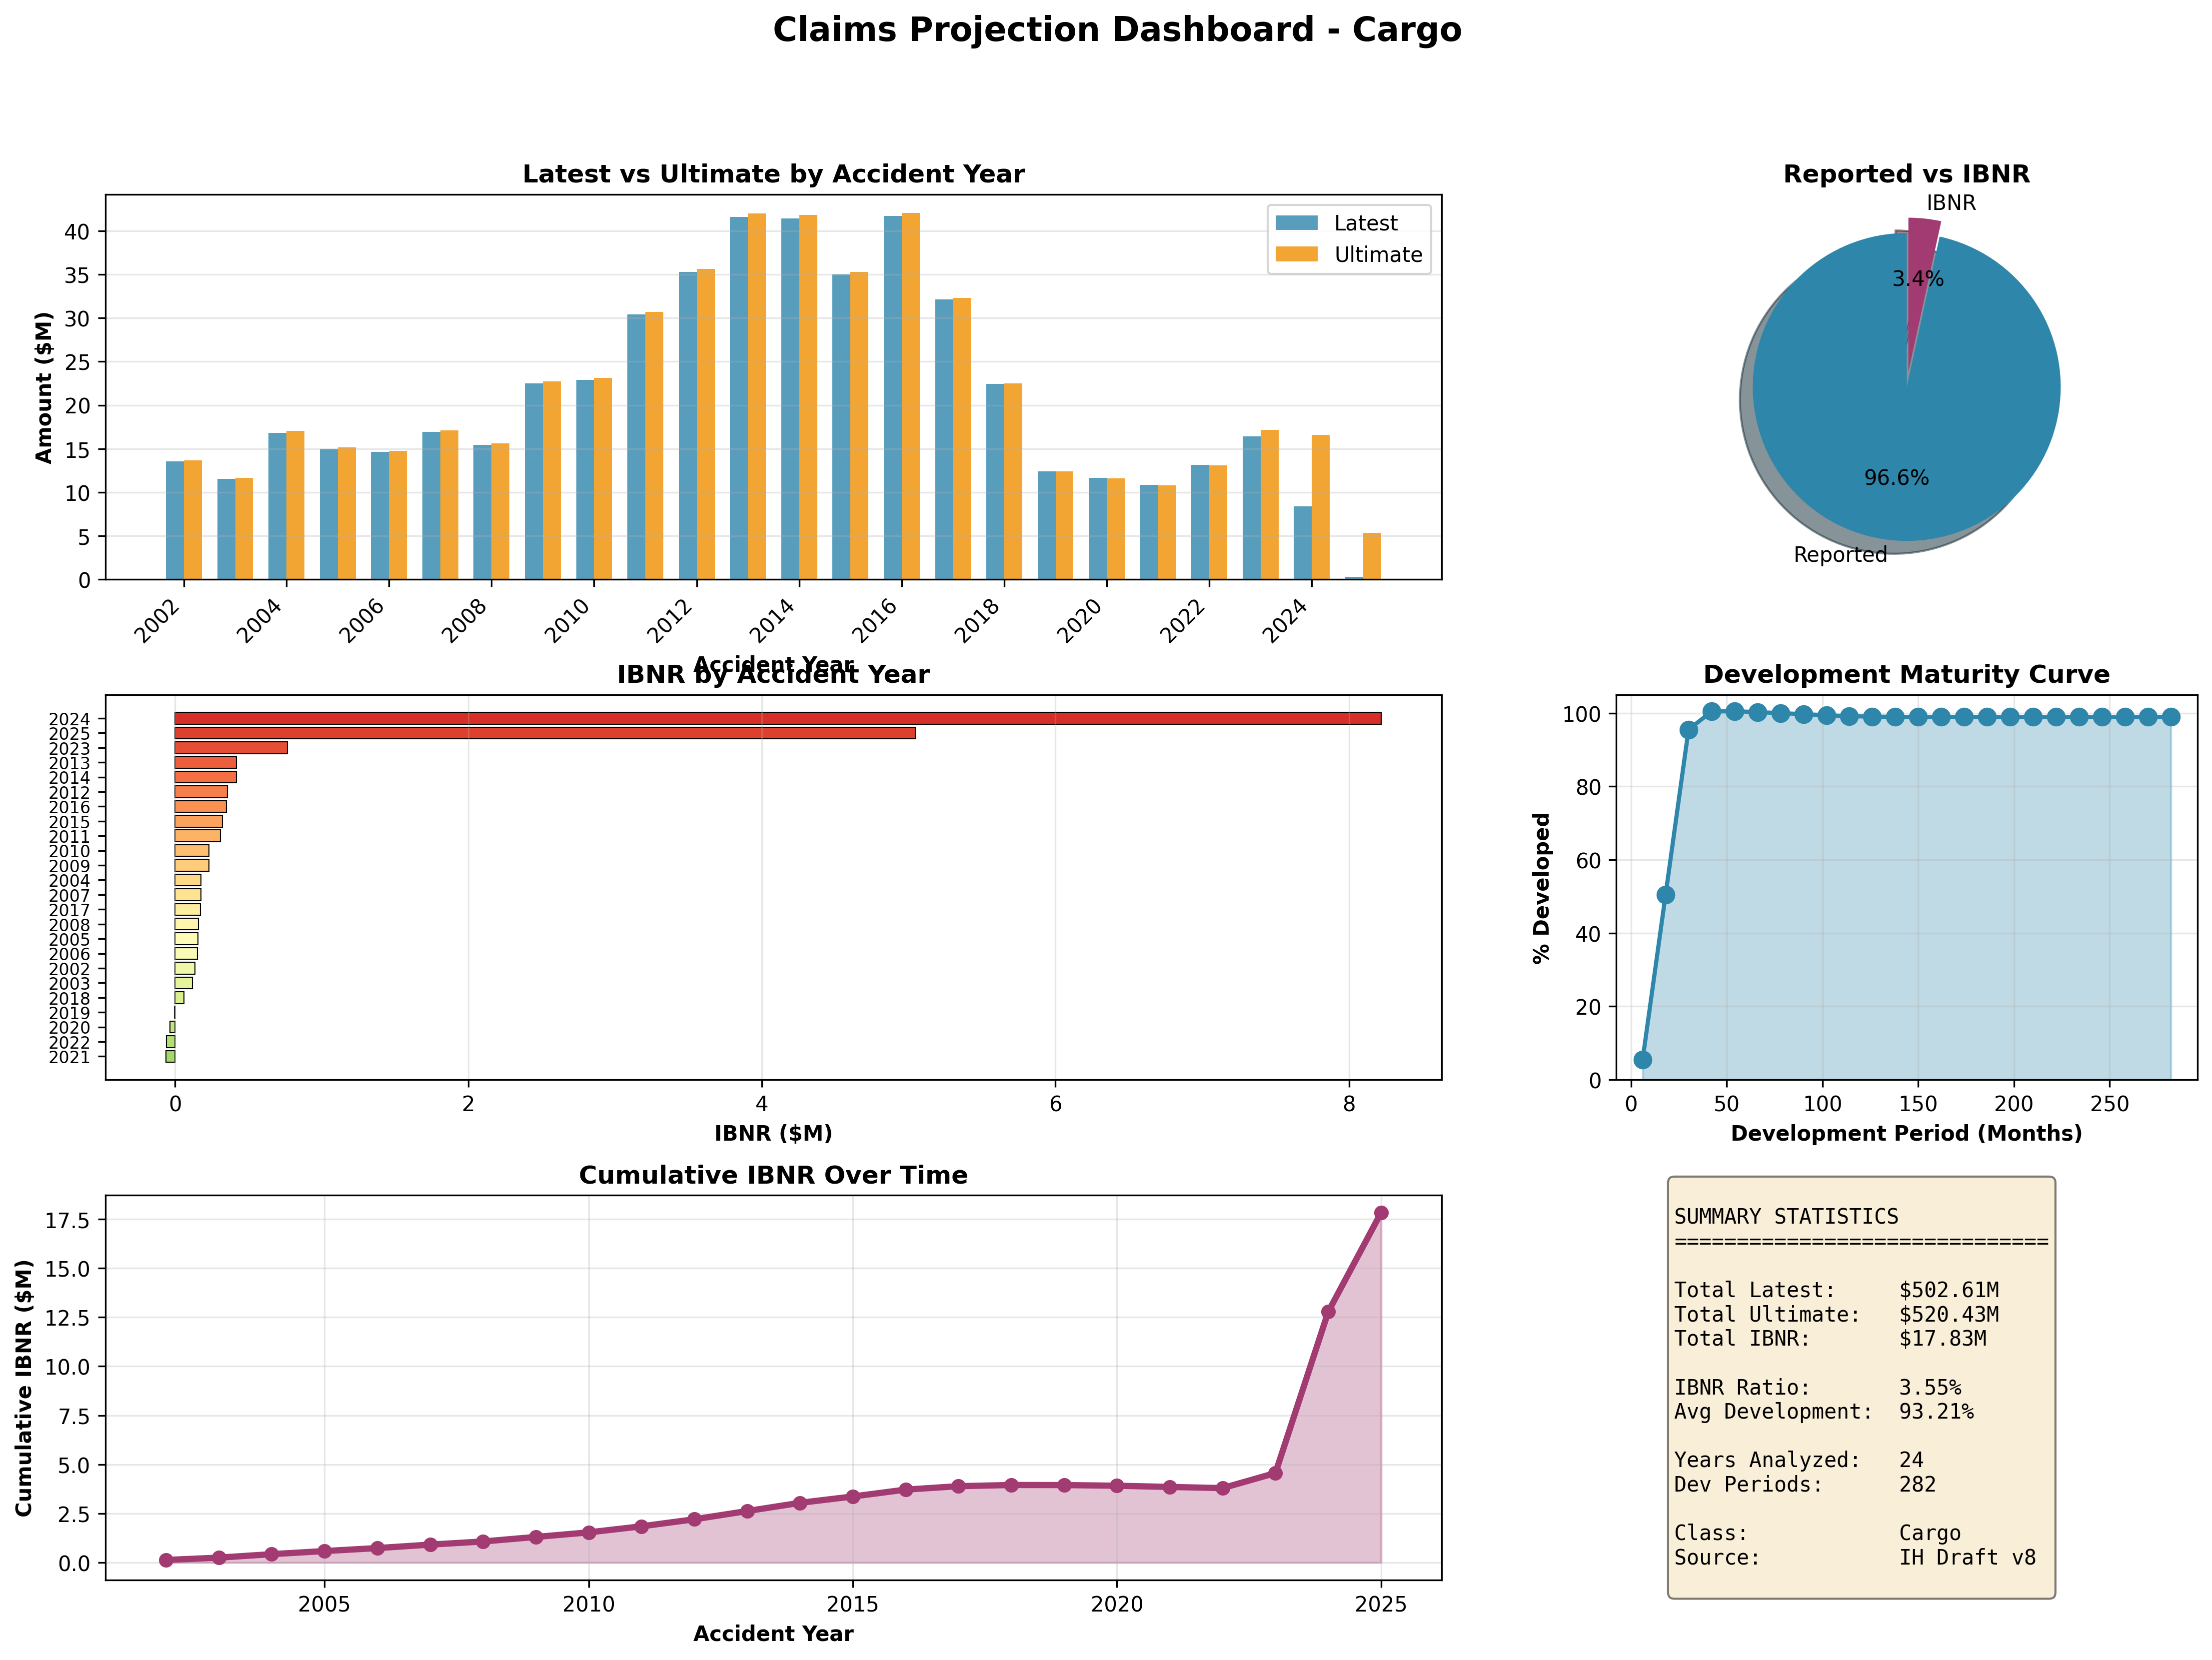

Figure 49:
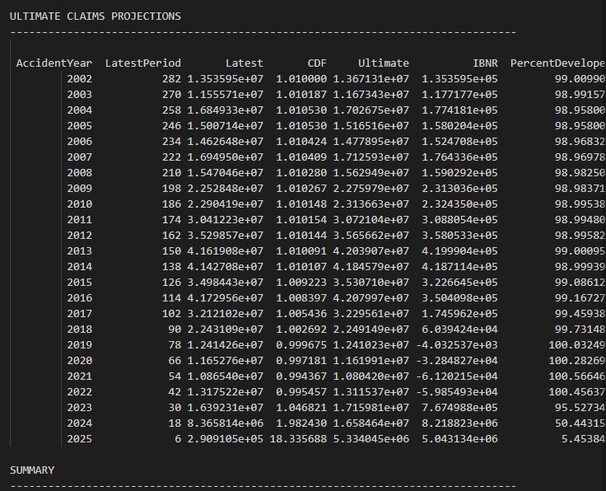

Figure 50:
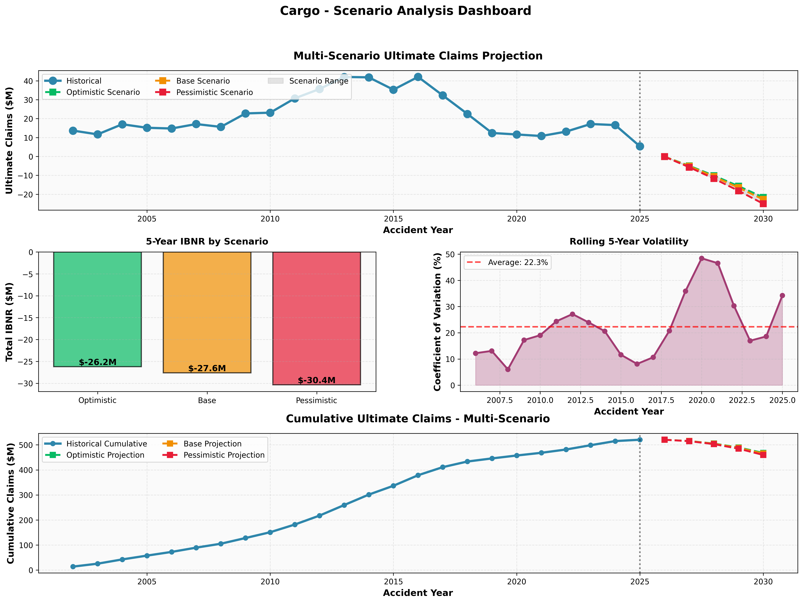

Figure 51:
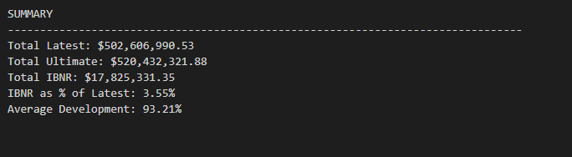

Figure 52:
