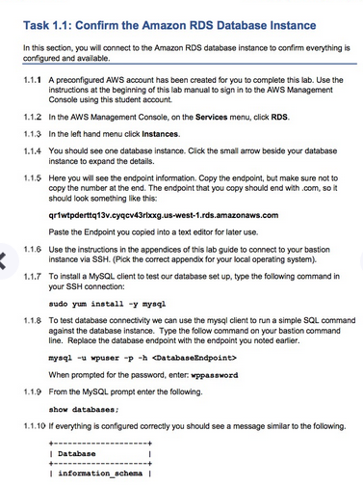



DevOps Engineering on AWS: Lab 5 - Using AWS OpsWorks - v1.5

==================================================================================================================

Using this command reference.

==================================================================================================================

1. Locate the section you need. Each section in this file matches a section in the lab instructions.

2. Replace items in angle brackets - < > - with appropriate values. For example, in this command you would replace the value - <JobFlowID> - (including the angle brackets) with the parameter indicated in the lab instructions:

elastic-mapreduce --list <JobFlowID>. You can also use find and replace to change bracketed parameters in bulk.

3. Do NOT enable the Word Wrap feature in Windows Notepad or the text editor you use to view this file.

++++1. Task: Deploying an Application with AWS CodeDeploy

==================================================================================================================

1.1: Confirm the RDS database instance

==================================================================================================================

1.1.7 Install a MySQL client

sudo yum install -y mysql

1.1.8 Test database connectivity

mysql -u wpuser -p -h <DatabaseEndpoint>

CMD: mysql -u wpuser -p -h “qruvcyn13km6xq.c9bzverkf0xw.us-east-1.rds.amazonaws.com”

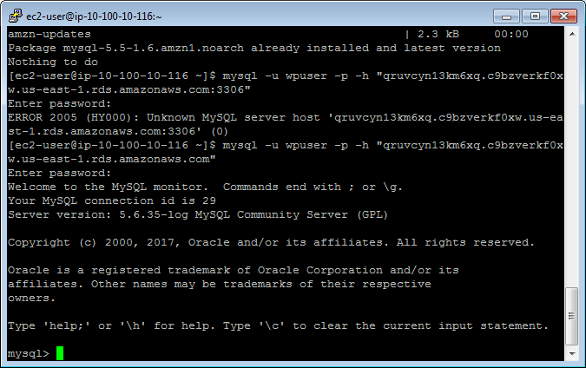

1.1.10 From the MySQL prompt enter the following.

show databases;

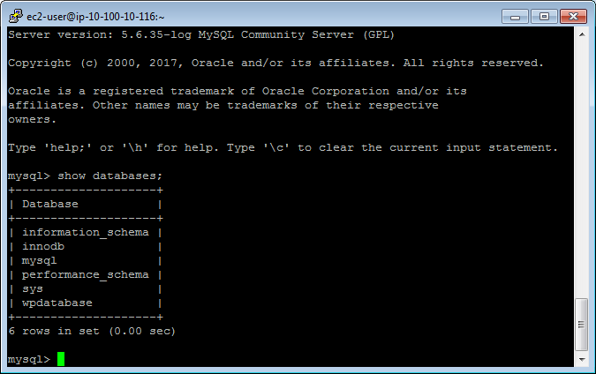

OUTPUTS:

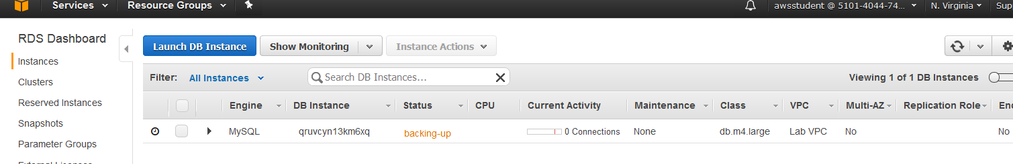 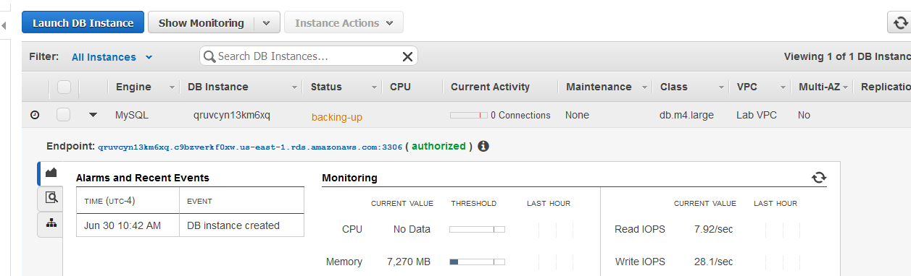

Endpoint: qruvcyn13km6xq.c9bzverkf0xw.us-east-1.rds.amazonaws.com:3306

SSH:

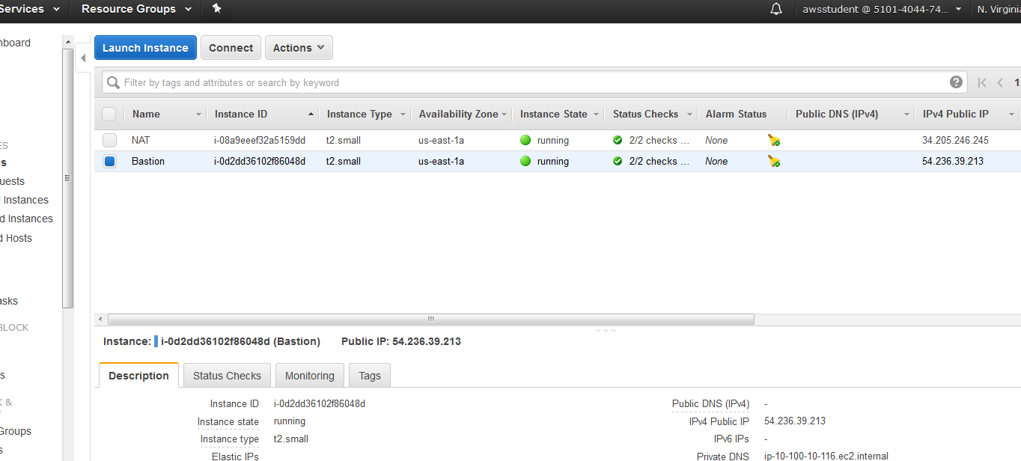

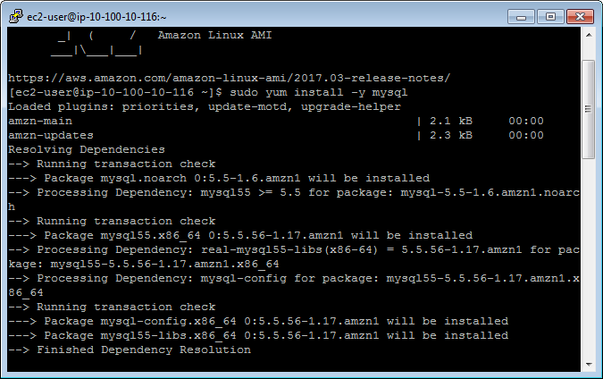

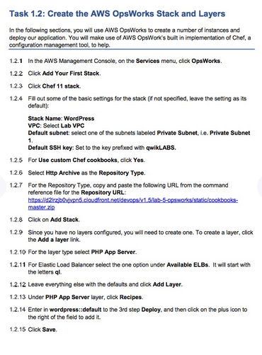 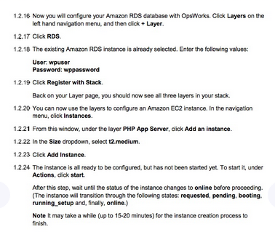

==================================================================================================================

1.2: Create the AWS OpsWorks Stack and Layers

==================================================================================================================

1.2.7 Repository URL

https://d2lrzjb0vjvpn5.cloudfront.net/devops/v1.5/lab-5-opsworks/static/cookbooks-master.zip

OUTPUTS:

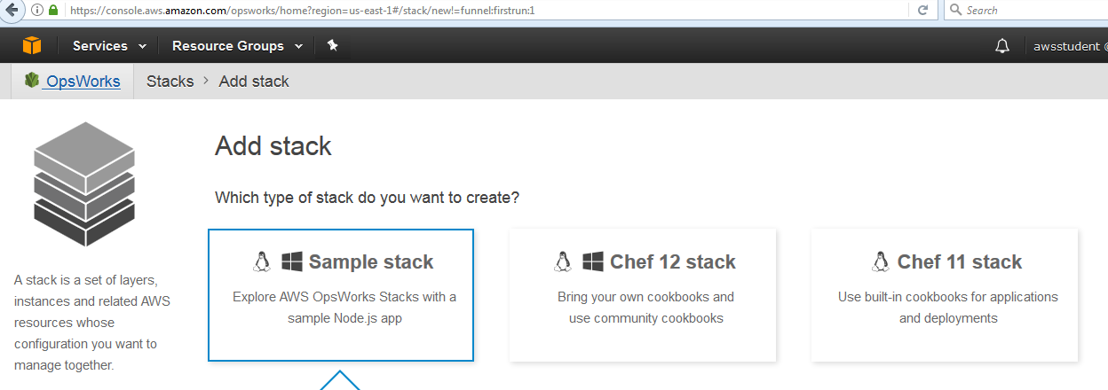

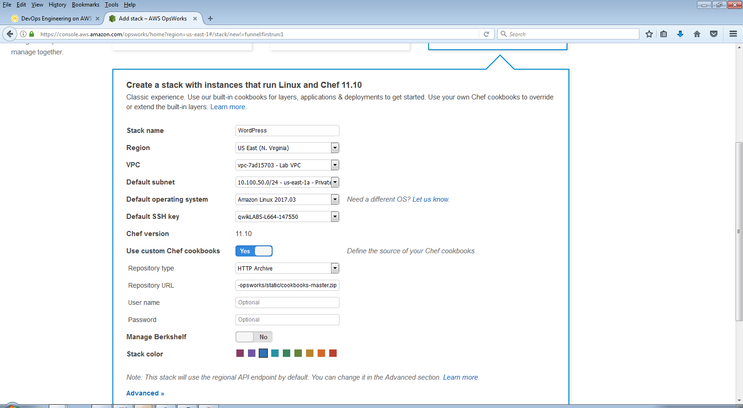 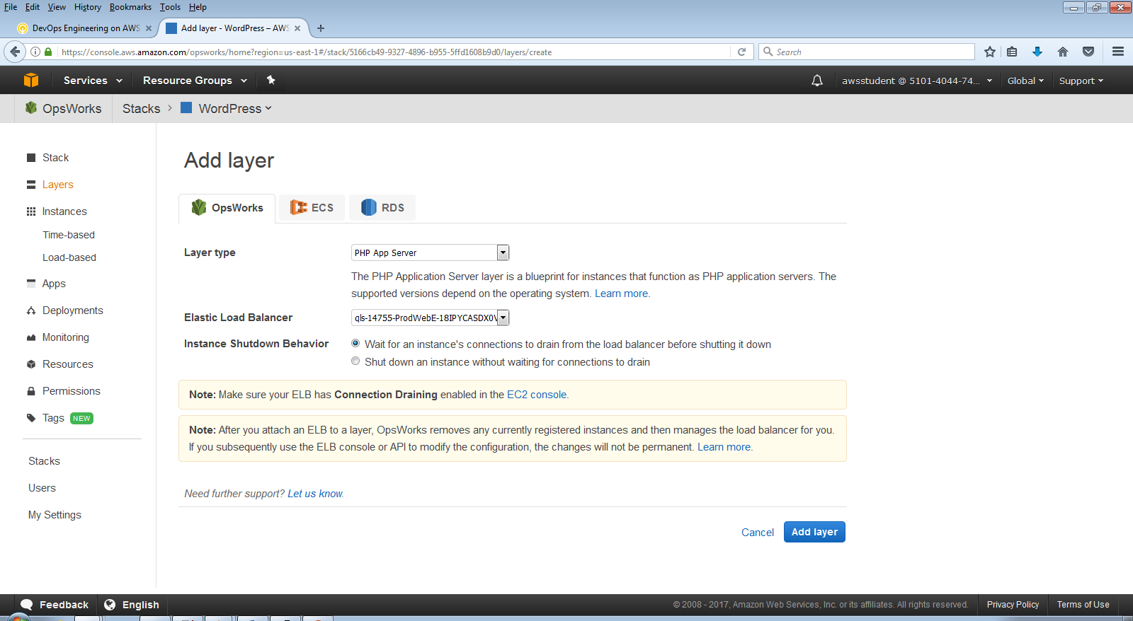 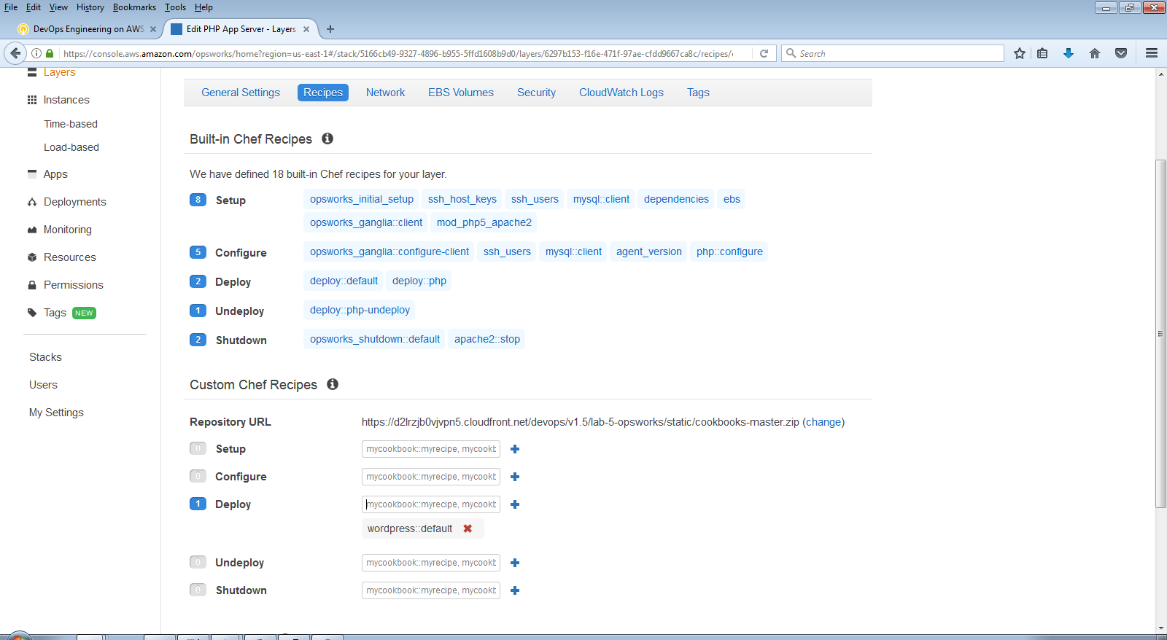 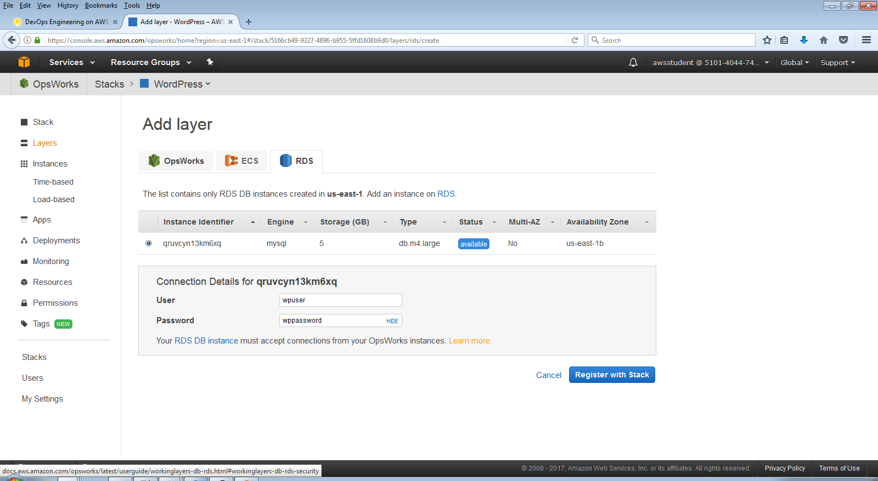 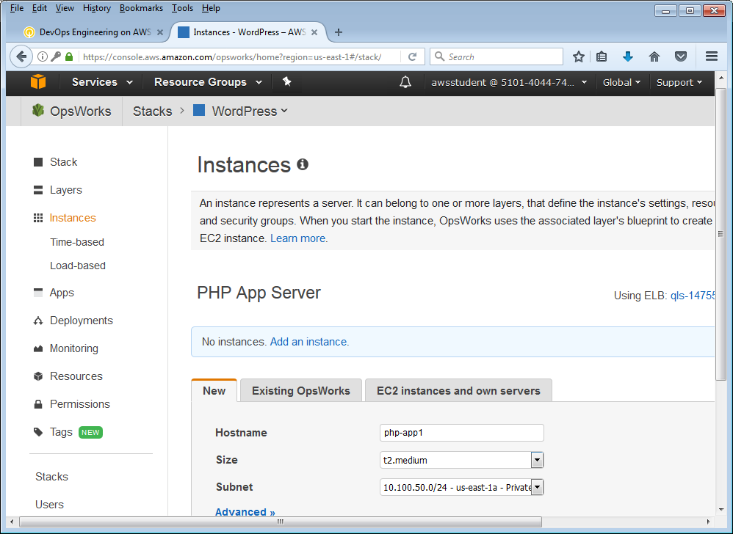

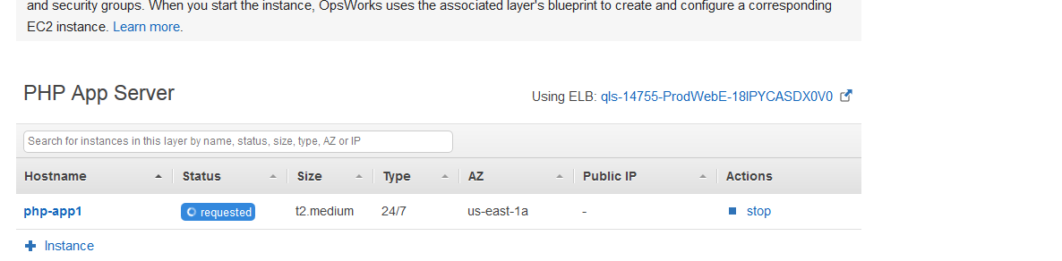

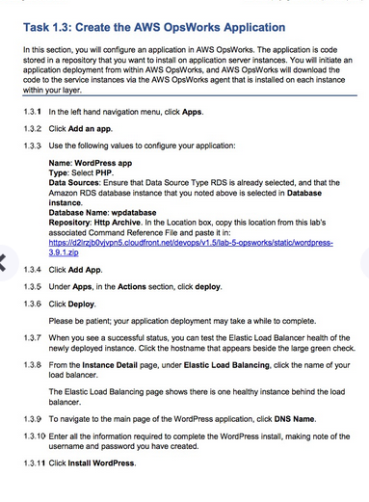 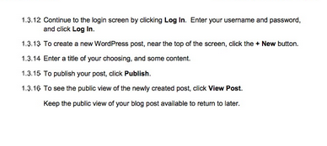 ==================================================================================================================

1.3: Create the AWS OpsWorks Application

==================================================================================================================

1.3.3 Location of the WordPress application

https://d2lrzjb0vjvpn5.cloudfront.net/devops/v1.5/lab-5-opsworks/static/wordpress-3.9.1.zip

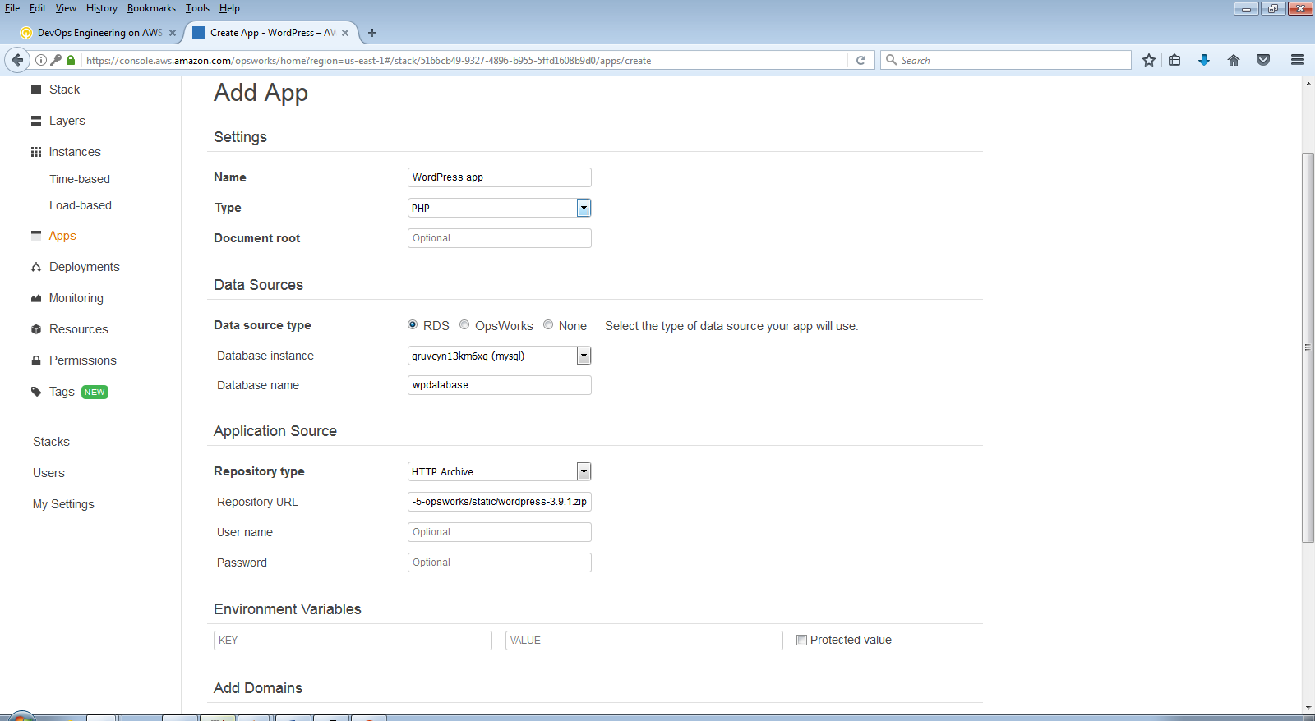

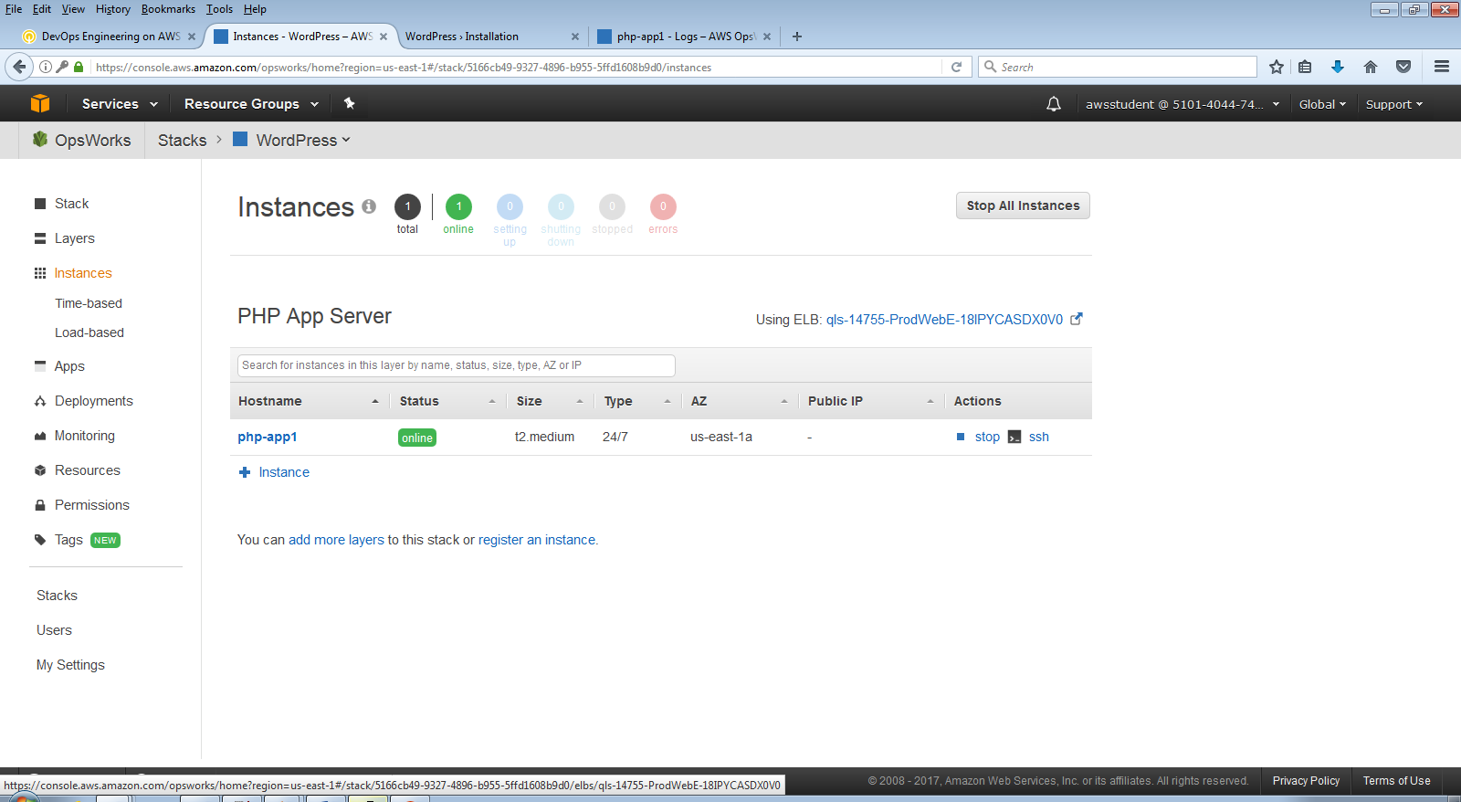

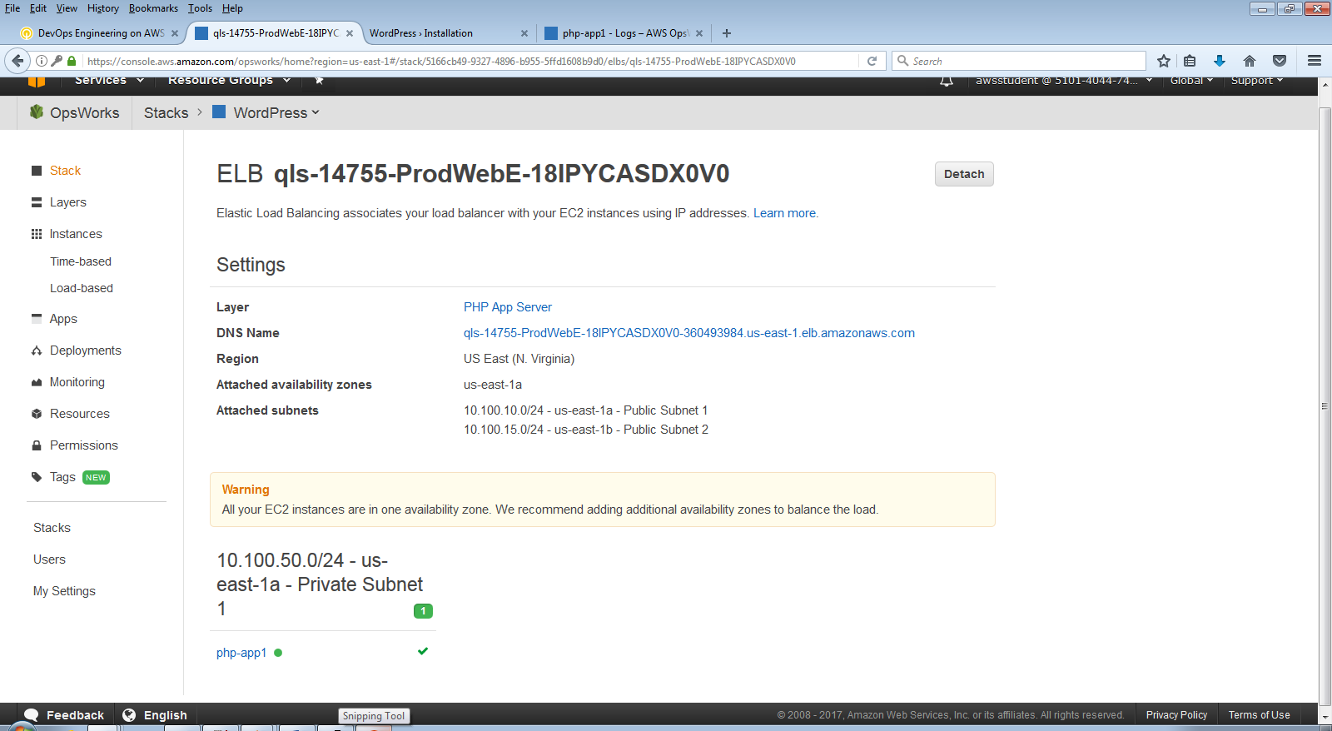

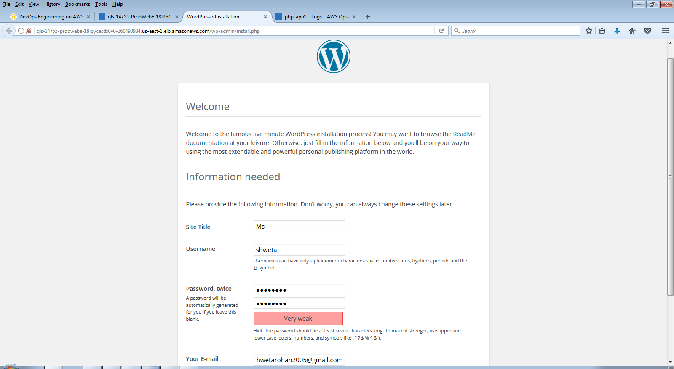

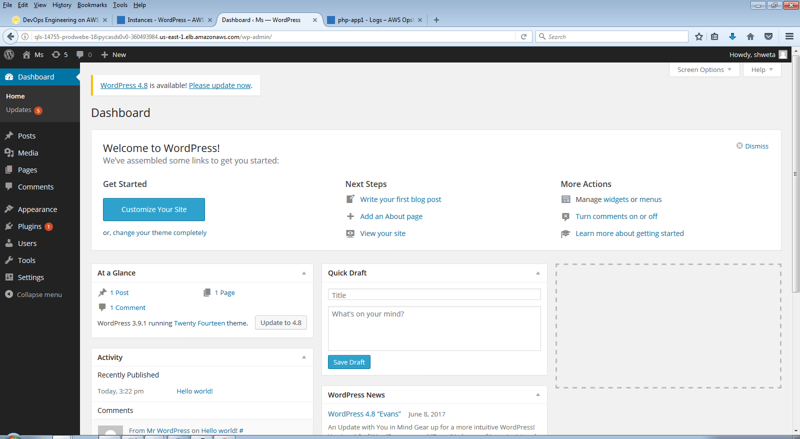

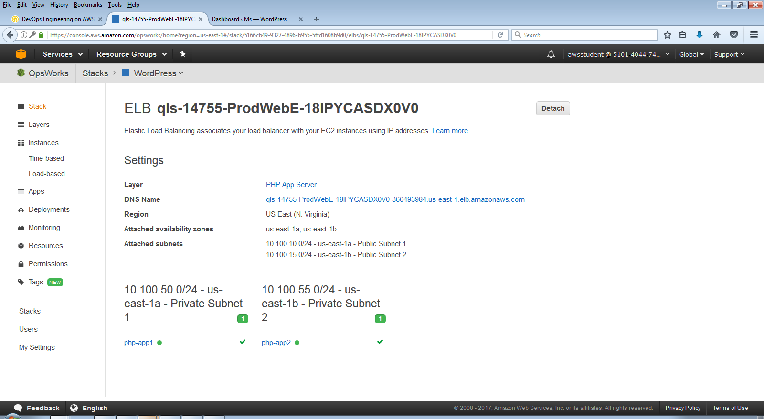

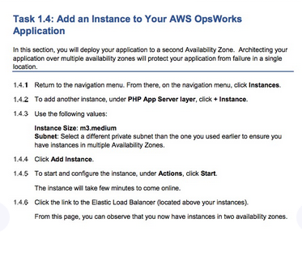 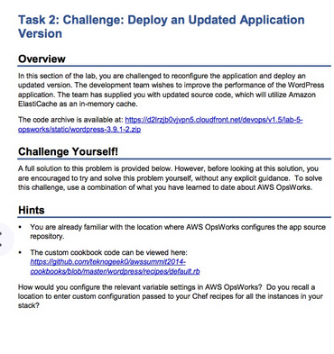 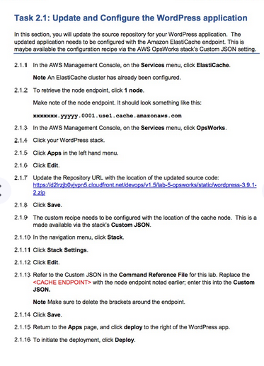

OUTPUT:

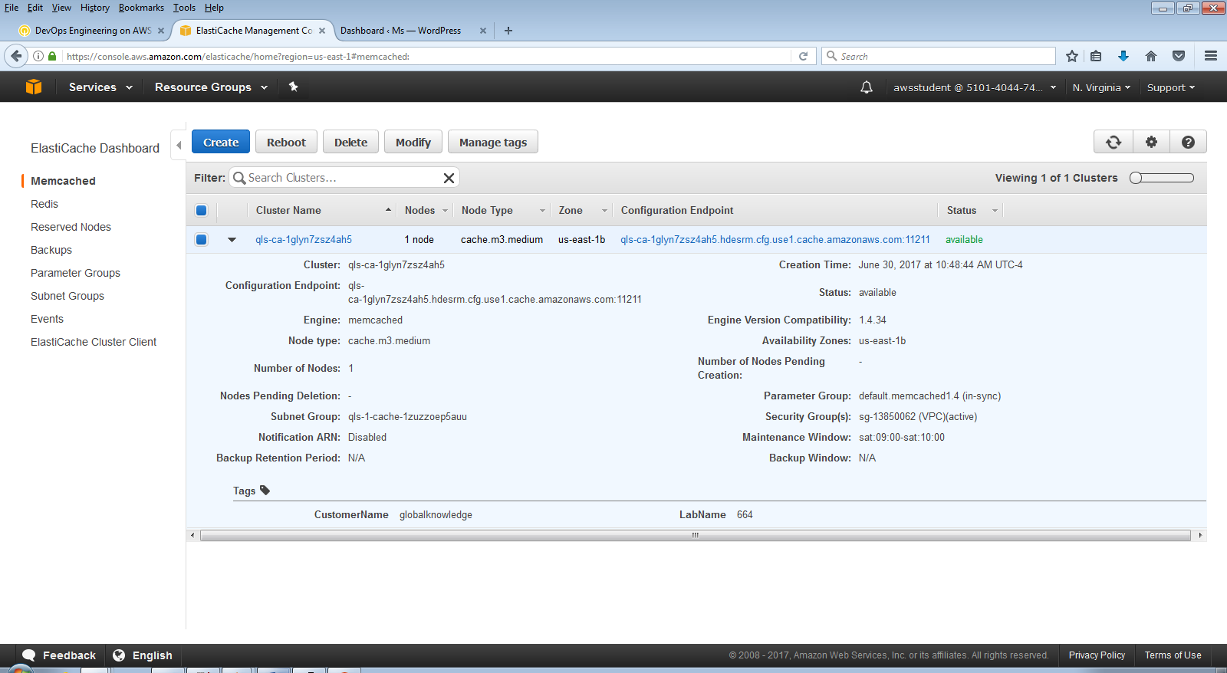

Endpoint: qls-ca-1glyn7zsz4ah5.hdesrm.cfg.use1.cache.amazonaws.com

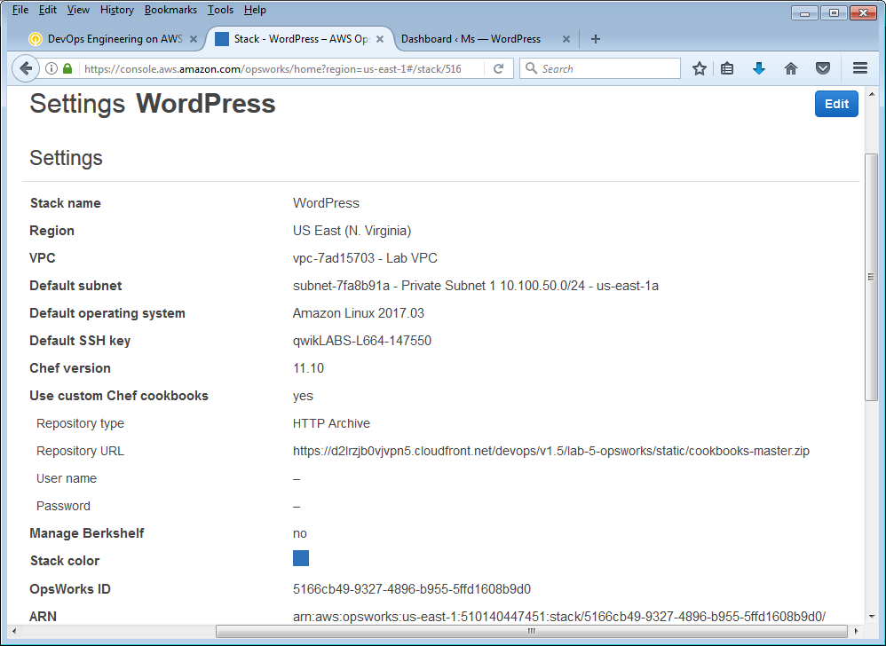

==================================================================================================================

2.1: Update and Configure the WordPress Application

==================================================================================================================

2.1.7 Updated Repository URL

https://d2lrzjb0vjvpn5.cloudfront.net/devops/v1.5/lab-5-opsworks/static/wordpress-3.9.1-2.zip

2.1.13 Custom JSON

{

"wordpress" :

{

"cachenode" : "<CACHE ENDPOINT>"

}

}

