Security

Well-­Architected Pillar  1:  Security

A **web application firewall** (**WAF**) is an **application firewall** for HTTP **applications**. It applies a set of rules to an HTTP conversation. Generally, these rules cover common attacks such as cross-site scripting (XSS) and SQL injection. While proxies generally protect clients, WAFs protect servers.

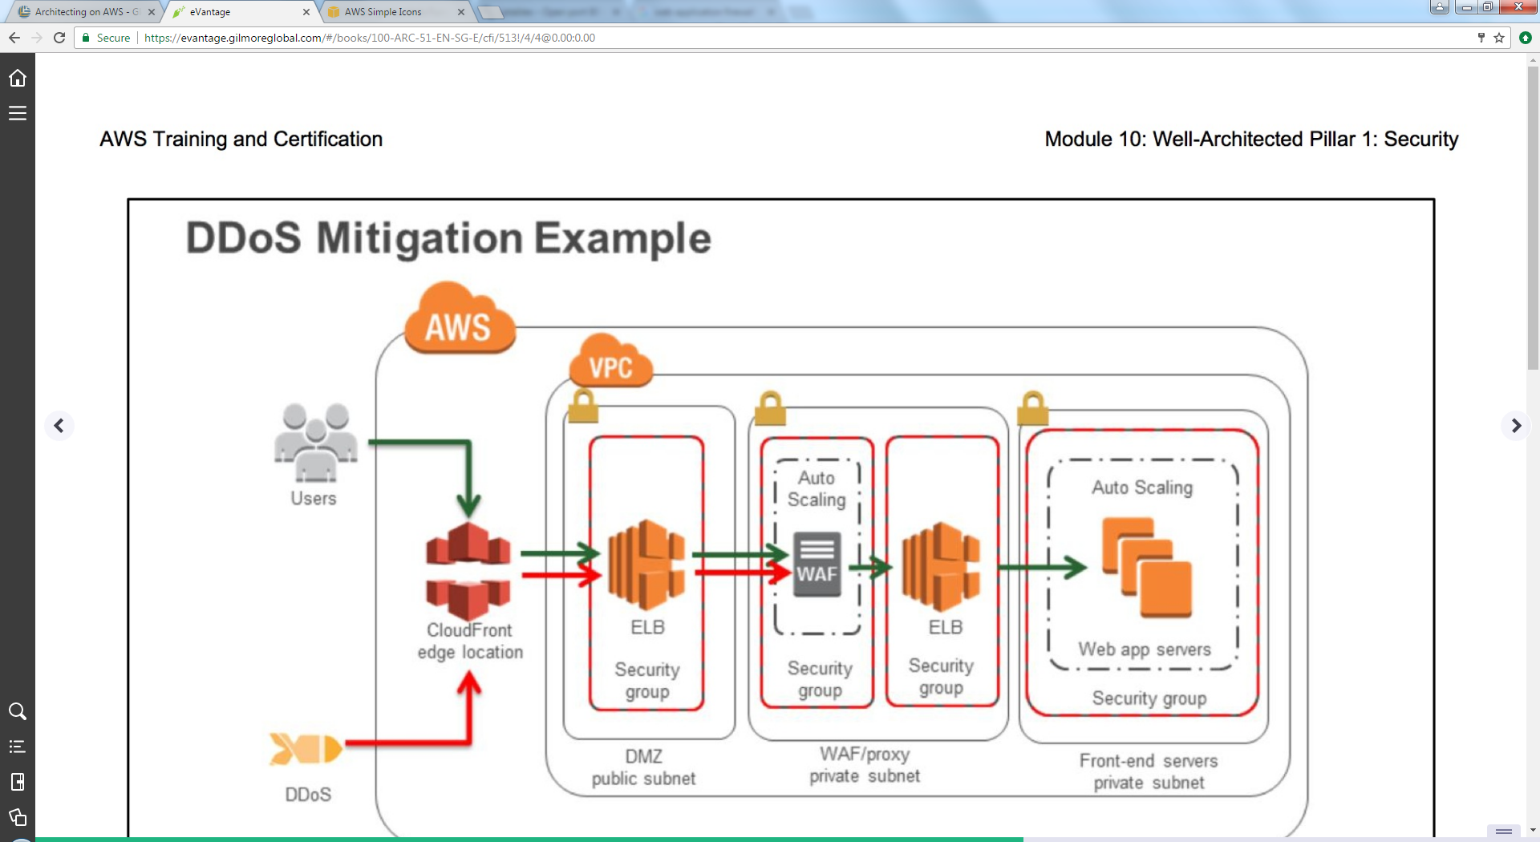

OAI: Get objects from s3 and feed them to cloud front, they are not real users.

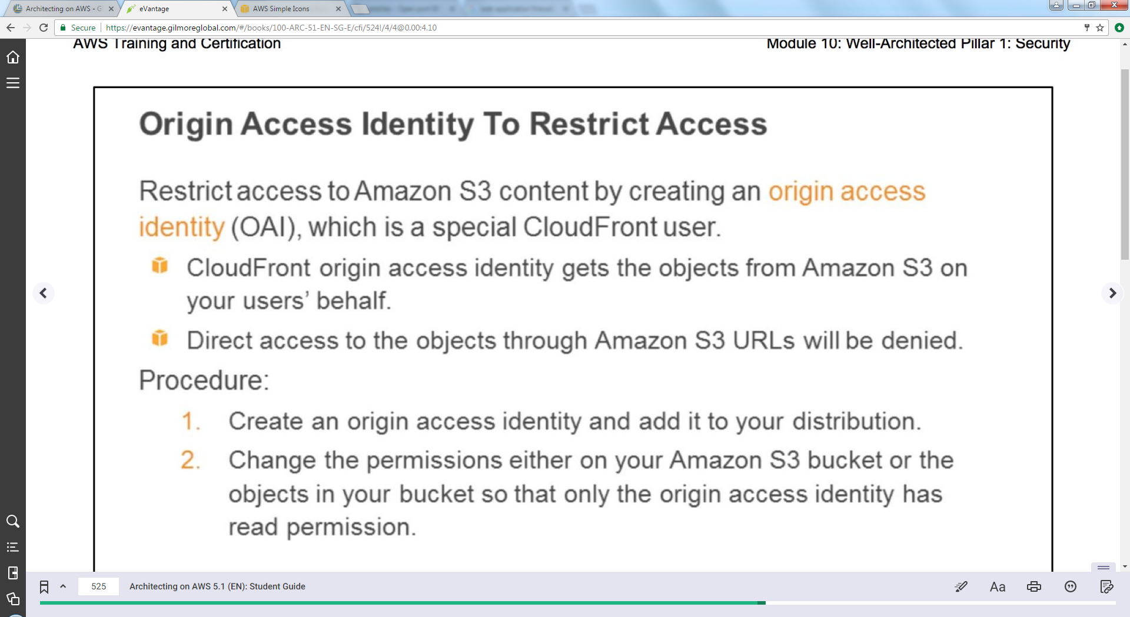

Encryption

Envelop encryption: fast and simple, encrypt data key with master key.

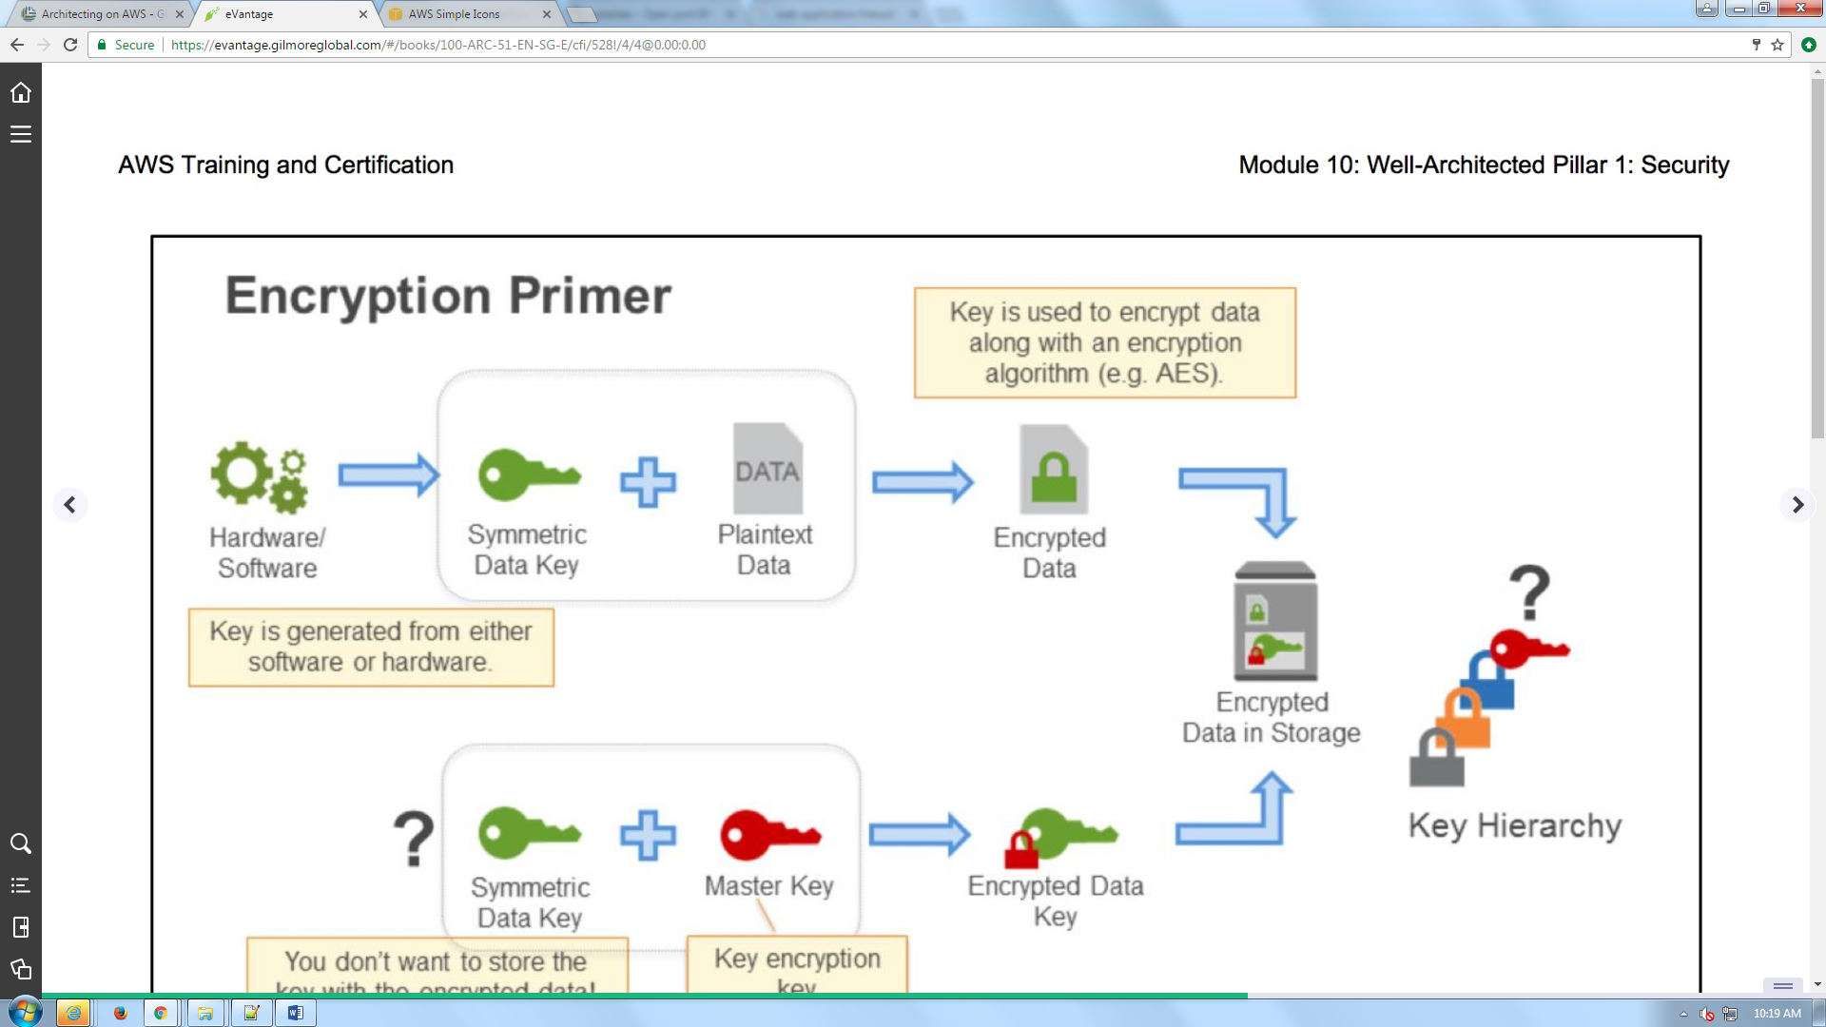

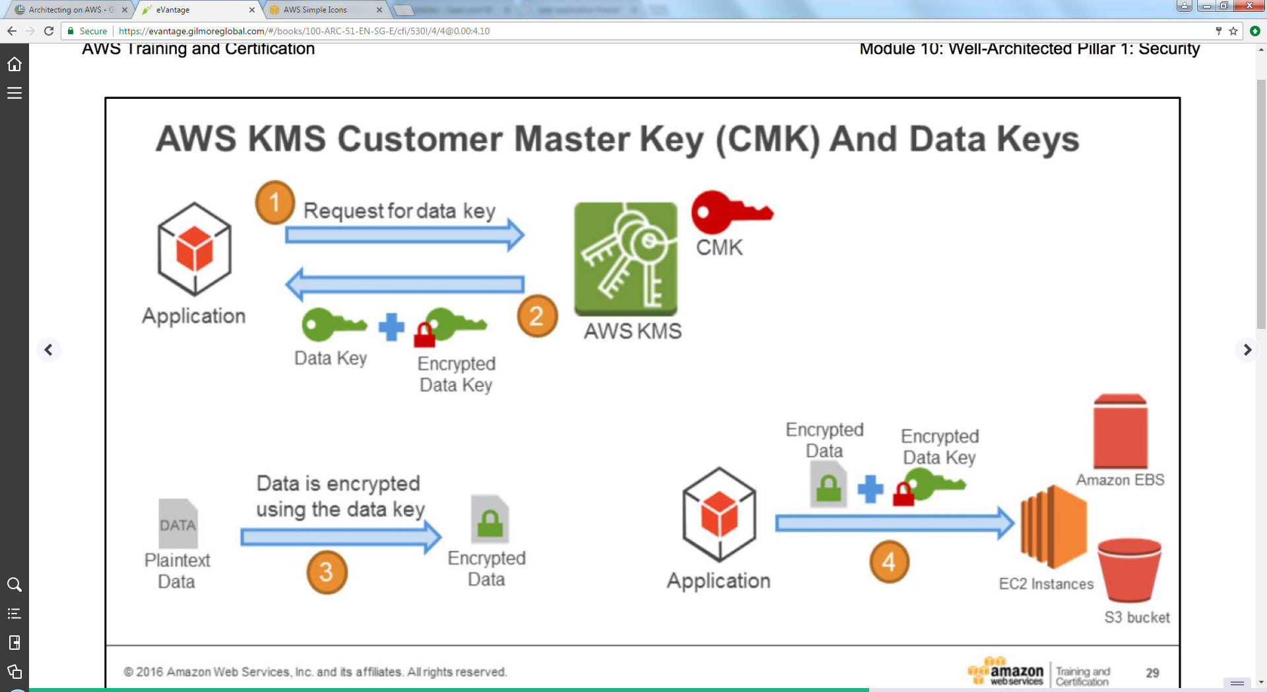



* KMS managed by amazon.
* KMS has shared tendency.
* Kms: key management services
* Encrypted keys or master keys are always in KMS.
* No noticeable performance lag using encryption

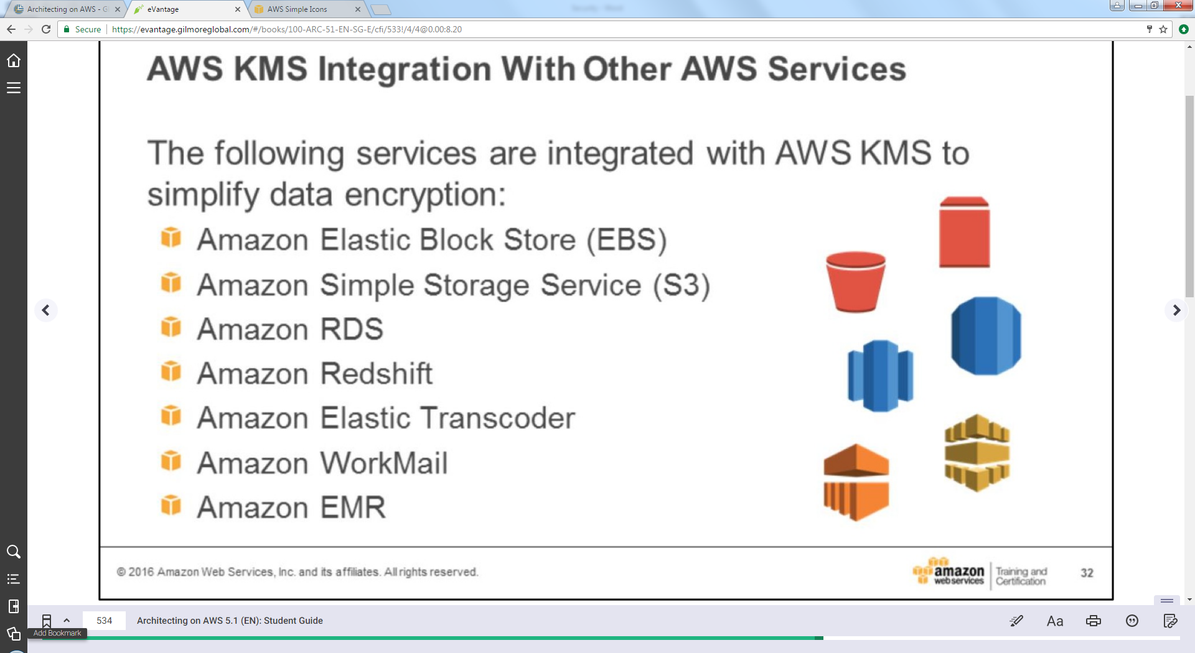

Elastic transcoder: to transcode video files