For excel model worked with: Ish, Sumeeth, Ajaiy

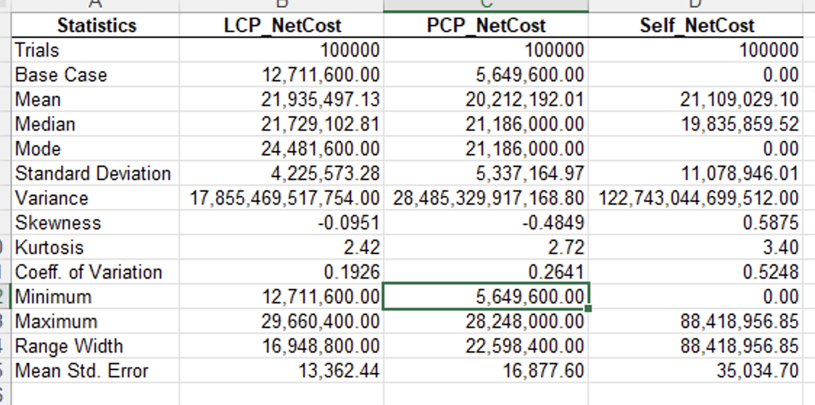

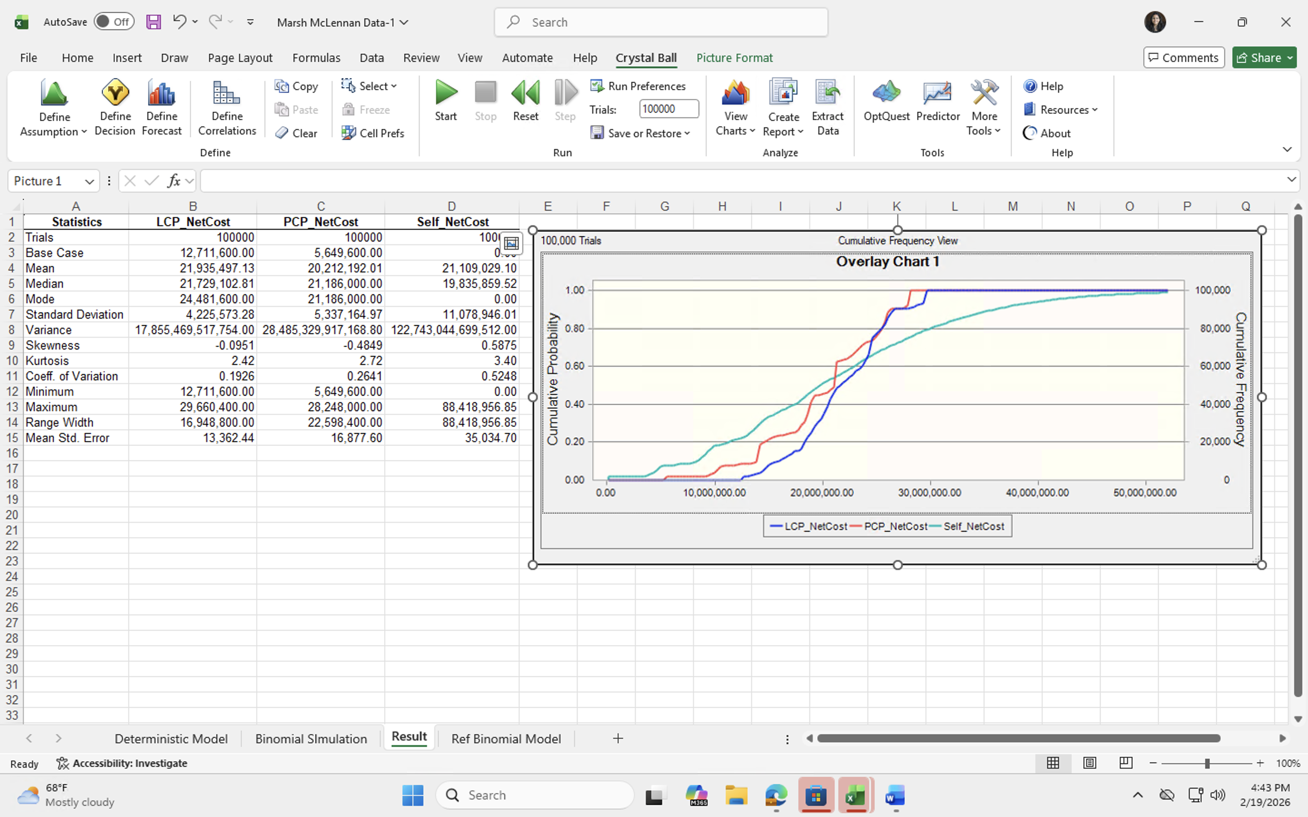

Plan | Mean
PCP | $20,212,192
LCP | $21,935,497
Self-Insured | $21,109,029

Clearly PCP has the lowest expected cost.
Plan | Std Dev.
LCP | 4,225,573.28
PCP | 5,337,164.97
Self-Insured | 11,078,946.01

PCP is slightly riskier than LCP.
Self-insurance is dramatically riskier. Self-insurance means: Eastern pays 100% of all hull losses itself. No caps. No smoothing. No insurer sharing the risk. It exposes Eastern Airlines to very large and unpredictable losses without offering a cost advantage. Based on the simulation, self-insurance does not have the lowest expected cost and has much higher volatility(Std Dev) and extreme downside risk compared to the insurance plans. In bad scenarios, losses could reach very high levels, which could seriously affect the airline’s financial stability. Since aircraft crashes are low-frequency but high-severity events, transferring that risk through insurance is financially more prudent than bearing it entirely.
So:
LCP = safer
PCP = cheaper but slightly more volatile
Self = very risky

Plan | Maximum
LCP | 29,660,400.00
PCP | 28,248,000.00
Self-Insured | 88,418,956.85
Plan | Mean | Std Dev. | Minimum | Maximum
LCP | $21,935,497 | 4,225,573.28 | 12,711,600.00 | 29,660,400.00
PCP | $20,212,192 | 5,337,164.97 | 5,649,600.00 | 28,248,000.00
Self-Insured | $21,109,029 | 11,078,946.01 | 0 | 88,418,956.85

However, if we look at the overlay charts
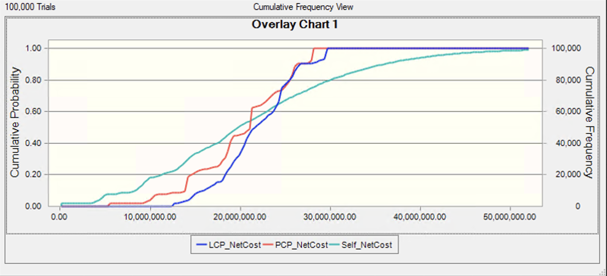
At any given point, for Probability of X amount of loss, PCP has higher probability than LCP. And later both of them reach the same maximum exceeded limit. LCP has lower standard deviation and smoother mid-range outcomes, even though its expected cost is slightly higher.
Which makes it better choice out of all. Hence, I would recommend going with Loss Conversion plan for Marsh & McLennan.

