Shwetank Kumar

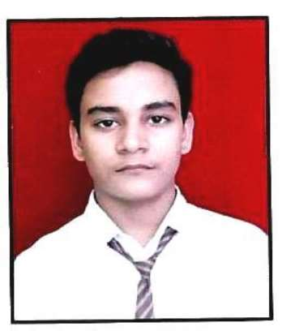

(Innovative, Quick-Learner, Dedicated

& Problem-Solver)

[Shwetank99kumar@gmail.com](mailto:Shwetank99kumar@gmail.com)

+91 7906522158

https://www.linkedin.com/in/shwetank-kumar-7b5965182/

**CAREER OBJECTIVE**: I want to create and develop all types of application

& software with the help of AI and ML and wants to

Become the part of a technology-driven company to

Achieve my goals and to improve my skills for future

Technology revolution.

# EDUCATION: Bachelor of Engineering (B.E.), Computer

**Science & Engineering (2016- 2020)**

IPS College of Technology and Management (Gwalior)

CGPA: 7.99

# XII (Senior Secondary), Science (2015-2016)

Vishwa Bandhu Academy, Gajraula (U.P) (CBSE Board)

PERCENTAGE: 60.8

# X (Secondary)(2013-2014)

Vishwa Bandhu Academy, Gajraula (U.P) (CBSE Board)

CGPA: 7.80

**PROJECTS:**

**MINOR PROJECT:**

**1. Blog App**

Basically, it is a simple blog App where you

Easily add your blog posts and also see others blogs.

**2. Color picker**

It is a simple game in which you have to

Guess the right color from different colors.

**MAJOR PROJECT:**

**My Personal Doctor(using Machine-learning & Python)**

It is a disease prediction project which is based

On when user fill all details or symptoms

Related information about the disease he

/she Suffers from then this model will predict the best

Suitable result about the disease from a user is suffering from.

**Framework: Tkinter(It is a GUI framework)**

**Database: MYSQL**

**SKILLS:**

1. Good knowledge of Python programming language.

2. Intermediate knowledge of HTML and CSS

3. Good Knowledge of Data Structure and Algorithm.

4. Basic Knowledge of Machine learning.

5.Intermediate Knowledge of MYSQL.

# 

**HOBBIES**: 1. Playing Cricket.

2. Playing Badminton.

# 

# DECLARATION:

I do hereby declare that all the information so mentioned in the Resume, is best of my

Knowledge and belief.

**SHWETANK KUMAR**

‘