Endpoints:

For new user registration :L [**http://localhost:8080/users/form**](http://localhost:8080/users/form)

To Display the same user details : [**http://localhost:8080/users/process**](http://localhost:8080/users/process)

Registration page

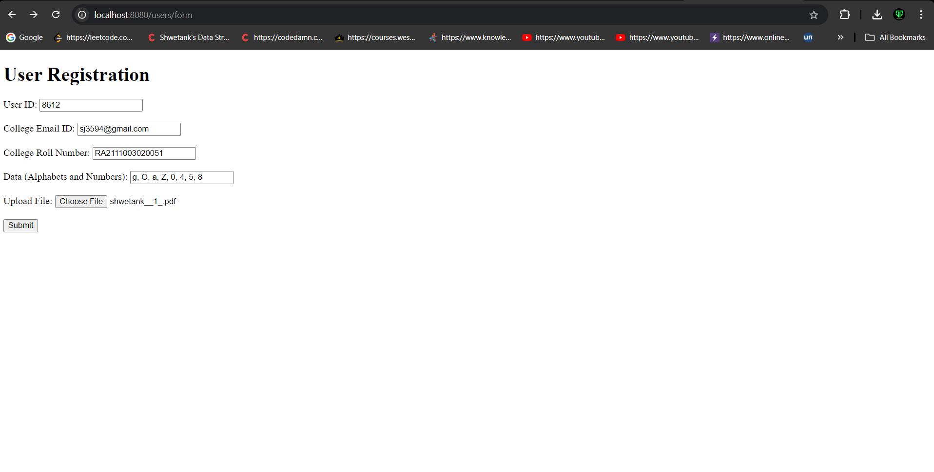

Users input display

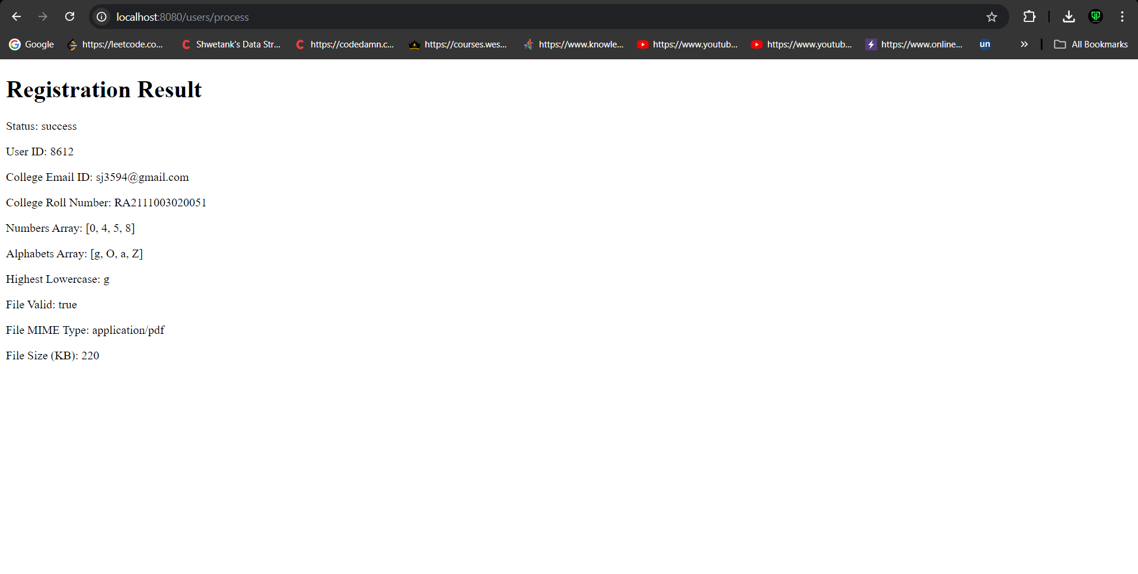

Saved data in MySQL

