Abhinay singh B7 19103226.
SET B(even) , LABTEST 1.

Q1.

#include<bits/stdc++.h>
#include<vector>
using namespace std;
int kthsmall(vector<vector<int>>& matrix, int k) {

priority_queue<int , vector<int> , greater<int>> pq;

int val = 0;
int n = matrix.size();
int m = matrix[0].size();

for(int i = 0 ;i < n;i++)
{
for(int j = 0;j<m;j++)
{
pq.push(matrix[i][j]);
}
}

while(k--)
{
val = pq.top();
pq.pop();
}
return val;
}
int main()
{ int n,k,m;
int sum=0,cnt=0,flag=0;
cout<<"Input col,row,and k respectively";
cin>>m>>n>>k;
vector<vector<int>> arr(m, vector<int>(n, 0)); //initialised by zero
for (int i = 0; i < m; ++i)
{
for (int j = 0; j < n; ++j)
{
cin>>arr[i][j];
}

}
int ans = kthsmall(arr,k);
cout<< ans;
return 0 ;

}

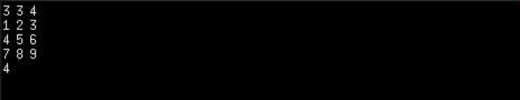

Explanation :- As the cols and rows are sorted we can use binary search approach
which will reduce TC to 0(logn) per row or per column.

Q2

#include <bits/stdc++.h>
using namespace std;
struct Node
{
char data;
struct Node *left;
struct Node *right;
Node(char x)
{
data = x;
left = NULL;
right = NULL;
}
};
struct Node *constBST(string postorder, int start, int end)
{
if (start > end)
{
return NULL;
}

struct Node *node = new Node(postorder[end]);

int i;
for (i = end; i >= start; i--)
{
if (postorder[i] < node->data)
{
break;
}
}

node->right = constBST(postorder, i + 1, end - 1);

node->left = constBST(postorder, start, i);

return node;
}

void inorder(Node *root)
{
if (root != NULL)
{
inorder(root->left);
cout << root->data << " ";
inorder(root->right);
}
}
int main()
{
string post = "HIDJKEBLMFNOGCA";
int n = post.size();
Node *root = constBST(post, 0, n - 1);
inorder(root);
cout << endl;
return 0;
}

