**“Information Security and Assurance”**

**“Cracking DES Algorithm”**

**Submitted By: Shweta, Pooja & Ahmed (TEAM 2)**

**PART 1: PROJECT ARCHITECTURE**

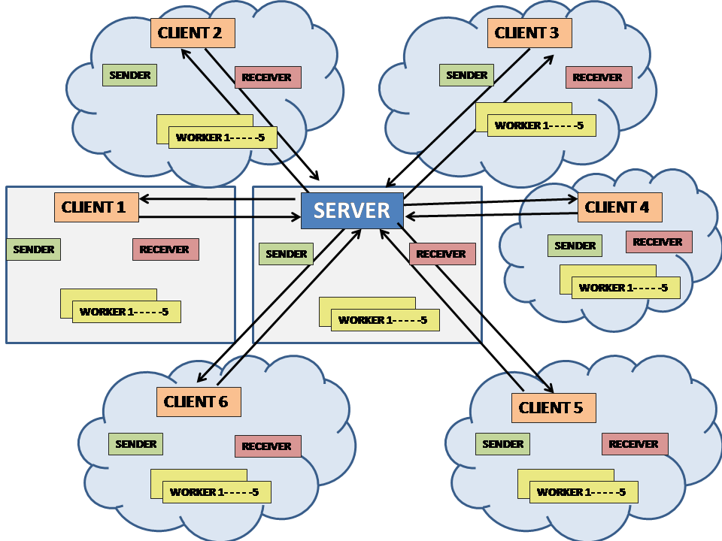

**PART 2: Machine Setup**

1. Download Linux OS latest version and run it through a Virtual Machine (VMware or VMFusion).
2. Setup Ubuntu latest environment on your linux.
3. Install Eclipse IDE and GCC Complier into Ubuntu .
4. Download the source code file provided, then create a C project named ‘**Test2DES**’ in Eclipse, clean it, build it. This will create the binaries.

Note: Make sure before building the code add “pthread” to the GCC Linker libraries.

1. Repeat same steps in 2 physical machines.
2. Create 5 AWS EC2 Linux instances. These 5 will act as 5 other Virtual machines. Below are the steps to create AWS EC2 Linux instances.

step1: write (amazone web service "aws") in browser   
step2:Click on Amazon Web Services (AWS) - Cloud Computing Services   
step3:Click on "My account"   
step4:select this option "AWS Management Console"   
Step5:Write your email and choose I am a new user   
Step6:Create login credentials by writing your name and password   
Step7:Complete Contact Information then click on agreement button then Click on Create account and continue   
Step8:Fill Payment Information (They ask about visa card)   
Step9:Identity Verification .Put your number and press on call me now they will call you and ask you to enter the pin that is appear on the page.   
Step10:Press Continue to choose your plan   
Step11:Choose your plan (We choose basic that is free)   
Step12:Fill the gabs about use case (They ask some quistions like What is your primary Use Case? What is your Job Role? ... etc then press submit.

Step13:Click on launch management console.   
Step14:Enter your password to log in your account.   
Step15:Click on Ec2 (Virtual Servers in the cloud)   
Srep16:Click on Launch Instansec   
Step17:Choose your system i.e ubuntu then click Select button.   
Step18:Choose an Instance Type i.e t2micro then press review and launch   
Step19:Review your instance launch details then press launch to continue.   
Step20: Select an existing key pair or create new one.   
Step21:At the first time create new key pair and write any name for it.   
Step22:Download this key pair with file .pem then click on Launch instances Step23:You will see this message "Your instances are now launching"   
Step24: You can click on view instances to see it.   
Step25: Repeat these steps for other instances.

1. In our architecture there is one master and 6 clients. The master invokes the program. So in order to search the key there fields in each system need to be set. These 3 fields are:

* isMaster: if system is master then this field is 1 else 0.
* maxNoOfcomputers: Total no of systems participating, which is 7 in our case.
* computer_id: Id of the system. For master this field id always 1 and for others it will be 2,3,4,5,6,7 accordingly.

1. To execute the program from the terminal, run the command **./Test2DES** from the master system.
2. This will initiate all the clients, and application gets stops once master or any client founds the key.
3. There is a terminal application called ‘sshpass’ that we have installed on ubuntu so that we can pass the password for the physical client for ssh command that executes the client system remotely from the master system.

sshpass -p shweta ssh shweta@192.168.0.15 '/home/shweta/workspaceDES/Test2DES/Debug/Test2DES' &"

1. We have used ssh command to execute clients on AWS using the secret key of each client.

sftp -i AboFaris.pem ubuntu@52.25.7.51

ssh -i /home/pooja/Desktop/amazon_ec2_keys/AboFaris.pem ubuntu@52.25.7.51 '/home/ubuntu/Test2DES' &

sftp -i AboFaris.pem ubuntu@52.26.166.209

ssh -i /home/pooja/Desktop/amazon_ec2_keys/AboFaris.pem ubuntu@52.26.166.209 '/home/ubuntu/Test2DES' &

sftp -i AboFaris.pem ubuntu@52.25.254.10

ssh -i /home/pooja/Desktop/amazon_ec2_keys/AboFaris.pem ubuntu@52.25.254.10 '/home/ubuntu/Test2DES' &

sftp -i AboFaris.pem ubuntu@52.27.206.53

ssh -i /home/pooja/Desktop/amazon_ec2_keys/AboFaris.pem ubuntu@52.10.212.11 '/home/ubuntu/Test2DES' &

sftp -i AboFaris.pem ubuntu@52.26.253.60

ssh -i /home/pooja/Desktop/amazon_ec2_keys/AboFaris.pem ubuntu@52.26.253.60 '/home/ubuntu/Test2DES' &

**PART 3: SECRET KEY & SECRET MESSAGE**

**Still in progress…………**