NAME-SHWETA RAHATE
ROLL NO.23
BATCH-B2
SEPM LAB-5
DEPLOYMENT DIAGRAM
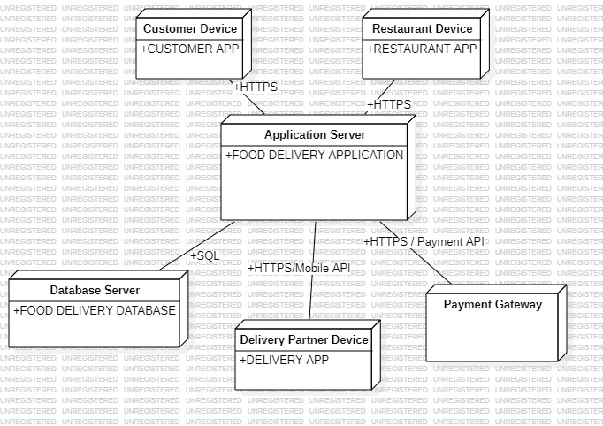

COMPONENT DIAGRAM
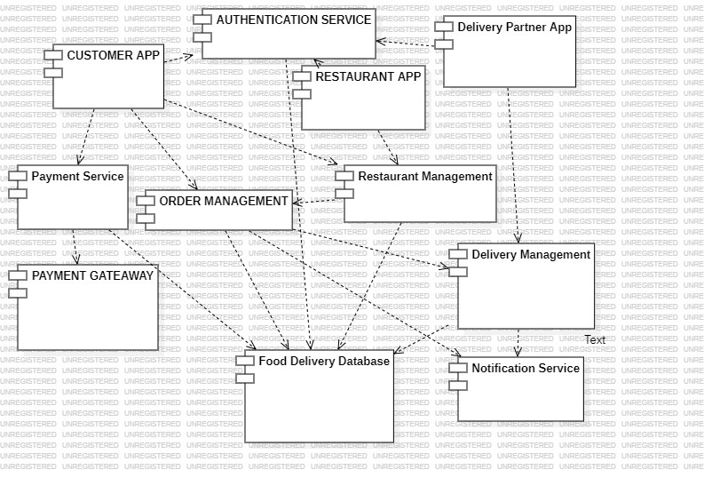

STATE DIAGRAM
