**C-DAC Mumbai**

**Subject: Algorithm and Data Structure**

**Assignment 1**

**Solve the assignment with following thing to be added in each question.**

-Program

-Flow chart

-Explanation

-Output

-Time and Space complexity

1. Armstrong Number

Problem: Write a Java program to check if a given number is an Armstrong number.

Test Cases:

Input: 153

Output: true

Input: 123

Output: false

Program code:

import java.util.Scanner;

public class Armstrong {

public static void main(String[] args) {

Scanner sc = new Scanner(System.in);

System.out.println("Enter a Number:");

int num = sc.nextInt();

int n1 = num;

int result = 0, rem, n = 0;

while (num != 0) {

num /= 10;

n++;

}

num = n1;

while (num != 0) {

rem = num % 10;

result += Math.pow(rem, n);

num /= 10;

}

if (n1 == result) {

System.out.println(n1 + " is an Armstrong number.");

} else {

System.out.println(n1 + " is not an Armstrong number.");

}

}

}

Output:

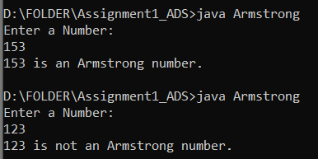

Flow Chart:

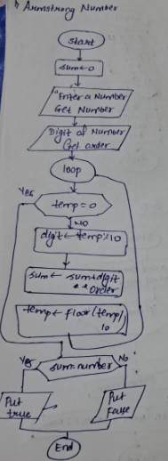

**Code Explanation:**

* Enter a number and stores it in num.
* It first counts the number of digits in the number (n) by repeatedly dividing num by 10.
* Then, it calculates the sum of each digit raised to the power of n using Math.pow().
* Finally, we checks if the sum is equal to the original number (n1). If true, it declares it as an Armstrong number; otherwise, it is not an armstromg number.

**Time complexity: Olog(n)**

**Space complexity:** O(1)

2. Prime Number

Problem: Write a Java program to check if a given number is prime.

Test Cases:

Input: 29

Output: true

Input: 15

Output: false

Program code:

import java.util.Scanner;

public class PrimeNumber{

public static void main(String[] args){

Scanner sc = new Scanner(System.in);

System.out.print("Enter a number: ");

int number = sc.nextInt();

boolean isPrime = true;

if(number <= 1){

isPrime = false;

}

else{

for(int i = 2; i<number;i++){

if(number % i == 0){

isPrime = false;

break;

}

}

}

if(isPrime){

System.out.println( number +" is a prime number");

}

else{

System.out.println(number + " is not a prime number");

}

sc.close();

}

}

Output:

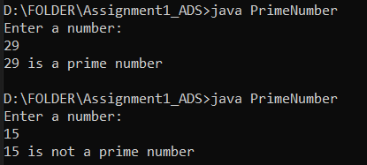

**Code Explanation:**

* The function takes an integer n as input.

• It determines if a number is prime or not by comparing it to one.   
• If the number is bigger than 1, it checks to see if it is divisible by any value in this range by looping from 2 to number-1.   
• The number is indicated as not prime if a divisor is identified; if not, it is prime.

Flow chart:

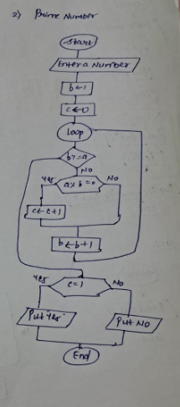

**Time Complexity:**

* **Worst case:** O(N), where N is the input number. The for loop runs up to N-2 times, checking for divisors.
* **Best case:** O(1),

**Space complexity:** O(1)

3. Factorial

Problem: Write a Java program to compute the factorial of a given number.

Test Cases:

Input: 5

Output: 120

Input: 0

Output: 1

Program:

class Factorial{

static int fact(int n) {

if (n <= 1) {

return 1;

} else {

return n * fact(n - 1);

}

}

public static void main(String args[]) {

System.out.println(fact(5));

}

}

Output:

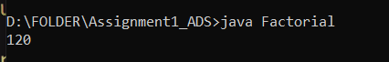

Flow chart:

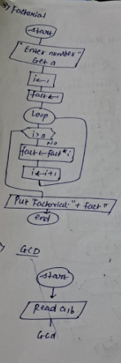

**Code Explanation:**

• The factorial of a given number n can be found using the recursive function fact().   
• The basic case returns 1 as the factorial of 0 and 1 is 1 after determining whether n is less than or equal to 1.  
• Otherwise, the method recursively calls itself with n-1, multiplying n with the factorial of n-1 until it reaches the base case.   
• The program runs fact(5) in the main() method and outputs the result (5! = 120).

**Time complexity:** O(n)

**Space complexity:** O(n)

4. Fibonacci Series

Problem: Write a Java program to print the first n numbers in the Fibonacci series.

Test Cases:

Input: n = 5

Output: [0, 1, 1, 2, 3]

Input: n = 8

Output: [0, 1, 1, 2, 3, 5, 8, 13]

Programing code:

import java.util.Scanner;

public class Fibonacci{

public static void main(String[] arge){

Scanner sc = new Scanner(System.in);

System.out.println("Enter number for fibseq: ");

int n = sc.nextInt();

int a = 0;

int b = 1;

System.out.println(" fibonacci series: ");

for(int i = 1; i<=n;i++){

System.out.println(a);

int c = a+b;

a = b;

b = c;

}

sc.close();

}

}

Output:

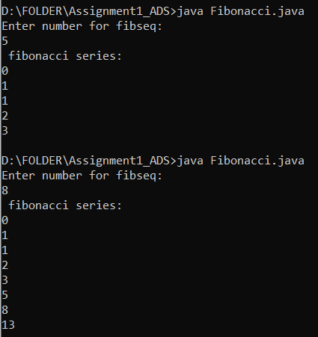

Flowchart:

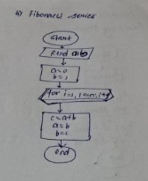

5. Find GCD

Problem: Write a Java program to find the Greatest Common Divisor (GCD) of two numbers.

Test Cases:

Input: a = 54, b = 24

Output: 6

Input: a = 17, b = 13

Output: 1

Program code:

import java.util.Scanner;

public class GCD {

private static int gcd(int n1, int n2) {

if(n2==0)

return n1;

return gcd(n2,n1%n2);

}

public static void main(String[] args) {

Scanner sc=new Scanner(System.in);

System.out.println("Enter Two Number:");

int n1=sc.nextInt();

int n2=sc.nextInt();

System.out.println("GCD:"+gcd(n1,n2));

}

}

Output:

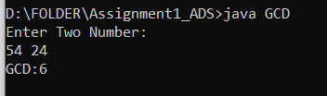

Flow chart:

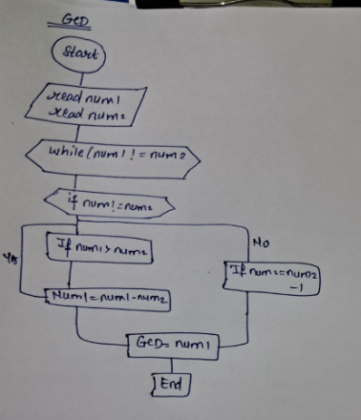

**Explaination:**

Initialize Numbers the two numbers are taken from the user and passed to the function, which checks to see if n2 is equal to 0 and returns n1 otherwise performing a recursion.

**Time Complexity: O(log(n))**

**Space Complexity: O(log(n))**

6. Find Square Root

Problem: Write a Java program to find the square root of a given number (using integer approximation).

Test Cases:

Input: x = 16

Output: 4

Input: x = 27

Output: 5

Program code:

import java.util.Scanner;

public class Squareroot{

static int Sqrt(int x)

{

if (x == 0 || x == 1)

return x;

int i = 1, result = 1;

while (result < x) {

i++;

result = i * i;

}

return i ;

}

public static void main(String[] args)

{

Scanner sc=new Scanner(System.in);

System.out.println("Enter a number:");

int x = sc.nextInt();

System.out.print("Square Root:"+Sqrt(x));

}

}

Output:

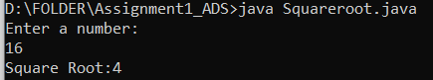

Flow chart:

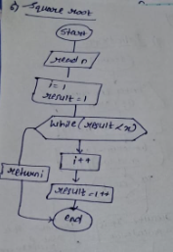

**Code Explanation:**

Take input Number number from user check number is 0 or 1 it is 0 or 1 then return that number.then use the while condition to set I=1 and result=1; if the result is less than num, then increment I and execute result=i*I.

**Time Complexity: O(1)**

**Space Complexity: O(1)**

7. Find Repeated Characters in a String

Problem: Write a Java program to find all repeated characters in a string.

Test Cases:

Input: "programming"

Output: ['r', 'g', 'm']

Input: "hello"

Output: ['l']

Program code:

import java.util.Scanner;

public class RepeatedCharacters {

private static void findRepeat(String str) {

char[] c=str.toCharArray();

System.out.println("Repeated Character:");

for(int i=0;i<str.length();i++) {

for(int j=i+1;j<str.length();j++)

{

if(c[i]==c[j])

{

System.out.print(c[j]+" ");

}

}

}

}

public static void main(String[] args) {

Scanner sc=new Scanner(System.in);

System.out.println("Enter a String:");

String str=sc.nextLine();

findRepeat(str);

}

}

Output:

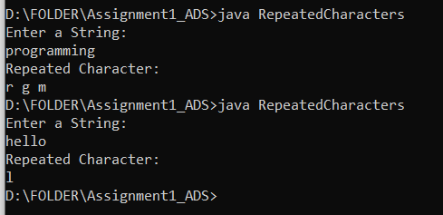

**Time Complexity: O(n)**

**Space Complexity: O(1)**

Flow chart:

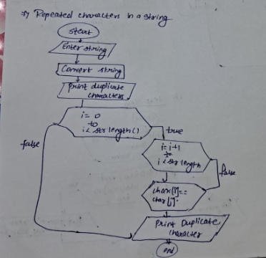

**Code Explanation:**

Using a for loop and a string converter from the user, convert the input string to char using to Char Array. If char[I]==char[j], the value is saved in char[j] and printed.

8. First Non-Repeated Character

Problem: Write a Java program to find the first non-repeated character in a string.

Test Cases:

Input: "stress"

Output: 't'

Input: "aabbcc"

Output: null

Program code:

import java.util.Scanner;

public class NonRepeatedCharacter{

public static void main(String[] args){

Scanner sc = new Scanner(System.in);

System.out.print("Enter String: ");

String str = sc.nextLine();

char[] arr = str.toCharArray();

for(int i=0; i<arr.length; i++)

{

for(int j=i+1; j<arr.length; j++)

{

if(arr[i] != arr[j])

{

System.out.println(arr[j]);

System.exit(0);

}

else

{

System.out.println("null");

System.exit(0);

}

}

}

}

}

Output:

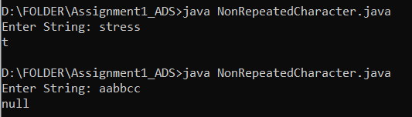

Flow chart:

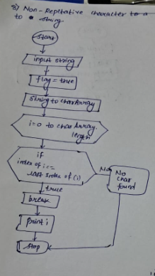

**Code Explanation:**

1. First we set string and converts the string to a character array (arr).
2. It uses two nested loops to compare each character with the subsequent ones in the array.
3. If the character at index i is not equal to the character at index j (first non-repeated), it prints the character and exits.
4. If the characters are equal (repeated), it prints "null" and exits the program immediately.

**Time complexity:** O(n²)

**Space complexity:** O(1)

9. Integer Palindrome

Problem: Write a Java program to check if a given integer is a palindrome.

Test Cases:

Input: 121

Output: true

Input: -121

Output: false

Program code:

import java.util.Scanner;

public class IntegerPalindrome {

public static void main(String[] args) {

Scanner sc = new Scanner(System.in);

System.out.print("Enter a word: ");

String input = sc.nextLine();

boolean isPalindrome = true;

int left = 0;

int right = input.length() - 1;

while (left < right) {

if (input.charAt(left) != input.charAt(right)) {

isPalindrome = false;

break;

}

left++;

right--;

}

if (isPalindrome) {

System.out.println(input + " is a palindrome.");

} else {

System.out.println(input + " is not a palindrome.");

}

}

}

Output:

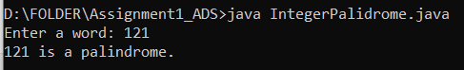

Flow chart:

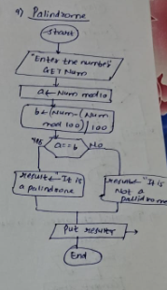

**Algorithm:**

1: First Initialize the Variables

2: Compare Characters from Both Ends

3. Increment left and decrement right

4. Repeat steps 2-3 until left pointer meets or crosses right

5.print result.

**Time Complexity**: O(n)

**Space Complexity:** O(1)

10. Leap Year

Problem: Write a Java program to check if a given year is a leap year.

Test Cases:

Input: 2020

Output: true

Input: 1900

Output: false

Program code:

import java.util.*;

class LeapYear{

public static void main(String args[]) {

Scanner sc = new Scanner(System.in);

System.out.print("Enter the year you want to choose: ");

int year = sc.nextInt();

if (year % 4 == 0 && year %100 != 0 || year % 400 == 0)

{

System.out.println(true);

}

else

{

System.out.println(false);

}

}

}

Output:

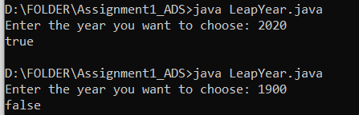

Flow chart:

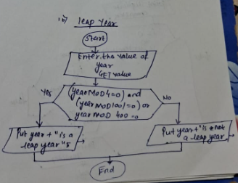

**Explanation:**

1: Firstly get user Input

2: Check Divisibility by 4

3: If year is divisible by 100, it must also be divisible by 400 to be a leap year

4:If year is divisible by 100 but not 400, it's not a leap year (then goto Step 6)

5:If year passes checks step 2,3, it's a leap year

6:Display leap year or not

**Time Complexity**: O(n)

**Space Complexity:** O(1)