***Assignment –1***

Creating sample tables and inserting values.

Create the following tables with the given structures and insert sample data as specified: -

1. To create database: ex cdacmumbai

Query: Create Database Databasename (ex: cdacmumbai)

To created database;

Query: show databases;

1. Use databases:

Query: use databasename (ex: cdacmumbai;)

1. *SALESPEOPLE*

Snum int(4)

Sname varchar(10)

City varchar(10)

Comm float(3,2)

Query for creating the table SALESPEOPLE and inserting data int in that table.

Create table:

Create Table SALESPEOPLE(

Snum int(4) NOT NULL,

Sname varchar(10),

City varchar(10),

Comm float(3,2)

);

*SALES PEOPLE*

|  |  |  |  |
| --- | --- | --- | --- |
| SNUM | SNAME | CITY | COMM |
| 1001 | Peel | London | .12 |
| 1002 | Serres | San Jose | .13 |
| 1004 | Motika | London | .11 |
| 1007 | Rifkin | Barcelona | .15 |
| 1003 | Axelrod | New York | .10 |

Insert Query:

INSERT INTO Salespeople (Snum, Sname, City, Comm)

VALUES

(1001, 'Peel', 'London', 0.12),

(1002, 'Serres', 'San Jose', 0.13),

(1004, 'Motika', 'London', 0.11),

(1007, 'Rifkin', 'Barcelona', 0.15),

(1003, 'Axelrod', 'New York', 0.10);

(1007, 'Rifkin', 'Barcelona', 0.15),

(1003, 'Axelrod', 'New York', 0.10);

Query

Select * from salespeople;

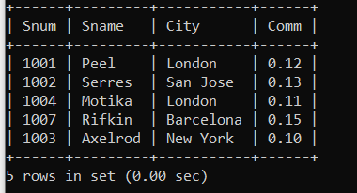

1. *CUSTOMERS*

Cnum int(4)

Cname varchar(10)

City varchar(10)

Rating int(4)

Snum int(4)

Query for creating the table CUSTOMERS and inserting data int that table:

Query to create Table:

Create Table CUSTOMERS(

-> Cnum INT(4),

-> Cname VARCHAR(10),

-> City VARCHAR(10),

-> Rating INT(4),

-> Snum INT(4)

-> );

*CUSTOMERS*

|  |  |  |  |  |
| --- | --- | --- | --- | --- |
| CNUM | CNAME | CITY | RATING | SNUM |
| 2001 | Hoffman | London | 100 | 1001 |
| 2002 | Giovanni | Rome | 200 | 1003 |
| 2003 | Liu | San Jose | 200 | 1002 |
| 2004 | Grass | Berlin | 300 | 1002 |
| 2006 | Clemens | London | 100 | 1001 |
| 2008 | Cisneros | San Jose | 300 | 1007 |
| 2007 | Pereira | Rome | 100 | 1004 |

INSERT INTO CUSTOMERS (Cnum, Cname, City, Rating, Snum)

VALUES

(2001, 'Hoffman', 'London', 100, 1001),

(2002, 'Giovanni', 'Rome', 200, 1003),

(2003, 'Liu', 'San Jose', 200, 1002),

(2004, 'Grass', 'Berlin', 300, 1001),

(2006, 'Class', 'Landon', 100, 1007),

(2008, 'Cisneros', 'San Jose', 300, 1007),

(2007, 'Pereira', 'Rome', 100, 1004);

Query :

select * from CUSTOMERS;

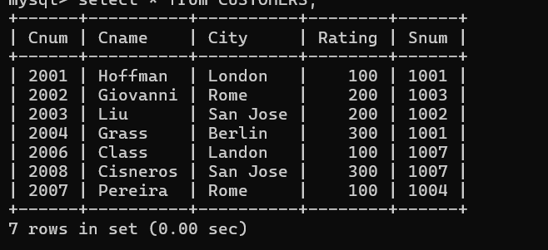

1. *ORDERS*

Onum int(4)

Amt float(7,2)

Odate date

Cnum int(4)

Snum int(4)

Query for creating the table Orders and inserting data int the that table.

Query for creating trable:

Create Table ORDERS(

Onum int(4),

Amt float(7,2),

Odate date,

Cnum int(4),

Snum int(4)

);

*ORDERS*

|  |  |  |  |  |
| --- | --- | --- | --- | --- |
| ONUM | AMT | ODATE | CNUM | SNUM |
| 3001 | 18.69 | 03-OCT-1990 | 2008 | 1007 |
| 3003 | 767.19 | 03- OCT -1990 | 2001 | 1001 |
| 3002 | 1900.10 | 03- OCT -1990 | 2007 | 1004 |
| 3005 | 5160.45 | 03- OCT -1990 | 2003 | 1002 |
| 3006 | 1098.16 | 03- OCT -1990 | 2008 | 1007 |
| 3009 | 1713.23 | 04- OCT -1990 | 2002 | 1003 |
| 3007 | 75.75 | 04- OCT -1990 | 2004 | 1002 |
| 3008 | 4723.00 | 05- OCT -1990 | 2006 | 1001 |
| 3010 | 1309.95 | 06- OCT -1990 | 2004 | 1002 |
| 3011 | 9891.88 | 06- OCT -1990 | 2006 | 1001 |

INSERT INTO ORDERS(Onum, Amt, Odate, Cnum, Snum)

VALUES

(3001, 18.69, '1990-10-03', 2008, 1007),

(3003, 767.19, '1990-10-03', 2001, 1001),

(3002, 1900.10, '1990-10-03', 2007, 1004),

(3005, 5160.45, '1990-10-03', 2003, 1002),

(3006, 1098.16, '1990-10-03', 2008, 1007),

(3009, 1713.23, '1990-10-04', 2002, 1003),

(3007, 75.75, '1990-10-04', 2004, 1002),

(3008, 4723.00, '1990-10-05', 2006, 1001),

(3010, 1309.95, '1990-10-06', 2004, 1002),

(3011, 9891.88, '1990-10-06', 2006, 1001);

Query OK, 10 rows affected (0.04 sec)

Records: 10 Duplicates: 0 Warnings: 0

Query:

select * from ORDERS;

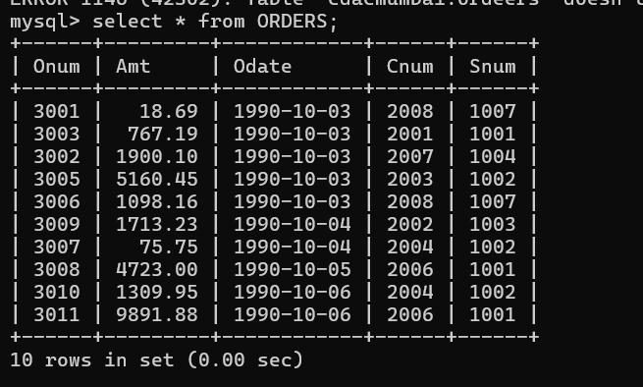

Shoew Tables;

