**CDAC Mumbai PG-DAC AUGUST 24**

**Assignment No- 2**

1)Write a program that checks if a given year is a leap year or not using both if-else and switch-case.

Solution:

Method 1:

import java.util.*;

public class LeapYearCheck{

public static void main(String[] args){

Scanner scanner = new Scanner(System.in);

System.out.println("Enter year: ");

int year = scanner.nextInt();

if((year % 4 == 0 && year % 100 == 0) || (year % 400 == 0)){

System.out.println(year + " is a leap year.");

} else {

System.out.println(year + " is not a leap year.");

}

scanner.close();

}

}

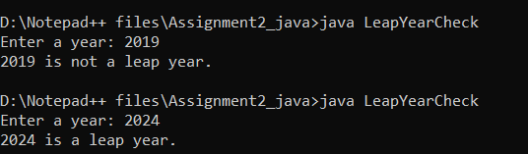

Method 2:

import java.util.*;

public class LeapYearCheck {

public static void main(String[] args) {

Scanner scanner = new Scanner(System.in);

System.out.print("Enter a year: ");

int year = scanner.nextInt();

int isLeap;

if ((year % 4 == 0 && year % 100 != 0) || (year % 400 == 0)) {

isLeap = 1;

} else {

isLeap = 0;

}

switch (isLeap) {

case 1:

System.out.println(year + " is a leap year.");

break;

case 0:

System.out.println(year + " is not a leap year.");

break;

}

}

}

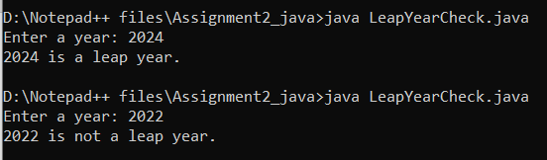

2)Implement a program that calculates the Body Mass Index (BMI) based on height and weight input using if-else to classify the BMI int categories (underweight, normal weight, over weight,etc).

Solution:

import java.util.*;

public class bim{

public static void main(String[] args) {

Scanner scan = new Scanner(System.in);

System.out.print("Enter a Height in CM: ");

double heightInCm = scan.nextDouble();

System.out.print("Enter a weight in KG: ");

double weightInKg = scan.nextDouble();

double heightInMeters = heightInCm / 100;

double bmi = weightInKg / (heightInMeters * heightInMeters);

System.out.printf("Your BMI score is: %.2f%n", bmi);

if (bmi < 18.5) {

System.out.println("Category: Underweight");

} else if (bmi >= 18.5 && bmi < 24.9) {

System.out.println("Category: Normal weight");

} else if (bmi >= 25.0 && bmi < 29.9) {

System.out.println("Category: Overweight");

} else {

System.out.println("Category: Obesity");

}

}

}

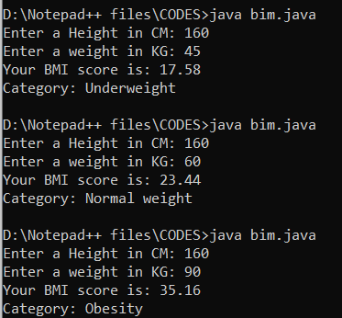

3)Write a program that checks if a person is eligible to vote based on their age.

Solution:

import java.util.*;

public class Voting {

public static void main(String[] args) {

Scanner scanner = new Scanner(System.in);

System.out.print("Enter your age: ");

int age = scanner.nextInt();

if (age >= 18) {

System.out.println("You are eligible to vote.");

} else {

System.out.println("You are not eligible to vote.");

}

scanner.close();

}

}

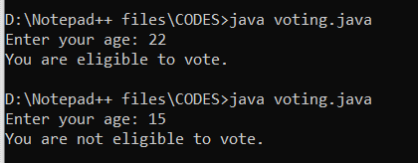

4)Write a program that takes a month (1-12) and prints the corresponding season (Winter, Spring, Summer, Autumn) using a switch case

Solution:

import java.util.*;

public class Tocheckseason{

public static void main(String[] args){

Scanner scanner = new Scanner(System.in);

System.out.print("Enter a month : ");

int month = scanner.nextInt();

switch (month) {

case 12:

case 1:

case 2:

System.out.println("season is Winter");

break;

case 3:

case 4:

case 5:

System.out.println("season is spring");

break;

case 6:

case 7:

case 8:

System.out.println("season is summer");

break;

case 9:

case 10:

case 11:

System.out.println("season is Autum");

break;

default:

System.out.println("Enter valid Month number");

break;

}

}

}

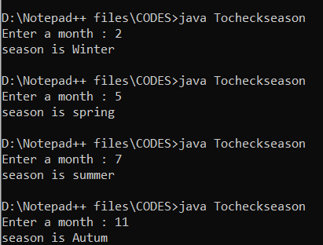

5)Write a program that allows the user to select a shape (Circle, Square, Rectangle, Triangle) and then calculates the area based on user-provided dimensions using a switch case.

Solution:

import java.util.*;

public class ToCalculateShape{

public static void main(String[] args){

Scanner scanner = new Scanner(System.in);

System.out.println("Type 1 To Calculate Circle ");

System.out.println("Type 2 To Calculate Rectangle ");

System.out.println("Type 3 To Calculate Square");

System.out.println("Type 4 To Calculate Triangle ");

Scanner sc = new Scanner(System.in);

int shape = sc.nextInt();

switch (shape) {

case 1 :

System.out.print("Enter the radius ");

int b1 = sc.nextInt();

double area = (3.14 *b1*b1);

System.out.println("Area is "+ area);

break;

case 2 :

System.out.print("Enter the length ");

int c1 = sc.nextInt();

System.out.print("Enter the Width ");

int c2 = sc.nextInt();

double are = (c1 * c2);

System.out.println("Area Of rectangle is "+ are);

break;

case 3 :

System.out.print("Enter the Length ");

int d1 = sc.nextInt();

double ar = (d1*d1);

System.out.println("Area Of Square is "+ ar);

break;

case 4 :

System.out.print("Enter the base ");

int e1 = sc.nextInt();

System.out.print("Enter the Height");

//int e1 = sc.nextInt();

int e2 = sc.nextInt();

double g = ((e1*e2)/2);

System.out.println("Area of Triangle is "+ g);

break;

}

}

}

