FundAnything

-a Crowdfunding WebApp

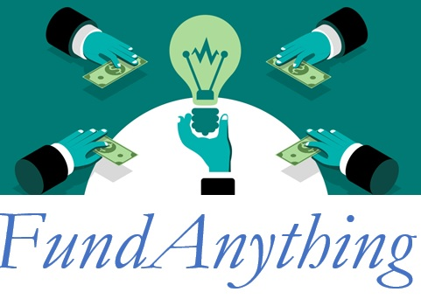

Shweta Patil  
StudentID: 800989198

10/02/2017

## Project Name: FundAnything - a Crowdfunding WebApp

## To Date Project Summary:

Following tasks are completed till date:

|  |  |  |  |
| --- | --- | --- | --- |
| # | Tasks | Start Date | End Date |
| 1 | Deliverables 1 – ERD | 10/ 02/ 2017 | 10/ 08/ 2017 |
| 2 | Design a database | 10/ 09/ 2017 | 10/ 15/ 2017 |
| 3 | Deliverable 2 - Progress | 10/ 16/ 2017 | 10/ 22/ 2017 |
| 4 | Coding specific pages | 10/ 23/ 2017 | 11/ 05/ 2017 |
| 5 | Coding functionalities | 11/ 06/ 2017 | 11/ 05/ 2017 |
| 6 | Testing completed application | 11/ 06/ 2017 | 11/ 19/ 2017 |
| 7 | User Manual | 11/ 20/ 2017 | 11/ 26/ 2017 |
| 8 | Presentation/ Demo | 11/ 27/ 2017 | 12/ 11/ 2017 |

* DB Creation
* Searching images to market project idea
* Designing JSPs, choosing appropriate styles for front end pages
* Designing “Home page”, “Login Page”, “Signup Page”, “About Us Page” using JSP
* Making DB calls using servlet
* Utility classes to access database.

URL: <http://default-environment.bprtwhknmg.us-east-1.elasticbeanstalk.com/>

## Effort Remaining:

* Design of following pages:

1. Build Your Profile
2. Search Campaign List
3. Build Your Campaign
4. History
5. Campaign History
6. Funding History

* Including servlets for above pages
* Email functionality for communication between 2 user roles
* Login Functionality with session management

## Concerns (if applicable):

NA