#Company_Logo#

**Business Rules Guide for App_Name**

*User guide for administrators to set rules in App_Name*

*The guide walks through the section of business rules to configure different types of rules for application.*

Company_Name

Date_Create

**COPYRIGHT**

Business Rules Guide for App_Name (Date_Create at Time_Create)

The information provided in this document, including URL and other Internet Web site references is "as-is" and for informational purposes only. The information contained herein is subject to change without notice and is not warranted to be error-free. Unless otherwise noted, the companies, organizations, products, domain names, e-mail addresses, logos, people, places, and events depicted in examples herein are fictitious and for only illustration purposes. No association with any real company, organization, product, domain name, e-mail address, logo, person, place, or event is intended or should be inferred.

This document does not provide you with any legal rights to any intellectual property in any section of application App_Name. You may copy and use this document for your internal, reference purposes.

© 2016 Company_Name. All rights reserved.

# Document Revision

Table : Revision History

|  |  |  |
| --- | --- | --- |
| Version | Date Published | Key Notes |
| 1.0 | Date_Create | First Release |
|  |  |  |
|  |  |  |
|  |  |  |

Table of Contents

Document Revision 3

Preface 6

Intended Audience 6

Document Accessibility 6

Related Documents 6

Conventions 6

About This Guide 8

Purpose and Scope 8

Point of Contact 8

Glossary 8

Introduction 10

Types of Business Rule Conditions 11

Condition Type 11

Operator Types 11

Getting Started 13

What you need 13

What are business rules? 13

Business rule uses 13

Accessing Business Rules 13

Set Business Rules 15

Rule Name 16

Select Entity 16

Apply for following roles 17

Select Criteria Type 17

Add Action 17

Example Business Rule 23

Test Business rule 25

# Preface

## Intended Audience

The document is intended for individuals/administrators who use App_Name application developed for Company_Name. The document is assessment of business rule capabilities of App_Name application. This guide also demonstrates implementing the business rule in the application.

## Document Accessibility

The company focuses on making products, services and supporting documents accessible with great usability to its users. To that end, this document includes features that make information available to users of technology. This document is published in WORD format and does not contain markup. Accessibility standards will continue to upgrade on timely basis and Company_Name is constantly engaging itself in activities to address technical obstacles to furnish the document to all its customers.

**Accessibility of Links to External Web Sites in Documentation**

The document may contain links to other websites (not owned by Company_Name) if required. Company does not evaluate nor makes any representations regarding the accessibility of these web sites.

## Related Documents

The document is first revision in its section and available only at respective application(s) portals. The company is not responsible for about authenticity of this document, if accessed from any third party website. The documents available are:

* App_Name User Guide
* Current Security Settings
* Current Business Rules
* Security Configuration Manual
* Business Rules Configuration Manual
* General Deployment Guide
* Database Design Document
* Troubleshooting Guide

## Conventions

Following are the conventions used in this document:

Words in single inverted commas (‘) are the nouns. These words in common English sometimes are used in different manners as required. Inverted commas differentiate these words used as simple English terms and specific terms (nouns). Ex: properties, associations, datatype etc.

™: The words with TM (Trademark) as superscript are registered words and cannot be used without prior permission of respective organization for commercial and profit activities.

Hyperlinks: Hyperlinks are the content that reflects the source at another place having a web address. The hyperlinks are URLs to these web addresses and are accessible by pressing (CTRL + click) in static documents and simple clicks on web pages.

Illustrative numbers: The numbering is done in figures (for example: figure 2) for users convenience to find the data easily. The contents are arranged numerically as per the figure.

Save: For any changes you, ‘Save’ button store these changes. The save button is present in all the forms and fields in App_Name and is not repeatedly acknowledged.

Cancel: For any changes you, ‘Cancel’ button discards these changes. The cancel button is present in all the forms and fields in App_Name and is not repeatedly acknowledged.

Checkbox: Checkbox presents the conditions that could be marked as true or false. The right sign in checkbox ✓ marks the condition as true. If left blank, the system considers it as false.

Fields: Fields are the space provided to fill the data. Some fields may have conditions depending on respective section or the rules.

Back to list: This option discards the changes and redirects you to the previous page.

Save and continue: This option saves your current changes and redirects you to next page.

Next: This option without saving current changes redirects you to next page.

Previous: This option without saving current changes redirects you to previous page.

# About This Guide

The guide describes how to configure a business rule in App_Name. It gives you an in-depth explanation on what a business rule signifies and how you can add a new one. A detailed list of what business rules App_Name uses are described in the requirement guide.

## Purpose and Scope

This manual is intended for application administrators. Any prior knowledge of a programming language will be helpful but not required or mandatory.

## Point of Contact

If you have any questions or concerns, please contact Company_Name at Company_Email.

## Glossary

This table explains all the variables are/may be used throughout this guide

Table : Variables used in this guide

|  |  |
| --- | --- |
| **Android APK** | The downloadable android application |
| **App** | Application |
| **ASP.NET** | Open Source server-side Web Application framework |
| **Association** | Relation between two entities |
| **Browser** | The interface used to access the internet |
| **Cancel** | Discard your unsaved changes and redirects you to previous page |
| **CRUD** | Create Read Update Delete |
| **Dependent Dropdown** | Dependency of one association on another |
| **Entity** | An independent existing thing |
| **Faceted Search** | Searching information from properties of an entity |
| **Group** | Collective display of properties (and associations) |
| **Launch** | Generate the application from present model |
| **Mobile View** | The application designed according to mobile interface |
| **Model Generator** | Defines entities, properties, associations and other features of application |
| **MVC** | Model View Controller (Microsoft’s technology) |
| **Next** | Redirects you to next page in form |
| **Password** | Password is the secret key, required to access the application |
| **Permissions** | Accessibility to add/edit/delete/view data of entity |
| **Previous** | Redirects you to previous page in form |
| **Property** | The things that belong to entity |
| **Record** | Complete details of data for an entity |
| **Roles** | Set of permissions to add/edit/view/delete for each entity |
| **Save** | Save your changes you made |
| **Save & Continue** | Save your changes and keeps you on same page |
| **Username** | It is the unique field that identifies an associated user |
| **Users** | People who have access to application |
| **Value** | Specific field of a record |
| **Workflow** | Defines status of application for any particular record in entity |

# Introduction

This document presents how to configure the business rules in *App_Name*.

To understand the document and business rules better, the table below gives a quick summary of the different business rules concepts supported by *App_Name*, and their impact on application behavior. The business rules in application are role specific i.e. the rule will be effective only on all users of role defined in rule.

|  |  |
| --- | --- |
| Name | Description |
| Email Notification | When users perform some specific action for example: a new registration or perform some operation in record, the email notification can automatically triggered to notify that user and other users of application about it. |
| Lock Record | If a user of a role puts invalid or undesired value in record, the complete record will be locked for all users of that role. On edit, the fields of record will show read only behavior and only privileged users can change the value to unlock it. |
| Conditional Mandatory Field | Some fields of a record can be made mandatory based on the value of other fields. For example: Tax field will be mandatory if the field of Total bill is greater than 20$. Conditional mandatory fields are imposed before data is saved and prevents users from missing any field in the form. |
| Read only Fields | An entity in application generally contains combination of all fields that users in different role is required. This makes many of the fields irrelevant to unconcerned users of another role. The record once saved value in property that fulfills the condition, the edit page of that record will make all fields unnecessary for users as read only. The users can assign value to property that matches with desired condition and on ‘save and continue’ or editing the record, the undesired fields will be read only. |
| Filter Dropdown | The values of dropdown by default shows the display names of all the records present in associated entity. The values can be filtered in dropdown based on condition set in associated entity. For example: a hospital has employees with employee type as doctor and nurse. In patient details, the doctor dropdown will only show list of doctors and nurse dropdown will show list of nurses. |
| Make fields hidden | On the same principles of read only fields, the irrelevant fields can be hidden for users of a role when condition is met in record. |
| Set Value | With business rule, the value of a property can automatically be set using the rule. The value can be constant, picked from a list (supported in dropdowns only) or a dynamic value from property of its own entity or an associated entity. |
| Invoke Action | Users can also invoke the action(s) of a verb(s) using business rule. The action will be invoked when the users will work on an entity. The application will evaluate the rule and when business rule condition meets the input given by user, it will invoke the action verb. |
| Date Calculations | The date calculations can be used to evaluate condition and/or to set desired future or historical date as a record automatically in desired fields. |
| Validate Before Save | You can allow users not to save records if a particular condition matches. While using the application if a particular condition meets than Turanto will restrict the saving of records. The rule evaluates the condition on create page i.e. before saving the record. |
| Lock Record and Associations | Along with the records of given entity, the associated records can also be locked from business rule. Even if the user of a given role will try to access the record remotely or directly from the entity, permission will be denied to update or delete the record. |

## Types of Business Rule Evaluation

The conditions in business rule define how a rule will be evaluated in entity of App_Name for a given role(s). The conditions are implemented in any of following categories:

### Condition Type

1. **On Add:** The condition is applicable whenever users will attempt to create a new record.
2. **On Update:** The condition is applicable whenever users will attempt to edit/update/modify the existing records of entity.
3. **On Property Change:** The condition is applicable whenever users will attempt to change any property of existing records in entity. If ‘Changes to anything’ is selected than any change in property will be considered for evaluation
4. **Scheduled:** Scheduling a business rule evaluates the condition and forces the action for given dates and time as an iterative process. The rule can be scheduled to execute for one time or repeat it daily/weekly/monthly/yearly. From start date to end date, the rule will run at given days and time.
5. **Single Condition:** Single condition means business rule has only one condition to be checked before executing the actions.
6. **Multiple Conditions:** When multiple conditions are present for a rule, the rule will check all the conditions before executing the action. The multiple conditions use ‘AND’ and ‘OR’ connectors to connect each condition.
   1. 1. The rule evaluates conditions in Top-Down hierarchy.
   2. 2. The connector of current condition defines connectivity with next condition.
   3. 3. The combined result of all previous conditions is considered as one condition and next condition is evaluated against it. During evaluation the connector of previous condition decides the connectivity with next condition.
   4. 4. Do not add more than 3 conditions if using both 'AND' 'OR' connectors. However if you are using same connector, any number of conditions can be added.
   5. 5. The connector in last condition is used only when you edit the rule and add more conditions.

### Operator Types

1. **Equals to:** The action will execute when the value of property in entity will match the value defined in rule.
2. **Greater than:** The business rule will execute when the value of property in entity is greater than the value defined in rule.
3. **Less than:** The business rule will execute when the value of property in entity is less than the value defined in rule.
4. **Less than or equals to:** The business rule will execute when the value of property in entity is less than or equal to the value defined in rule.
5. **Greater than or equals to:** The business rule will execute when the value of property in entity is greater than or equal to the value defined in rule.
6. **Contains:** The business rule will execute when the value of property in entity contains the value defined in rule.
7. **Not equals to:** The business rule will execute when the value of property in entity is not equal to the value defined in rule.
8. **Changes to Anything:** (Only applicable for ‘On Property Change’) the rule is evaluated when any change is made in selected property. The rule will not be evaluated when a new record is added.
9. **Match:** Match is same as ‘Equals to’ but defines a well-structured rule when used with ‘Regular Expression.

### Value Types

1. **Constant:** Constant takes the property value as it is to match with record while evaluating the rule.
2. **Pick from List:** The business rule will execute when the value of association matches with the value that is picked from the dropdown.
3. **Changes to Anything:** (Only applicable for ‘On Property Change’) the rule is evaluated when any change is made in selected property. The rule will not be evaluated when a new record is added.
4. **Regular Expression:** C# expression as a sequence of symbols and characters to express specific pattern. Value in the record matching with this expression will only be considered for evaluation.
5. **Dynamic:** In runtime to evaluate the rule, dynamic condition fetch value from target property (property can be from same entity or entities in dropdown)

# Getting Started

## What you need

You need to have administrative access for App_Name in order to view or modify the business rules. If you see the Admin button on the top right corner of your homepage, you have admin privileges.

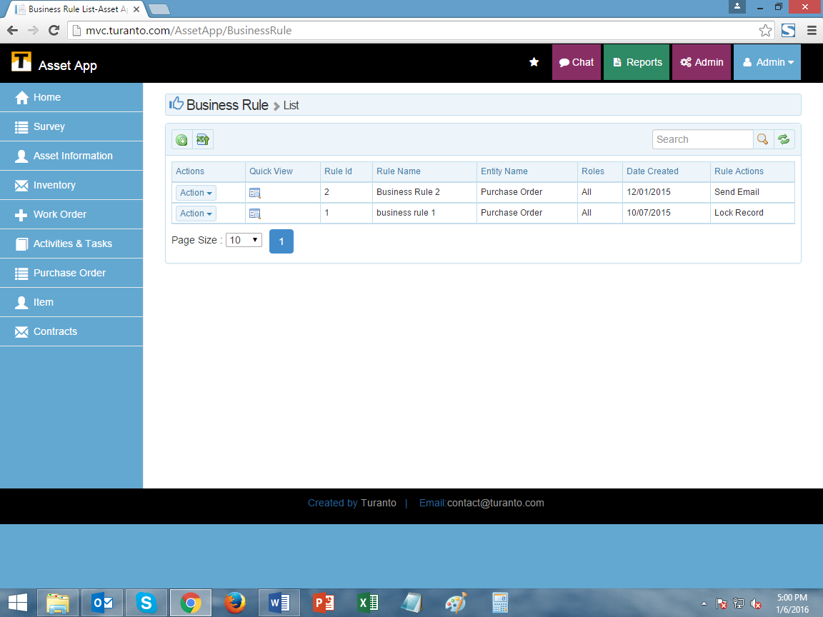

Figure : Admin options on the top right

Please contact your system administrator if you do not have the admin access.

## What are business rules?

Business rules are the custom ‘condition’ and ‘action’ arguments. They are the set of rules in an organization that define or constraint some aspect of business and always revolve to either true or false. The business rules are applicable at property level and if a condition is provided to a property than respective action will be taken at same and parallel properties.

## Business rule uses

The most important application of business rules is that you can set security polices based on them. Some real-life scenarios require a more complex access strategy or policy, which can involve specifying a series of rules to define the conditions under which an entity’s attributes can be accessed.

Example of business rule based security:

Consider a scenario in which the business rules require that all records with a customer turnover:

* Greater than or equal to $1M have the profit field restricted or hidden
* Less than $1M have the profit field displayed

The App_Name business rule settings can be configured to filter out and display records after applying the business rule.

You can use them to avoid reckless and insecure entries in forms. Assigning the business rules to create basic ‘case’ and ‘cause’ conditions.

In addition to the security and data integrity, business rules can also be set for conditions and trigger actions as configured like E-Mail Notifications, Alerts.

## Accessing Business Rules

Click on the purple admin button on the top right of App_Name homepage. This opens up the admin option pages.

For more information on Users, Roles, User based security, set company profile, and user defined pages, please visit the Security guide for App_Name.

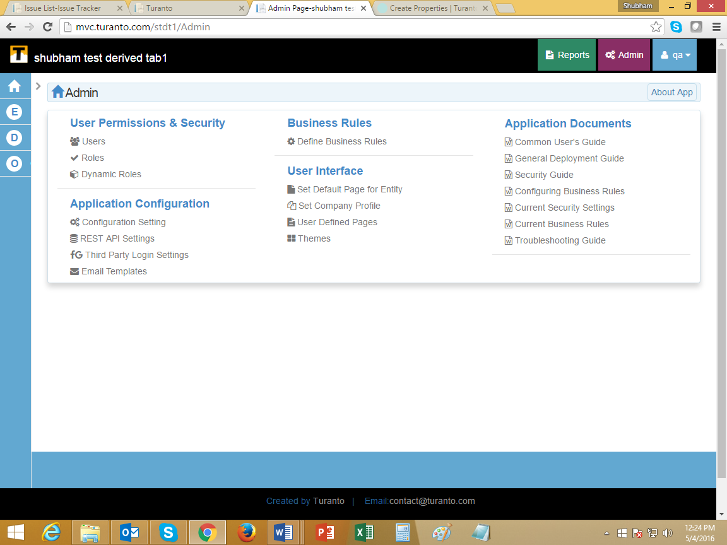

TODO: Replace this Image

Figure : TODO (Write Caption) Business rules in the admin section

## Set Business Rules

Business rules are intended to assert business structure or to control or influence the behavior of the business. In App_Name ‘Business Rules’ are the set of conditions and actions in an entity applicable to all user roles. These rules are applicable on all records of the entity once created. Generally an entity can have more than one rule but it is not recommended.

A business rule can be set enabled/disabled based on its use. The option to disable a rule is available on index page of business rules and on detail (create and edit) page of individual rules.

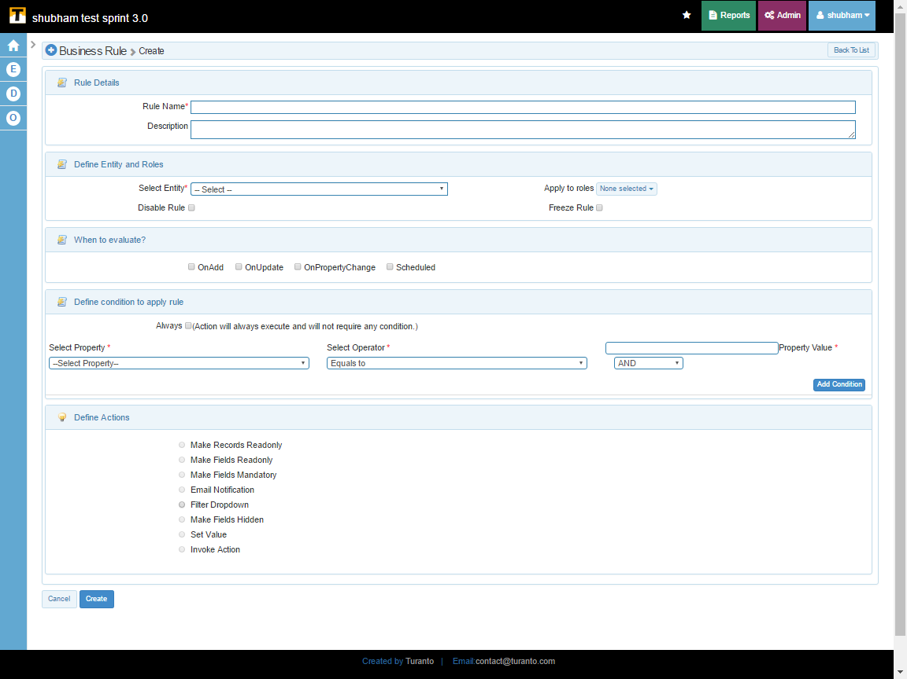

TODO: Replace this Image

Figure : TODO (Write Caption) Create business rules screen

# How to Set Business Rules

## Rule Details

### Rule Name

The rule is recognized by this name. This field is mandatory as it is the identifier of the rule.

### Description

A text box field to write the details about the rule.

## Define Entity and Roles

### Select Entity

The dropdown displays the list of all the entities. The rule will be applicable on the entity selected. This field is also mandatory.

### Apply To roles

The rules are applicable on a user. Every user is classified by ‘application roles’. Multiple roles can be selected on which rule shall be applied.

### Disable

If checked true, the rule will not evaluate the conditions and no actions will be taken

### Freeze Rule

If checked true, editing the rule will not be allowed.

## When to Evaluate?

The five conditions are the case of rule. If any record meets this case, the rule will cause relative ‘action’.

### On Add

The rule will be evaluated only when new record is created in entity.

### On Update

The rule will be evaluated only when an existing record is updated/modified in entity.

### On Property Change

The rule will be evaluated only when the specific property is updated/modified.

### Scheduled

The rule will be evaluated only at given date and time parameters. The action included in scheduled business rule are set value, email notification and invoke action.

Scheduling includes following properties:

* + 1. **One time Schedule:** One time schedule evaluates the condition only one time and executes the action.

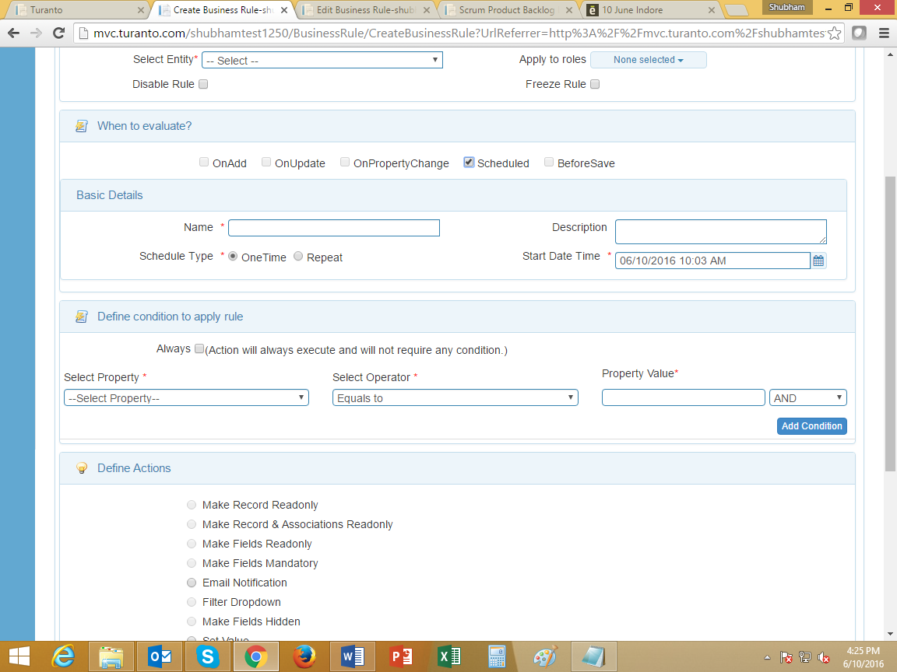

TODO: Replace this Image

Figure : TODO (Write Caption) One time schedule rule

* + 1. **Repeat:** The business rule will repeat at given date-time iteratively to evaluate the condition and execute the action. The rule can be set to run daily/weekly/monthly/yearly. The option is similar to ‘Google Calendar’ and following options are available:
       1. Daily- The rule will evaluate condition daily or will repeat evaluation after given no. of days
       2. Weekly- Rule can be set for evaluation on particular days of week and repeat after given no. of weeks.
       3. Monthly- Rule can be evaluated on:
          1. Given day of month
          2. Last day of month
          3. First day of month
       4. Yearly- Rule can be set for evaluation on given date in year and repeat after given no. of years.
       5. End- The rule can be set to terminate either on specific date or after a no. of occurrences.
* Task History: (View Page) It includes Journal of business rule runtime history (Figure 6)

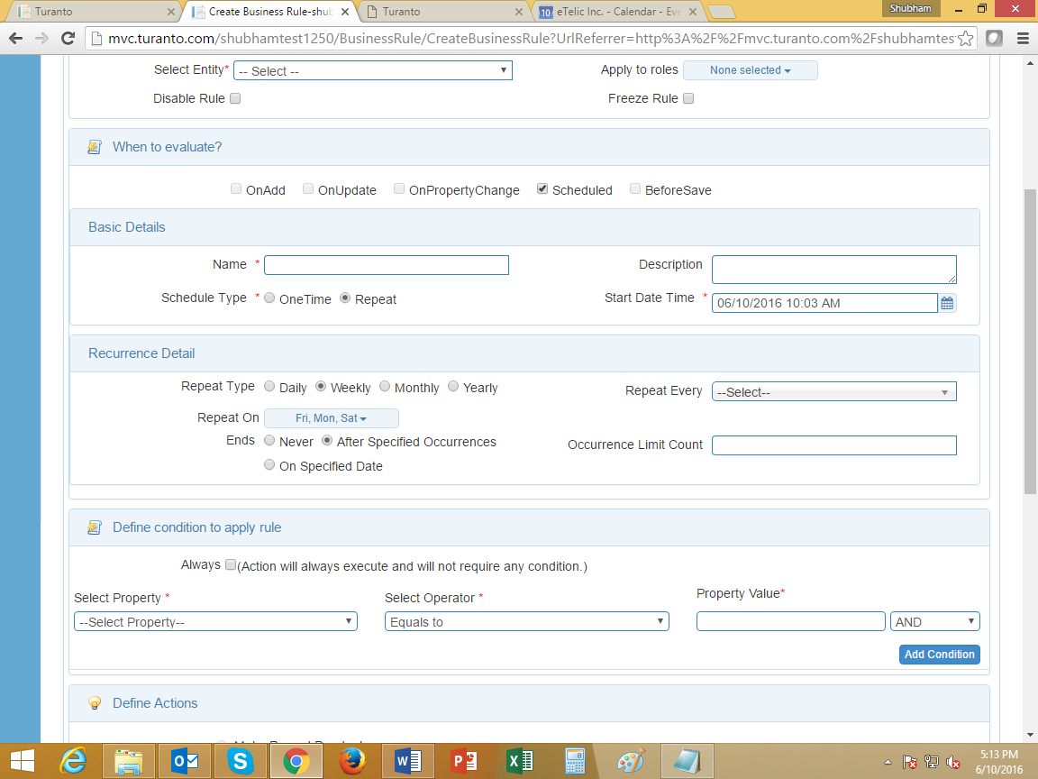

TODO: Replace this Image

Figure : TODO (Write Caption) Repeat Business Rule (Screenshot of weekly rule)

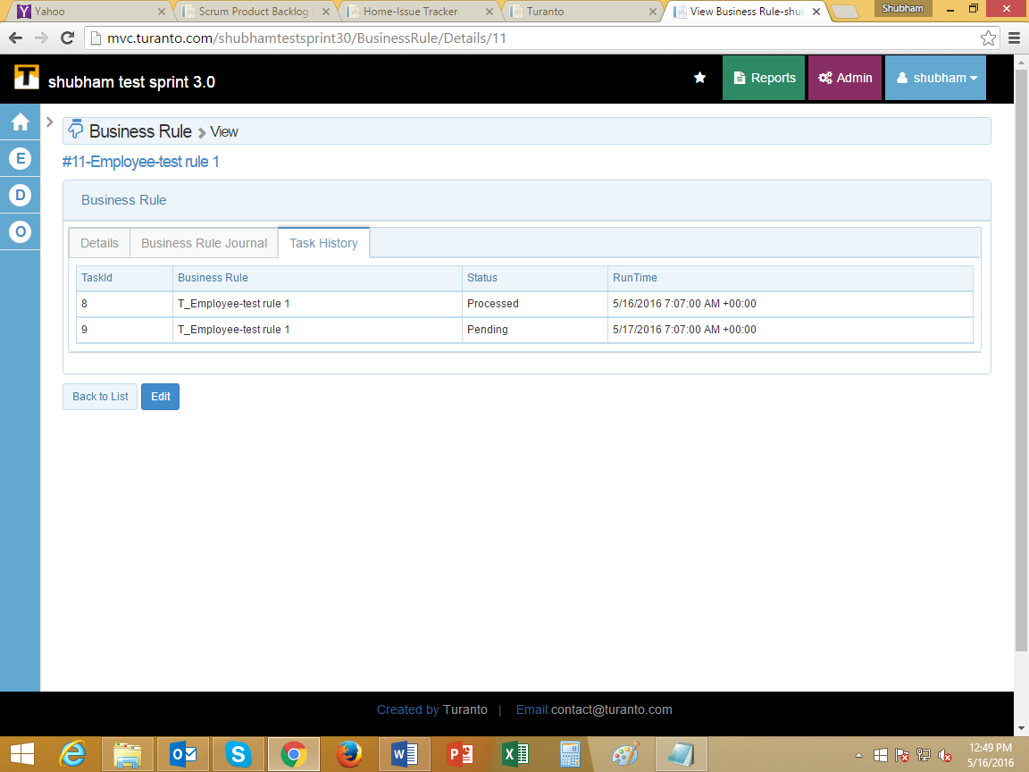

TODO: Replace this Image

Figure : TODO (Write Caption) Task History Tab of Schedule business rule

### Before Save

The rule will be evaluated before saving a record. The difference between ‘on add, update’ and ‘before save’ lies in their definition. The prior evaluates the rule when you hit create/save button while the later evaluates rule even before you hit create/save button.

## Define Condition to Apply Rule

The conditions defined here will be used to evaluate the business rule. There can be one or more conditions that can be used to evaluate rule.

### Select Property

Select any property of the mother entity. If the property selected is a dropdown, than you need to select the property of associated entity. If date field is selected in property, the ‘property value’ will automatically show ‘Today’. This reflects the condition will be evaluated on system’s current date.

### Select Operator

Nine operating conditions are present to choose from:

* Equals to: Checks if property value of record is equal to that defined in rule.
* Greater than: Checks if property value of record is greater than the value defined in rule.
* Less than: Checks if property value of record is less than the value defined in rule.
* Less than or Equals to: Checks if property value of record is less than or equal to the value defined in rule.
* Greater than or Equals to: Checks if property value of record is greater than or equal to the value defined in rule.
* Contains: Checks if property value of record contains the value defined in rule.
* Not Equals to: Checks if property value of record is not equals to the value defined in rule. This is favorable operator to use **regular expressions**.
* Changes to anything: [Applicable only for ‘On Property Change’] Checks if property value of record changes to anything.
* Match: Checks if property value of record matches the value defined in rule. This is favorable operator to use **regular expressions**.

### Select Value Type

Select how the property value should be defined.

* Constant: Allows you to insert property value manually.
* Pick from List: [Applicable only if an association is selected] populates the list of available records. The records belong to the property of association selected in 'select property'. If your desired record is not being displayed, try selecting display value of associated entity.
* Changes to Anything: [Applicable only for ‘On Property Change’] Checks if property value of record changes to anything.
* Regular Expression: [Recommended Users: Developers] only valid C# expressions are allowed. The rule will evaluate the record to match the expression defined in ‘property value’.
* Dynamic: Displays the list of available property/associations in ‘property value’ to select from. The rule will match the value of target property to evaluate the rule.

### Property Value

There are many input formats of property value:

* Type the value if value type is constant.
* Select from multi-select dropdown if value type is ‘pick from list’.
* Field will be disabled if value type is ‘changes to anything’.
* Proper C# regular expression if value type is ‘regular expression’.
* Select property from dropdown if value type is ‘dynamic’.
* ‘Null’ to evaluate rule when property is empty.
* ‘Today’ will be filled automatically if selected property has date-time datatype. This reflects that condition will be evaluated on system’s current date. There are some additional fields displayed for date calculation (Applicable in both conditions and actions)
  + Property value can be today or a specific date (Format: MM/DD/YYYY)
  + Add (+) or Subtract (-) are the operators
  + Enter number allows numerical values. It acts as second operand
  + Options to define that the number to be calculated as no. of Days/Weeks/Months/Years.

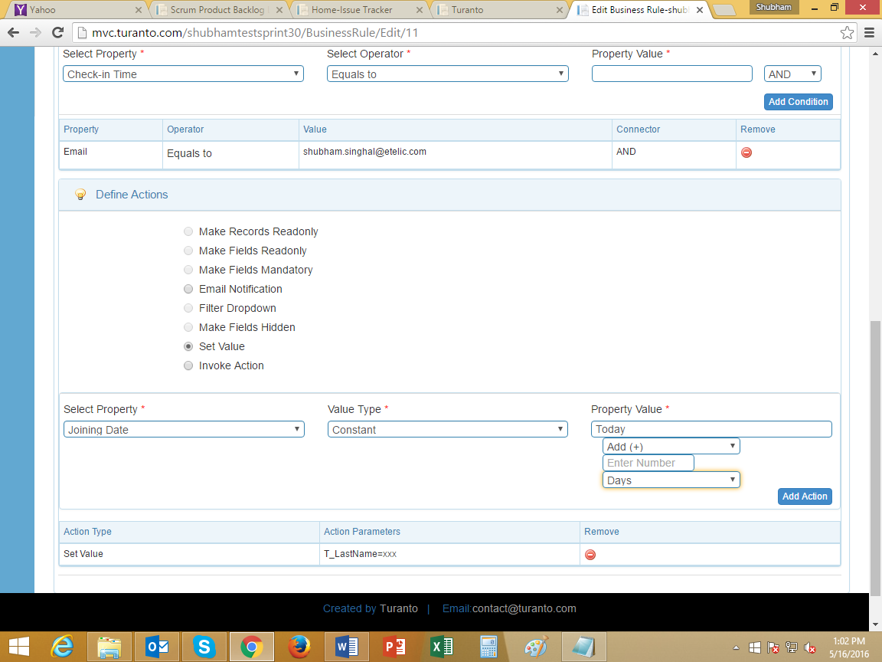

TODO: Replace this Image

Figure : TODO (Write Caption) Date Calculation Fields

### AND OR Connector

When multiple conditions are present for a rule, the rule will check all the conditions before executing the action. The multiple conditions use ‘AND’ and ‘OR’ connectors to connect each condition.

* 1. 1. The rule evaluates conditions in Top-Down hierarchy.
  2. 2. The connector of current condition defines connectivity with next condition.
  3. 3. The combined result of all previous conditions is considered as one condition and next condition is evaluated against it. During evaluation the connector of previous condition decides the connectivity with next condition.
  4. 4. Do not add more than 3 conditions if using both 'AND' 'OR' connectors. However if you are using same connector, any number of conditions can be added.
  5. The connector in last condition is used only when you edit the rule and add more conditions.

## Define Actions

Following are types of ‘actions’ caused in case of any above criteria. One or more than one actions can be defined in a rule. The actions execute on properties of same entity, entity associated as inline association and entities associated as dropdown.

### Make Records Read Only

(It works only on ‘On Update’) The records of the entity will be locked edit permission from selected roles will be withdrawn.

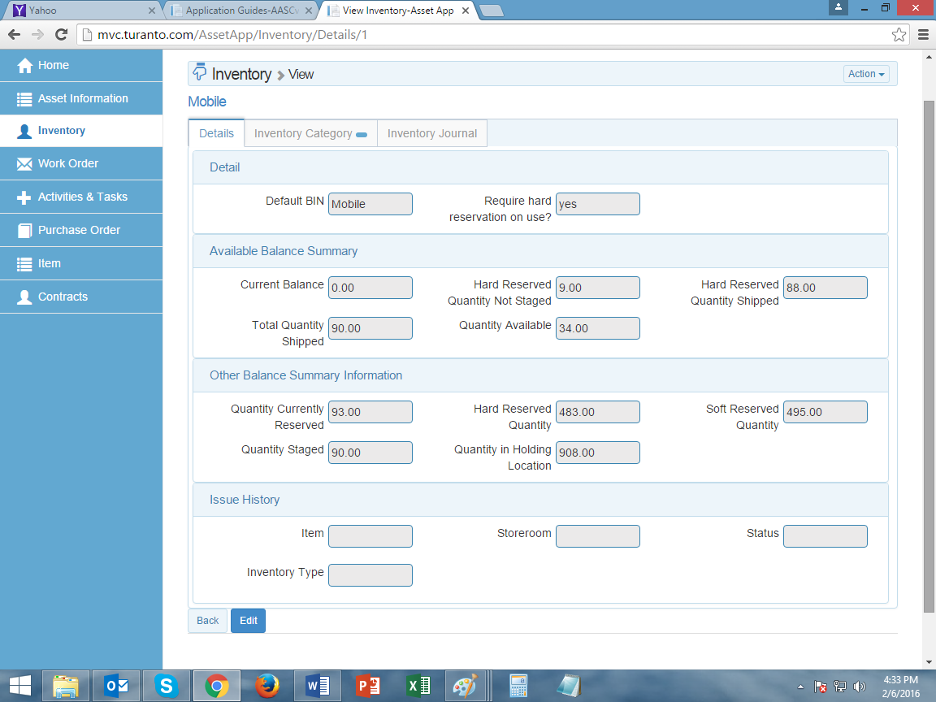

TODO: Replace this Image

Figure : TODO (Write Caption) Record is read-only because of business rule

### Make Fields Read Only

(It works only on ‘On Update’). Multiple properties selected in this section will not be editable for any record of entity.

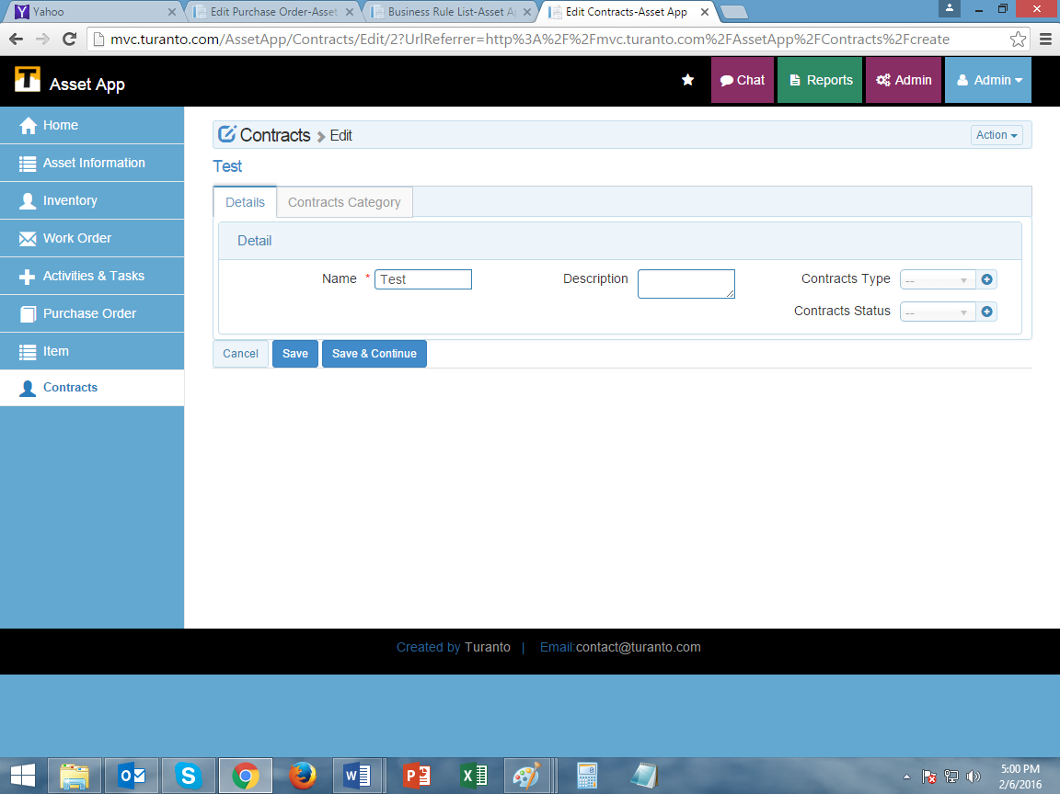

TODO: Replace this Image

Figure : TODO (Write Caption) [Note: Contract type and contact status are read only fields]

### Make Fields Mandatory

Multiple properties selected in this section will be marked as mandatory.

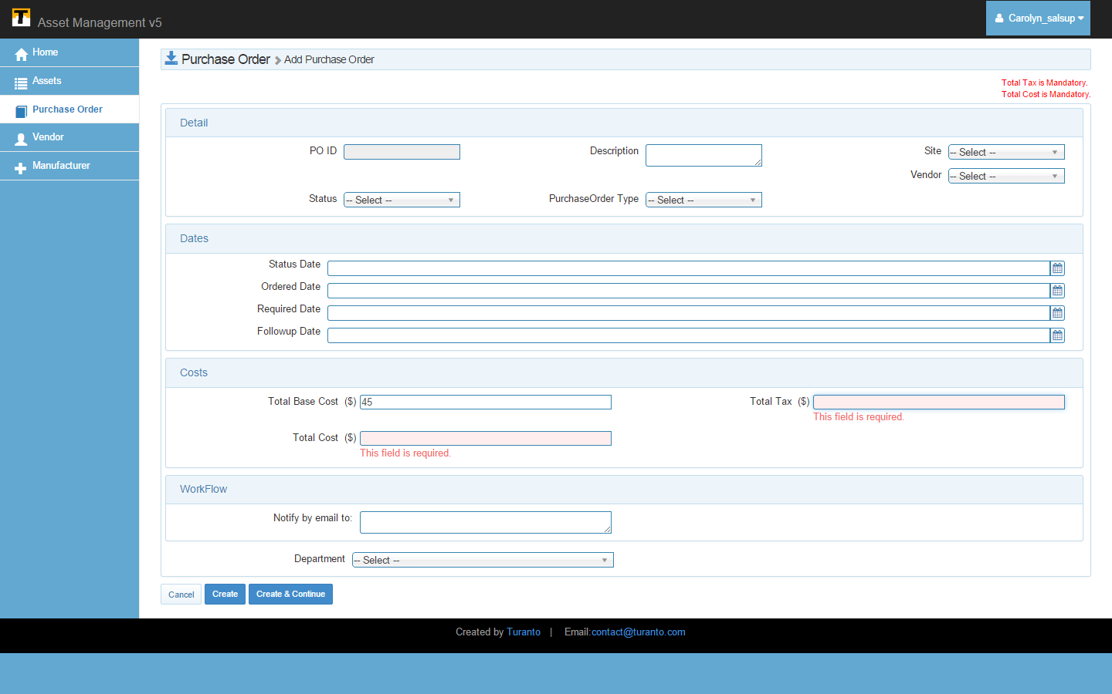

TODO: Replace this Image

Figure : TODO (Write Caption) Fields mandatory because of business rule

### Email Notification

The notification has four fields:

**Notify Within Days**

Select the days you want to delay the notification (in case accidental rule is made). Select 0 if you want to send immediate notification.

**Notify To**

Select the users you want to send notification to. If the entity is not associated with users, only logged in user will be displayed.

**Notify To Roles**

The email notification can be sent to all the users of a role selected here. However please note that the email message will list the address of all the users to whom email is sent.

**Special Extra Email-Ids**

Type the email ids you want to acknowledge.

**Notification Message**

Type the notification message you want to send. Type the notification message you want to send. In notification message you can amend the complete record and link to record using keywords ###Record### and ###RecordLink### respectively along with message.

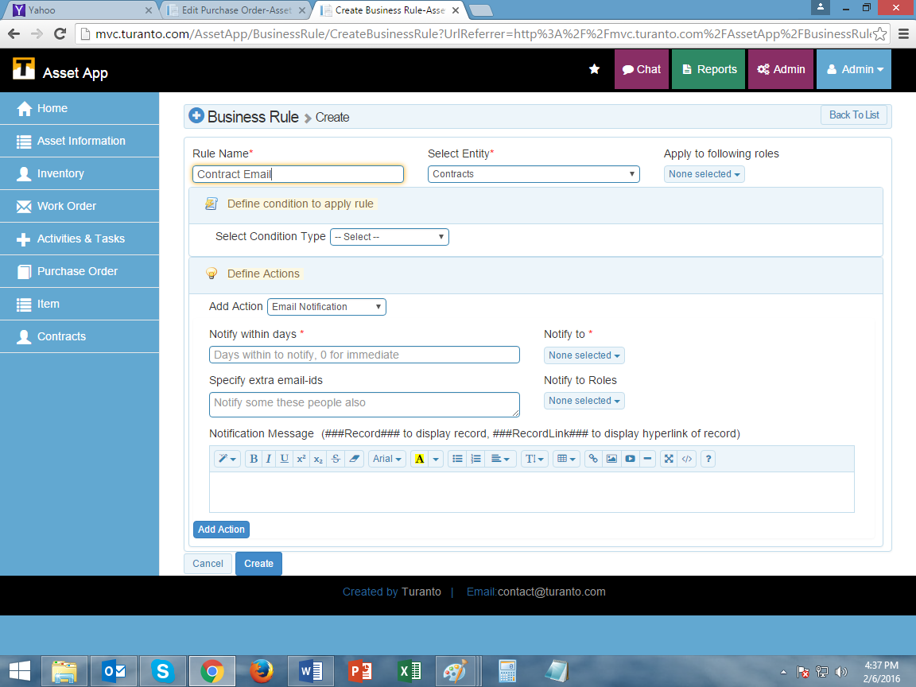

TODO: Replace this Image

Figure : TODO (Write Caption) Email Notification Settings

### Filter Dropdown

The value of an entity can be filtered as what records are shown in dropdowns of associated entities. The business rule gives an option ‘filter dropdown’ as action; and condition of filtering of records based on value of its property.

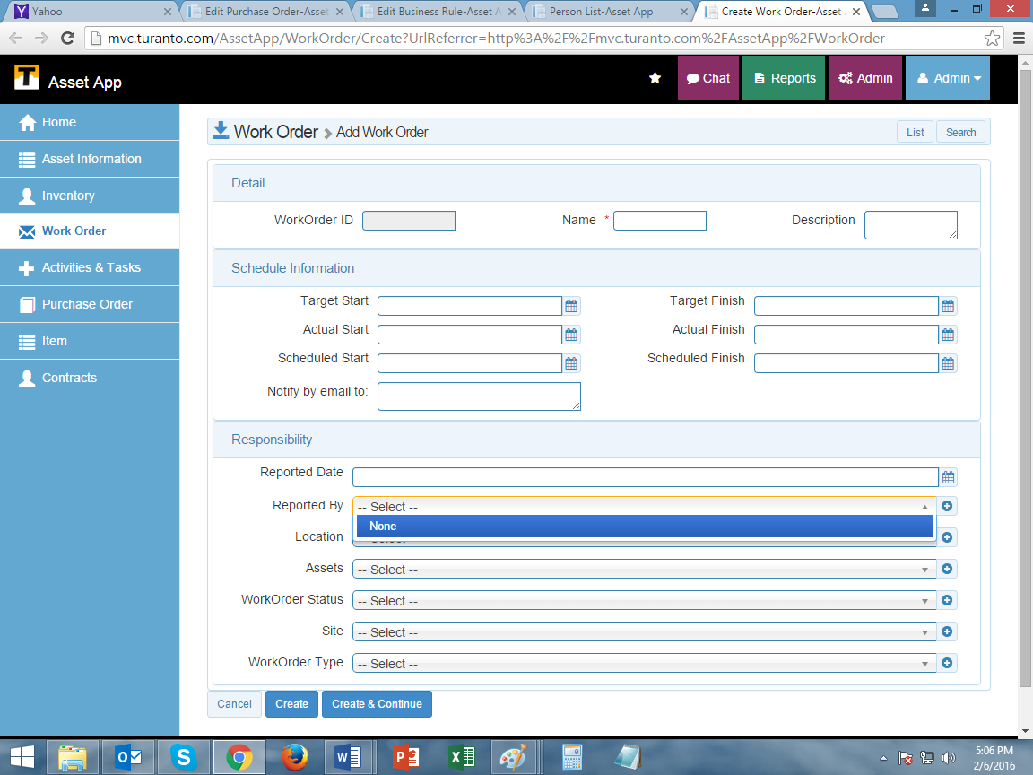

TODO: Replace this Image

Figure : TODO (Write Caption) [Note: The person with person status = Active will only be shown here]

### Make Fields Hidden

The rule will hide all the desired fields on evaluating the condition. The action executes on the edit page to prevent accidental hiding a field that is mandatory on create page.

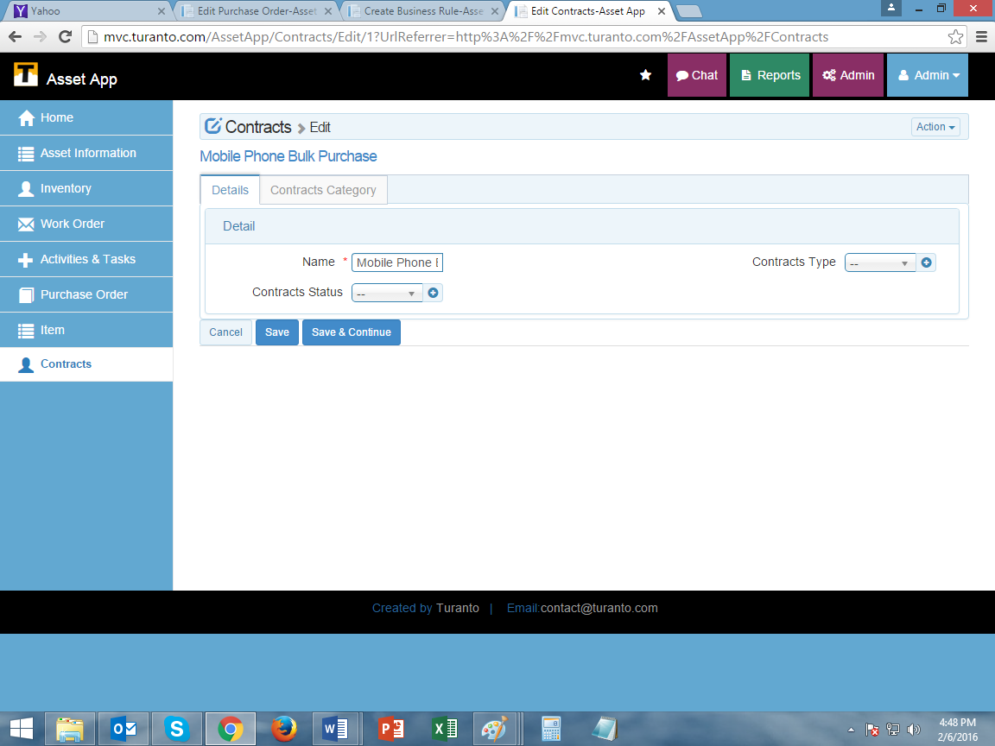

TODO: Replace this Image

Figure : TODO (Write Caption) [Note: Description field is hidden here]

### Set Value

Business rule can be applied to an entity to set value in property based on a condition. The value to be set can be a constant, picked from list (supported in associations only) or dynamic value. Dynamic value if set than on saving the record, the property will fetch value from target property (property can be from same entity or entities in dropdown)

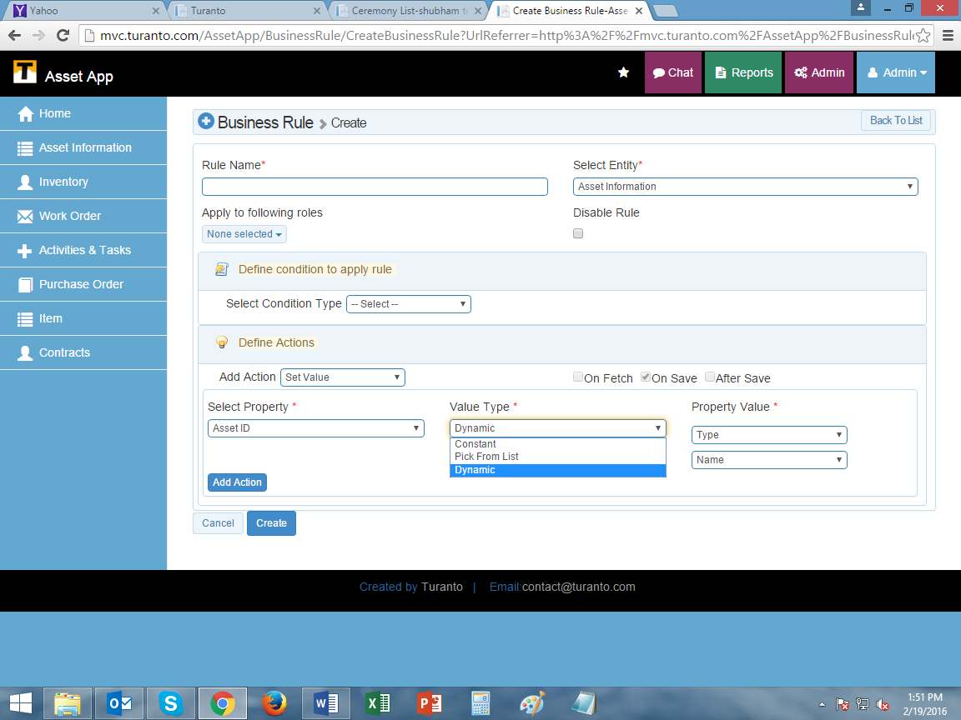

Figure : TODO (Write Caption) Set Value in Business Rule

### Invoke Action

The verbs can be triggered from business rule using invoke action. While saving the record if the condition of business rule is met, the invoke action will trigger the verb (custom verb only) and relevant action will be executed. The verbs available in action of business rule will be associated directly or indirectly with entity on which rule is applied.

### Validate Before Save

This action prevents saving of record when the condition of business rule is met. Validate before save is the typical action for ‘regular expression’. In condition create a condition: ‘Selected property is not equal to regular expression defined in property value’. This will allow records only to save values that match regular expressions.

# Example Business Rule

TODO: Replace the section with your own rule

The following section describes how to add a business role in an entity called Purchase Order in a mock application.

For example:

1. In Entity ‘**Purchase Order**’
2. For the role ‘**Sales Supervisor**’ and ‘**Sales Manager**’
3. On new add
4. If rate is greater than 0 (i.e. data is inserted in rate field)
5. The ‘**Total Cost**’ and ‘**Total Tax**’ fields will become mandatory.

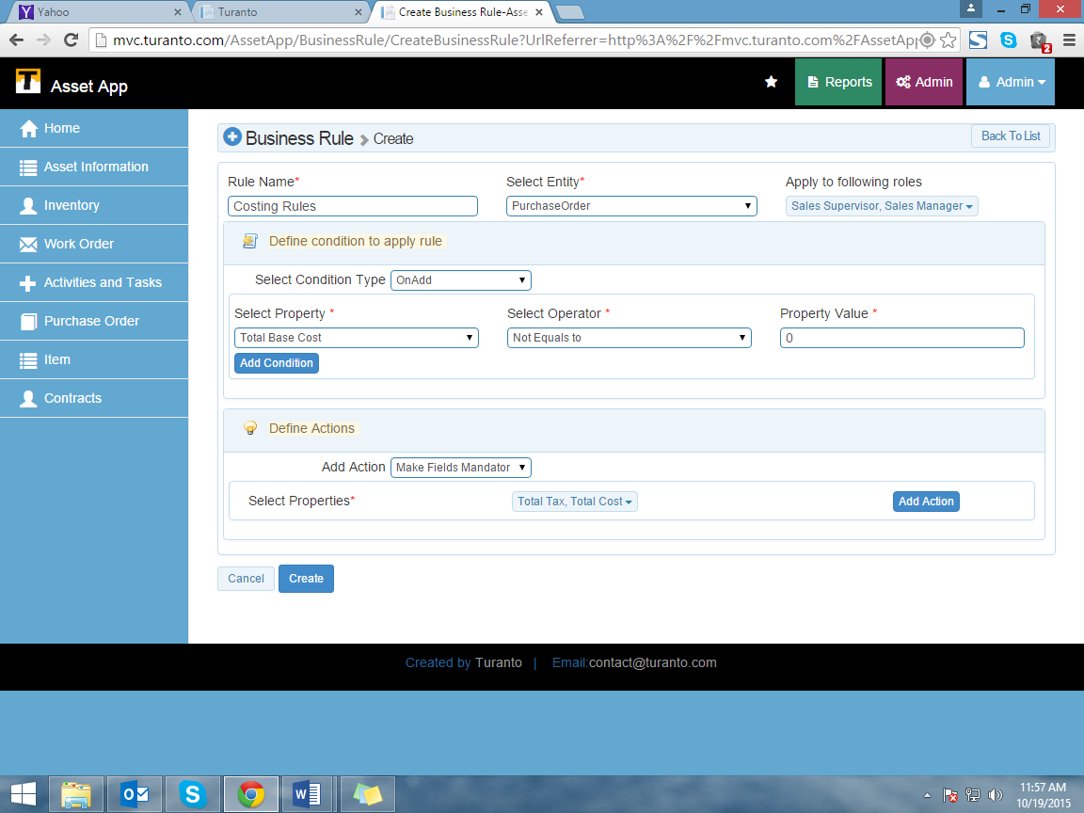

TODO: Replace this Image

Figure : TODO (Write Caption) Business Rule for ‘Purchase Order’

When a business rule is saved, it is visible on index page of Business Rules. Index page provides option to view, unfreeze, disable/enable and delete options for a rule. To edit a rule, click view and then go to edit.

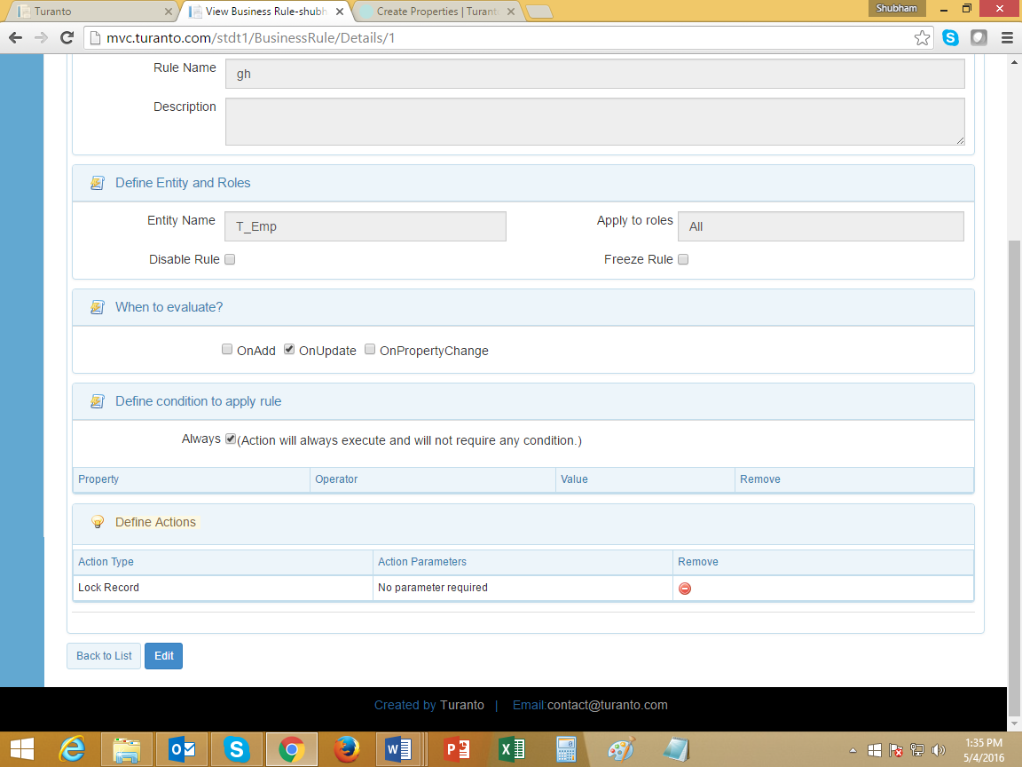

TODO: Replace this Image

Figure : TODO (Write Caption) View Business Rule

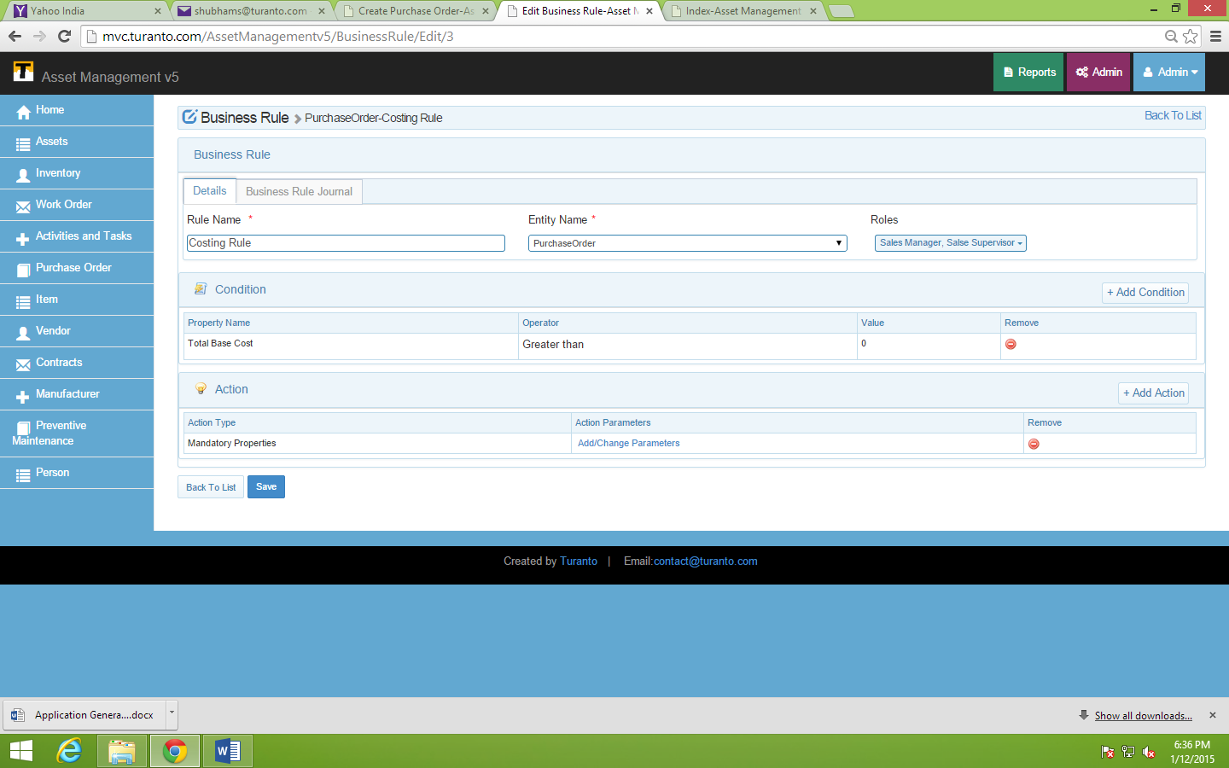

TODO: Replace this Image

Figure : TODO (Write Caption) Edit a Business Rule (Add more conditions and actions)

# **Test Business rule**



TODO: Replace this Image

Figure : TODO (Write Caption) Business Rule Example- ‘Total Base Cost > 0’ made ‘Total Tax’ and ‘Total Cost’ Properties Mandatory