#Company_Logo#

**App_Name Troubleshooting Guide**

**COPYRIGHT**

App_Name Troubleshooting Guide (Release Version 1.0)

The information provided in this document, including URL and other Internet Web site references is "as-is" and for informational purposes only. The information contained herein is subject to change without notice and is not warranted to be error-free. Unless otherwise noted, the companies, organizations, products, domain names, e-mail addresses, logos, people, places, and events depicted in examples herein are fictitious and for only illustration purposes. No association with any real company, organization, product, domain name, e-mail address, logo, person, place, or event is intended or should be inferred.

This document does not provide you with any legal rights to any intellectual property in any Turanto product. You may copy and use this document for your internal, reference purposes.

© 2015 eTelic Inc. All rights reserved.

Table of Contents

Preface 4

Intended Audience 4

Related Documents 4

Conventions 4

Introduction to Turanto 5

Point of Contact 5

Primary Business Function 5

Getting Started 5

Admin Area Errors 5

IIS Errors 5

Database Errors 6

Application Errors 7

Login Errors 7

Mandatory Fields 7

Import Errors 8

Issue Tracker 9

# Preface

*Leverage Turanto ™ Cloud Solution - build web & mobile applications without programming*

## Intended Audience

This manual is intended for individuals/organizations interested in application development and deploying on their own server using Turanto™. The guide covers some common problems faced by users.

## Related Documents

The document is first revision in its section and available only at respective application(s) portals. The company is not responsible for about authenticity of this document, if accessed from any third party website. The documents available are:

* Turanto Guide to Build Applications
* Common User’s Guide
* Security Guide
* General Deployment Guide
* Database Design Document
* Troubleshooting Guide
* Configuring Business Rules

## Conventions

Following are the conventions used in this document:

‘’: words in single inverted commas are the nouns. These words in common English sometimes are used in different manners as required. Inverted commas differentiate these words used as simple English terms and specific terms (nouns). Ex: properties, associations, datatype etc.

TM: The words with TM (Trademark) as superscript are registered words and cannot be used without prior permission of respective organization for commercial and profit activities.

Hyperlinks: Hyperlinks are the content that reflects the source at another place having a web address. The hyperlinks are URLs to these web addresses and are accessible by pressing (CTRL + click) in static documents and simple clicks on web pages.

Save: For any changes you, ‘Save’ button store these changes. The save button is present in all the forms and fields in Turanto and is not repeatedly acknowledged.

Cancel: For any changes you, ‘Cancel’ button discards these changes. The cancel button is present in all the forms and fields in Turanto and is not repeatedly acknowledged.

Checkbox: Checkbox presents the conditions that could be marked as true or false. The right sign in checkbox ✓ marks the condition as true. If left blank, the system considers it as false.

Fields: Fields are the space provided to fill the data. Some fields may have conditions depending on respective section or the rules.

# Introduction to Turanto

A while ago Microsoft had "Patterns & Practices" publication as part of their Architecture Group. The architecture and designs of Turanto is based a lot on those documents. While Turanto did not follow it verbatim, it had a significant influence on the design.

The common business applications - tracking inventory, tracking sales, tracking marketing events, etc. can be constructed with significant time savings - almost 70% - can be achieved through the use of Turanto. The algorithmic and calculation aspects can then be integrated through standard programming, since the entire code base is available. In Turanto you need to just know what items you want managed, how they are related to each other. You "tell" this by using forms with drop downs (similar to booking an airline flight), and not with programming.

The common customizations such as logo, user interface elements, header, and footer are all available without downloading code. If you want to customize further, you can download the code and only touch the layers you wish to touch - typically, this is the User Interface, unless you want to modify the default Business Logic. Modifying one layer has no impact on others and they automatically adjust to reflect the changes made in other layers.

## Point of Contact

For any queries or to make any request, feel free to contact us at [contact@etelic.com](mailto:contact@etelic.com) or [info@turanto.com](mailto:info@turanto.com).

## Primary Business Function

You want to create an application to manage the stuffs of your office. Each stuff has its own identity and is associated with number of operations. The application should be cloud based and should be supportive on any browser. You selected Turanto because you don’t know even ‘C’ of coding and interested only in organizing your stuffs according to required categories (single and multiple)

# Getting Started

The following sections will describe errors you may encounter in different areas of your application. You will require administrative access to App_Name, the database server and the application server to resolve most of these errors. These errors are updated frequently.

# Admin Area Errors

You can go to the Admin section (by clicking on the purple admin button on the homepage) and view all the errors by clicking on ‘Errors List’. It will give you a list of all errors that have occurred in App_Name.

# IIS Errors

In case of any errors, please follow these instructions:

• If you have two different servers for the database and the application, please check that they can communicate with each other using a connection.udl file.

• Check that the appropriate ports are open

• Check that the connection string in the web.config is correct

• Check that the application pool is set correctly

• Check that the bindings are correct

# Database Errors

In case of any errors, please follow these instructions:

* If you are having trouble logging into SSMS, please make sure that your server name, username and password is correct
* If you are having trouble attaching the database, make sure your user has the right privileges but checking the ‘Security’ option in SSMS or contact the database administrator
* Make sure you are not attaching a database with the same name as an already existing database
* Make sure that you have saved the database (that you are going to attach in SSMS) in the SQL Data folder

# Application Errors

This section describes the error you can get in App_Name during day to day activities.

## Login Errors

You get the ‘Invalid username or password’ if you type in an incorrect username or password. If you enter your username or password wrong five times in a row, your account will be locked. It will be automatically activated in a couple of hours or please contact your system administrator to unlock it immediately.

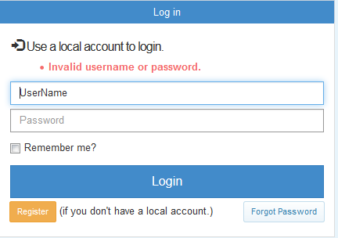

Figure : Invalid Username/password error

## Mandatory Fields

All the fields marked with a red asterisk are mandatory and you have to fill them before you save any changes. You get an error saying “The name field is required” which tells you exactly which field you need to enter before you are allowed to save.

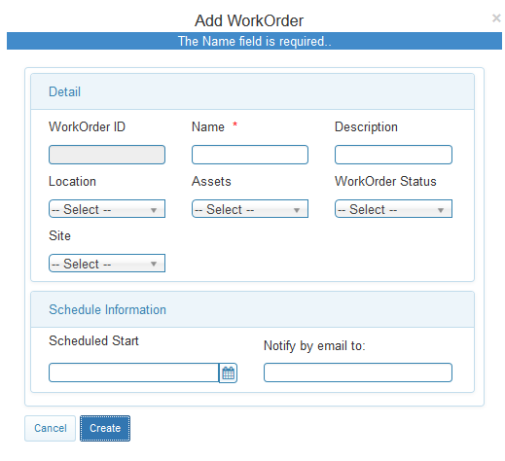

Figure : Mandatory Fields

## Import Errors

If you don’t enter the date in the upload screen, you get the following error. To resolve this error, please enter a date in the box or select it from the calendar.

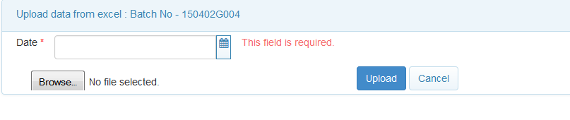

Figure : Date error

If your Excel file does not contain all the columns that AASR needs or the column names are different from the AASR mappings, you will receive the following error:

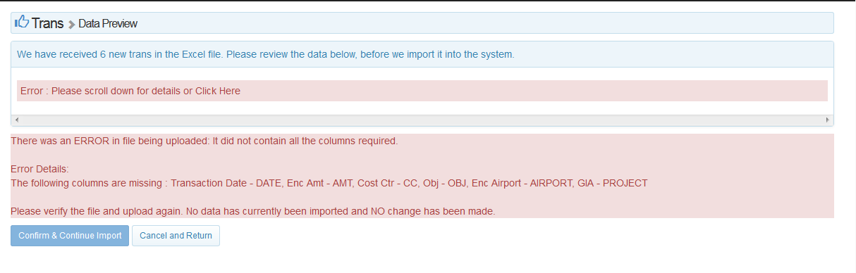

Figure : Excel file mapping error

The error tells you which columns are missing from the excel file and what their names should be in your excel file. For instance, the transaction date should be labelled as ‘DATE’ in your excel file. Please modify your Excel file and then re-upload.

In the case of details.all file, you will not be allowed to upload duplicate transaction ID. The system will give you the following error:

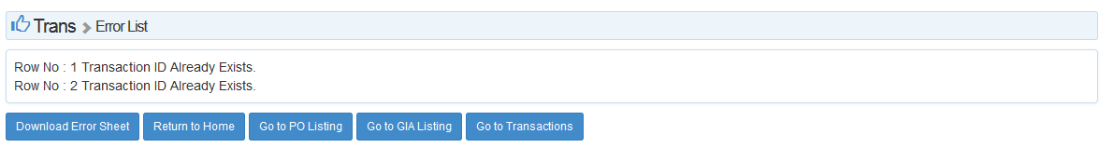

Figure : Error message for duplicate transaction

# Issue Tracker

An issue tracker can be deployed on your server to better keep track of all the errors and their statuses. The issue tracker already contains most of the things you would need to record the errors like the severity, status, summary of the error etc but it is also customizable. You can also attach any documents or images to the issue.

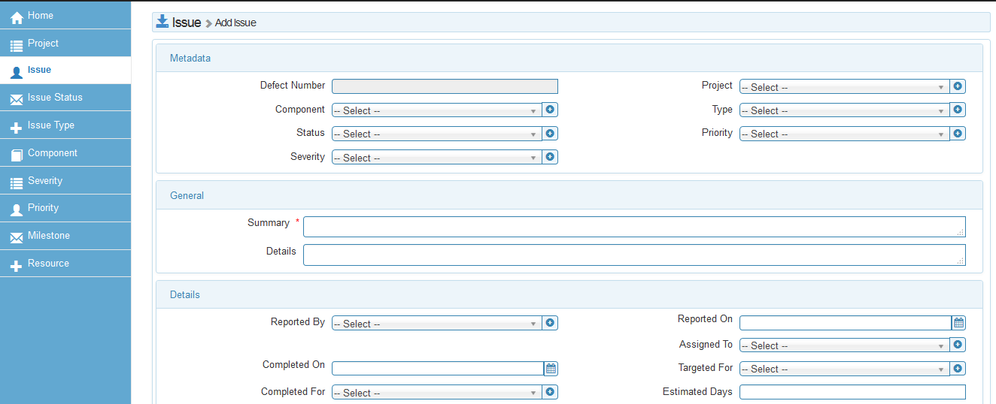

Figure : Example issue Tracker