**1.Move files from one folder to respective folder**

touch abc.txt def.txt ghi.txt jkl.txt

STATUS-EMBEDDED@DESKTOP-GDI2HTE MINGW64 ~/gitbashpractice/assgn1

$ mkdir abc def ghi jkl

STATUS-EMBEDDED@DESKTOP-GDI2HTE MINGW64 ~/gitbashpractice/assgn1

$ ls

abc/ abc.txt def/ def.txt ghi/ ghi.txt jkl/ jkl.txt

STATUS-EMBEDDED@DESKTOP-GDI2HTE MINGW64 ~/gitbashpractice/assgn1

$ mv abc.txt abc

STATUS-EMBEDDED@DESKTOP-GDI2HTE MINGW64 ~/gitbashpractice/assgn1

$ mv def.txt def

STATUS-EMBEDDED@DESKTOP-GDI2HTE MINGW64 ~/gitbashpractice/assgn1

$ mv ghi.txt ghi

STATUS-EMBEDDED@DESKTOP-GDI2HTE MINGW64 ~/gitbashpractice/assgn1

$ mv jkl.txt jkl

STATUS-EMBEDDED@DESKTOP-GDI2HTE MINGW64 ~/gitbashpractice/assgn1

$ ls

abc/ def/ ghi/ jkl/

STATUS-EMBEDDED@DESKTOP-GDI2HTE MINGW64 ~/gitbashpractice/assgn1

$ ls -al

total 8

drwxr-xr-x 1 STATUS-EMBEDDED 197609 0 Dec 16 12:46 ./

drwxr-xr-x 1 STATUS-EMBEDDED 197609 0 Dec 16 12:44 ../

drwxr-xr-x 1 STATUS-EMBEDDED 197609 0 Dec 16 12:46 abc/

drwxr-xr-x 1 STATUS-EMBEDDED 197609 0 Dec 16 12:46 def/

drwxr-xr-x 1 STATUS-EMBEDDED 197609 0 Dec 16 12:46 ghi/

drwxr-xr-x 1 STATUS-EMBEDDED 197609 0 Dec 16 12:46 jkl/

STATUS-EMBEDDED@DESKTOP-GDI2HTE MINGW64 ~/gitbashpractice/assgn1

$ ls ..

NewFile copyfiles.sh echo forloop loopfor.txt

assgn1/ done foldername/ loopfor

STATUS-EMBEDDED@DESKTOP-GDI2HTE MINGW64 ~/gitbashpractice/assgn1

$ pwd

/c/Users/STATUS-EMBEDDED/gitbashpractice/assgn1

STATUS-EMBEDDED@DESKTOP-GDI2HTE MINGW64 ~/gitbashpractice/assgn1

$ ls -l

total 0

drwxr-xr-x 1 STATUS-EMBEDDED 197609 0 Dec 16 12:46 abc/

drwxr-xr-x 1 STATUS-EMBEDDED 197609 0 Dec 16 12:46 def/

drwxr-xr-x 1 STATUS-EMBEDDED 197609 0 Dec 16 12:46 ghi/

drwxr-xr-x 1 STATUS-EMBEDDED 197609 0 Dec 16 12:46 jkl/

**2.Append current date to all log files**

$ touch abc.log.1 def.log.1 ghi.log.1 jkl.log.1 mno.log.1

STATUS-EMBEDDED@DESKTOP-GDI2HTE MINGW64 ~/gitbashpractice/assgn1

$ ls -a

./ abc/ def/ ghi/ jkl/ mno.log.1

../ abc.log.1 def.log.1 ghi.log.1 jkl.log.1

STATUS-EMBEDDED@DESKTOP-GDI2HTE MINGW64 ~/gitbashpractice/assgn1

$ ls/bin

bash: ls/bin: No such file or directory

STATUS-EMBEDDED@DESKTOP-GDI2HTE MINGW64 ~/gitbashpractice/assgn1

$ echo abc.log.1-"`date +"%d-%m-%Y"`"

abc.log.1-16-12-2021

STATUS-EMBEDDED@DESKTOP-GDI2HTE MINGW64 ~/gitbashpractice/assgn1

$ echo def.log.1-"`date +"%d-%m-%Y"`"

def.log.1-16-12-2021

STATUS-EMBEDDED@DESKTOP-GDI2HTE MINGW64 ~/gitbashpractice/assgn1

$ echo ghi.log.1-"`date +"%d-%m-%Y"`"

ghi.log.1-16-12-2021

STATUS-EMBEDDED@DESKTOP-GDI2HTE MINGW64 ~/gitbashpractice/assgn1

$ echo jkl.log.1-"`date +"%d-%m-%Y"`"

jkl.log.1-16-12-2021

**3. Archive files which have modified 7 days ago and move it to your backup folder**

find /f/shweta/STM32PDF/*.pdf -mtime +7

/f/shweta/STM32PDF/12inch-User-Development-Guide-200327.pdf

/f/shweta/STM32PDF/12inchdatasheet.pdf

/f/shweta/STM32PDF/Astra-30ProcessFlow.pdf

/f/shweta/STM32PDF/DAC7760.pdf

/f/shweta/STM32PDF/Datasheet STVA151WT-01for12inch.pdf

/f/shweta/STM32PDF/PID_TUne_Cal.pdf

/f/shweta/STM32PDF/STONE-Designer-user-manual.pdf

/f/shweta/STM32PDF/TOOL2019_4.3-User-Development-Guide.pdf

/f/shweta/STM32PDF/Wrist-Cooling-System_using peltier.pdf

/f/shweta/STM32PDF/ads8675.pdf

/f/shweta/STM32PDF/dac7760data (1).pdf

/f/shweta/STM32PDF/dm00124865-stm32f75xxx-and-stm32f74xxx-advanced-armbased-32bit-mcus-stmicroelectronics (1).pdf

/f/shweta/STM32PDF/dm00276557-discovery-kit-with-stm32f769ni-mcu-stmicroelectronics (1).pdf

/f/shweta/STM32PDF/dm00276557-discovery-kit-with-stm32f769ni-mcu-stmicroelectronics.pdf

/f/shweta/STM32PDF/peltier.pdf

/f/shweta/STM32PDF/stm32f303c6.pdf

/f/shweta/STM32PDF/stm32f303vct6.pdf

/f/shweta/STM32PDF/stm32f769ii.pdf

/f/shweta/STM32PDF/stv121wt-User-Development-Guide-200327.pdf

/f/shweta/STM32PDF/tec_controller8A_24V.pdf

STATUS-EMBEDDED@DESKTOP-GDI2HTE MINGW64 ~/gitbashpractice/assgn1

$ pwd

/c/Users/STATUS-EMBEDDED/gitbashpractice/assgn1

STATUS-EMBEDDED@DESKTOP-GDI2HTE MINGW64 ~/gitbashpractice/assgn1

$ mkdir backup

STATUS-EMBEDDED@DESKTOP-GDI2HTE MINGW64 ~/gitbashpractice/assgn1

$ mv /f/shweta/STM32PDF/*.pdf backup

STATUS-EMBEDDED@DESKTOP-GDI2HTE MINGW64 ~/gitbashpractice/assgn1

$ ls backup

12inch-User-Development-Guide-200327.pdf

12inchdatasheet.pdf

Astra-30ProcessFlow.pdf

DAC7760.pdf

'Datasheet STVA151WT-01for12inch.pdf'

PID_TUne_Cal.pdf

'Project_Schematic_1 (1).pdf'

STONE-Designer-user-manual.pdf

TOOL2019_4.3-User-Development-Guide.pdf

'Wrist-Cooling-System_using peltier.pdf'

ads8675.pdf

'dac7760data (1).pdf'

'dm00124865-stm32f75xxx-and-stm32f74xxx-advanced-armbased-32bit-mcus-stmicroelectronics (1).pdf'

'dm00276557-discovery-kit-with-stm32f769ni-mcu-stmicroelectronics (1).pdf'

dm00276557-discovery-kit-with-stm32f769ni-mcu-stmicroelectronics.pdf

peltier.pdf

stm32f303c6.pdf

stm32f303vct6.pdf

stm32f769ii.pdf

stv121wt-User-Development-Guide-200327.pdf

tec_controller8A_24V.pdf

**4.Check if folder exist or not**

notepad test.txt

STATUS-EMBEDDED@DESKTOP-GDI2HTE MINGW64 ~/gitbashpractice/assgn1

$ bash test.txt

test.txt: line 3: echo/c/Users/STATUS-EMBEDDED/gitbashpractice/assgn1/abc/abc.txt exists.: No such file or directory

STATUS-EMBEDDED@DESKTOP-GDI2HTE MINGW64 ~/gitbashpractice/assgn1

$ notepad test.txt

STATUS-EMBEDDED@DESKTOP-GDI2HTE MINGW64 ~/gitbashpractice/assgn1

$ bash test.txt

test.txt: line 3: echo/c/Users/STATUS-EMBEDDED/gitbashpractice/assgn1/abc exists.: No such file or directory

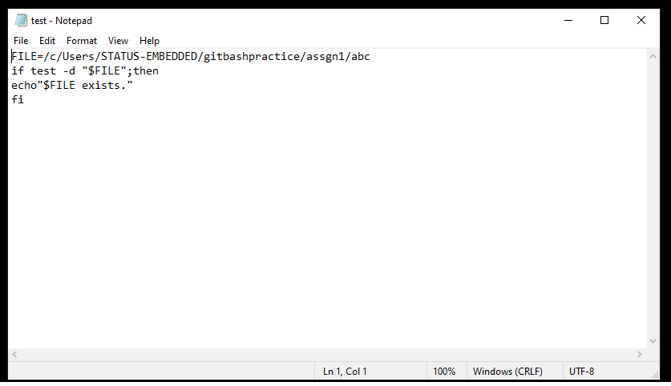

notepad test.txt

STATUS-EMBEDDED@DESKTOP-GDI2HTE MINGW64 ~/gitbashpractice/assgn1

$ bash test.txt

/c/Users/STATUS-EMBEDDED/gitbashpractice/assgn1/xyz does not exist

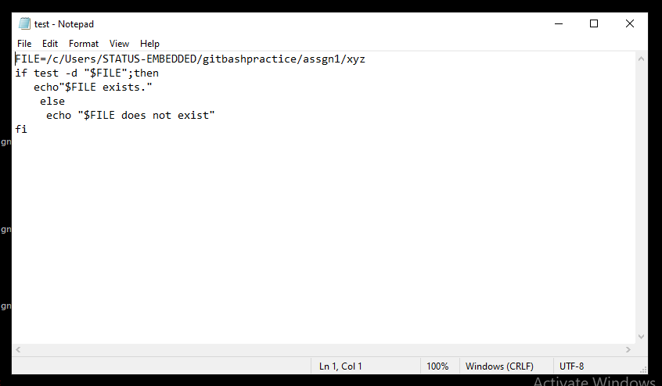

**5.** **execute command hello and ls and check its execution status**

$ echo hello

hello

STATUS-EMBEDDED@DESKTOP-GDI2HTE MINGW64 ~

$ echo $?

0

STATUS-EMBEDDED@DESKTOP-GDI2HTE MINGW64 ~

$ ls

'3D Objects'/

AppData/

'Application Data'@

'Arduino Proteus Library.rar'

Contacts/

Cookies@

Documents/

Downloads/

Favorites/

IntelGraphicsProfiles/

Links/

'Local Settings'@

MicrosoftEdgeBackups/

Music/

'My Documents'@

NTUSER.DAT

NTUSER.DAT{f5e607d0-03d6-11ec-8fcc-c465163c841e}.TM.blf

NTUSER.DAT{f5e607d0-03d6-11ec-8fcc-c465163c841e}.TMContainer00000000000000000001.regtrans-ms

NTUSER.DAT{f5e607d0-03d6-11ec-8fcc-c465163c841e}.TMContainer00000000000000000002.regtrans-ms

NetHood@

OneDrive/

PrintHood@

Recent@

STM32Cube/

STMicroelectronics/

'Saved Games'/

Searches/

SendTo@

'Start Menu'@

Templates@

Videos/

abc/

abc.txt

copyfiles.sh

data.csv

def/

def.txt

gitbashpractice/

ntuser.dat.LOG1

ntuser.dat.LOG2

ntuser.ini

stone_project_1.st

STATUS-EMBEDDED@DESKTOP-GDI2HTE MINGW64 ~

$ echo $?

0

**6. Set Environment usersecret=”dH34xJaa23”if it is not already set**

STATUS-EMBEDDED@DESKTOP-GDI2HTE MINGW64 ~/gitbashpractice

$ env usersecret=dH34xJaa23

USERDOMAIN=DESKTOP-GDI2HTE

OS=Windows_NT

COMMONPROGRAMFILES=C:\Program Files\Common Files

PROCESSOR_LEVEL=6

PSModulePath=C:\Program Files\WindowsPowerShell\Modules;C:\WINDOWS\system32\WindowsPowerShell\v1.0\Modules;c:\Program Files (x86)\Microsoft SQL Server\110\Tools\PowerShell\Modules\

CommonProgramW6432=C:\Program Files\Common Files

CommonProgramFiles(x86)=C:\Program Files (x86)\Common Files

MSYSTEM_CARCH=x86_64

DISPLAY=needs-to-be-defined

HOSTNAME=DESKTOP-GDI2HTE

PUBLIC=C:\Users\Public

OLDPWD=/c/Users/STATUS-EMBEDDED/gitbashpractice/stage1_review

CONFIG_SITE=/etc/config.site

EXEPATH=C:\Program Files\Git

MSYSTEM_CHOST=x86_64-w64-mingw32

NIDAQmxSwitchDir=C:\Program Files (x86)\National Instruments\NI-DAQ\Switch\

USERNAME=STATUS-EMBEDDED

LOGONSERVER=\\DESKTOP-GDI2HTE

PROCESSOR_ARCHITECTURE=AMD64

LOCALAPPDATA=C:\Users\STATUS-EMBEDDED\AppData\Local

COMPUTERNAME=DESKTOP-GDI2HTE

!::=::\

SYSTEMDRIVE=C:

USERPROFILE=C:\Users\STATUS-EMBEDDED

PATHEXT=.COM;.EXE;.BAT;.CMD;.VBS;.VBE;.JS;.JSE;.WSF;.WSH;.MSC

SYSTEMROOT=C:\WINDOWS

USERDOMAIN_ROAMINGPROFILE=DESKTOP-GDI2HTE

PROCESSOR_IDENTIFIER=Intel64 Family 6 Model 158 Stepping 10, GenuineIntel

MINGW_PACKAGE_PREFIX=mingw-w64-x86_64

OneDriveConsumer=C:\Users\STATUS-EMBEDDED\OneDrive

PWD=/c/Users/STATUS-EMBEDDED/gitbashpractice

SSH_ASKPASS=/mingw64/bin/git-askpass.exe

HOME=/c/Users/STATUS-EMBEDDED

TMP=/tmp

LC_CTYPE=en_US.UTF-8

TERM_PROGRAM=mintty

TERM_PROGRAM_VERSION=3.5.2

MSYSTEM_PREFIX=/mingw64

OneDrive=C:\Users\STATUS-EMBEDDED\OneDrive

PROCESSOR_REVISION=9e0a

TMPDIR=/tmp

NUMBER_OF_PROCESSORS=4

ProgramW6432=C:\Program Files

_JAVA_OPTIONS=-Djava.net.preferIPv4Stack=true

COMSPEC=C:\WINDOWS\system32\cmd.exe

APPDATA=C:\Users\STATUS-EMBEDDED\AppData\Roaming

TERM=xterm

SHELL=/usr/bin/bash

NIEXTCCOMPILERSUPP=C:\Program Files (x86)\National Instruments\Shared\ExternalCompilerSupport\C\

WINDIR=C:\WINDOWS

MINGW_CHOST=x86_64-w64-mingw32

ProgramData=C:\ProgramData

SHLVL=2

PLINK_PROTOCOL=ssh

PROGRAMFILES=C:\Program Files

ACLOCAL_PATH=/mingw64/share/aclocal:/usr/share/aclocal

MSYS=enable_pcon

MANPATH=/mingw64/local/man:/mingw64/share/man:/usr/local/man:/usr/share/man:/usr/man:/share/man

ORIGINAL_TEMP=/tmp

ORIGINAL_TMP=/tmp

ALLUSERSPROFILE=C:\ProgramData

TEMP=/tmp

java_home=C:\Program Files\Java\jdk-17.0.1

DriverData=C:\Windows\System32\Drivers\DriverData

MSYSTEM=MINGW64

MINGW_PREFIX=/mingw64

SESSIONNAME=Console

ProgramFiles(x86)=C:\Program Files (x86)

PATH=/c/Users/STATUS-EMBEDDED/bin:/mingw64/bin:/usr/local/bin:/usr/bin:/bin:/mingw64/bin:/usr/bin:/c/Users/STATUS-EMBEDDED/bin:/c/Program Files (x86)/Java/jdk-17.0.1/bin:/c/Program Files/Common Files/Oracle/Java/javapath:/c/ProgramData/Oracle/Java/javapath:/c/Program Files (x86)/Common Files/Oracle/Java/javapath:/c/WINDOWS/system32:/c/WINDOWS:/c/WINDOWS/System32/Wbem:/c/WINDOWS/System32/WindowsPowerShell/v1.0:/c/WINDOWS/System32/OpenSSH:/c/Program Files (x86)/STMicroelectronics/STM32 ST-LINK Utility/ST-LINK Utility:/c/Program Files/PuTTY:/c/Program Files (x86)/Microsoft SQL Server/110/Tools/Binn:/c/Program Files/Microsoft SQL Server/110/Tools/Binn:/c/Program Files/Microsoft SQL Server/110/DTS/Binn:/c/Program Files (x86)/Microsoft SQL Server/110/Tools/Binn/ManagementStudio:/c/Program Files (x86)/Microsoft SQL Server/110/DTS/Binn:/cmd:/c/Users/STATUS-EMBEDDED/AppData/Local/Microsoft/WindowsApps:/usr/bin/vendor_perl:/usr/bin/core_perl

PS1=\[\033]0;$TITLEPREFIX:$PWD\007\]\n\[\033[32m\]\u@\h \[\033[35m\]$MSYSTEM \[\033[33m\]\w\[\033[36m\]`__git_ps1`\[\033[0m\]\n$

HOMEDRIVE=C:

PKG_CONFIG_PATH=/mingw64/lib/pkgconfig:/mingw64/share/pkgconfig

INFOPATH=/usr/local/info:/usr/share/info:/usr/info:/share/info

HOMEPATH=\Users\STATUS-EMBEDDED

ORIGINAL_PATH=/mingw64/bin:/usr/bin:/c/Users/STATUS-EMBEDDED/bin:/c/Program Files (x86)/Java/jdk-17.0.1/bin:/c/Program Files/Common Files/Oracle/Java/javapath:/c/ProgramData/Oracle/Java/javapath:/c/Program Files (x86)/Common Files/Oracle/Java/javapath:/c/WINDOWS/system32:/c/WINDOWS:/c/WINDOWS/System32/Wbem:/c/WINDOWS/System32/WindowsPowerShell/v1.0:/c/WINDOWS/System32/OpenSSH:/c/Program Files (x86)/STMicroelectronics/STM32 ST-LINK Utility/ST-LINK Utility:/c/Program Files/PuTTY:/c/Program Files (x86)/Microsoft SQL Server/110/Tools/Binn:/c/Program Files/Microsoft SQL Server/110/Tools/Binn:/c/Program Files/Microsoft SQL Server/110/DTS/Binn:/c/Program Files (x86)/Microsoft SQL Server/110/Tools/Binn/ManagementStudio:/c/Program Files (x86)/Microsoft SQL Server/110/DTS/Binn:/cmd:/c/Users/STATUS-EMBEDDED/AppData/Local/Microsoft/WindowsApps

java-home=C:\Program Files (x86)\Java\jdk-17.0.1

_=/usr/bin/env

usersecret=dH34xJaa23

STATUS-EMBEDDED@DESKTOP-GDI2HTE MINGW64 ~/gitbashpractice

$

**7.find word in all files and print number of occurance**

STATUS-EMBEDDED@DESKTOP-GDI2HTE MINGW64 ~/gitbashpractice

$ grep -c -R 'echo'

2random.txt:1

assgn1/abc/abc.txt:0

assgn1/abc.log.1:0

assgn1/backup/12inch-User-Development-Guide-200327.pdf:0

assgn1/backup/12inchdatasheet.pdf:0

assgn1/backup/ads8675.pdf:0

assgn1/backup/Astra-30ProcessFlow.pdf:0

assgn1/backup/DAC7760.pdf:0

assgn1/backup/dac7760data (1).pdf:0

assgn1/backup/Datasheet STVA151WT-01for12inch.pdf:0

assgn1/backup/dm00124865-stm32f75xxx-and-stm32f74xxx-advanced-armbased-32bit-mcus-stmicroelectronics (1).pdf:0

assgn1/backup/dm00276557-discovery-kit-with-stm32f769ni-mcu-stmicroelectronics (1).pdf:0

assgn1/backup/dm00276557-discovery-kit-with-stm32f769ni-mcu-stmicroelectronics.pdf:0

assgn1/backup/peltier.pdf:0

assgn1/backup/PID_TUne_Cal.pdf:0

assgn1/backup/Project_Schematic_1 (1).pdf:0

assgn1/backup/stm32f303c6.pdf:0

assgn1/backup/stm32f303vct6.pdf:0

assgn1/backup/stm32f769ii.pdf:0

assgn1/backup/STONE-Designer-user-manual.pdf:0

assgn1/backup/stv121wt-User-Development-Guide-200327.pdf:0

assgn1/backup/tec_controller8A_24V.pdf:0

assgn1/backup/TOOL2019_4.3-User-Development-Guide.pdf:0

assgn1/backup/Wrist-Cooling-System_using peltier.pdf:0

assgn1/def/def.txt:0

assgn1/def.log.1:0

assgn1/filetest.txt:2

assgn1/ghi/ghi.txt:0

assgn1/ghi.log.1:0

assgn1/jkl/jkl.txt:0

assgn1/jkl.log.1:0

assgn1/mno.log.1:0

assgn1/test.txt:2

copyfiles.sh:1

day4.sh:0

done:0

echo:0

envfile.txt:0

foldername/random.txt:1

forloop:0

loopfor:0

loopfor.txt:2

oldfile.txt:0

stage1_review/Add.java:0

stage1_review/Division.cs:0

stage1_review/Multiply.py:0

stage1_review/Sub.js:0

STATUS-EMBEDDED@DESKTOP-GDI2HTE MINGW64 ~/gitbashpractice

$

**8.print employee name and total pay**

STATUS-EMBEDDED@DESKTOP-GDI2HTE MINGW64 ~

$ awk '{print $2,$7}' data.csv

EmployeeName TotalPay

NATHANIEL 567595

GARY 538909

ALBERT 335279

CHRISTOPHER 332343

PATRICK 326373

DAVID 316285

ALSON 315981

DAVID 307899

JOANNE 302377

PATRICIA 297608

EDWARD 294580

POOJA 20000

STATUS-EMBEDDED@DESKTOP-GDI2HTE MINGW64 ~

$

**9.Aggregate total pay whoes job title is CAPTAIN**

STATUS-EMBEDDED@DESKTOP-GDI2HTE MINGW64 ~

$ cat data.csv | grep CAPTAIN | awk '{total+=$4}END{print total/NR}'

156142

STATUS-EMBEDDED@DESKTOP-GDI2HTE MINGW64 ~

$

**10.print average of base pay**

STATUS-EMBEDDED@DESKTOP-GDI2HTE MINGW64 ~

$ cat data.csv | awk '{total+=$4}END{print total/NR}'

147359

STATUS-EMBEDDED@DESKTOP-GDI2HTE MINGW64 ~

$

**10.Find the difference between original file and updated file**

STATUS-EMBEDDED@DESKTOP-GDI2HTE MINGW64 ~/gitbashpractice

$ mkdir original updated

STATUS-EMBEDDED@DESKTOP-GDI2HTE MINGW64 ~/gitbashpractice

$ touch original.txt updated.txt

STATUS-EMBEDDED@DESKTOP-GDI2HTE MINGW64 ~/gitbashpractice

$ notepad original.txt

STATUS-EMBEDDED@DESKTOP-GDI2HTE MINGW64 ~/gitbashpractice

$ notepad updated.txt

STATUS-EMBEDDED@DESKTOP-GDI2HTE MINGW64 ~/gitbashpractice

$ diff original.txt updated.txt

0a1

> Tamil Nadu

2,3c3

< Uttar Pradesh

< Kolkata

---

> Andhra Pradesh

5c5

< Jammu and Kashmir

\ No newline at end of file

---

> Uttar pradesh

\ No newline at end of file

STATUS-EMBEDDED@DESKTOP-GDI2HTE MINGW64 ~/gitbashpractice

$

**Use linux command to search word and print occurences in linux**

STATUS-EMBEDDED@DESKTOP-GDI2HTE MINGW64 ~/gitbashpractice

$ grep -c basename stage2.sh

0

STATUS-EMBEDDED@DESKTOP-GDI2HTE MINGW64 ~/gitbashpractice

$ notepad casestatement1.sh

STATUS-EMBEDDED@DESKTOP-GDI2HTE MINGW64 ~/gitbashpractice

$ grep -c echo casestatement1.sh

6

STATUS-EMBEDDED@DESKTOP-GDI2HTE MINGW64 ~/gitbashpractice

$