Tools Used: Advanced Combinatorial Testing Tool (ACTS) 3.3 Version tool to generate sample test cases.

I have implemented a Design of Experiments approach for pairwise testing. Detailed description is provided below.

_____________________________________________________________________________

Design of experiments is a methodical approach to evaluate the cause-and-effect relationship of the different input factors of the system. It can help in analyzing the importance of factors and their impacts, deciding on different combinations to test and evaluating the constraints of those factors based on feasibility. In this assignment, I have used this method to understand and evaluate household Microwave oven functionality based on multiple user-input factors. Following the DOE, I have defined the software specification of the system, identified input factors and values that it can take and used fractional factorial design to create subset of different combinations to test the system. Then, according to the practical feasibility of setting these factors in the microwave, which are constraints in DOE of this system, I selected the actual tests to run on the system.

**Software Specification:**

To verify the functionality of Microwave Oven based on user input for various settings.

1. Microwave oven in the consideration of this assignment offers features like cooking, defrost and reheating to the user.
2. Users can set the cook time in minutes with an option from (0.5, 1, 2, 5 and 10 mins) to run the microwave.
3. Users can set the approximate weight of the food from options 1, 5, 10 and 20 lbs
4. Users can also manually set the cook power level setting to 5 different options (Warm, Low, Medium, Medium High, High)
5. It also has a “Auto Cook” feature, where users can turn this feature on, select one of the functions (cook, reheat and defrost), select the type of food category (Rice, vegetables, dinner plate and beverages) and set the weight of the food, then the microwave is preprogrammed to set the cook time and cook power level.
6. When "Auto Cook” is off, and function type is “Defrost”, users must set the food weight and food type, where food type “Beverages” cannot be selected with “Defrost”. Microwave will automatically set the cook time and cook power level based on the food weight and type input.
7. When “Auto Cook” is off, and function type is either “Cook” or “Reheat”, users must set the food weight, food type and cook time. Microwave can set the cook power level to a pre-programmed level based on the weight and food type, but the user can still manually override the cook power level setting.
8. As a safety measure, so that the food doesn’t burn, the system does not allow the user to select function type “Reheat” for cook time of “10” minutes with cook power level of “High”.

Based on the DOE, I have identified the following factors and levels based on the different inputs and values that it can take.

**Factors and Levels:**

|  |  |  |
| --- | --- | --- |
| Factor | Level | Description |
| 1. Function Type | 3 Levels: (A) Cook (B) Defrost  (C) Reheat | Function type set by the user |
| 2. Food Weight (lbs.) | 4 Levels: (A) 1 (B) 5 (C) 10 (D) 20 | Food Weight in microwave set by the user. |
| 3. Food Type | 4 Levels: (A) Rice (B) Vegetables (C) Dinner Plate (D) Beverages | Type of Food set by the user. |
| 4. Cook Time (Minutes) | 5 Levels: (A) 0.5 (B) 1 (C) 2 (D) 5 (E) 10 | Cook time set by the user |
| 5. Auto Cook | 2 Levels: (A) On (B) Off | Auto cook feature setting |
| 6. Cook Power Level | 5 Levels: (A) Warm (B) Low (C) Medium (D) Medium high (E) High | Warm (10), Low (30), Medium (50), Medium High (70), High (100) Percentage power (%PW) |

Considering the next step in DOE, I have partitioned the above factors in different combinations. As we are using pairwise testing, I have partitioned the factors in the size of 2 factors per partition.

Total 15 number of partitions possible for 5 factors:

|  |  |  |
| --- | --- | --- |
| 1. Function Type| Food Weight | 6.Food Weight (lbs.) | Food Type | 11.Food Type | Auto Cook |
| 2. Function Type| Food Type | 7.Food Weight (lbs.) | Cook Time (Minutes) | 12.Food Type |Cook Power Level |
| 3. Function Type| Cook Time (Min) | 8. Food Weight (lbs.) | Auto Cook | 13.Cook Time (Minutes)|Auto Cook |
| 4. Function Type| Auto Cook | 9.Food Weight (lbs.) | Cook Power Level | 14.Cook Time (Minutes) |Cook Power Level |
| 5. Function Type| Cook Power Level | 10.Food Type |Cook Time (Minutes) | 15.Auto Cook |Cook Power Level |

**Description of ACTS Tool and why I chose the tool:**

Advanced Combinatorial Testing System (ACTS) supports t-way combinatorial test generation and thus can be used for pairwise testing. ACTS covers high strength testing, mixed-strength test generation and constraint handling. It also supports orthogonal arrays testing [1]. ACTS generates a set of test data which covers all combinations of parameter values for strength selected from 2 to 6-way coverage [2].

ACTS has 3 different interfaces, Command line Interface (CLI), Application Programming interface (API) and Graphical User Interface (GUI) which makes this tool user friendly compared to the other pairwise testing tools. Using the GUI of ACTS makes the tool easier to use and for user to ramp up on tool usage quickly [3].

ACTS uses IPOG (In-Parameter-Order General) strategy to build a t-way test set. It incrementally builds the test set based on the factors. As explained in the paper [4], it starts out by building test set for n parameters and then continues to add n+1th parameter to create combinations without adding redundancy. It continues to extend the set in horizontal and vertical growth.

For comparison with other tools, I have also tried to use PICT and Pairwise Online. For me, I thought ACTS was better than PICT as it had both GUI and command line interface compared to PICT which only had CLI. Similarly, compared to Pairwise online, I found it much easier to use ACTS tool to input factors and levels, and add constraints.

Thus, in comparison with other tools, I chose the latest version of Advanced Combinatorial Testing Tool (ACTS) 3.3 because of its advanced features. It is also a free, open-source tool written in Java developed by NIST so it is a secure tool, and it can handle complex systems with large parameter inputs and in statistics it shows graphical representation of test coverage ratio which can be helpful to evaluate the test cases generated.

**Tool Reports:**

Screenshots of ACTS Tool with providing parameter name as factors and parameter value as levels. (Number of parameters: 6)

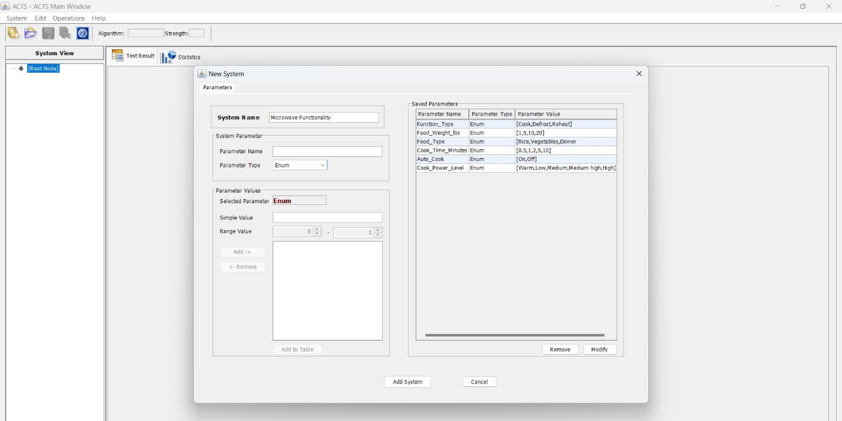

As we are using pairwise testing – selecting “Strength” as 2.

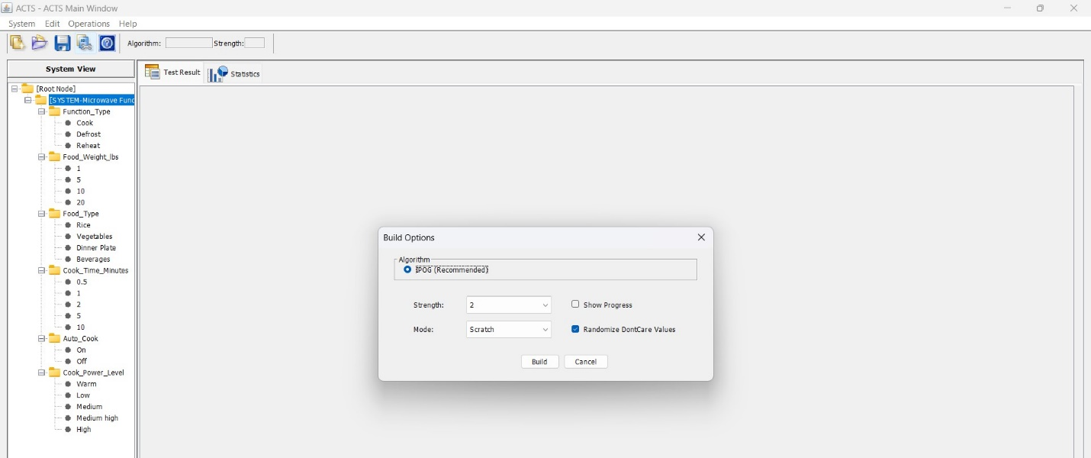ACTS tool generated 25 test cases which cover all possible pairwise combinations of values (levels) of given factors. From the coverage graph below, it seems that the tool used IPOG algorithm and went through 217 different combinations to conclude that 25 test cases are required to reach 1.0 coverage ratio (which is all possible pairwise combinations complete).

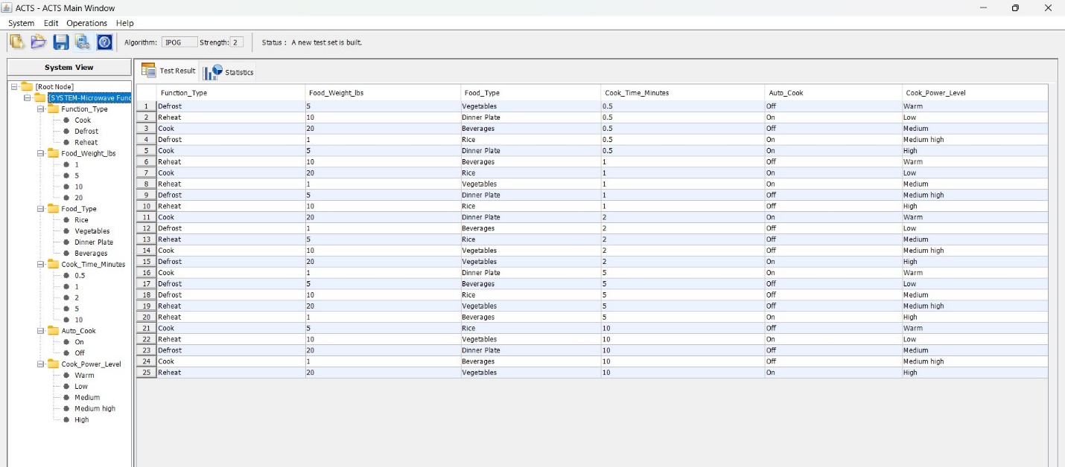

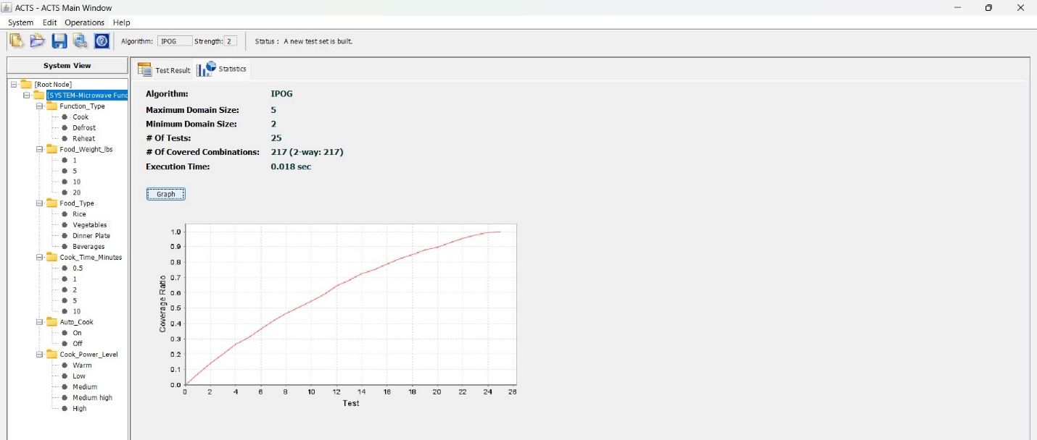

Pairwise testing is helpful in minimizing the test cases and it covers all parameter pairs at least once. It is effective to find bugs while testing the software. In this type of testing, the primary focus is to test all combinations of two variables at a time. It is unlike exhaustive testing where a lot of combinations are possible increasing the number of tests. For the above test cases generated by the tool, I have explained how it meets the pairwise testing combinations for factors of the microwave oven.

In the following screenshots, I have mapped and verified all pairwise combinations of different parameters and it satisfies 2-way coverage in 25 test cases generated by the tool.

**Note:** Color used for verifying pairwise combinations for below parameters.

Defrost-Blue, Reheat-Green, Cook-Yellow

1. Function Type| Food Weight | 2. Function Type| Food Type

3. Function Type| Cook Time (Min) | 4. Function Type| Auto Cook

5. Function Type| Cook Power Level

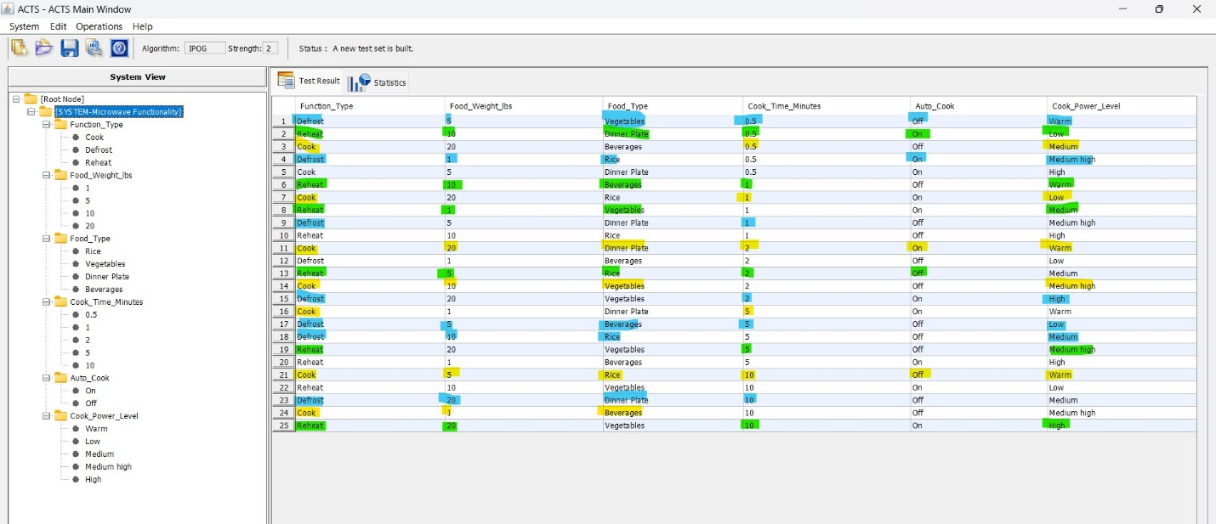

**Note:** Color used for verifying pairwise combinations for below parameters.

1 lbs.-Orange,5 lbs.-Blue, 20 lbs.-Green, 10 lbs.-Yellow

6.Food Weight (lbs) | Food Type | 7. Food Weight (lbs) | Cook Time (Minutes)

8. Food Weight (lbs) | Auto Cook | 9. Food Weight (lbs) | Cook Power Level

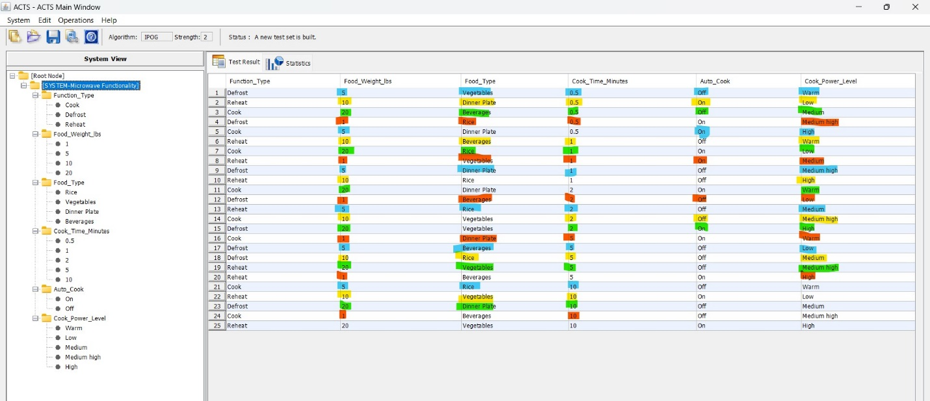

**Note:** Color used for verifying pairwise combinations for below parameters.

Beverages -Pink, Dinner Plate -Blue, Rice -Green, Vegetables-Yellow

10.Food Type |Cook Time (Minutes) | 11. Food Type | Auto Cook

12.Food Type |Cook Power Level

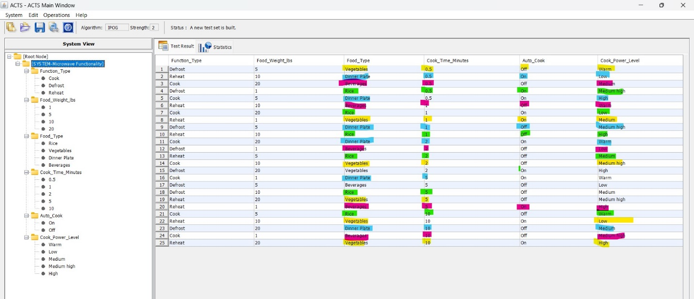

**Note:** Color used for verifying pairwise combinations for below parameters.

0.5 min -Blue, 1 min-Yellow, 2 min-Green ,5 min-Orange, 10 min-Pink

13.Cook Time (Minutes)|Auto Cook | 14. Cook Time (Minutes) |Cook Power Level

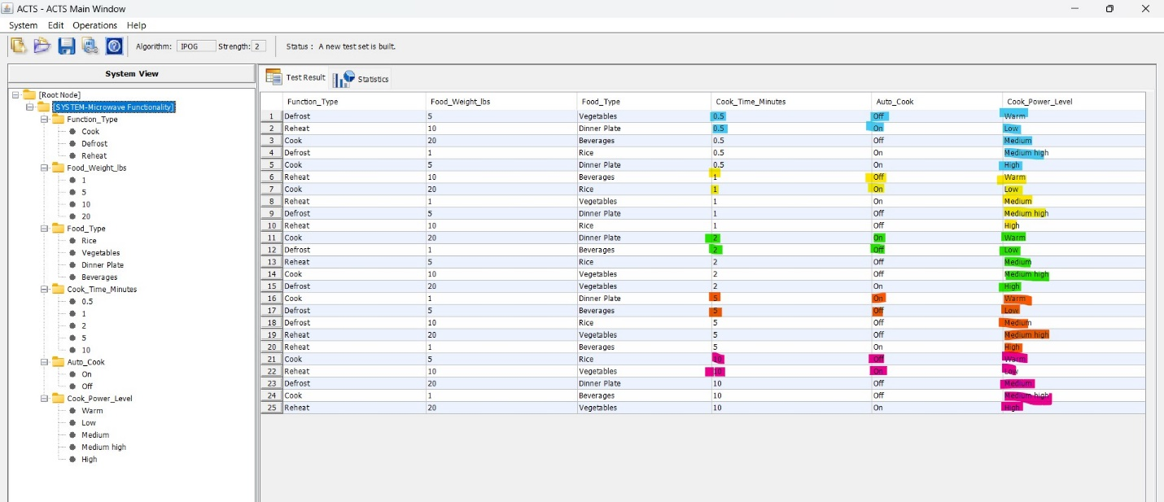

**Note:** Color used for verifying pairwise combinations for below parameters.

Auto cook Off-Green, Auto cook On-Yellow

15.Auto Cook |Cook Power Level

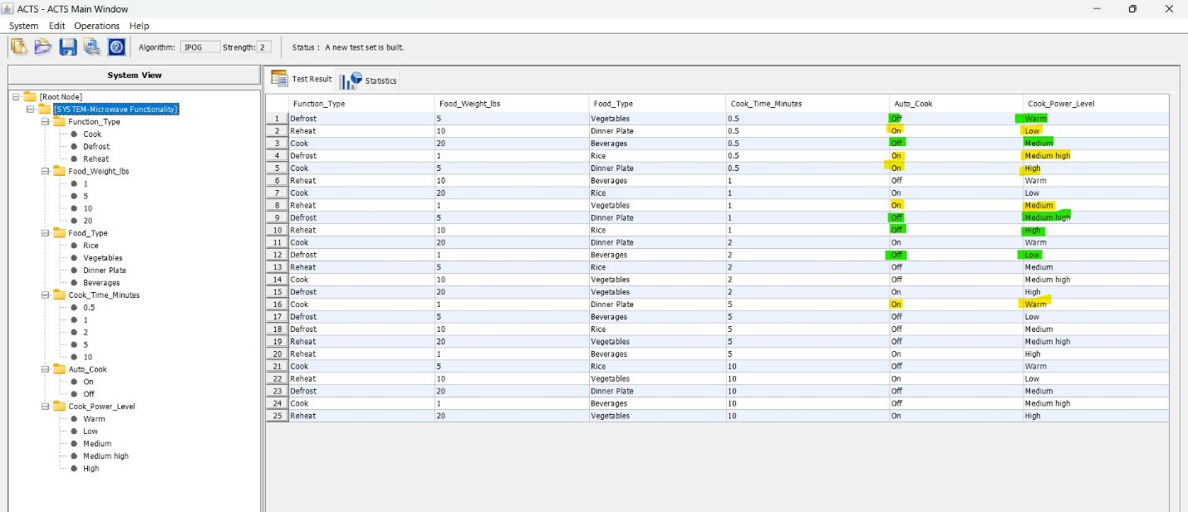

**Test cases**

Essential part in Design of experiment is writing constraints which prohibit combinations of partition which are practically not feasible, for “Microwave functionality” constraints are listed below:

1. When Cook Power Level is High and Function Type is Reheat and Cook Time Minutes is 10 then exclude such combination because as per the software specification (safety measure) and as per practical feasibility, it might burn the food.
2. If Function Type= Defrost and Food Type= Beverages, then exclude such combinations as mentioned in the software spec and doesn’t have any meaning practically for the microwave oven.

**Constraints:**

1. !(Cook_Power_Level ="High" && Function_Type ="Reheat" && Cook_Time_Minutes = "10")
2. !(Function_Type="Defrost" && Food_Type =" Beverages ")

After adding constraints, ACTS tool rearranged the testcase and generated 25 test cases. I choose to run below 25 test cases because they are practically feasible to run and have good coverage as shown in below coverage graph [5].

For some test cases, some of the parameter values could be a don’t care according to the specification. Although they are mentioned in the table generated by the tool, I have listed the test cases with only relevant input values according to the software specification to be tested.

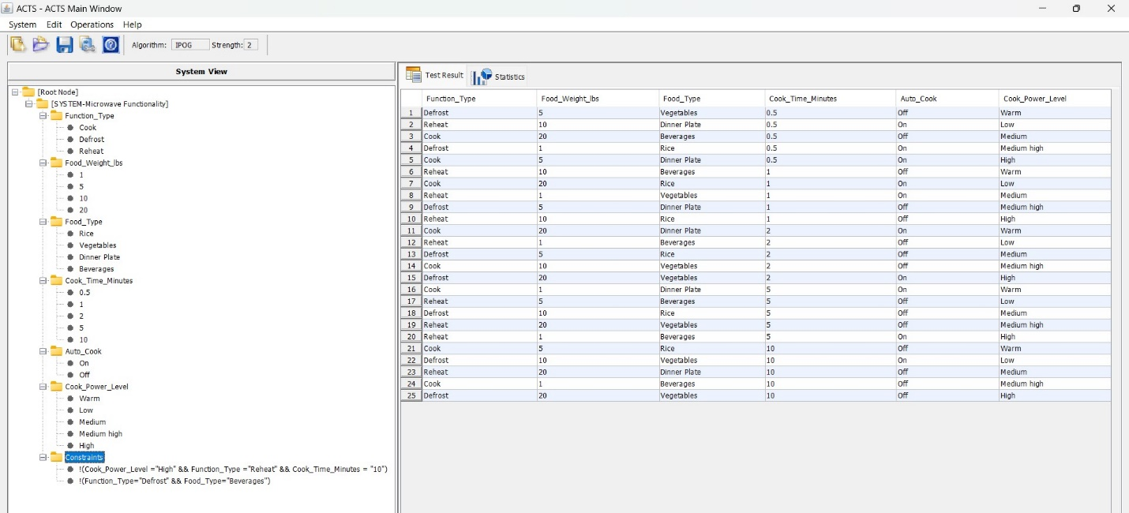**Coverage Graph:**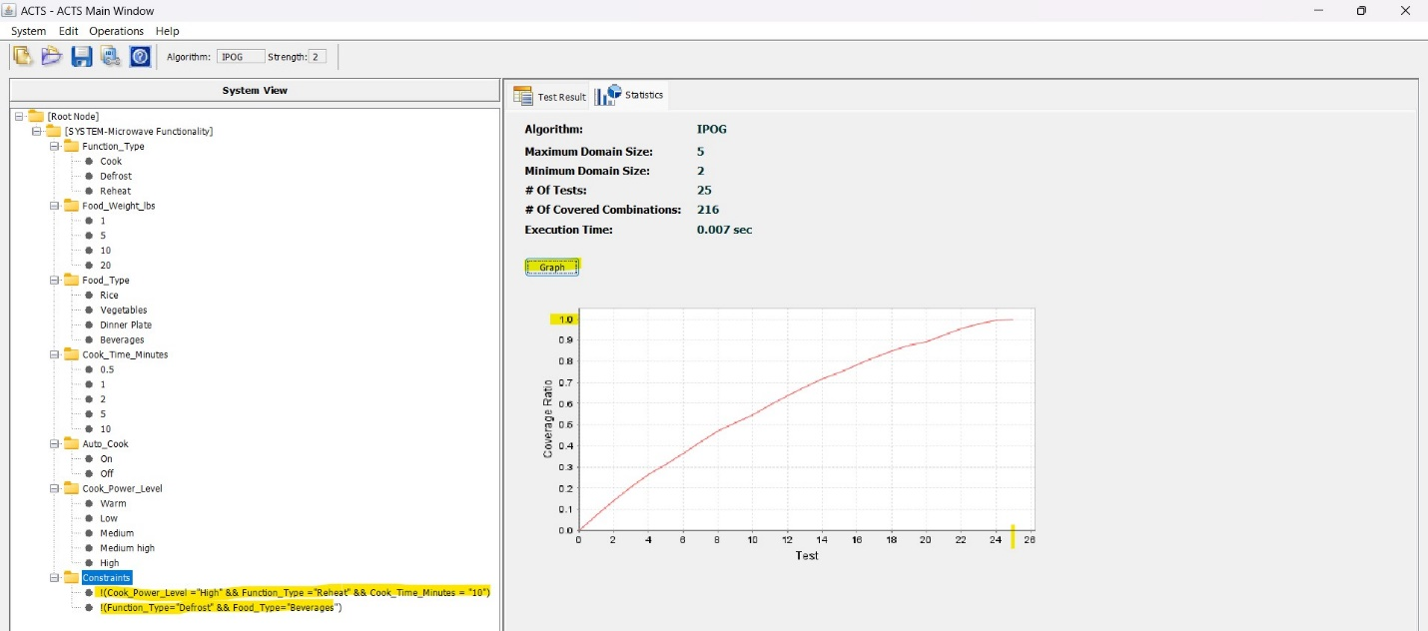

|  |  |
| --- | --- |
| Test Case Id | Description |
| TC001 | TC001_Verify microwave feature functioning properly when user select function as Defrost, set food weight as 5 lbs, select food category as Vegetables and set auto cook feature as Off. |
| TC002 | TC002_Verify microwave feature functioning properly when user select function as Reheat, set food weight as 10 lbs, select food category as Dinner Plate and set auto cook feature as On. |
| TC003 | TC003_Verify microwave feature functioning properly when user select function as Cook, set food weight as 20 lbs, select food category as Beverages, set cook time as 0.5 minute and set auto cook feature as Off. |
| TC004 | TC004_Verify microwave feature functioning properly when user select function as Defrost, select food category as, set food weight as 1 lbs and set auto cook feature as On. |
| TC005 | TC005_Verify microwave feature functioning properly when user select function as Cook, set food weight as 5 lbs. and select food category as Dinner Plate and set auto cook feature as On. |
| TC006 | TC006_Verify microwave feature functioning properly when user select function as Reheat, set food weight as 10 lbs, select food category as Beverages, set cook time as 1 minute and set auto cook feature as Off. |
| TC007 | TC007_Verify microwave feature functioning properly when user select function as Cook, set food weight as 20 lbs, select food category as Rice and set auto cook feature as On. |
| TC008 | TC008_Verify microwave feature functioning properly when user select function as Reheat, set food weight as1 lbs, select food category as Vegetables and set auto cook feature as On. |
| TC009 | TC009_Verify microwave feature functioning properly when user select function as Defrost, set food weight as 5 lbs, select food category as Dinner Plate and set auto cook feature as Off. |
| TC010 | TC010_Verify microwave feature functioning properly when user select function as Reheat, set food weight as 10 lbs, select food category as Rice, set cook time as 1 minute and set auto cook feature as Off. |
| TC011 | TC011_Verify microwave feature functioning properly when user select function as Cook, set food weight as 20 lbs, select food category as Dinner Plate and set auto cook feature as On. |
| TC012 | TC012_Verify microwave feature functioning properly when user select function as Reheat, set food weight as 1 lbs, select food category as Beverages, set cook time as 2 minute and set auto cook feature as Off. |
| TC013 | TC013_Verify microwave feature functioning properly when user select function as Defrost, set food weight as 5 lbs, select food category as Rice and set auto cook feature as Off. |
| TC014 | TC014_Verify microwave feature functioning properly when user select fuction as Cook, set food weight as 10 lbs, select food category as Vegetables, set cook time as 2 minutes and set auto cook feature as Off. |
| TC015 | TC015_Verify microwave feature functioning properly when user select function as Defrost, set food weight as 20 lbs, select food category as Vegetables and set auto cook feature as On. |
| TC016 | TC016_Verify microwave feature functioning properly when user select function Cook, set food weight as 1 lbs, select food category as Dinner Plate and set auto cook feature as On. |
| TC017 | TC017_Verify microwave feature functioning properly when user select function as Reheat, set food weight as 5 lbs, select food category as Beverages, set cook time as 5 minute and set auto cook feature as Off. |
| TC018 | TC018_Verify microwave feature functioning properly when user select function as Defrost, set food weight as 10 lbs, select food category as Rice and set auto cook feature as Off. |
| TC019 | TC019_Verify microwave feature functioning properly when user select fuction as Reheat, set food weight as 20 lbs,select food category as Vegetables, set cook time as 5 minute and set auto cook feature as Off. |
| TC020 | TC020_Verify microwave feature functioning properly when user select function as Reheat, set food weight as 1 lbs, select food category as Beverages and set auto cook feature as On. |
| TC021 | TC021_Verify microwave feature functioning properly when user select function as Cook, set food weight as 5 lbs, select food category as Rice, set cook time as 10 minute and set auto cook feature as Off. |
| TC022 | TC022_Verify microwave feature functioning properly when user select function as Defrost, set food weight as 10 lbs, select food category as Vegetables and set auto cook feature as On. |
| TC023 | TC023_Verify microwave feature functioning properly when user select function as Reheat, set food weight as 20 lbs, select food category as Dinner Plate, set cook time as 10 minute and set auto cook feature as Off. |
| TC024 | TC024_Verify microwave feature functioning properly when user select function as Cook, set food weight as 1 lbs, select food category as Beverages, set cook time as 10 minute and set auto cook feature as Off. |
| TC025 | TC025_Verify microwave feature functioning properly when user select function as Defrost, set food weight as 20 lbs, select food category as Vegetables and set auto cook feature as Off. |

**References:**

[1]. L. Yu, Y. Lei, R. N. Kacker and D. R. Kuhn, "ACTS: A Combinatorial Test Generation Tool," *2013 IEEE Sixth International Conference on Software Testing, Verification and Validation*, Luxembourg, Luxembourg, 2013, pp. 370-375, doi: 10.1109/ICST.2013.52.

[2]. R. Bartholomew, "Using Combinatorial Testing to Reduce Software Rework," *CrossTalk - The Journal of Defense Software Engineering*, vol. 27, no. 1, pp. 18-23, Jan./Feb. 2014.

[3]. NIST, "Downloadable Tools," Automated Combinatorial Testing for Software (ACTS), <https://csrc.nist.gov/Projects/automated-combinatorial-testing-for-software/downloadable-tools>.

[4]. Y. Lei, R. Kacker, D. R. Kuhn, V. Okun, and J. Lawrence, "IPOG: A general strategy for t-way software testing," in *Proceedings of the 14th Annual IEEE International Conference and Workshops on the Engineering of Computer-Based Systems (ECBS)*, Tucson, AZ, USA, 2007, pp. 549-556

[5]. "How to write test cases in Excel: A step-by-step guide," *Enterprise DNA Blog*. [Online]. Available: https://blog.enterprisedna.co/how-to-write-test-cases-in-excel-a-step-by-step-guide.