

**Khulna University of Engineering & Technology, Khulna**

**Department of Computer Science & Engineering**

Course No. - CSE 3104

Project Report on

**“Smart Car Parking System”**

**Submitted By**

Abu Noman Md. Sakib

Roll : 1607058

Section : A

Year : 3rd

Term :1st

Md. Badiuzzaman Shuvo

Roll : 1607043

Section : A

Year : 3rd

Term :1st

**ABSTRACT**

Smart car parking project aims at providing a confusion free and easy parking. This project helps the drivers of the cars to park their vehicles with minimum wastage of time with accurate information of the availability of the space to park It includes an Arduino Uno as the microcontroller unit to which the servo motors, LCD display ultrasonic sensors (HC-05) are interfaced. The LCD displays the availability of the space, the ultrasonic sensors keeps the check of the number of cars entering and exiting the parking space. The ultrasonic sensors detect the availability of the parking space.

**THEORY**

An automated car parking system is a process through which car parking can be done more efficiently and easily than manual method. The system will provide the user better services.

The system counts the number of cars in the garage and checks if there’s any vacancy. There’s an entry and exit path. When vehicle enters, the display shows the number of cars inside. When any vehicle leaves, the count decreases and shown on display. If the garage is full. The display will show a message regarding that.

This whole process includes the use of Arduino, Display and sonar. The sonar detects whether the vehicle is entering or leaving. The report then showed on display.

**Hardware Design**

Hardware equipment that we need in order to build the project are given below:

1. Arduino UNO
2. Ultrasonic Sensor
3. LCD Screen
4. Bread Board
5. Power Supply
6. Connecting Wires

**Block Diagram**

Block Diagram of our proposed system is given below :

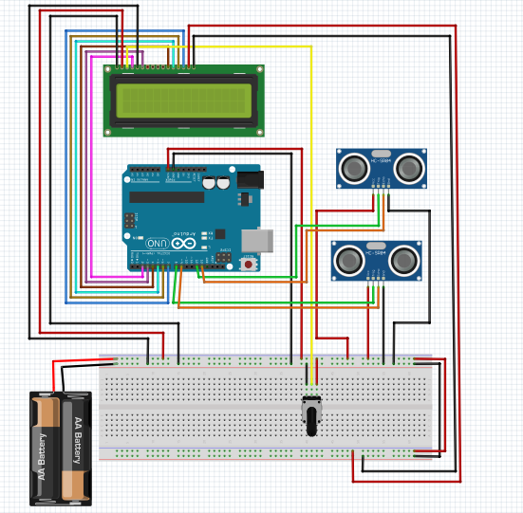

Figure-1 : Block diagram of Smart Car Parking System

**Pseudocode**

*include LiquidCrystal.h*

*trig_out := 12, ech_out := 13, trig_in := 8, ech_in := 9*

*d4 := 4, d5 := 5, d6 := 6, d7 := 7, rs := 2, en := 3*

*out := false, in := false, c_chg := true*

*count := 0, tr := 10, total := 10, wait := 0, wait_tr := 5*

*LiquidCrystal lcd(rs, en, d4, d5, d6, d7)*

*function setup()*

*pinMode trig_out to output*

*pinMode ech_out to input*

*pinMode trig_in to output*

*pinMode ech_in to input*

*end function*

*function loop()*

*set delay to 100ms*

*if d_out less than tr*

*if !out AND !in*

*out := true, wait := 0*

*end if*

*else if !out AND in*

*count--, in := false, c_chg := true*

*end if*

*end if*

*else if d_in less than tr*

*if !out AND !in*

*in := true, wait := 0*

*end if*

*else if out AND !in*

*count++, out := false, c_chg := true*

*end if*

*end if*

*if count less than 0*

*count := 0*

*end if*

*else if count greater than total*

*count := total*

*end if*

*if c_chg*

*lcd.clear()*

*if count greater or equal total*

*set lcd cursor to (0,0)*

*print “Garage is full!!" in lcd*

*set lcd cursor to (0, 1)*

*print "No new car entry" in lcd*

*end if*

*else*

*set lcd cursor to (0,0)*

*print vacancy/total in lcd*

*end if*

*c_chg = false;*

*end if*

*if in OR out*

*wait++*

*if count less than total*

*set lcd cursor to (0,0)*

*print “ ” in lcd*

*end if*

*end if*

*if wait greater than wait_tr*

*in := false, out := false, wait := 0*

*end if*

*if !in AND !out AND count less than total*

*set lcd cursor to (0,1)*

*print "Ready..." in lcd*

*end if*

*trig_out in LOW mode*

*set delay to 2ms*

*trig_out in HIGH mode*

*set delay to 10ms*

*trig_out in LOW mode*

*duration := pulseIn(HIGH to ech_out)*

*d_out := duration*0.034/2*

*trig_in in LOW mode*

*set delay to 2ms*

*trig_in in HIGH mode*

*set delay to 10ms*

*trig_in in LOW mode*

*duration := pulseIn(HIGH to ech_in)*

*d_in := duration*0.034/2*

*end function*

**Flow Chart**

The flow chart includes how the system works. The program flow chart is given below:

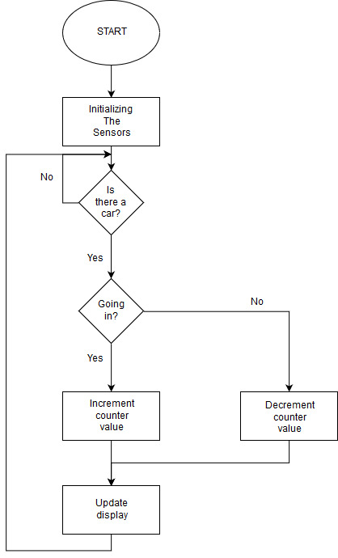

Figure-2 : Flow chart of Smart Car Parking System

**System Testing**

We have tested the design system with a dummy car. There are usually two possibilities.

* Entry : While entering, the car is noticed by the sonars. Firstly the outer sonar and then the inner sonar. The count increases and result is shown in display.
* Exit : In this case, Firstly the inner sonar notices and then the inner sonar. The count decreases and result is shown in display.

**Prototype**

A prototype was built under the system concepts. Figure-3 shows the built prototype at a glance.

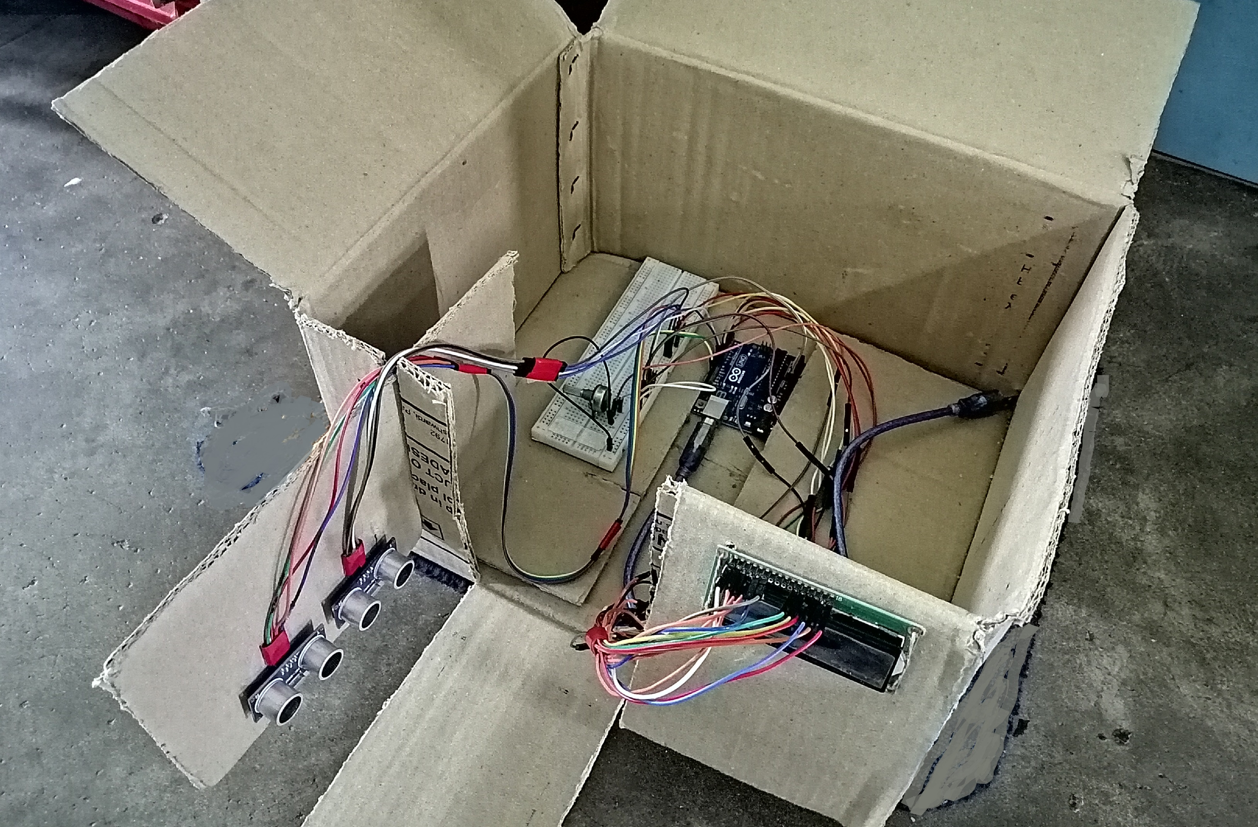

Figure-3 : Prototype of Smart Car Parking System

**Experimental Results**

We have experimented the system to gather some statistical results. After the experience, we have found the inner sonar and outer sonar works perfectly. As the result shows, the system is almost 100% correct. The whole experiment was done couple of times by us. Dummy cars were used. The prototype was not always correct due to the limitations of the use of low quality sensors. But the performance was satisfactory enough.

**References**

1. <https://www.engineersgarage.com/electronic-components/16x2-lcd-module-datasheet>
2. <https://store.arduino.cc/usa/arduino-uno-rev3>
3. <http://www.micropik.com/PDF/HCSR04.pdf>