# Portfolio Design

## Introduction

The Portfolio Design is a web application that works as a creative way to demonstrate and show the projects that you worked on. This application provides a platform to showcase your academic and professional experience with a creative twist. This application is more focused to exhibit the summary of different projects involved in by a backed developer.

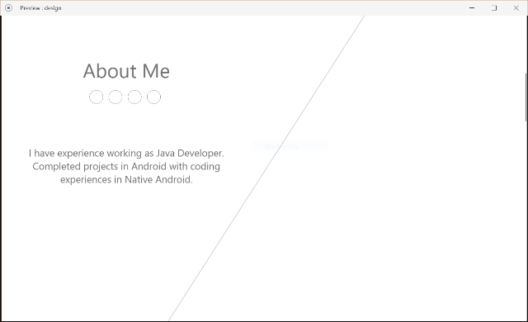 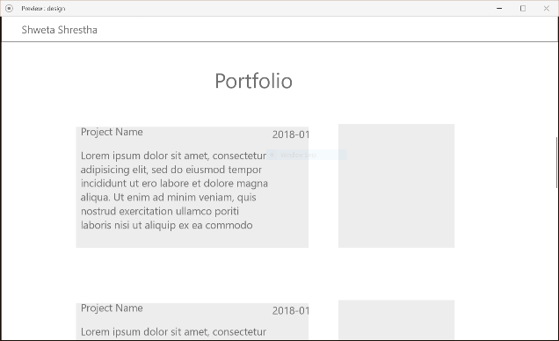

## Expected List of Features

* **Home**: This is the landing page which will contain a cover photo, profile picture and the title of the person.
* **About**: This section contains detailed description about the individual and a link to a traditional resume. This section will also contain links to social media for easy access.
* **Portfolio**: This section will showcase snapshots of different projects which will link to a descriptive version of the project.
* **Education and Work Experience**: The work experiences and academic certifications will be listed in this section.
* **Blog**: If the individuals have a blog or a separate site, this section will hold the snapshot and link to those sites.
* **Contact**: This section will contain the media through which the individual can be contacted.

## Market Survey

Following websites and templates were reviewed for design and concept inspirations. Most of the designs were minimal and focused more on providing a placeholder for the snapshots of previous projects for easy viewing. Following are some of the websites that stood out for me:

* [Freelancer Design](https://blackrockdigital.github.io/startbootstrap-freelancer/): This template shows a simple portfolio design that focuses more on graphical designs. The division of the page to simple and minimum sections was notable.
* [Grid Based Resume Design](https://neuethemes.net/preview/gridus/?page=layouts/mark/index.html): The use of grid formatted design to divide the page into sections makes the website more organized even with a lot of information.
* [Photographs Based Design](https://prothemereviewer.com/theme/sv-jaman/index-1.html#home): The use of creative photographs in different context as background images and cover pictures provides a different way of showcasing your products.

## References

* <https://neuethemes.net/preview/gridus/?page=layouts/mark/index.html>
* <https://prothemereviewer.com/theme/sv-jaman/index-1.html#home>
* <https://blackrockdigital.github.io/startbootstrap-freelancer/>
* <https://blackrockdigital.github.io/startbootstrap-creative/>
* <https://medium.freecodecamp.org/15-web-developer-portfolios-to-inspire-you-137fb1743cae>