# Portfolio Design

## Introduction

The Portfolio Design is a web application that works as a creative way to demonstrate and show the projects that you worked on. This application provides a platform to showcase your academic and professional experience with a creative twist. This application is more focused to exhibit the summary of different projects involved in by a backed developer.

## User Interface and Prototyping

The wireframe design was conceived keeping in mind the purpose of the portfolio. The design simply enhances the visuals thus making it easier for the viewer to follow the important details. The following wireframe was created using Adobe Indesign.

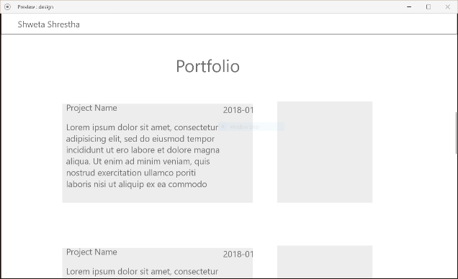 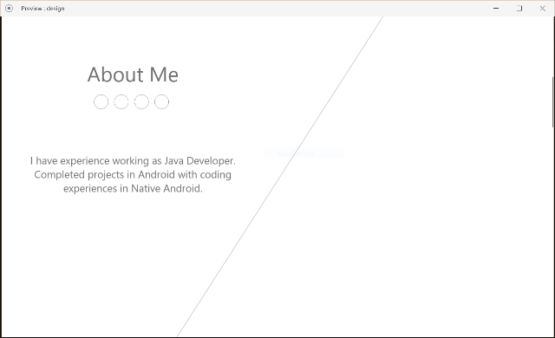

## Navigation Structure

The web page is designed to be a single page, however the list of sections will be available at the navigation bar. This will make it easier to navigate through the long page and contributing towards a better user experience.

## References

* <https://neuethemes.net/preview/gridus/?page=layouts/mark/index.html>
* <https://prothemereviewer.com/theme/sv-jaman/index-1.html#home>
* <https://blackrockdigital.github.io/startbootstrap-freelancer/>
* <https://blackrockdigital.github.io/startbootstrap-creative/>
* <https://medium.freecodecamp.org/15-web-developer-portfolios-to-inspire-you-137fb1743cae>