Performing crud operations in web form connecting it with sql server database

SQL database

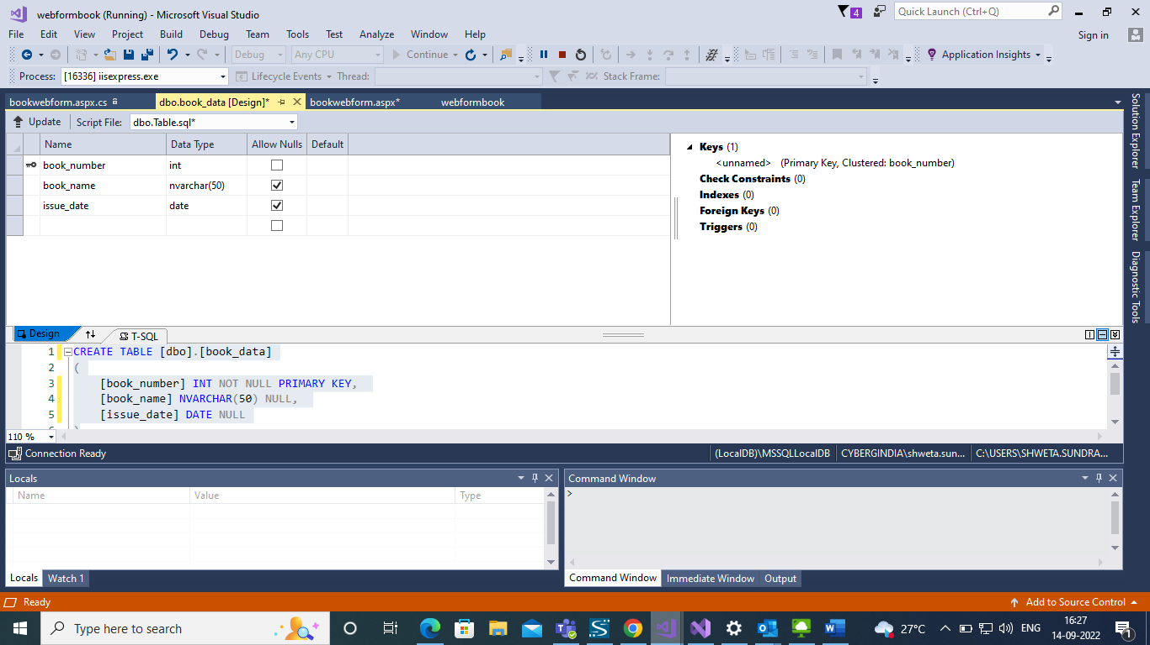

//web form overview

//inserted data in web form

//update the book_name having book_number=689

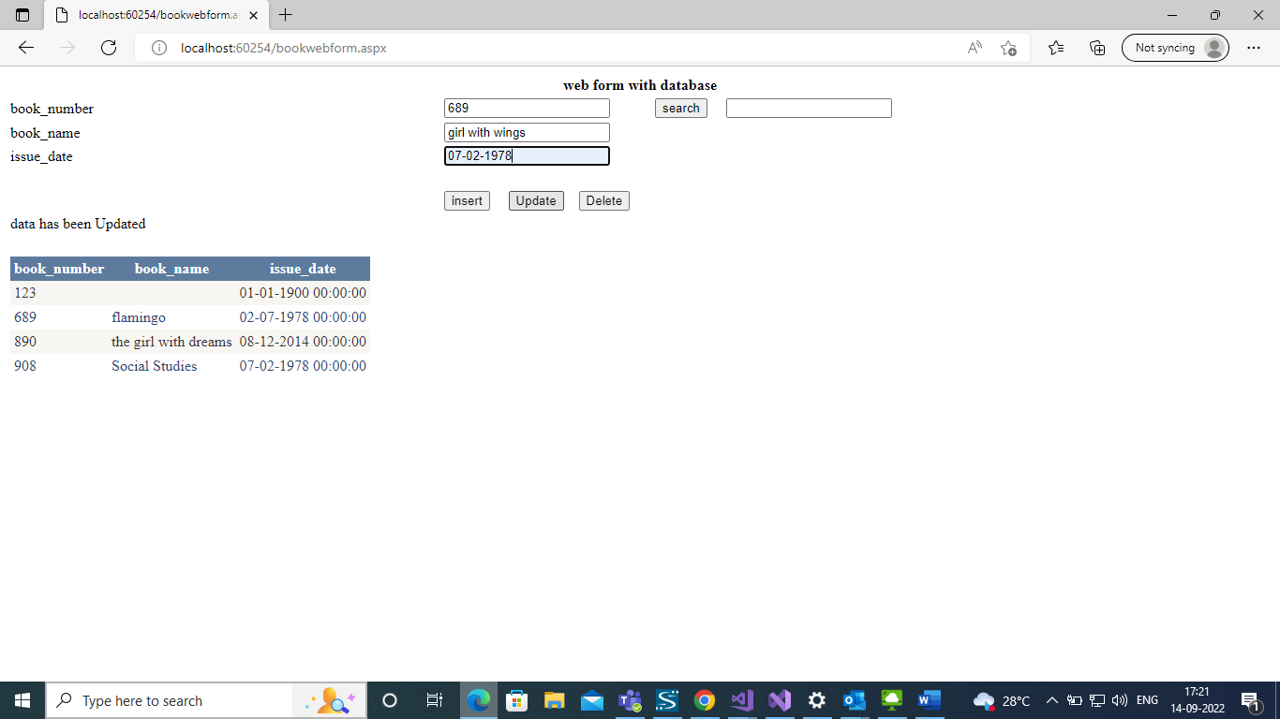

After updation

//deleting the book having book_number=123

//after deletion

//Searching the book with book_number=890

