**Items contain attributes and attributes contain information about an Item. At-  tributes can be controlled centrally at the Master Organization level or at the Inven-  tory Organization level.**

**Once the Item is created, we need to assign it to a category and an inventory organi-  zation.**

**For us to be able to perform transactions with the Item in the inventory, we need to  assign the Item to an inventory organization**

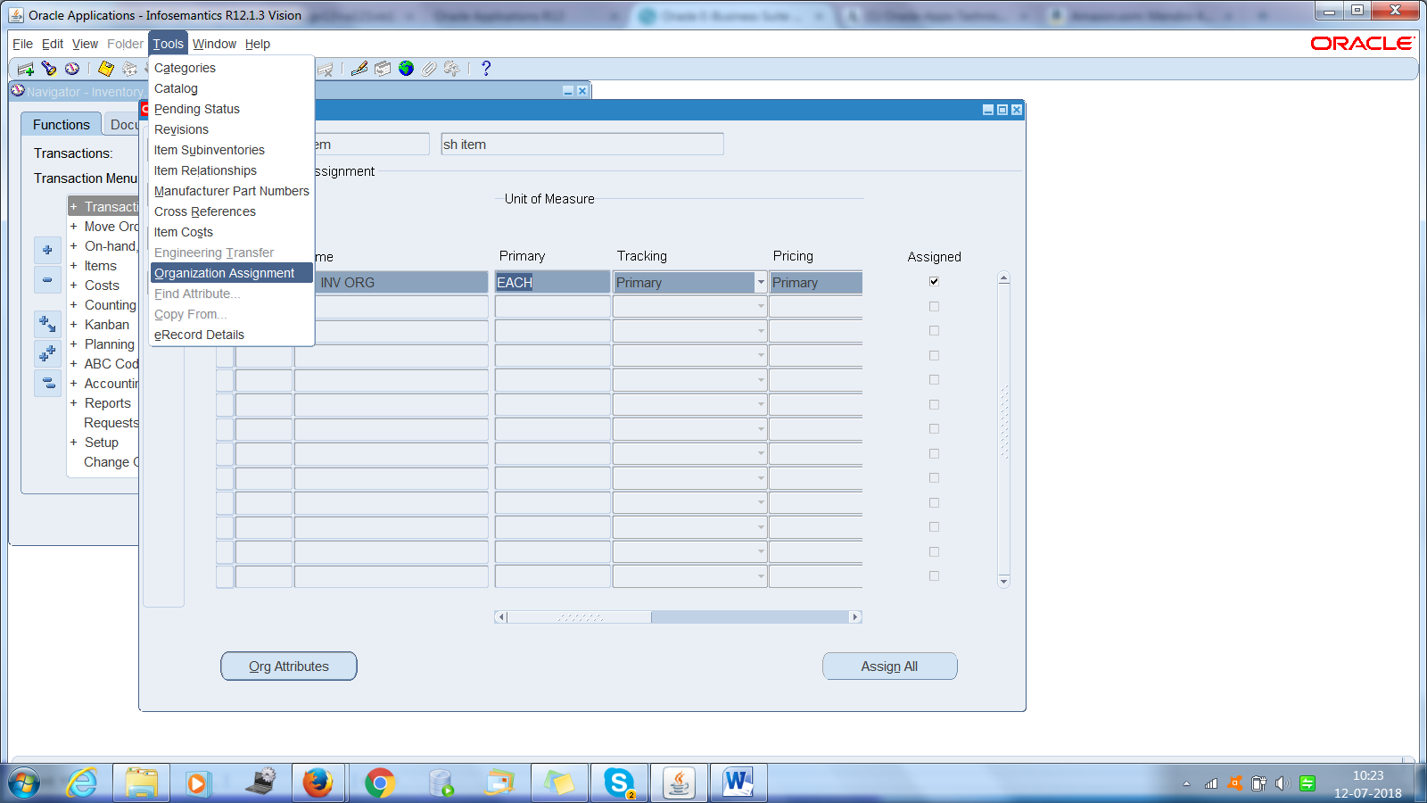

**The default value of the primary Unit of Measure (UOM) can be defined**

**in the INV: Default Primary Unit of Measure profile option.**

**The Primary UOM is the default  UOM used in other modules.**

**Cost of Goods Sold Account: The cost of goods sold account is en-**

**tered. This is a general ledger account. The value defaults from the  Organization parameters.**

**Create item template**

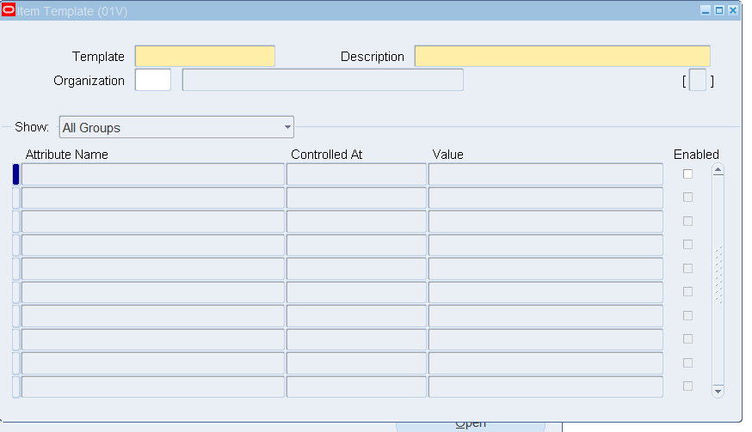

GL

We define currency in GL->setup->currency->define

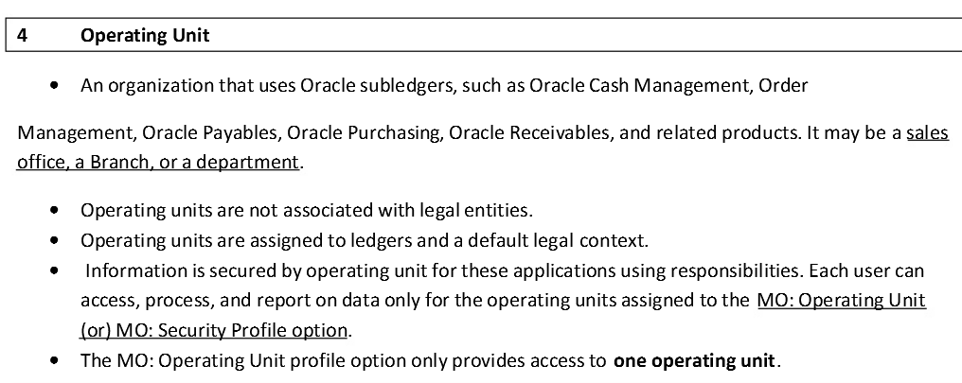

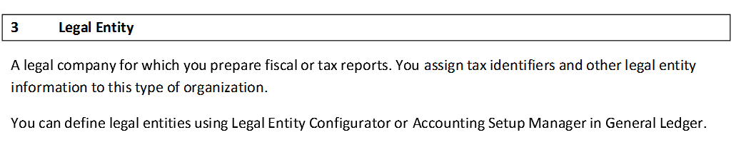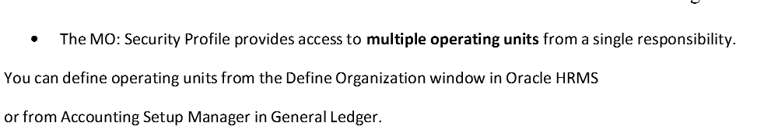

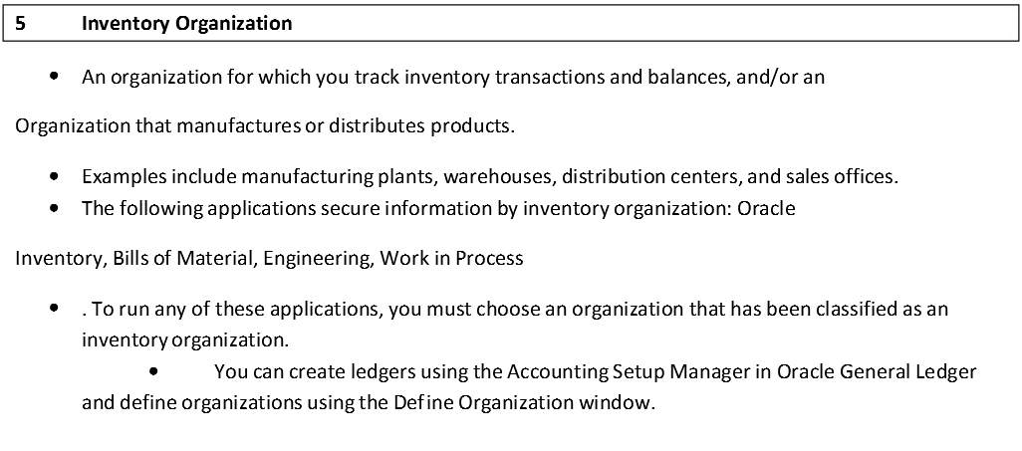

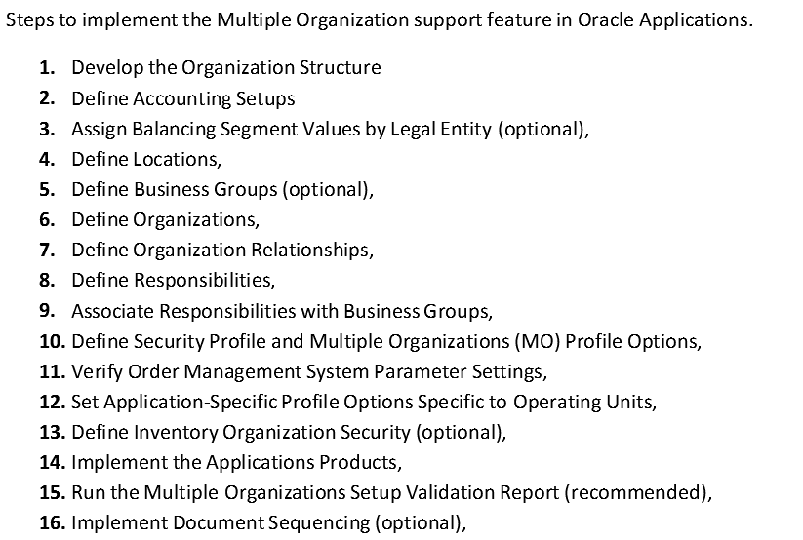

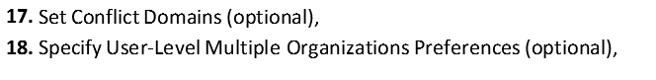

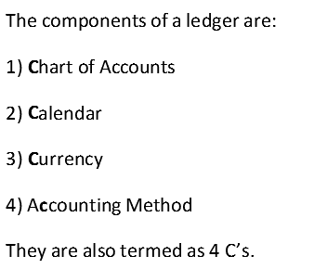

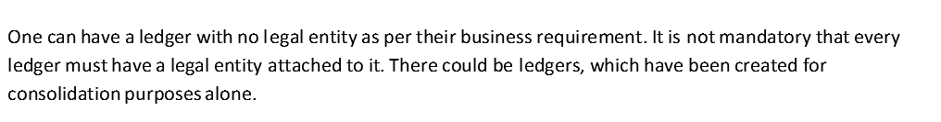

Pl/SQL

**Invisible indexes**

An invisible index is an index that is maintained by the database but ignored by the optimizer unless explicitly specified.

Starting in Oracle Database 12c, you can create two or more indexes with identical column lists. To do this only one of the indexes can be visible. The indexes must also differ on one or more of the following properties:

* B-tree versus bitmap
* Different partitioning strategies
* Unique versus non-unique
* A constant is a variable that is declared with the CONSTANT qualifier. The value of a constant may not be changed after it is initialized with the ":=" or "DEFAULT" clause from within the declaration of the constant. You *must* assign a value to the constant when it is declared.
* You can declare a constant in any sort of declaration section in a PL/SQL block, from anonymous block to package specification. Constants are, in fact, very often found in package specifications, since they can then serve as application-wide constants. Any schema with EXECUTE authority on the package will be able to reference the constants in that package.