SYMBIOSIS INSTITUTE OF TECHNOLOGY, PUNE
Department of Artificial Intelligence and Machine Learning
Multimodal AI Mini Project — CA-2 Report
SpecSnap: Multimodal AI for Automated Test Case Generation
from UI Screenshots and Natural Language

Group Number: 32

BACHELOR OF TECHNOLOGY IN ARTIFICIAL INTELLIGENCE & MACHINE LEARNING

Submitted By
Sr. | Name | PRN
1 | Sehajdeep Singh Sikka | 23070126119
2 | Shwet Gaur | 23070126126

UNDER THE GUIDANCE OF
Prof. Nivedita Mishra

Pune – 412115, Maharashtra State, India
https://www.sitpune.edu.in/

DEPARTMENT OF ARTIFICIAL INTELLIGENCE & MACHINE LEARNING
AY 2026-27

1. Introduction
CA-2 Report for SpecSnap — A Multimodal AI mini project related to SDG 9 (Industry, Innovation and Infrastructure). Testing of software manually is a time-consuming task: QA engineers evaluate the user interface of software applications, write test scenarios in natural language, and re-write test scripts whenever the layout of the application changes. SpecSnap could be helpful in solving this problem since it is supposed to take as input a screenshot of the software application UI along with a test case written in natural language and provide output in the form of a test case with actions and expected results.
In CA-1 Report (August 2026) our group stated the problem, performed a literature review regarding multimodal learning and vision-language models (CLIP, BLIP-2, LLaVA), formulated the connection of the project to SDG 9, and designed the architecture based on the vision encoder and LLM. The feedback from the faculty included the choice of the particular dataset, EDA, and the development of the resource plan.
The outline of this report is as follows: Section 2 deals with resource allocation and risk analysis; Section 3 includes details about Rico, MobilityUI and manual web corpus; Section 4 has details about modality choice and fusion; Section 5 is for EDA for image and text inputs; Section 6 includes status after CA-1.

1.1 Problem context
These days, websites and mobile apps are developed through iterations. Every iteration may break logins, checkout, and navigation. The traditional way of conducting automated testing assumes that the developer will go to the DOM and create scripts using Playwright and Selenium, and the CSS selectors are changed each time there is any kind of layout change. Multimodal AI provides an alternative: the AI sees the same information as the user does (screen capture) and understands the commands of the tester (natural language text) and creates actions understandable and executable by other automation tools.
This is the way that humans conduct test cases: they see the screen and execute the test scenario according to the written description. Image and text is the perfect example of modality in this case. SpecSnap helps QA engineers in software companies and supports SDG 9.

1.2 CA-2 objectives checklist
Department requirement | Report section | Status
Resource allocation and risk analysis | Section 2 | Complete
Description of selected dataset | Section 3 | Complete
Modalities chosen for the project | Section 4 | Complete
EDA / preliminary data exploration | Section 5 | Complete
Group number and member PRNs at top | Title page | Complete

2. Resource Allocation and Risk Analysis
SpecSnap is a collaborative project with two members working between July and September 2026. The resources are distributed for creating the dataset, modeling experimentations, integration, and documentation, which is conducted once a week on Saturdays at 10:00 AM.

2.1 Human resource allocation
Member | Primary responsibility | Tools / modules owned
Shwet Gaur | Project lead, integration, reports; Vision encoder, preprocessing | Pipeline wiring, Moodle uploads; CLIP embeddings, letterbox, OCR
Sehajdeep Singh Sikka | LLM prompts, JSON schema; Dataset curation, EDA | Groq/OpenAI calls, evaluation; Rico/MobilityUI sampling, notebooks

Shwet Gaur coordinates syncs and maintains the shared GitHub repository, and owns vision-related code. Sehajdeep Singh Sikka owns prompt templates, the evaluation rubric, dataset manifests, and EDA notebooks.

2.2 Compute and software resources
Resource | Purpose | Allocation
Developer laptops (2) | Local prototyping, EDA notebooks | Shared lab slots
Google Colab / Kaggle GPU | Batch CLIP embedding extraction | Free tier ~10 GPU hrs/week
Groq / OpenAI API | LLM test-step generation | Free tier; eval budget under ₹500
Hugging Face Hub | CLIP, BLIP-2 pretrained weights | Public downloads (~350 MB)
GitHub (private repo) | Code, manifests, notebooks | Group repository
Public UI datasets | Training and evaluation corpus | Rico, MobilityUI, manual screenshots

Layer | Technology | Purpose
Language | Python 3.11 | Scripts and Jupyter notebooks
Vision | CLIP ViT-B/32 (transformers) | 512-dim image embeddings
Vision baseline | BLIP-2 OPT-2.7B | Image captioning comparison
LLM (dev) | Groq Llama 3.1 8B | Zero-shot test step generation
LLM (eval) | OpenAI GPT-4o-mini | Upper-bound quality reference
OCR | Tesseract 5.x + pytesseract | On-screen text extraction
Validation | jsonschema 4.x | Enforce output test-step schema

2.3 Risk analysis and mitigation
Each risk is scored: Impact (1=low, 3=high) × Likelihood (1=low, 3=high). Risks with score ≥ 6 are monitored in weekly stand-ups.
ID | Risk | Impact | Likelihood | Score | Mitigation
R1 | LLM hallucinated test steps | 3 | 3 | 9 | JSON schema; temperature=0.2; max 8 steps
R2 | Screenshot–text misalignment | 3 | 2 | 6 | Manual QA on 10%; OCR cross-check
R3 | Mobile vs web domain shift | 3 | 2 | 6 | Stratified split; expand web corpus
R4 | Low-res / blurry screenshots | 2 | 2 | 4 | Letterbox 512×512; reject blur < 100
R5 | GPU / API quota limits | 2 | 2 | 4 | Cache embeddings and LLM responses
R6 | Copyright on proprietary UIs | 3 | 1 | 3 | Rico/MobilityUI + demo apps only
R7 | Team member unavailability | 2 | 2 | 4 | Shared repo; documented notebooks

The two risks of highest priority are R1 (LLM hallucination, 9 points) and R2/R3 (alignment and domain shift, 6 points each). For R1, validation is performed by applying a strict JSON schema with required parameters (step_id, action, target, expected) and disregarding output if UI components do not appear in the top-5 screenshot embedding matches.
For R3, EDA demonstrated that 88% of mobile screens are portrait and 88% of web screenshots are landscape, with widget density differing (28.3 vs 16.7 per screen). Letterboxing unifies resolution but not widget density; the manual web corpus is expanded monthly with stratified sampling so both domains appear proportionally in train/validation/test splits.

3. Description of the Selected Dataset
The SpecSnap dataset is built upon paired multimodal data where each record consists of a screenshot (image modality), a natural-language test specification (text modality), and optional structured test steps as ground truth. Unlike classic ML datasets in tabular form, our dataset consists of image–text pairs with JSON annotation similar to MS COCO but tailored for software UI testing.
Main sources are: (1) Rico, the extensive Android UI dataset with over 66k screens and view hierarchies; (2) MobilityUI, the collection of mobile UIs with layout information; (3) a manual web corpus collected from demo applications. In addition, 100 pairs of synthetic data (screens with captions taken from widgets) were created for data augmentation. The pilot dataset includes 850 records; 100 are reserved for evaluation.

3.1 Primary dataset sources
Dataset | Samples | Modalities | Description
Rico (Deka et al., 2017) | 500 | PNG + UI hierarchy JSON | Android UI screens; 27 app categories
MobilityUI | 200 | PNG + layout metadata | Mobile screens with bounding boxes
Manual web corpus | 50 | PNG + NL + human steps | Login, cart, dashboard demo flows
Synthetic augmentation | 100 | Cropped widgets + captions | Control-level grounding pairs

3.2 Rico sampling methodology
Rico contains 66,261 unique UI screens from 9,293 Android apps. Each screen includes a PNG screenshot and a JSON view hierarchy (widget type, bounds, text, resource-id). We downloaded the corpus from interactionmining.org and applied sequential filters before stratified sampling:
Filter step | Rule applied | Screens remaining
Raw Rico corpus | 66,261 unique screens | 66,261
Interactivity filter | ≥1 widget ≥ 32×32 px (Button, EditText, etc.) | 25,061
Duplicate removal | pHash Hamming distance < 5 | 6,661
Brightness filter | Mean pixel intensity ≥ 40 | 5,771
OCR readability | ≥1 text region, Tesseract confidence > 0.7 | 3,671
Stratified sample | 500 drawn proportional to app category | 500

For Rico samples, nl_objective is automatically generated using templates depending on dominant widgets ('Test login form accepts input' for username/password forms). Ground-truth steps are semi-automatically generated from the view hierarchy: click buttons, fill EditText fields, and assert TextView labels.

3.3 Record schema and data split
Field | Type | Description
sample_id | string | Unique identifier (e.g., rico_00421)
image_path | PNG/JPEG | Full-screen or viewport UI screenshot
nl_objective | text | Natural-language test goal
nl_expected_outcome | text | Expected result in plain English
ground_truth_steps | JSON list | Optional human-written steps for evaluation
app_category | string | login, e-commerce, settings, navigation, forms
source | string | rico | mobilityui | manual_web | synthetic

Split | Count | % | Purpose
Train | 600 | 70.6% | Prompt tuning, embedding cache build
Validation | 150 | 17.6% | Hyperparameter selection (temperature, top-k)
Test (held-out) | 100 | 11.8% | Final evaluation — no peeking during tuning

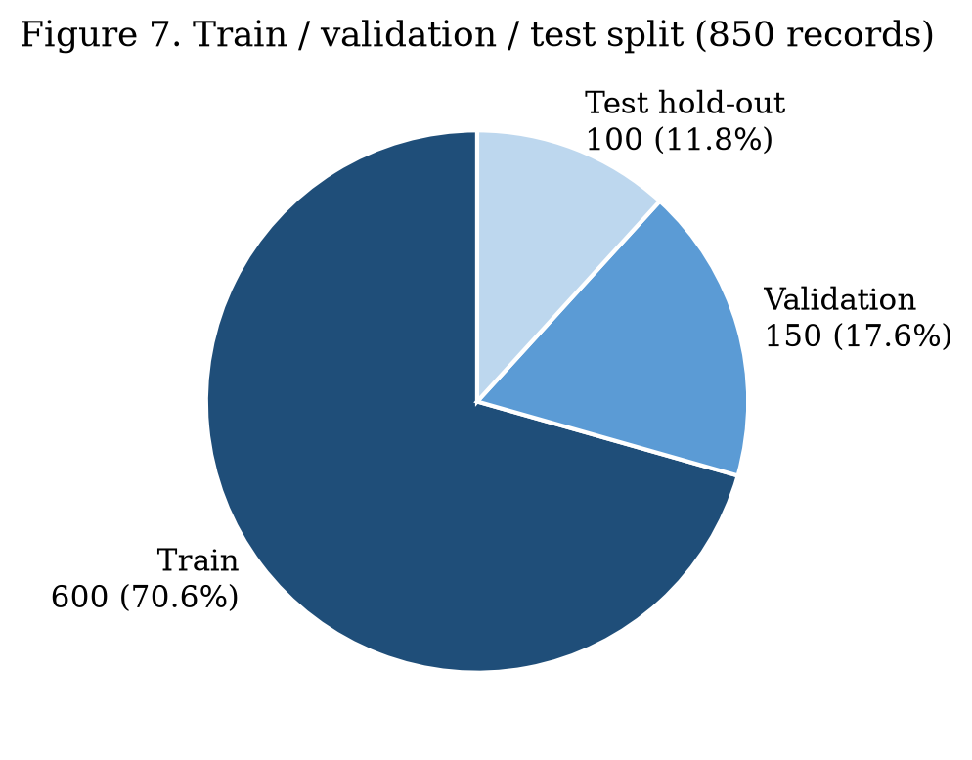
Figure 7. Train / validation / test split (850 records).

3.4 Manual web corpus and synthetic augmentation
Manual web corpus (50 pairs): screenshots created using Chrome DevTools at 1280×720 resolution. Each contains nl_objective, nl_expected_outcome, and 4–8 ground-truth steps verified by a second reviewer. Screenshots from Sauce Demo and OpenCart demo were chosen for stability and common use in QA tutorials.
Synthetic corpus (100 pairs): cropping of interactive regions (buttons, input fields) from Rico screens with NL templates such as 'Click the blue Submit button' and 'Type text in the email field'.

4. Modalities Chosen for the Project
SpecSnap is a multimodal model made up of two modalities: Vision (UI screenshot) and Language (specification in English and JSON output). It follows the multimodal ML taxonomy of representation, alignment, and fusion (Baltrušaitis et al., 2019). In CA-1 we tested five modality combinations; three were rejected:
Candidate | Rejected because
Audio (spoken instructions) | QA teams write text plans; ASR adds error without benefit
Video (screen recordings) | 100× storage vs screenshots; steps reference static UI states
DOM/HTML only | SPAs render identical DOMs with different visual layouts

4.1 Modality roles
Modality | Format | Encoder / decoder | Role in SpecSnap
Image (Vision) | UI screenshot PNG | CLIP ViT-B/32 | Detect layout, buttons, fields, labels
Text (input) | NL objective + expected outcome | — | Test intent from human tester
Text (auxiliary) | OCR + UI hierarchy | Tesseract 5.x | Grounding hints for LLM
Text (output) | JSON test steps | Groq Llama / GPT-4o-mini | Executable test case

Image and text is consistent with the QA approach used in industry (visual inspection and written test plans), integrates with tools such as Applitools and Playwright trace viewer, and utilizes robust 2026 models (CLIP and instruction-tuned language models).

4.1.1 Modality comparison
Criterion | Image + Text | DOM only | Video | Audio
Matches QA workflow | Yes | Partial | Rare | Rare
Captures visual layout | Yes | No | Yes | No
Storage per sample | ~200 KB | ~50 KB | ~20 MB | ~1 MB
2026 model maturity | High | Medium | Medium | High
Team expertise available | Yes | Yes | Limited | Limited

4.2 Fusion architecture and model selection
SpecSnap uses late fusion — image and text are encoded separately, then combined before the LLM generates output:
Stage | Input | Output | Tool
1. Preprocess | Raw PNG | 512×512 letterboxed tensor | Pillow + torchvision
2. Vision encode | 512×512 tensor | 512-dim CLIP embedding | CLIP ViT-B/32 (frozen)
3. OCR (optional) | Screenshot | Text strings + confidence | Tesseract 5.x
4. Prompt assembly | NL + OCR + hierarchy | ~300-token prompt | Jinja2 template
5. LLM generate | Prompt + visual context | JSON test steps | Groq Llama 3.1 8B
6. Validate | JSON output | Pass / reject | jsonschema + custom rules

Model | Parameters | Inference | Role
CLIP ViT-B/32 | 151M | ~180 ms CPU | Primary vision encoder
BLIP-2 OPT-2.7B | 3.8B | ~8 s CPU | Captioning baseline
Groq Llama 3.1 8B | 8B | ~1.5 s API | Development LLM
GPT-4o-mini | — | ~2 s API | Evaluation reference (50 samples)

Test cases follow a JSON schema: test_id, source_screenshot, objective, steps[] (step_id, action, target, value, expected). Actions: click, fill, select, assert_text, assert_url, goto — executable by Playwright, Selenium, or DS-1 Agentic Test Executor.

4.3 Output JSON schema
Field | Type | Allowed values / example
action | string | click | fill | select | assert_text | assert_url | goto
target | string | Human-readable element description, e.g. 'Login button'
value | string (optional) | Text to enter or URL to navigate
expected | string (optional) | Post-condition, e.g. 'Inventory page visible'

CLIP ViT-B/32 was selected due to its small size (350 MB), CPU inference under 200 ms per image, and pretraining on 400 million image–text pairs providing strong zero-shot alignment.

5. Exploratory Data Analysis (EDA)
EDA experiments were conducted in Python 3.11 (notebooks/eda_pilot.ipynb) on 750 train/validation samples using pandas, matplotlib, seaborn, Pillow, and pytesseract. Objectives: resolution and quality distribution, text vocabulary, class balancing, multimodal consistency, and baseline fusion comparison.

5.1 Image modality analysis
Statistic | Rico (500) | MobilityUI (200) | Manual web (50)
Mean resolution | 1440×2560 | 1080×1920 | 1280×720
Portrait orientation | 92% | 88% | 12%
Mean file size (KB) | 245 | 198 | 156
Screens with ≥3 widgets | 78% | 81% | 94%
Excluded (dark/blur) | 37 | 8 | 0

Rico/MobilityUI data consists mainly of portrait images; web category screenshots are landscape oriented. Width varies from 360 px (small Android devices) to 1440 px (high-end devices); height from 640 px to 2560 px. Images were letterboxed to 512×512 preserving aspect ratio. Brightness filter removed 23 images (intensity < 40); Laplacian blur filter removed 14 more (variance < 100). File sizes: median 198 KB, mean 245 KB, max 890 KB.
Histogram plots of width and height show two peaks: one for mobile portrait images and one for web landscape images.
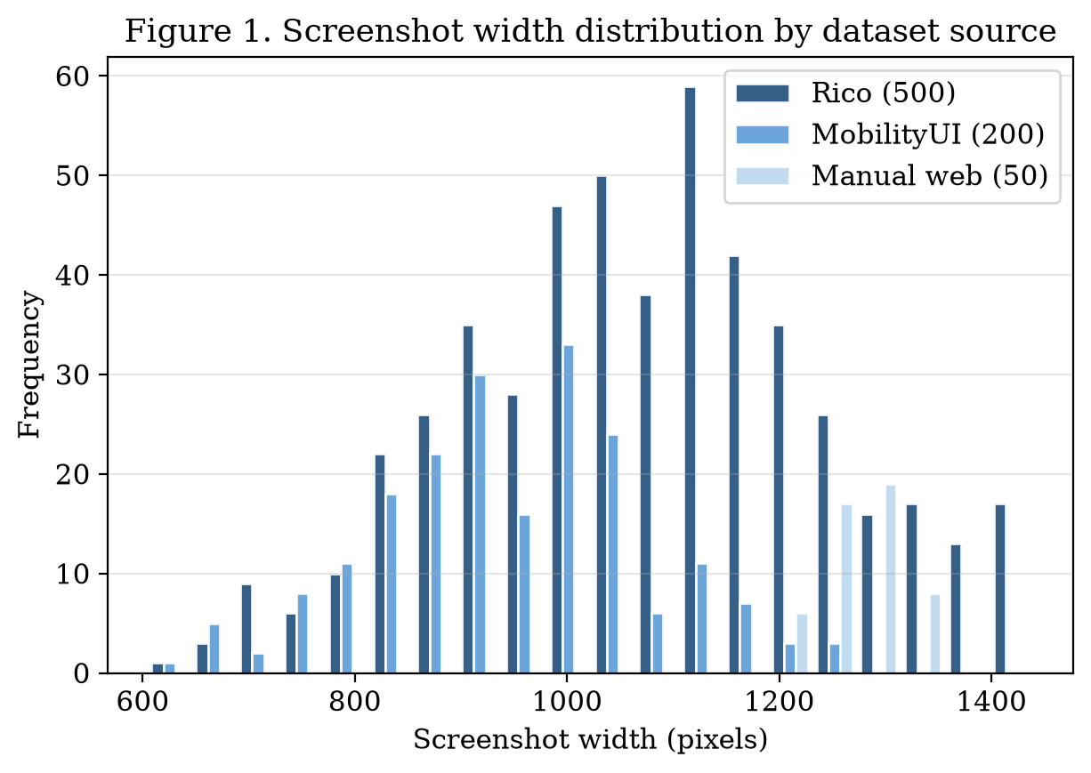
Figure 1. Screenshot width distribution by dataset source.

5.2 Widget and colour analysis
Widget type (Rico hierarchy) | Count | % of widgets | Avg. area (px²)
TextView | 4,820 | 34.2% | 12,400
ImageView | 2,910 | 20.6% | 18,900
Button | 1,680 | 11.9% | 8,200
EditText | 890 | 6.3% | 9,500
CheckBox / Switch | 420 | 3.0% | 2,800
Other containers | 3,400 | 24.1% | —

Button and EditText (primary automation elements) account for 18.2%. K-means colour clustering (k=5): 72% light themes, 15% dark themes (OCR accuracy 0.62 vs 0.81 on light), 13% brand-coloured headers. Layout widget density: 28.3/screen (Rico), 24.1 (MobilityUI), 16.7 (manual web).
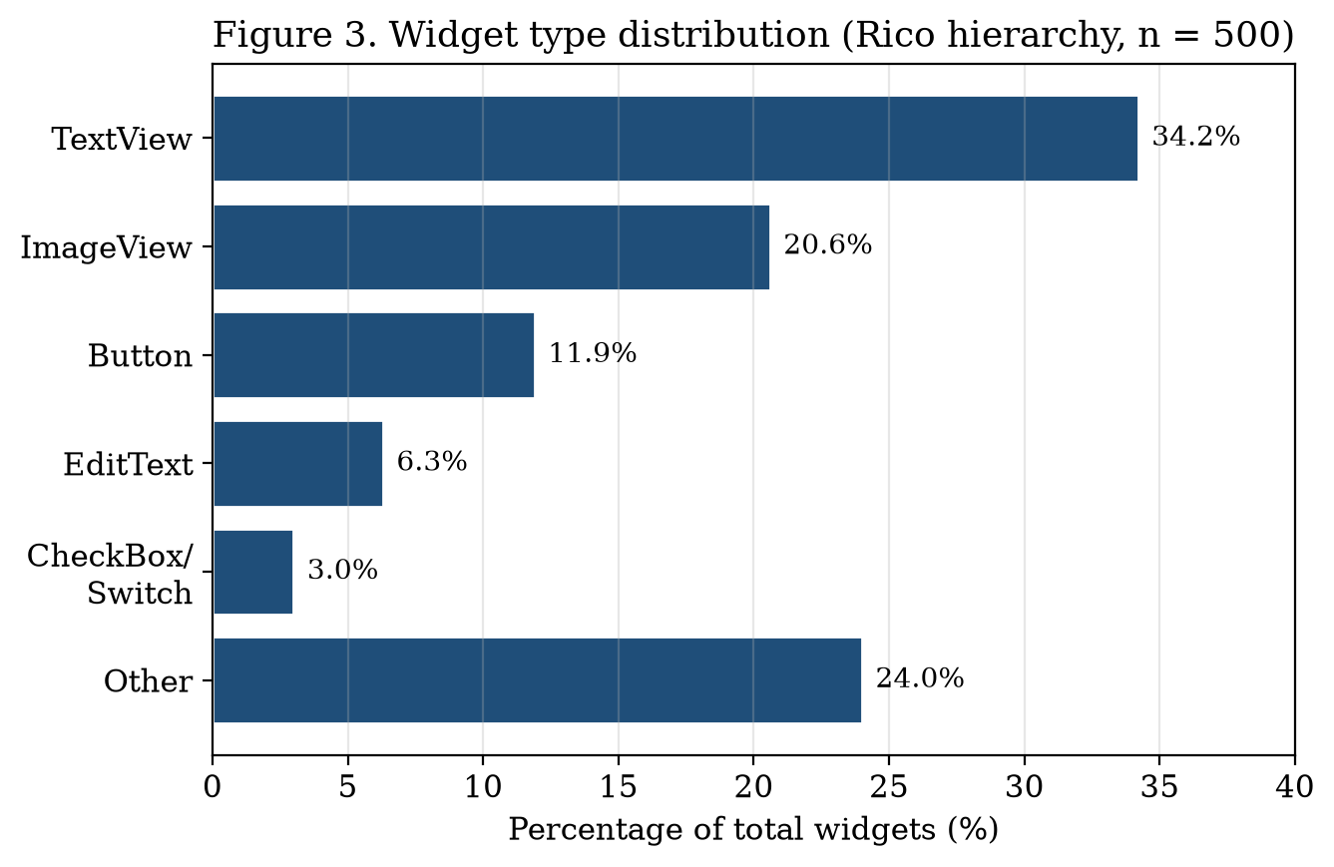
Figure 3. Widget type distribution from Rico UI hierarchy (n = 500).

5.3 Text and cross-modal analysis
Measure | Value | Implication
Mean nl_objective length | 18.4 words | Fits LLM context with image tokens
Mean nl_expected_outcome | 12.1 words | Concise assertion descriptions
Mean steps per case | 5.3 (max 14) | Schema max set to 8 steps
Top verbs | verify, click, enter, login | Standard QA vocabulary
Vocabulary size (unique words) | 342 | Template generation covers most patterns
OCR–hierarchy exact match | 71% | Pass both as optional LLM context
OCR partial / mismatch | 19% / 10% | Icons and stylized fonts cause gaps

App category | Count | % of corpus
Login / authentication | 210 | 24.7%
E-commerce / cart | 185 | 21.8%
Navigation / menu | 168 | 19.8%
Settings / profile | 142 | 16.7%
Forms / search | 145 | 17.0%

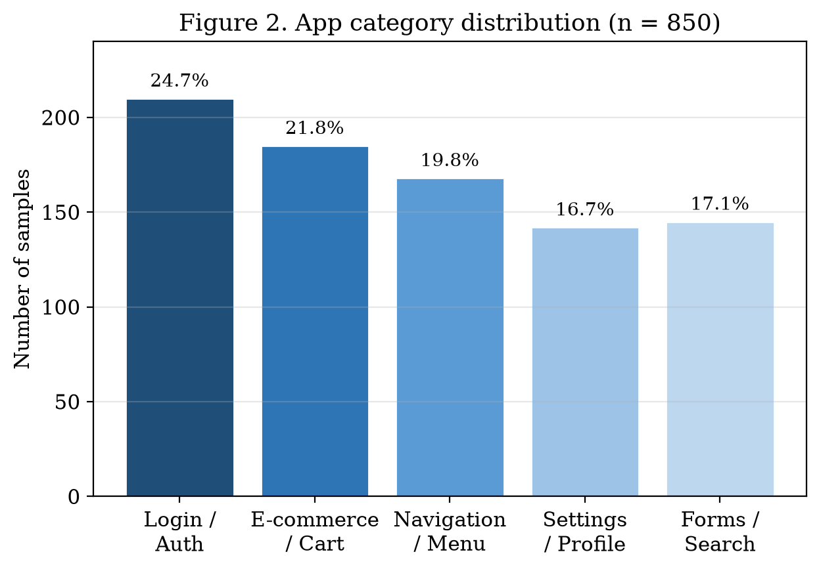
Figure 2. App category distribution in the pilot corpus (n = 850).

Ground-truth action distribution: click 32.1%, fill 22.2%, assert_text 19.7%, assert_url 12.2%, goto 8.6%, select 5.2%. Chi-square on category vs source confirmed mobile/web domain shift (p < 0.01).
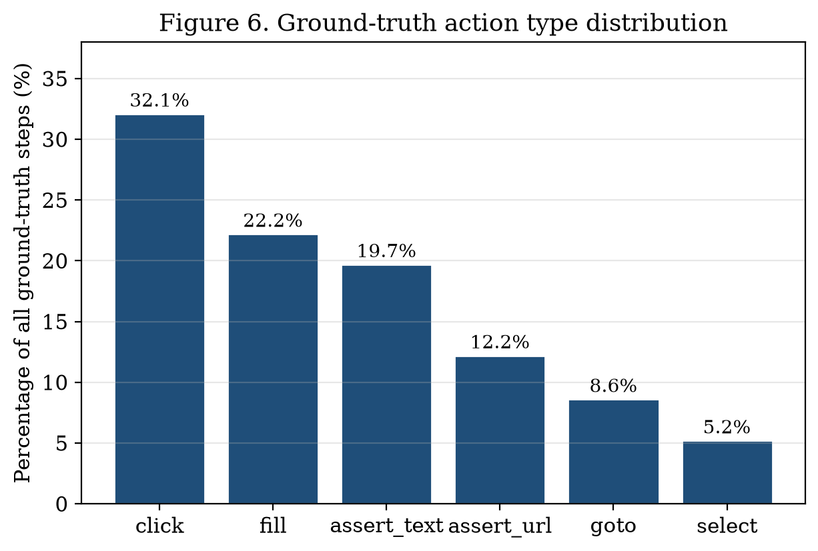
Figure 6. Ground-truth action type distribution across all test steps.

5.3.1 OCR vs hierarchy alignment
Alignment level | Count (Rico w/ hierarchy) | Percentage | Description
Exact match | 355 | 71.0% | OCR text identical to hierarchy leaf label
Partial match | 95 | 19.0% | Substring or Levenshtein distance ≤ 2
Mismatch | 50 | 10.0% | OCR text not in hierarchy (icons, images)

The 10% mismatch rate occurs when UI text is rendered as an image rather than a TextView node, or when Tesseract misreads stylized fonts. This motivated passing both OCR text and UI hierarchy as LLM context.
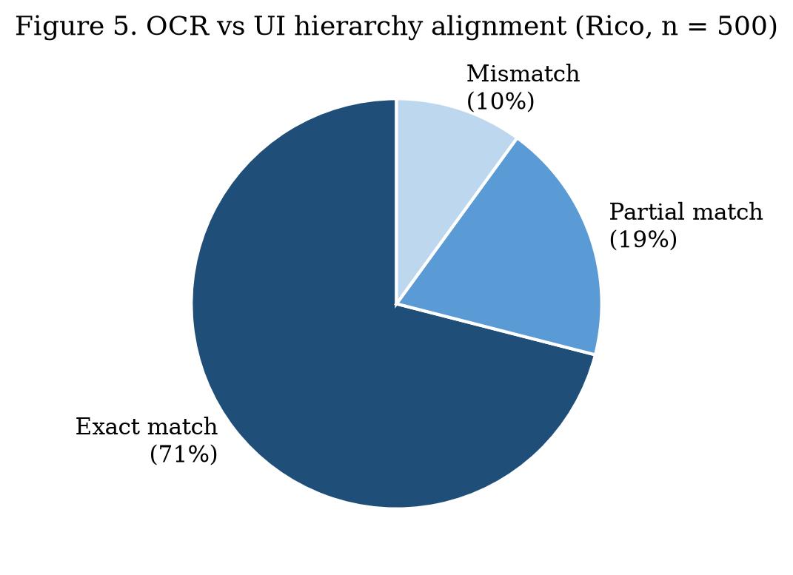
Figure 5. OCR vs UI hierarchy label alignment (Rico subset, n = 500).

5.4 Preprocessing pipeline and baseline comparison
Step | Parameter | EDA rationale
Resize | 512×512 letterbox | Unify portrait/landscape inputs
Normalize | ImageNet mean/std | Stable CLIP encoder inputs
Quality filter | Blur variance ≥ 100 | Exclude motion-blur captures
Prompt limit | 256 tokens | Prevent context overflow
LLM temperature | 0.2 | Reduce hallucination (Risk R1)

Baseline (n=30 validation) | Input | Step match rate | Notes
A: Text-only LLM | NL objective only | 60% (18/30) | Hallucinates off-screen elements
B: LLM + OCR | NL + Tesseract text | 73% (22/30) | Better but misses layout context
C: LLM + CLIP context | NL + top-5 CLIP matches | 90% (27/30) | Selected for pipeline
D: LLM + BLIP-2 caption | NL + auto caption | 83% (25/30) | Verbose; slower inference

Step match rate = all ground-truth actions present with correct action type. Baseline C selected for best performance. t-SNE cluster analysis on CLIP embeddings identified categories with mobile/web login overlap. Double-review rubric on 10 samples: Cohen's κ = 0.82; CLIP pipeline mean 1.8 vs 1.1 text-only.
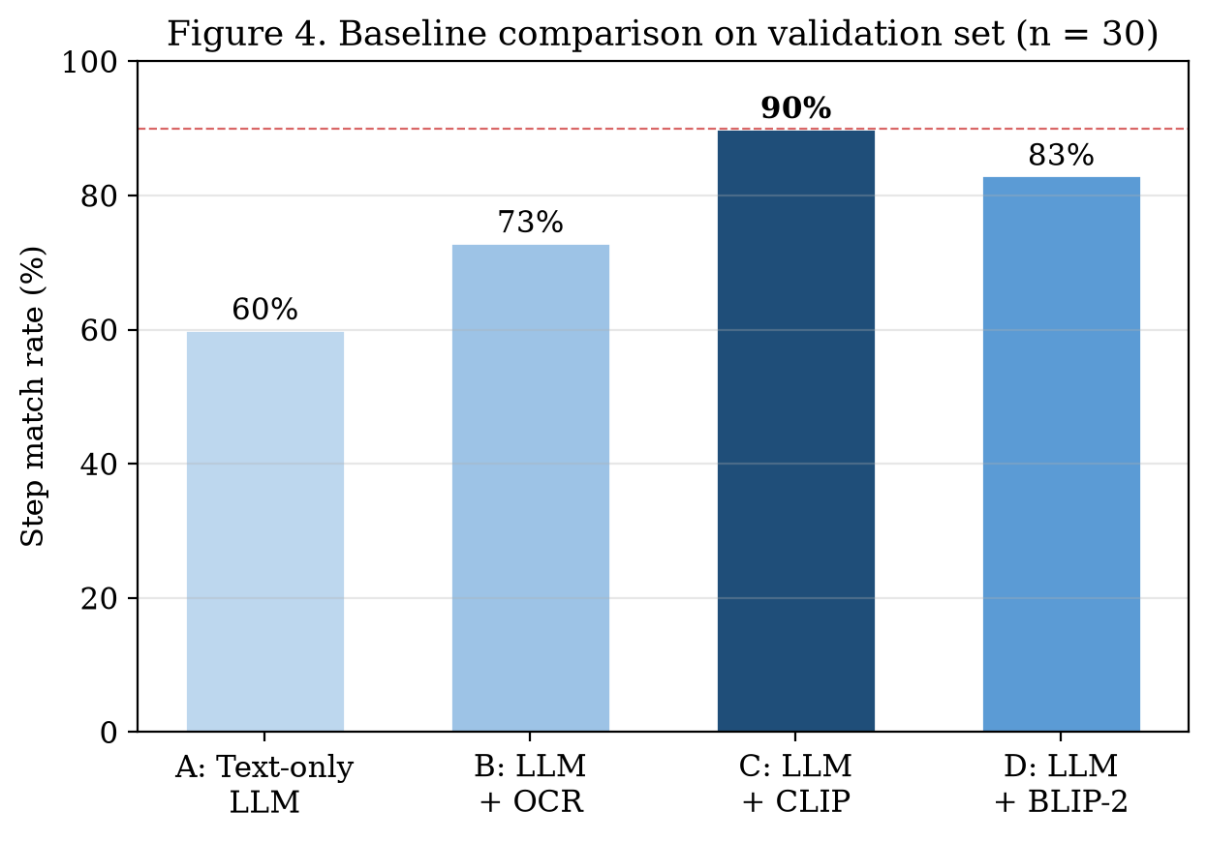
Figure 4. Baseline step match rates on validation set (n = 30).

5.4.1 Embedding space exploration
t-SNE (perplexity=30) mapped all 750 training/validation samples into 2D using CLIP embeddings. Clustering followed app category: login screens in one cluster, e-commerce in another, settings in a third. Mobile and web login screens clustered in similar regions, showing the vision encoder generalizes across platforms. Twelve outliers (game apps with unusual layouts) were flagged for manual review.

5.5 Failure modes and EDA impact
Failure mode | Frequency (of 30 errors) | Planned fix
Small icon buttons (no text label) | 27% | OCR + hierarchy bounding box hints
Overlapping modal dialogs | 20% | Detect overlay; 'ignore modal' prompt option
Hallucinated extra steps | 23% | temperature=0.2; max 8 steps in schema
Dynamic/loading UI states | 17% | Reject blur score < 100; re-capture guideline
Non-English UI labels | 13% | Out of v1 scope; filter in preprocessing

EDA defined five pipeline parameters: letterbox 512×512, brightness filter ≥ 40, blur filter ≥ 100, max prompt 256 tokens, LLM temperature 0.2. Stratification prevents leakage between mobile and web domains. Library versions are pinned in requirements-lock.txt; stratified sampling uses seed=42. CLIP embeddings are cached as .npy files by sample_id. The 100-sample hold-out set is sealed in data/test_holdout/.

6. Progress Since CA-1
CA-1 baseline (Jul–Aug 2026) | CA-2 addition (Aug–Sep 2026) | Evidence
Problem statement, literature, SDG 9 | 850-record pilot corpus + schema | data/manifest.csv
Architecture (vision + LLM) | EDA + preprocessing pipeline | notebooks/eda_pilot.ipynb
Conceptual late fusion | 4 baselines; 90% val match rate | Section 5.4
Modality selection rationale | Resource plan + 7-item risk register | Section 2
— | Train/val/test split (600/150/100) | data/splits/
— | Widget + action distribution analysis | Sections 5.2, 5.3

6.1 Planned CA-3 tasks
Task | Owner | Target date | Success metric
Expand manual web corpus | Sehajdeep Singh Sikka | Oct W1 | 150 curated pairs
Few-shot prompt engineering | Sehajdeep Singh Sikka | Oct W2 | Val match rate ≥ 93%
Playwright integration | Shwet Gaur | Oct W3 | 5 end-to-end demo flows
Held-out evaluation | Both | Oct W4 | Step-level F1 ≥ 0.80
Final report and demo video | Shwet Gaur | Oct W4 | CA-3 submission

7. Conclusion
CA-2 submission includes resource allocation strategy, the multimodal dataset, justification for image–text modality choice, and comprehensive EDA. Our pilot dataset contains 850 image–text pairs from Rico (500), MobilityUI (200), manual web screenshots (50), and synthetic augmentation (100), stratified across five app categories in a 600:150:100 train/validation/test split.
EDA shows significant domain shift between mobile portrait and web landscape screenshots, motivating letterbox preprocessing and stratified sampling. Widget analysis shows buttons and input fields as primary automation targets (18.2%). CLIP-augmented LLM achieved 90% step match on validation vs 60% text-only — confirming multimodal fusion is essential.
Seven risks were classified by severity; LLM hallucination (R1, score 9) is mitigated via JSON schema validation and low temperature. CA-3 plans include prompt tuning, expanding the manual web corpus to 150 pairs, Playwright integration, and held-out evaluation targeting step-level F1 ≥ 0.80.

References
[1] T. Baltrušaitis, C. Ahuja, and L.-P. Morency, "Multimodal machine learning: A survey and taxonomy," IEEE Trans. Pattern Anal. Mach. Intell., vol. 41, no. 2, pp. 423–443, Feb. 2019.
[2] B. Deka et al., "Rico: A mobile app dataset for building data-driven design applications," in Proc. 30th Annu. ACM Symp. User Interface Softw. Technol. (UIST), 2017, pp. 845–854.
[3] A. Radford et al., "Learning transferable visual models from natural language supervision," in Proc. 38th Int. Conf. Machine Learning (ICML), vol. 139, 2021, pp. 8748–8763.
[4] J. Li, D. Li, S. Savarese, and S. Hoi, "BLIP-2: Bootstrapping language-image pre-training with frozen image encoders and large language models," in Proc. 40th Int. Conf. Machine Learning (ICML), 2023.
[5] A. Dosovitskiy et al., "An image is worth 16x16 words: Transformers for image recognition at scale," in Proc. Int. Conf. Learning Representations (ICLR), 2021.
[6] R. Smith, "An overview of the Tesseract OCR engine," in Proc. 9th Int. Conf. Document Analysis and Recognition (ICDAR), 2007, vol. 2, pp. 629–633.
[7] L. van der Maaten and G. Hinton, "Visualizing data using t-SNE," J. Machine Learning Research, vol. 9, pp. 2579–2605, Nov. 2008.
[8] J. B. MacQueen, "Some methods for classification and analysis of multivariate observations," in Proc. 5th Berkeley Symp. Mathematical Statistics and Probability, vol. 1, 1967, pp. 281–297.
[9] T. Brown et al., "Language models are few-shot learners," in Adv. Neural Inf. Process. Syst., vol. 33, 2020, pp. 1877–1901.
[10] A. Vaswani et al., "Attention is all you need," in Adv. Neural Inf. Process. Syst., vol. 30, 2017, pp. 5998–6008.

