**Hadoop**

**1nt19is172**

**Swetha A**

**CHECKING HADOOP IS INSTALLED OR NOT AND IT’S VERSION**

hdoop@admin1-HP-280-G4-MT-Business-PC:~$ hadoop version Hadoop 3.2.1 Source code repository https://gitbox.apache.org/repos/asf/hadoop.git -r b3cbbb467e22ea829b3808f4b7b01d07e0bf3842 Compiled by rohithsharmaks on 2019-09-10T15:56Z Compiled with protoc 2.5.0 From source with checksum 776eaf9eee9c0ffc370bcbc1888737 This command was run using /home/hdoop/hadoop-3.2.1/share/hadoop/common/hadoop-common-3.2.1.jar

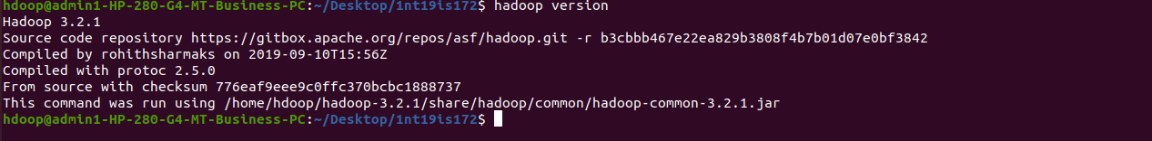

**CREATING DIRECTORY**

hdoop@admin1-HP-280-G4-MT-Business-PC:~$ $ hdfs dfs -mkdir /swethaa

**USING LS COMMAND**

hdoop@admin1-HP-280-G4-MT-Business-PC:~$ hdfs dfs -ls /

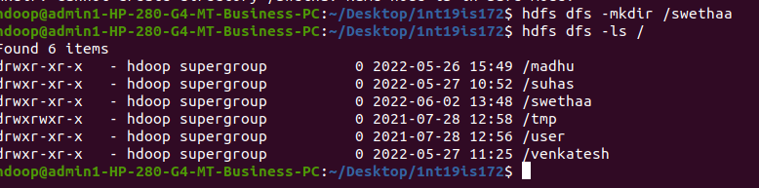

**ADDING EMPTY FILES**

touchz: It creates an empty file.

hdoop@admin1-HP-280-G4-MT-Business-PC:~$ hdfs dfs -touchz /swethaa/file1.txt

hdoop@admin1-HP-280-G4-MT-Business-PC:~$ hdfs dfs -touchz /swethaa/file2.txt



hdoop@admin1-HP-280-G4-MT-Business-PC:~$ hadoop fs -ls /swethaa

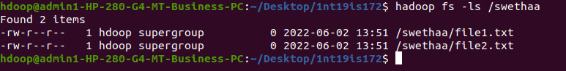

**MOVING FILE FROM LOCAL TO HADOOP USING PUT COMMAND**

copyFromLocal (or) put: To copy files/folders from local file system to hdfs store. This is the most important command. Local filesystem means the files present on the OS.

$ hdfs dfs -mkdir /1nt19is172

$ hdfs dfs -put /home/hdoop/Desktop/1nt19is172 /1nt19is172

$ hdfs dfs -ls /1nt19is172 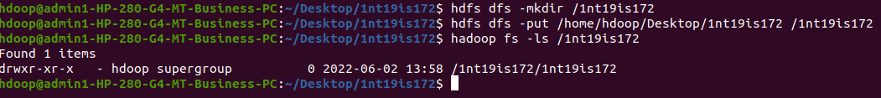

**MOVING FROM HADOOP TO LOCAL**

$ hadoop fs -get /1nt19is172/1nt19is172 /home/hdoop/Desktop

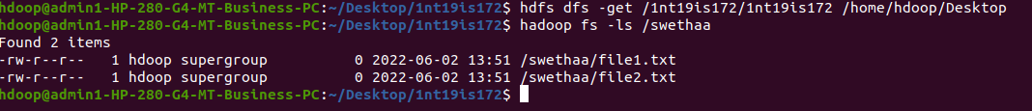

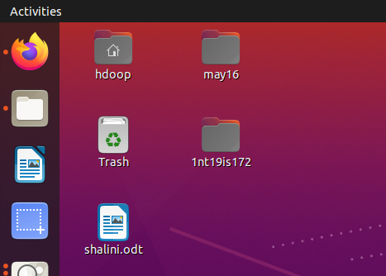

**MOVING FILE WITHIN HADOOP(From one directory to another)**

$ hadoop fs -cp /swethaa/file1.txt /1nt19is172

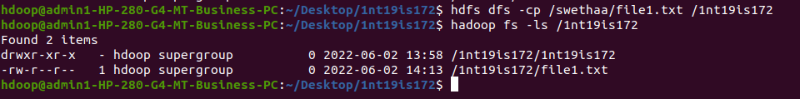

**SIZE OF FILES IN DIRECTORY**

$ hadoop fs -du -h /swethaa

$ hadoop fs -du -h /1nt19is172

