**1NT19IS172**

**SWETHA A**

**C2 BATCH**

**Command to enter into mongoDB**

$mongo

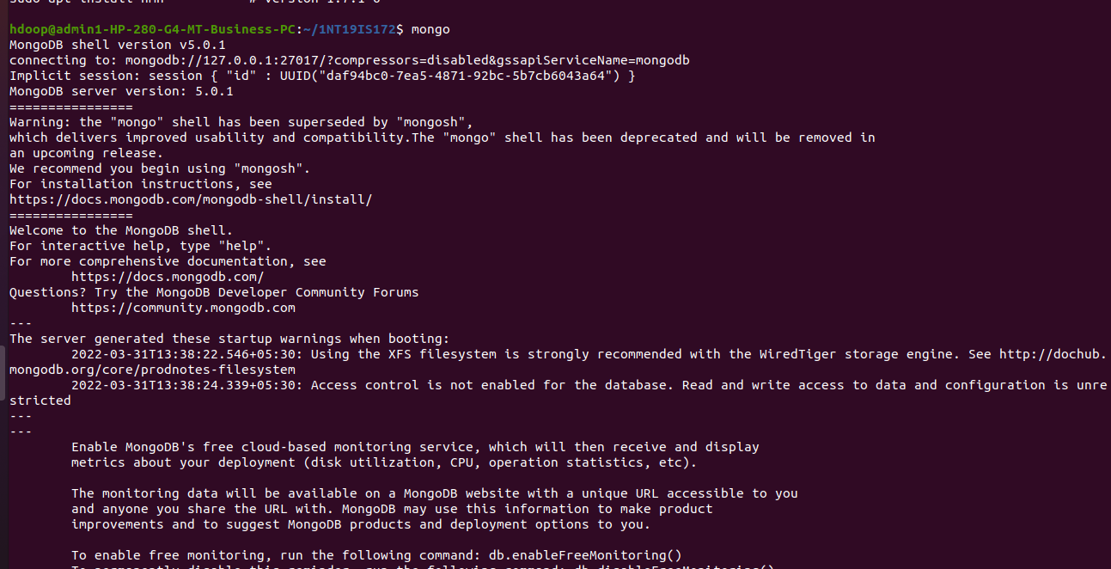

**Creating a database** //creates a new database if not present or if present switches to that database

use database_name



**Show databases**

show dbs

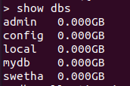

**Insertion of one value**

db.collection_name.insertOne()



**Insertion of many values**

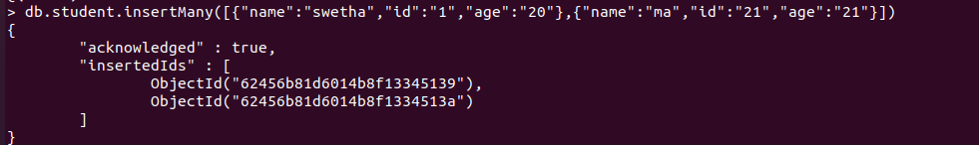

**Displaying contents**

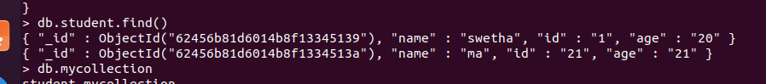

**Show collections**

db.mycollection



**Updating One value**

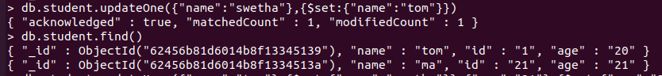

**Update Many values**

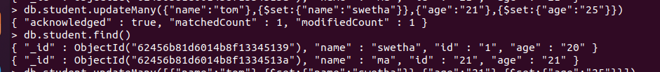

**Replace One value**

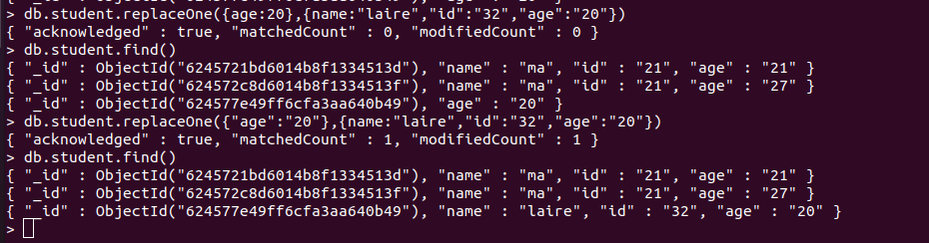

**Delete One value**

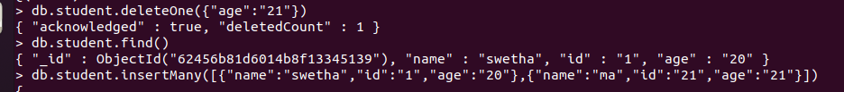

**Delete Many values**

