**Lab2**

**1NT19IS172**

**SWETHA A**

**C2 BATCH**

**And and OR operations**

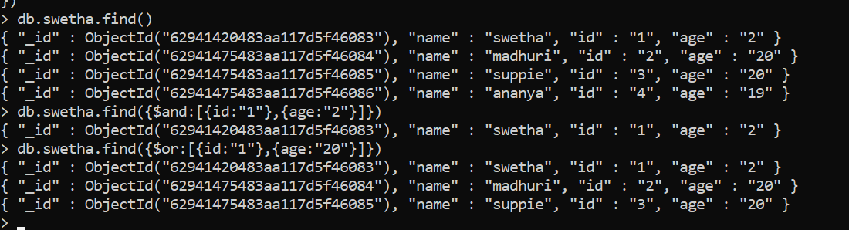

**Aggregate function**

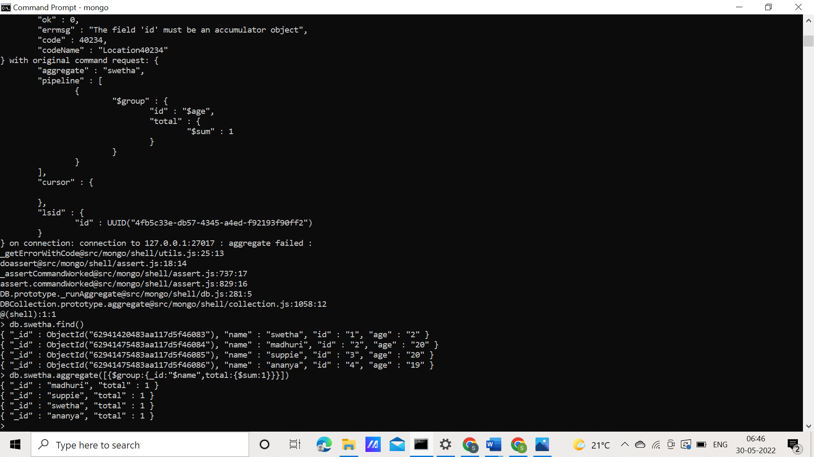

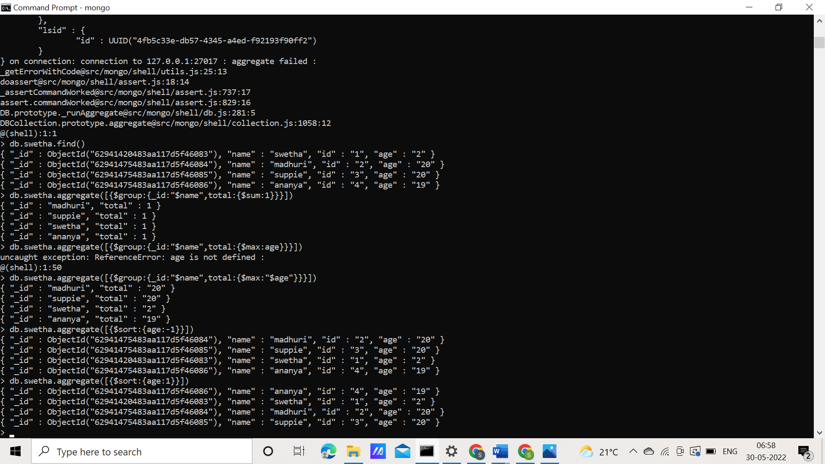

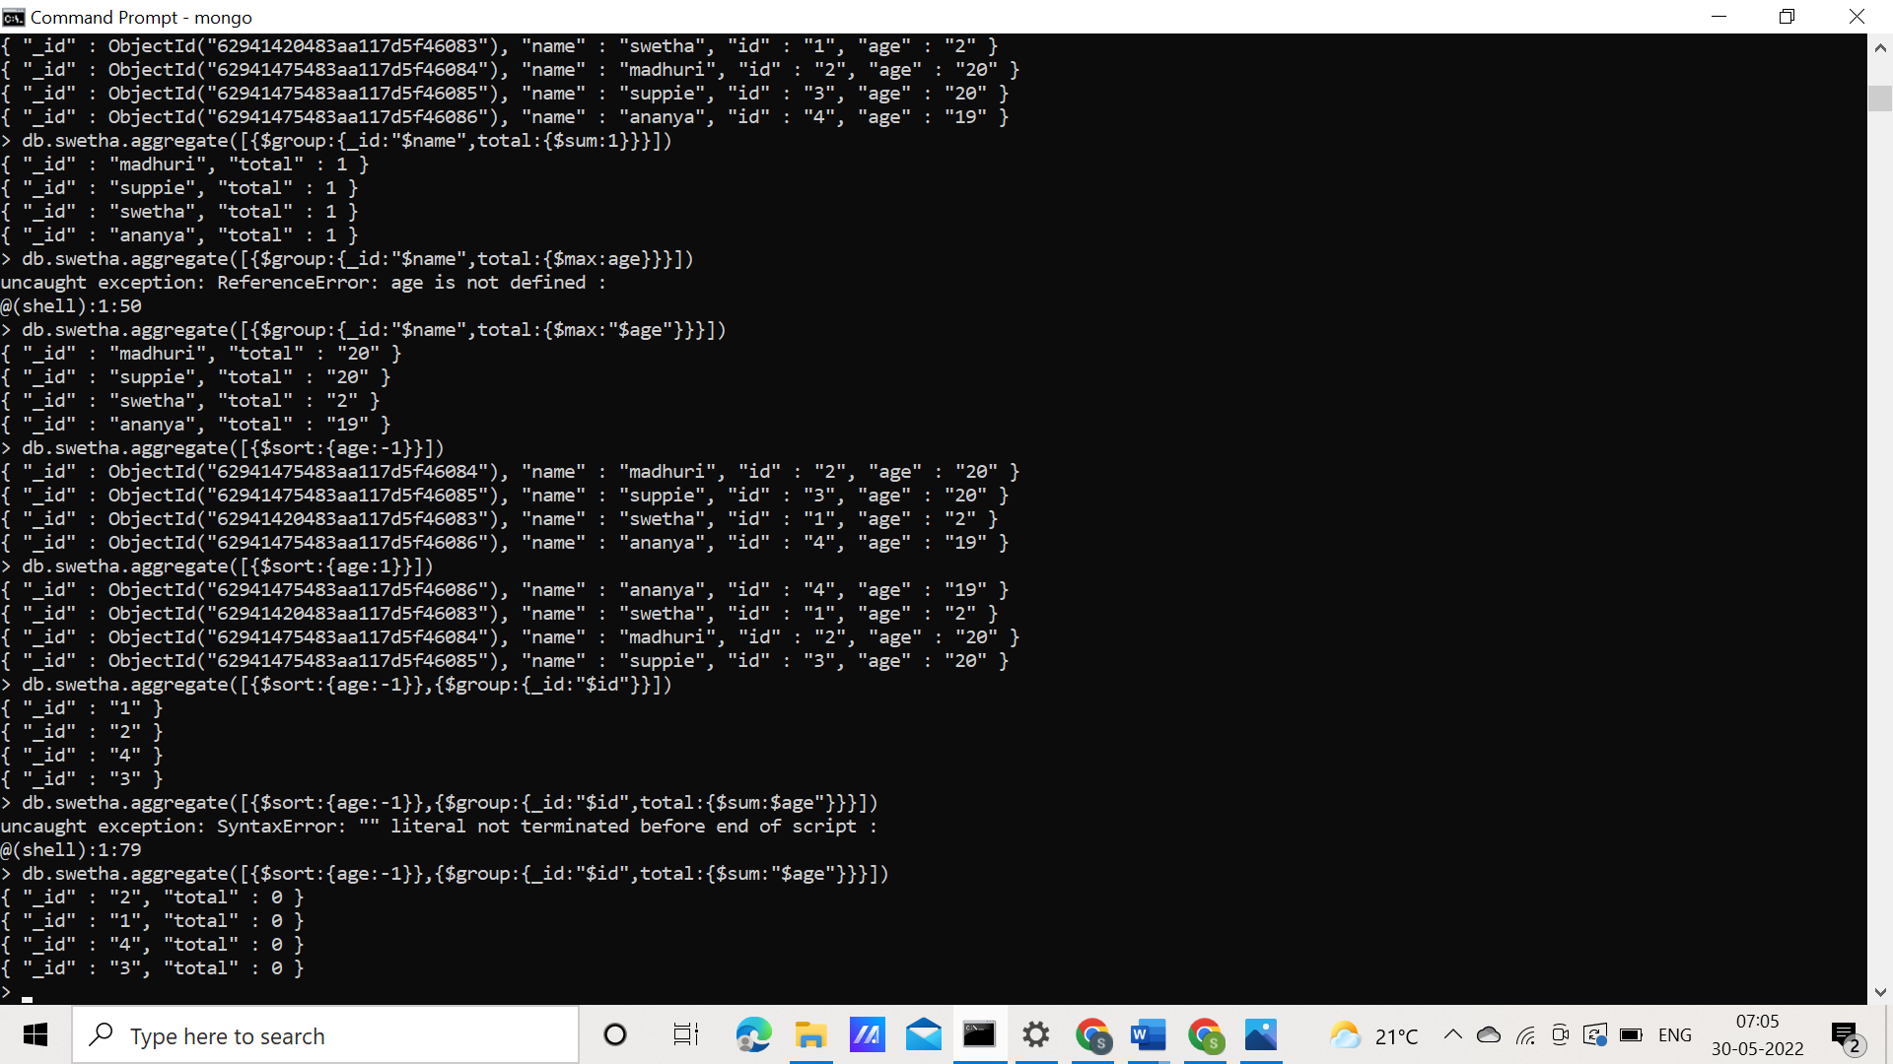

**Map Reduce**

