Name: Swetha A

USN: 1NT19IS172

Date:14.06.2022

Exercise-3: MAPREDUCE

Use the Hadoop framework to write a custom MapReduce program to perform word count operation on a custom data set.

Initially create a new project, package and class in eclipse to run a java code.

To install jar files:

Right click on project (Mapreduce)

Click on -> build a path -> add external archives -> Hadoop 3.2.1 -> share

In share 1. Click on common ->open hadoop-common-3.2.1.jar

2. Click on mapreduce -> open hadoop-mapreduce-client-core-3.2.1.jar

Right click on project -> export -> java -> jar file -> next

Browse the address of the java file and save it in desktop/document/downloads and name it

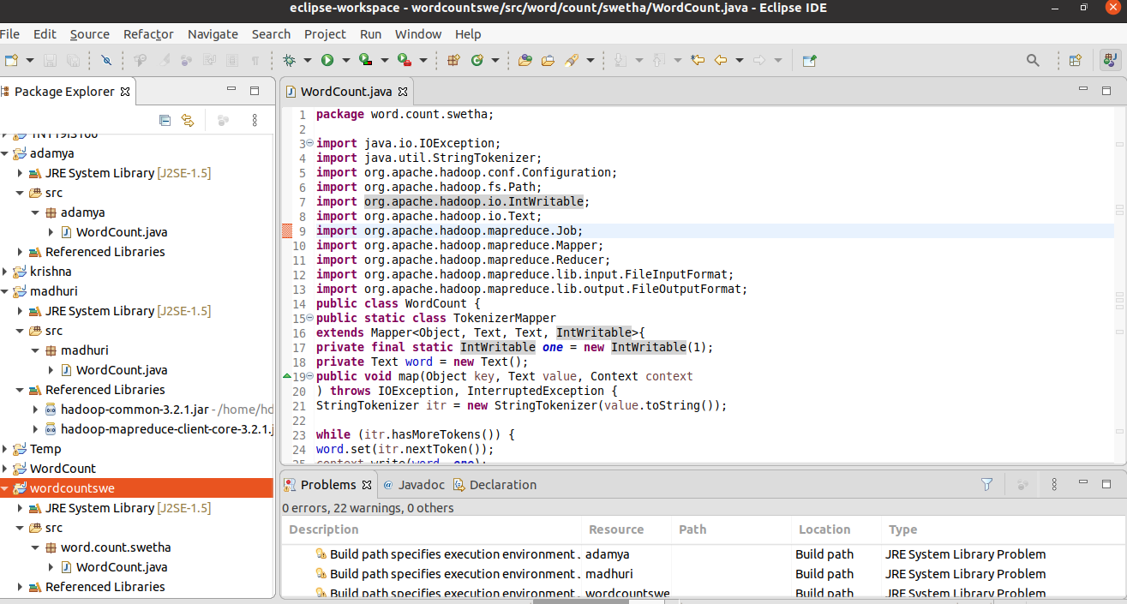

IN TERMINAL:

Run the commands:

cd $HADOOP_HOME

cd sbin

jps

start-all.sh

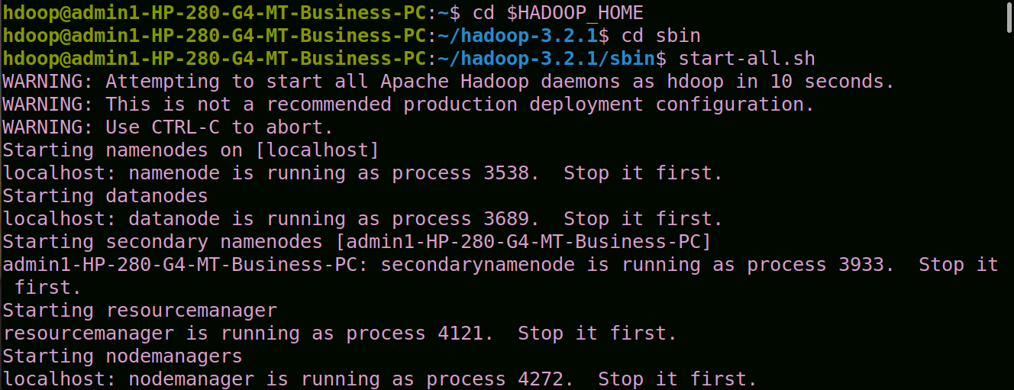

hdfs dfs -mkdir -p ~ /swetha

hdfs dfs -appendToFile - ~/swethat/file3.txt

Create a file and add content to it. ->(ctrl D two times)

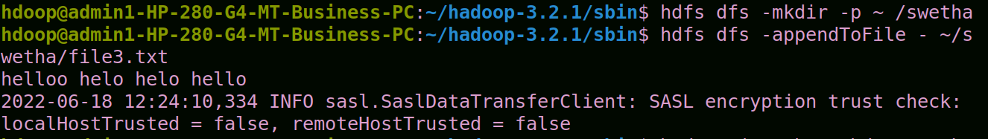

hadoop jar /home/hdoop/Desktop/swetha.jar ~/swetha ~/

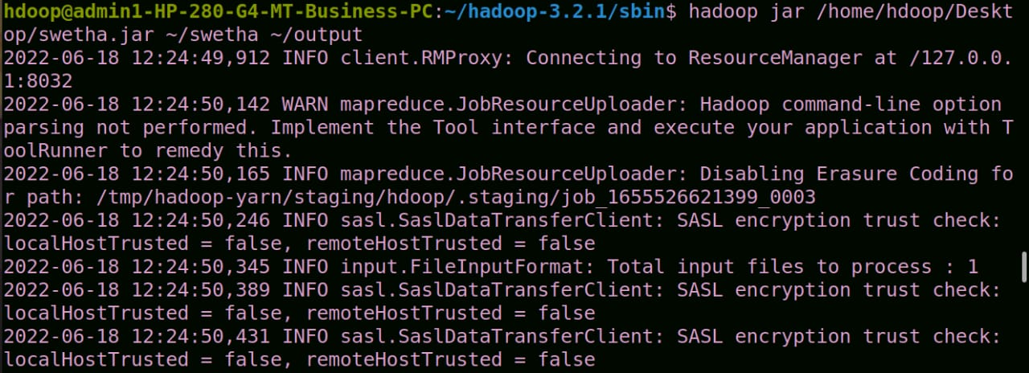

hdfs dfs -cat ~/output/part*

