Paatshala High School health Portal

BITS WILP Mtech in Software Engineering

FSAD assignment

Submitted by

Shwethaa Rajagopalan

2024TM93028

**System Overview**

The Paatshala High School health Portal is a web-based application designed to streamline the management and administration of vaccination programs. It provides a centralized platform to enable administrators to manage vaccine inventory, appointments, and reporting efficiently.

Key Features:

1. User Authentication: Secure user login functionality for administrators.
2. Vaccine Inventory Management: Enables administrators to track vaccine stock levels and manage distribution effectively.
3. Reporting and Analytics: Provides detailed reports on vaccination progress, user statistics, and inventory usage.

Architecture:

The system is built using a modern web development stack and follows a modular architecture for scalability and maintainability. It consists of the following components:

* Frontend: Developed using React to provide an intuitive and responsive user interface.
* Backend: Powered by Express.js to handle business logic and API endpoints.
* Database: Utilizes SqlLite to store user data, vaccination records, and inventory details.
* APIs: RESTful APIs facilitate communication between the frontend and backend, ensuring seamless data exchange.

Benefits:

* Improved Efficiency: Streamlines the scheduling and management of vaccination programs, reducing manual effort.
* Enhanced User Experience: Provides a user-friendly interface for seamless management.
* Data-Driven Insights: Offers analytics and reporting to help administrators make informed decisions.
* Scalability: Designed to handle a growing number of users and vaccination records.

Github Link: <https://github.com/shwethaar/BITS_WILP_Vaccination_Portal>

Video Link: https://github.com/shwethaar/BITS_WILP_Vaccination_Portal/blob/main/Video_Portal_Demo.mp4

Postman responses:

1. GET /student-vacc-info  
   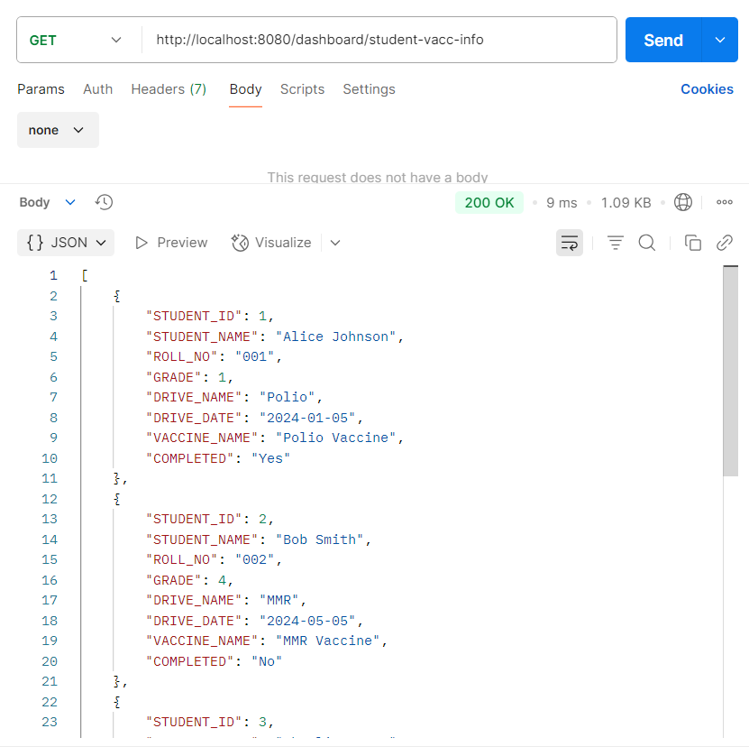
2. GET /grade-counts  
   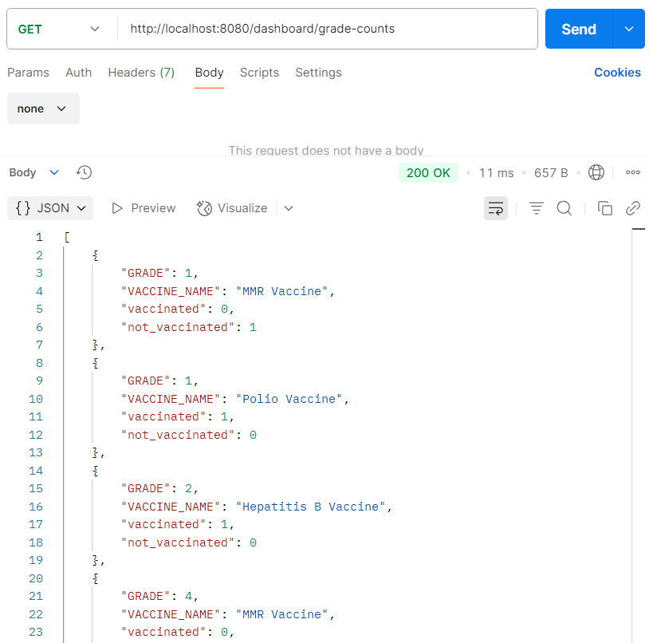
3. GET /ongoing-drives  
   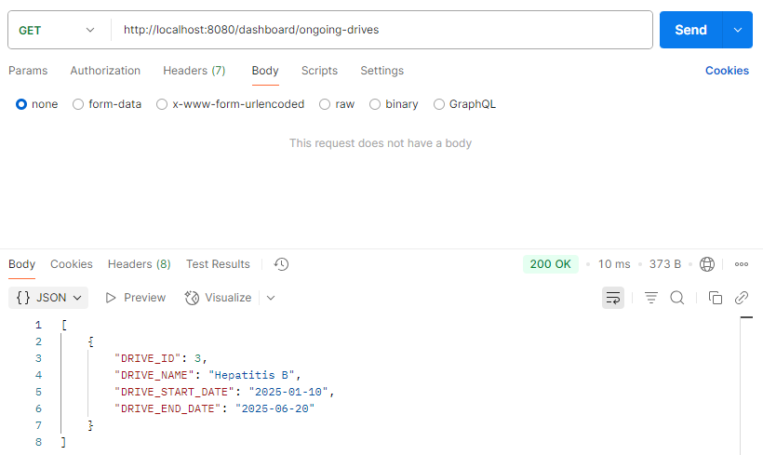
4. GET /upcoming-drives  
   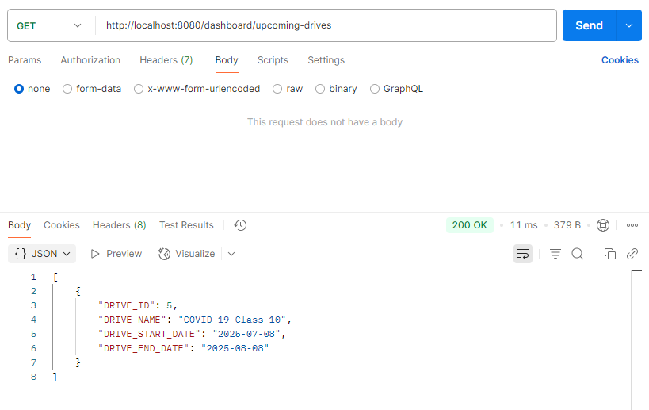
5. GET /available-vaccines  
   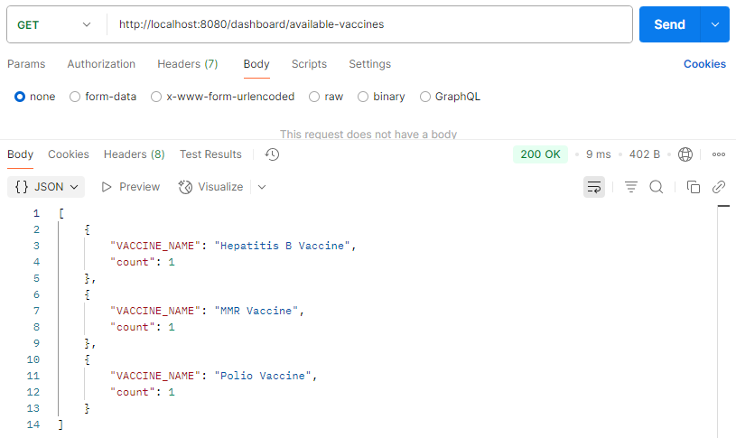
6. GET /student/  
   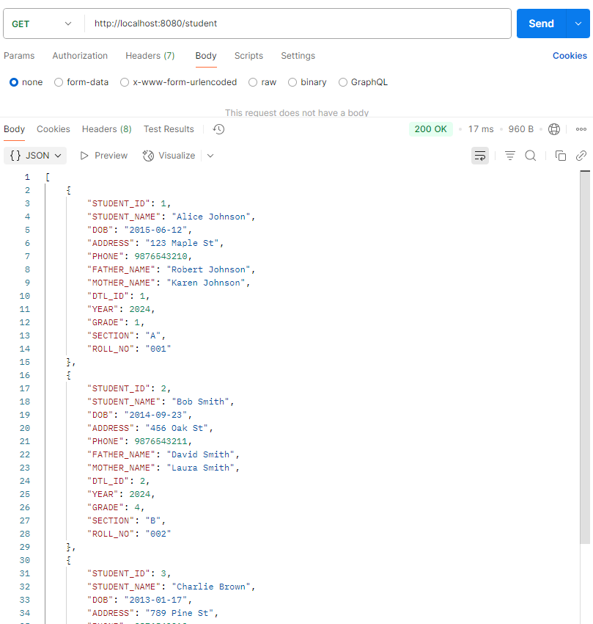
7. GET /student/:id  
   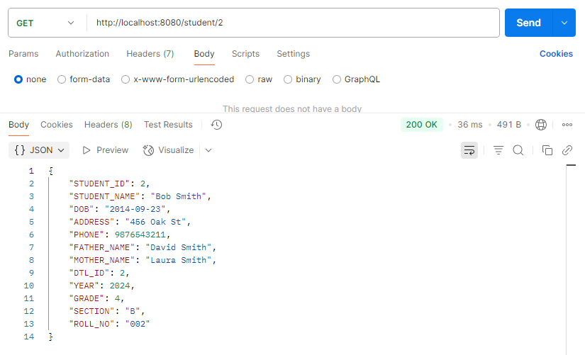
8. POST /student  
   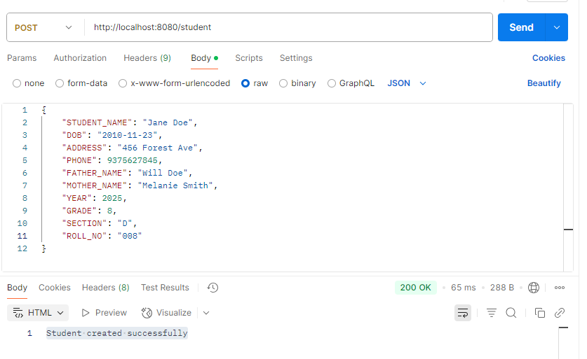
9. PUT /student  
   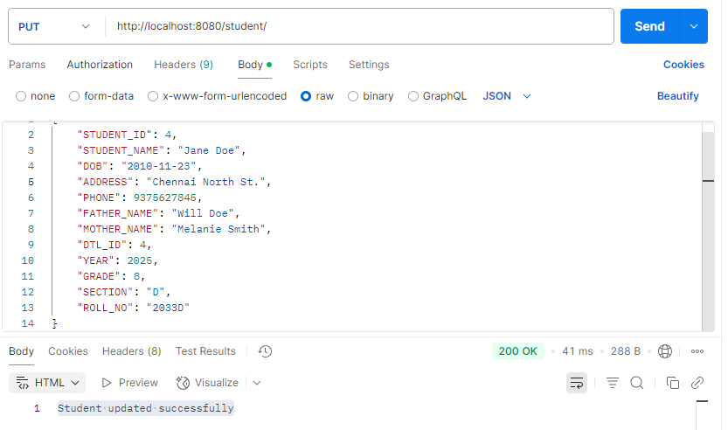
10. DELETE /student  
    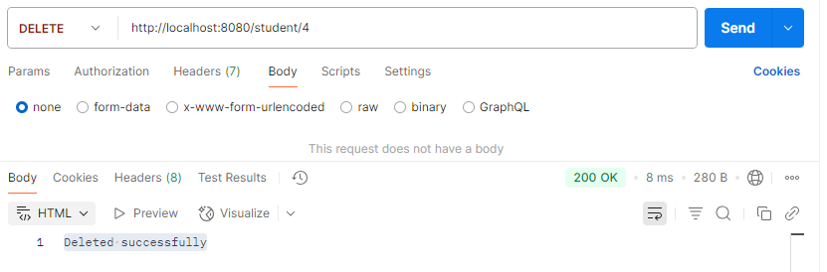
11. GET /vaccines  
    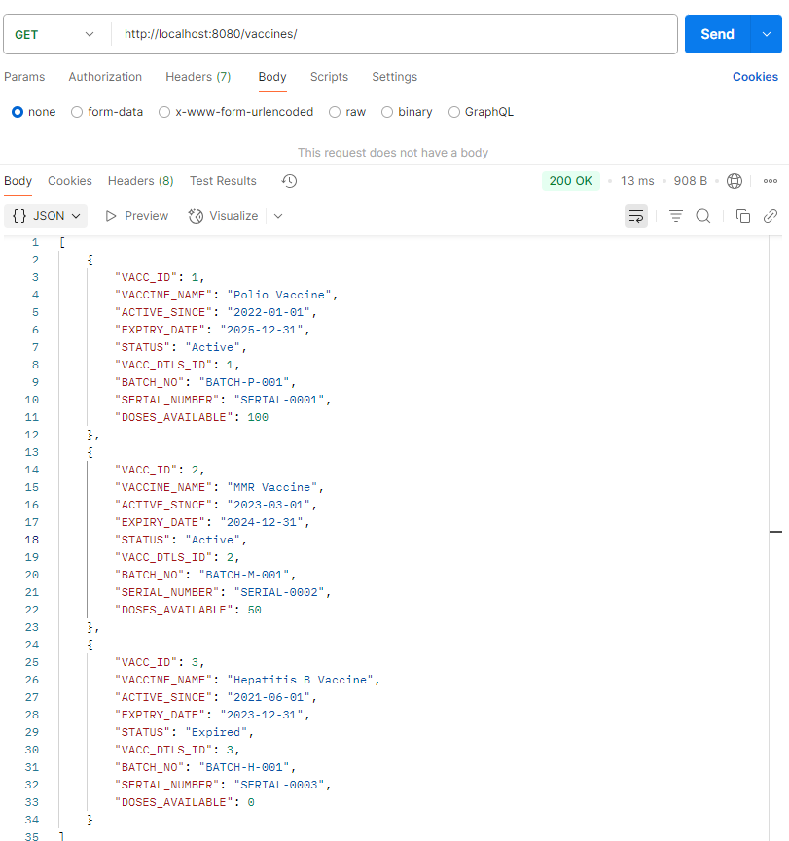
12. GET /vaccines/:id