Documentation

# Best Practices for Documenting Your Project

<https://guides.lib.berkeley.edu/how-to-write-good-documentation>

<https://helpjuice.com/blog/software-documentation>

<https://www.altexsoft.com/blog/business/technical-documentation-in-software-development-types-best-practices-and-tools/>

<https://www.altexsoft.com/blog/business/technical-documentation-in-software-development-types-best-practices-and-tools/>

[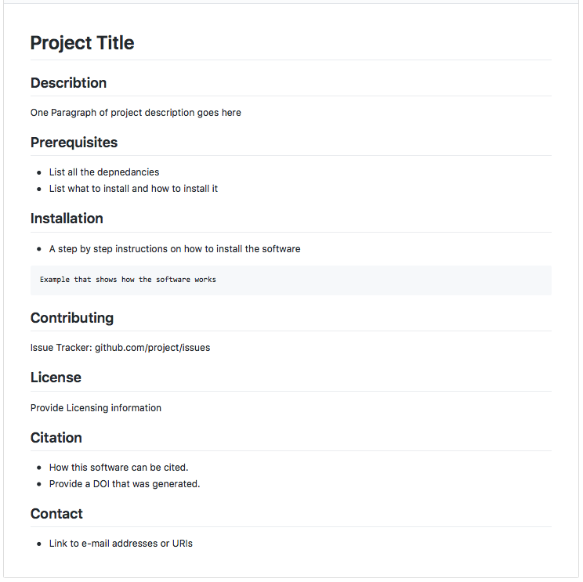](https://libapps.s3.amazonaws.com/accounts/125446/images/README_Sample.png)An example for README file.

**Best practices for writing documentation:**

1. Include A README file that contains
   * A brief description of the project
   * Installation instructions
   * A short example/tutorial
2. Allow issue tracker for others
3. Write an API documentation
   * What a function do
   * What the function's parameters or arguments are
   * What a function returns

[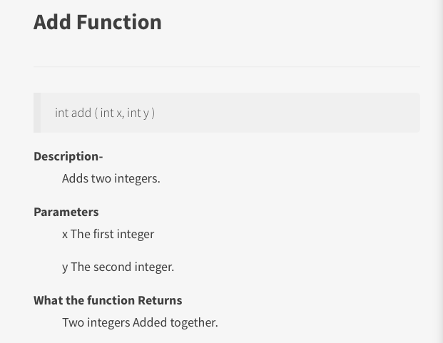](https://libapps.s3.amazonaws.com/accounts/125446/images/function_example.png)An example for code documentation.

1. Document your code
2. Apply coding conventions, such as file organization, comments, naming conventions, programming practices, etc.
3. Include information for contributors
4. Include citation information
5. Include licensing information
6. Link to your e-mail address at the end
7. List all the version of the files along with the major edits you did in each version

**An important tip: Naming files should be descriptive and consistent!**

<https://prabhukvn.wordpress.com/2016/02/24/swagger-documentation-for-servlet/>

<https://www.tutorialsteacher.com/webapi/request-response-data-formats-in-web-apis>

<https://swagger.io/docs/specification/describing-request-body/>

# Swagger

https://editor.swagger.io/

<https://editor.swagger.io/?_ga=2.96769759.1392076145.1626374655-1639208761.1626374655>

https://swagger.io/docs/specification/describing-responses/

**GET​/store​/inventory**

Returns pet inventories by status

**POST​/store​/order**

Place an order for a pet

**GET​/store​/order​/{orderId}**

Find purchase order by ID

**DELETE​/store​/order​/{orderId}**

Delete purchase order by ID