**VISVESVARAYA TECHNOLOGICAL UNIVERSITY**

**JnanaSangama , Belagavi – 590014**



**A Computer Graphics Project Report On**

**“MINIATURE STEAM ENGINE”**

**Submitted in Partial fulfillment of the Requirements for the VI Semester of the Degree of**

**Bachelor of Engineering**

**In**

**Computer Science & Engineering**

**By**

**SHWETHA (4MW15CS093)**

**SHWETHA JOGI (4MW15CS094)**

**Under the Guidance of**

**SOWMYA**

**Asst. Prof, Dept. of CSE**



# DEPARTMENT OF Computer SCIENCE AND ENGINEERING

**Shri Madhwa Vadiraja Institute of Technology & Management**

**Vishwothama Nagar, Bantakal-574115**

**JUNE, 2018**

**Shri Madhwa Vadiraja Institute of Technology and Management**

(A Unit of Shri Sode Vadiraja Mutt Education Trust ®, Udupi)

**Vishwothama Nagar, BANTAKAL – 574 115, Udupi District, Karnataka, INDIA**

**DEPARTMENT OF Computer SCIENCE AND ENGINEERING**



**CERTIFICATE**

Certified that the Computer Graphics Project work entitled **“MINIATURE STEAM ENGINE”** has been carried out by **STUDENT 1 (4MW1CS093)** bonafide student of Shri Madhwa Vadiraja Institute of Technology and Management in partial fulfillment for the award of **Bachelor of Engineering in Computer Science and Engineering** of the Visvesvaraya Technological University, Belgaum during the year **2017-2018**. It is certified that all corrections/suggestions indicated for Internal Assessment have been incorporated in the Report deposited in the departmental library. The Graphics Project Report has been approved as it satisfies the academic requirements in respect of project work prescribed for the said Degree.

**Mrs. SOWMYA Dr. VASUDEVA**

Project Guide, Professor and Head

Dept. of CSE Dept. of CSE

External Viva

Name of the examiners                                                       Signature with date

1

2.

**ACKNOWLEDGEMENT**

While presenting this Graphics Project on **MINIATURE** **STEAM ENGINE** we feel that it is our duty to acknowledge the help rendered to us by various persons.

We would like to express our heartfelt gratitude to **Dr. Thirumaleshwara Bhat, Principal, SMVITM, Bantakal, for extending his support.**

**We would also like to express our heartfelt gratitude to Dr. Vasudeva, HOD, Computer Science and Engineering whose guidance and support was truly invaluable.**

It is our privilege to express our sincerest regards to our project coordinator, **Mrs.Sowmya**, for her valuable inputs, able guidance, encouragement and whole-hearted cooperation throughout the duration of our project.

We take this opportunity to thank all our lecturers who have directly or indirectly helped our project.

We pay our respects and love to our parents and all other family members and friends for their love and encouragement throughout our career.

Last but not the least we express our thanks to our friends for their cooperation and support.

Thanking you all,

Shwetha(4mw15cs093)

Shwetha Jogi(4mw15cs094)

**TABLE OF CONTENTS**

**CHAPTERS PAGENO**

1. INTRODUCTION 1

2. REQUIREMENT ANALYSIS 3

3. DESIGN 4

4. IMPLEMENTATION 9

5. SCREEN LAYOUT 13

CONCLUSION 16

BIBLOGRAPHY 17

APPENDIX 18

1.INTRODUCTION:

The working of the steam engine is simulated by using OpenGL library functions.The linear

motion of the piston inside the cylinder and the linear motion is converted into rotary motion by

the crankshaft is shown.

The engine can be rotated in 3—dimensions which demonstrates the 3-dimensional rotation of

an object about an axis. The lighting effect is also demonstrated using a light source. The

motion of the engine also demonstrates the use of animation in OpenGL .The wireframe view

of the cylinder shows how a 3-dimensional object like a cylinder and disc is approximated

using line segments and polygons.

2.REQUIREMENT ANALYSIS:

Hardware Requirements:

* Intel P3 processor and above
* 32MB or 64MB RAM(Minimum), 128MB or 512MB for faster processing
* Minimum of 1GHz processor for better results
* Input and Output Devices

Software Requirements:

* Microsoft Visual C++ 6.0
* GL Files(GL Library Files)
* Windows or Linux or Mac OS
* Good Interface(Ex:Menu,Buttons,etc)

3.DESIGN:

Modeling of the Steam Engine:

The cylinder, piston, flywheel, crank, crankshaft are modeled by using a cylinder. Two disks

are placed on the top and bottom face of the cylinder in order to provide a more realistic look

when the engine is rotated. The length and the radius of the cylinder is specified according to the

dimensions of the parts of the cylinder. For example, the crank is a long rod with less thickness,

hence its radius has to be less and length has to be more, whereas the flywheel is a thick large

disc hence it is modeled using a cylinder of less length but more radius.

The various parts are first drawn with reference to the relative positions with respect to that part.

The different parts are then assembled together by placing them in the appropriate position on

the screen.The crank is the part of the engine which has no linear motion hence it is placed

first.The other parts are then placed using the crank as a reference. All these transformations are

carried out using the OpenGL functions glTranslate(),glRotate() and glScale()

ANIMATING THE STEAM ENGINE:

Once the engine is modeled and drawn on the screen the next step is to animate the engine. In

order to achieve this the amount of rotation of the cylinder, piston, crank, crankbell and flywheel

is to be determined. The angle by which the crank, flywheel, crankbell are to be rotated is

initially set to 0.It is then incremented in steps of 5.The angle of rotation of the cylinder depends

on the rotation of the crank. The rotation of the cylinder head for different crank angles is

calculated using the formula:

MAGNITUDE*atan( (ARC_RADIUS * sin ( PHASE – (k/FREQ_DIV)) **/**

( ARC_LENGTH – (ARC_RADIUS*cos(PHASE – (k/FREQ_DIV) ) ) )

for the values of k from 0 to 360 degrees and stored in an array. Then the rotation of the

cylinder for a particular crank angle is obtained by indexing the crank angle into the array. The

piston connects the crankbell to the cylinder hence it should be rotated by an angle equal to the

difference between the crank angle and the head angle.The rotations are computed using the

glRotate() function and the model is redisplayed after each step.This gives the perception of the

animation.

Light Effects:

The OpenGL lighting model considers the lighting to be divided into four independent

components: emissive, ambient, diffuse, and specular. All four components are computed

independently and then added together.

Ambient illumination is light that's been scattered so much by the environment that its direction

is impossible to determine - it seems to come from all directions.When ambient light strikes a

surface, it's scattered equally in all directions. The diffuse component is the light that comes from

one direction, so it's brighter if it comes squarely down on a surface than if it barely glances off

the surface. Once it hits a surface, however, it's scattered equally in all directions, so it appears

equally bright, no matter where the eye is located. specular light comes from a particular

direction, and it tends to bounce off the surface in a preferred direction.Shiny metal or plastic has

a high specular component, and chalk or carpet has almost none.

4.IMPLEMENTATION:

* Drawing Cylinder

1. Specify the radius of top face and bottom face.
2. Draw a Cylinder using gluCylinder() function.
3. Set radius of inner and outer circles of disc
4. Draw a Disc at bottom face and top face using gluDisc()
5. Rotate Disc by 180 degree about Y-axis

* Drawing Cylinder Head of the Engine

1. Set the Color
2. Draw Cylinder
3. Rotate by 90 degree about X-axis.
4. Rotate by Head angle about the X-axis at pivot point.
5. Draw disc at the top face.
6. Rotate disc by 180 degree about X-axis

* Drawing Crank of the Engine

1. Draw Cylinder
2. Rotate it by Crank angle about X-axis
3. Rotate it by 90 degree about Y-axis.

* Drawing Crankbell of the Engine

1. Draw Cylinder
2. Rotate it by crank angle about X-axis
3. Rotate it by 90 degree about Y-axis
4. Draw a smaller cylinder to connect the crank bell and piston
5. Rotate it by crank angle about X-axis
6. Rotate it by 90 degree about Y-axis.

* Drawing the Piston of the Engine

1. Draw a tiny Cylinder to connect the piston to the crankbell.
2. Rotate it by 180 degree about Y-axis.
3. Rotate it by crank angle-head angle about X-axis
4. Rotate it by 90 degree about Y-axis
5. Draw a Cylinder representing the piston rod.
6. Rotate it by 180 degree about Y-axis
7. Rotate it by crank angle-head angle about X-axis
8. Rotate it by -90 degree about Y-axis
9. Draw Cylinder representing the main part of the piston
10. Rotate it by 180 degree about Y-axis
11. Rotate it by crank angle-head angle about X-axis
12. Rotate it by -90 degree about Y-axis

* Drawing the Flywheel of the Engine

1. Draw Cylinder representing the Flywheel of the Engine
2. Rotate it by crank angle about X-axis
3. Rotate it by 90 degree about Y-axis

SNAPSHOT:

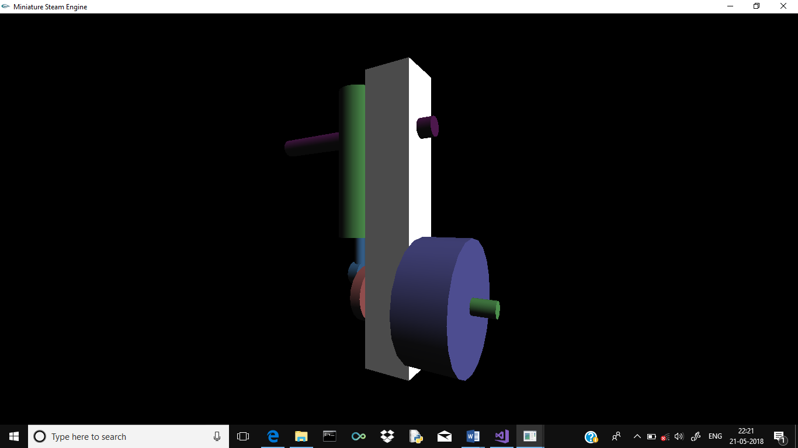

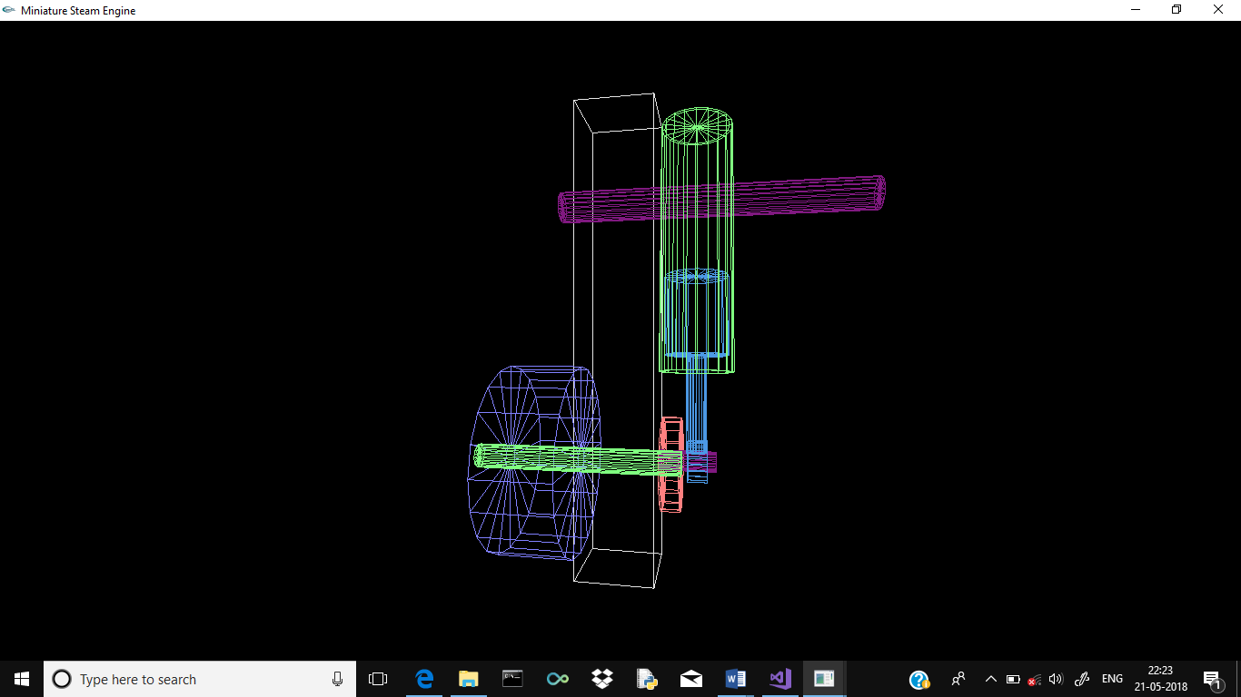

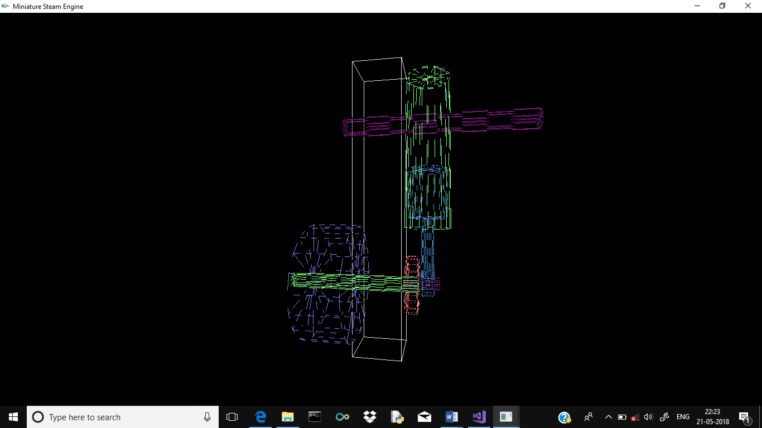

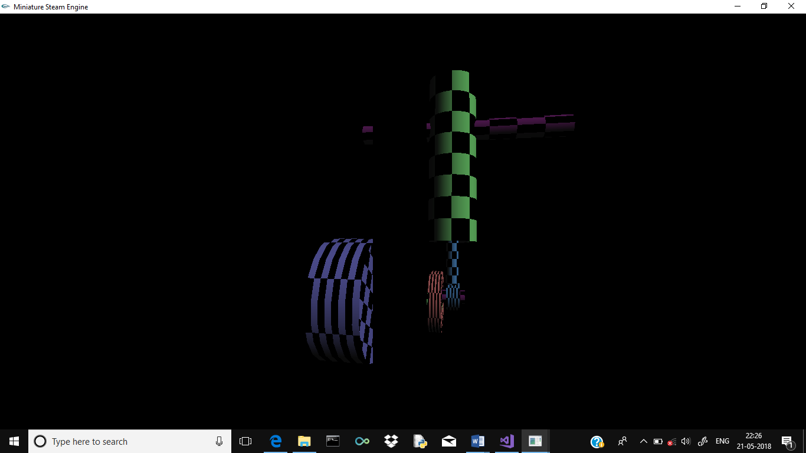.

Description:

The program simulate the working of Miniature Steam Engine with wire frame and 3D shaped

views. The animation shows the movement as how the steam engine work. It is quite complex

program make use of texture and simple check pattern. It has a wide range of user interaction as

well.

Usages: Click either button and choose to animate and select the views and exit.

Shaded :ForShading the object  
Animation  :To start Animating the work.  
Texture :Texture mapping  
Transparency**:** Make use of  Transparency in objects.  
Right Light  : To view as light falling on right side.  
Left Light  :To view as light falling on left side.  
Speed UP   :  Speed up the motion by 1   
Slow Down**:**Speed Down the motion by 1  
  
  
Keyboard functions:  
a: Animate manually in  anti-clockwise direction  
z: Animate manually in  clockwise direction  
s: Toggle b/w wire frame and shaped views.  
+: Increase the speed by 1  
-: Decrease the speed by 1  
2: Moving the Whole engine down  
4: Moving the Whole engine left  
6: Moving the Whole engine right  
8: Moving the Whole engine up

CONCLUSION

The mini project develop as a scope for future enhancement too as follows.It can be used

in CAD and architectural field. It can be used in gaming. This can be used in video imaging and

creating animated movies. It can be tried to make more interactive like a user want a

particular details of project is shown pictorially which helps in commercial and business

world.

BIBLIOGRAPHY

* Edward’s Angel’s interactive computer graphics Pearson education 5th edition.

WEBSITE

* www.OPenGL Redbook .
* www.OPenGL simple examples.
* www.OPenGL programming guide.