**Shwetha. T –** [**shwetht@deloitte.com**](mailto:shwetht@deloitte.com)

**Mini Assignment -1**

**Step1:** Load Data into Snowflakes database tables

**Method1:**

Using snowsql

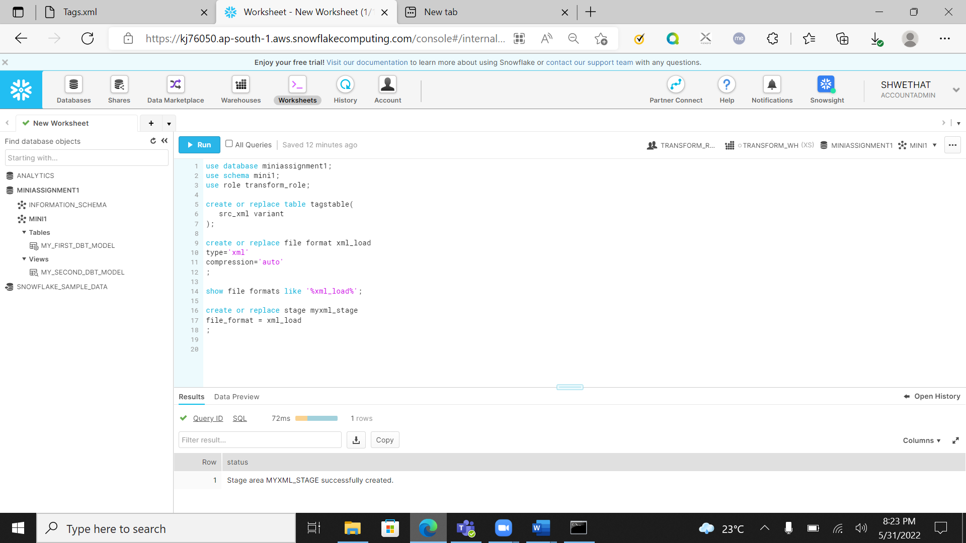

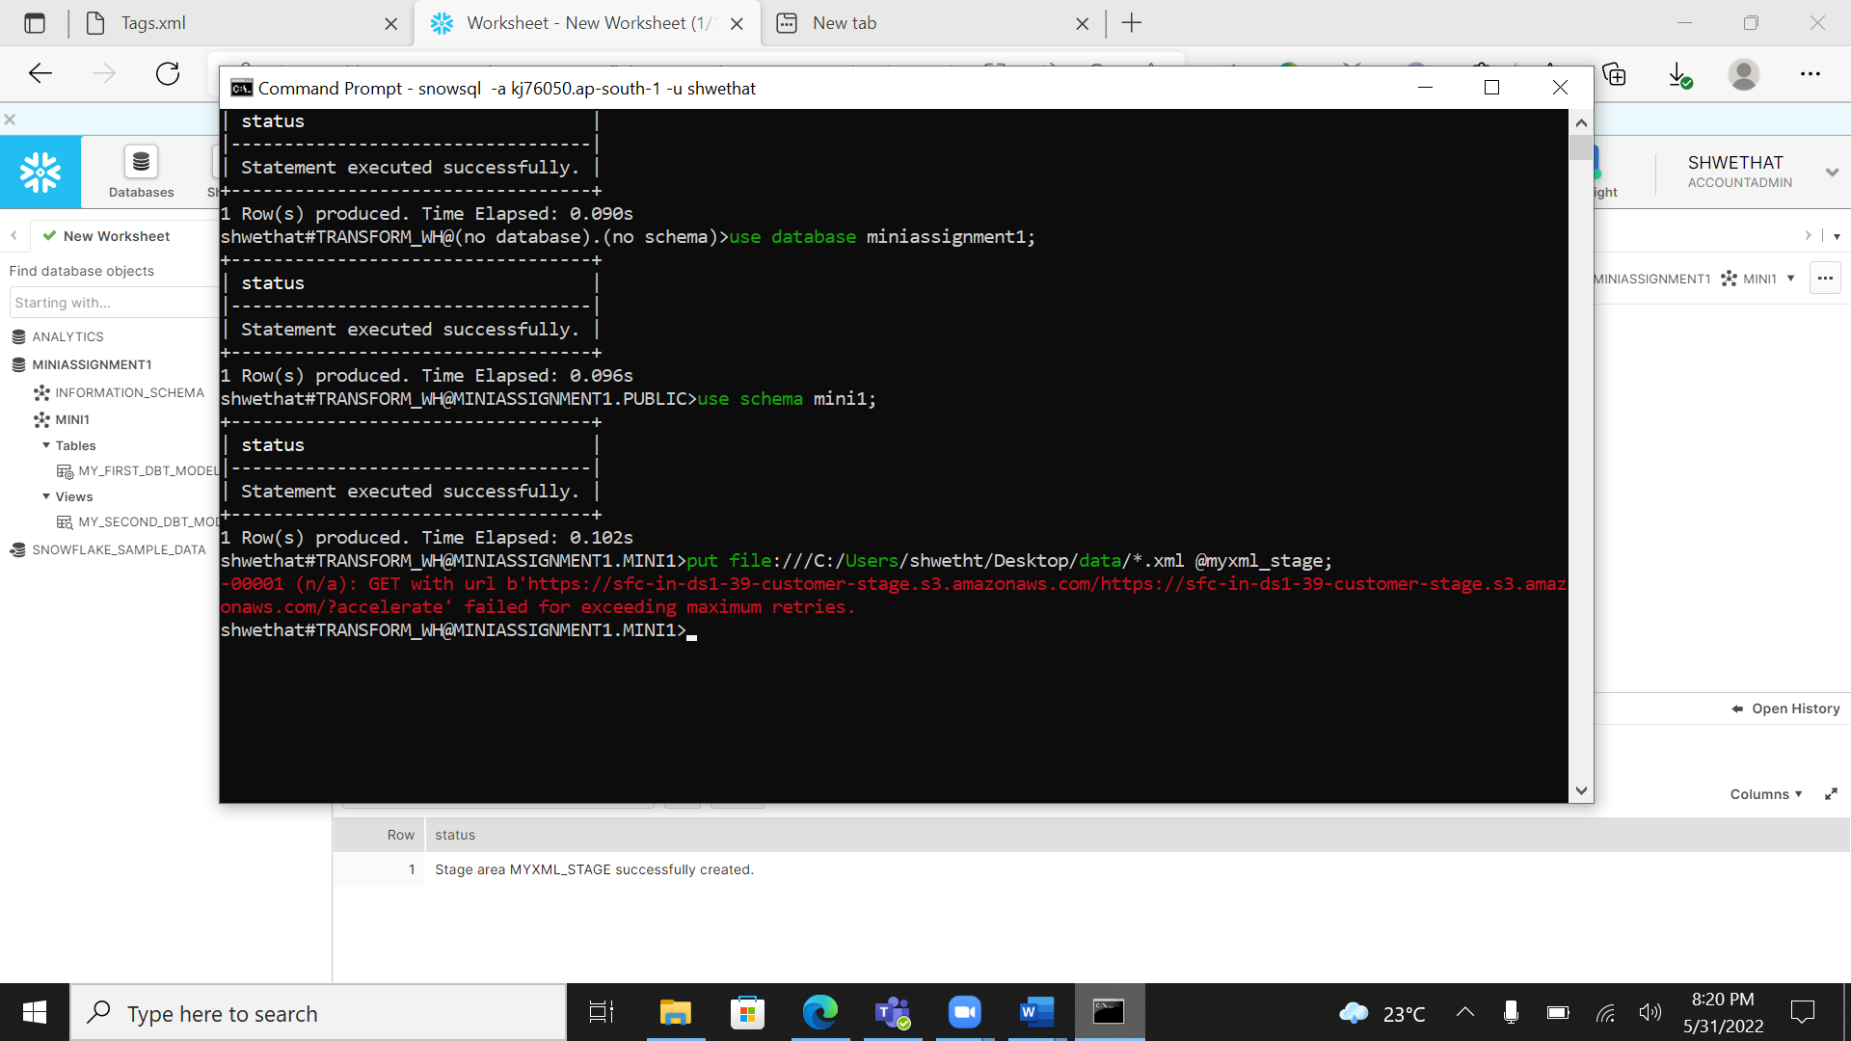

Getting error while adding all xml files to staging file. Method1 is not successful so trying with method2.

**Method2:**

Using Python Script

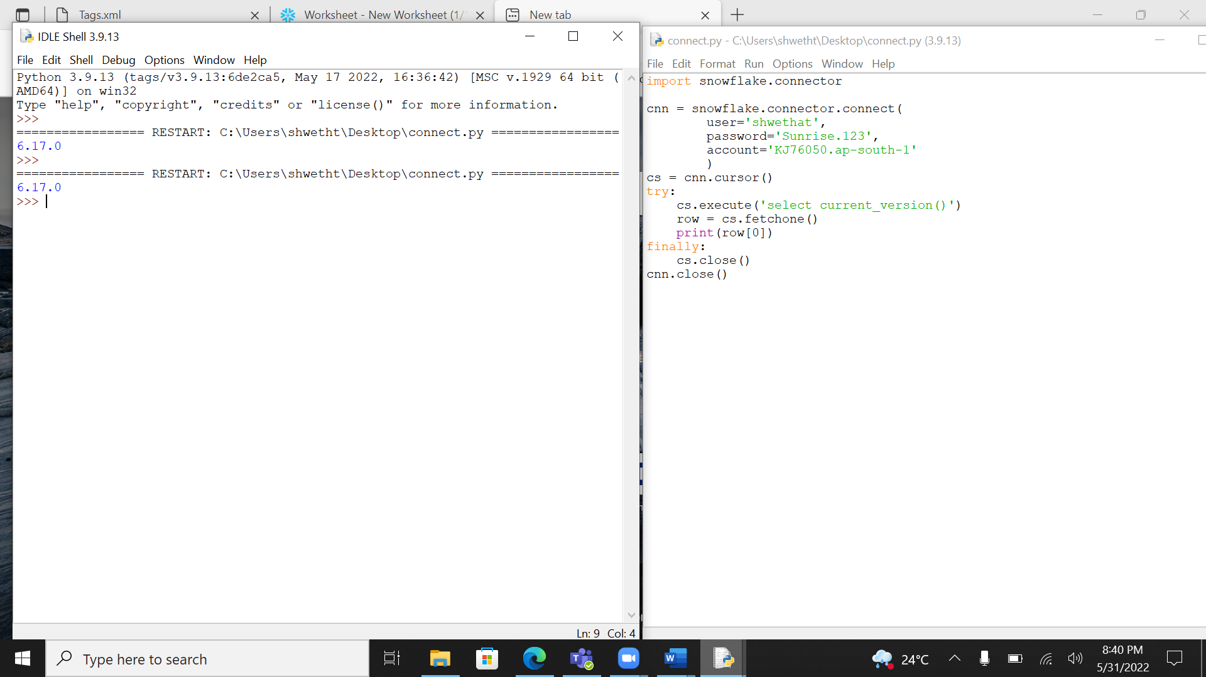

Connection to snowflakes is success

Now load data into table

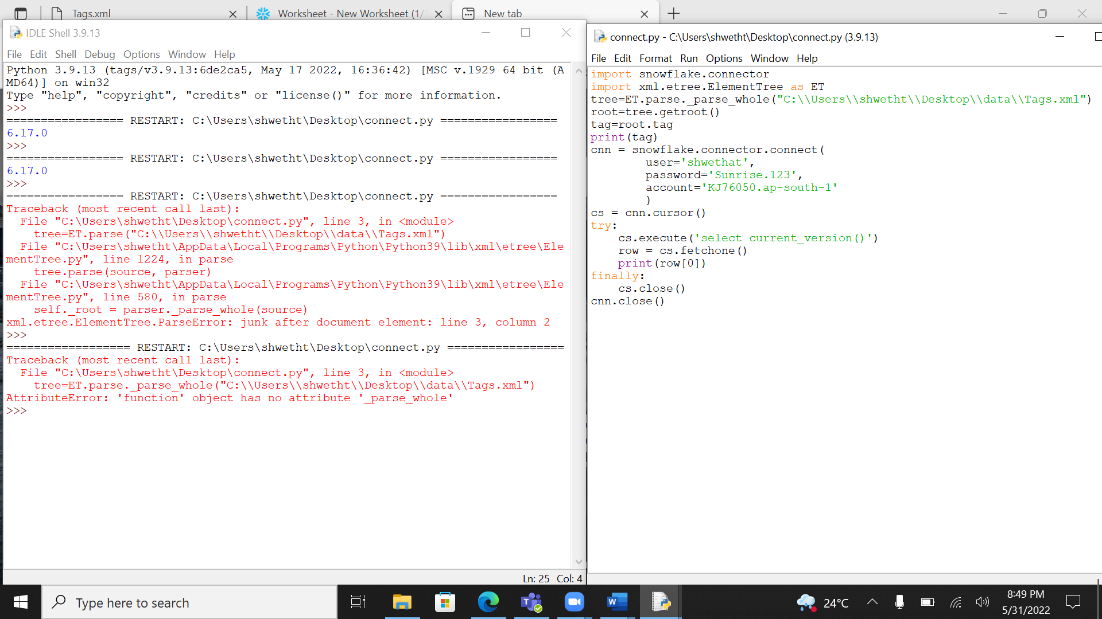

Not able to get xml data so this approach is also having issue with python script. So need to try with the last Method

**Last Method:**

Load data Manually in UI

Queries used:

create table badgestable(

badge_var variant

);

select * from badgestable;

select badge_var: "@Id" as Id,

badge_var: "@UserId" as UserId,

badge_var: "@Name" as Name,

badge_var: "@Date" as Date,

badge_var: "@Class" as Class,

badge_var: "@TagBased" as Tagbased

from badgestable

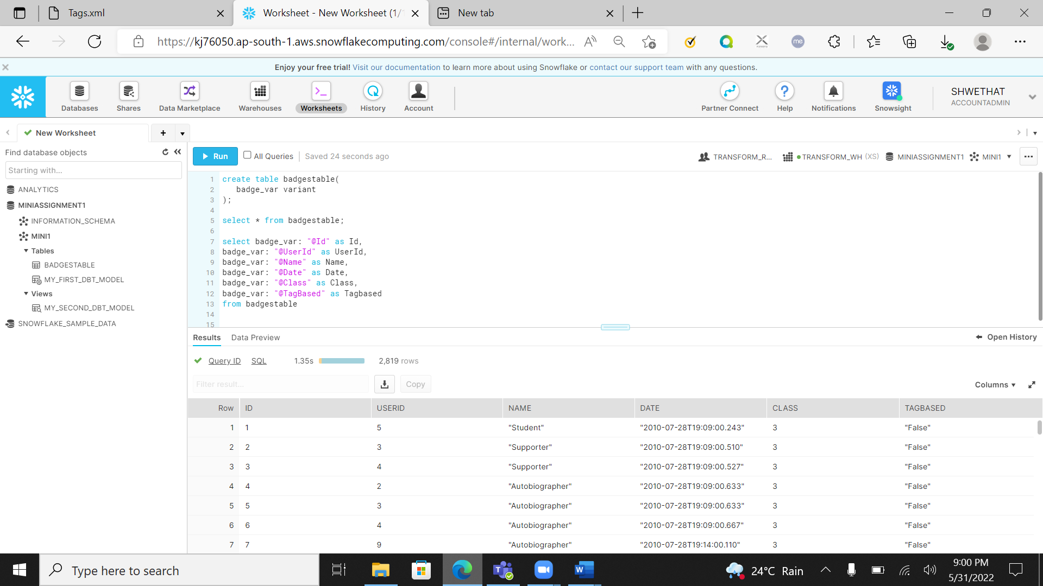

Data Loaded successfully

### #MOST POPULAR BADGES

Query :

select count(badge_var: "@Id") as No_of_User, badge_var: "@Name" as Name

from "MINIASSIGNMENT1"."MINI1"."BADGESTABLE"

group by Name

order by No_of_User desc

limit 10

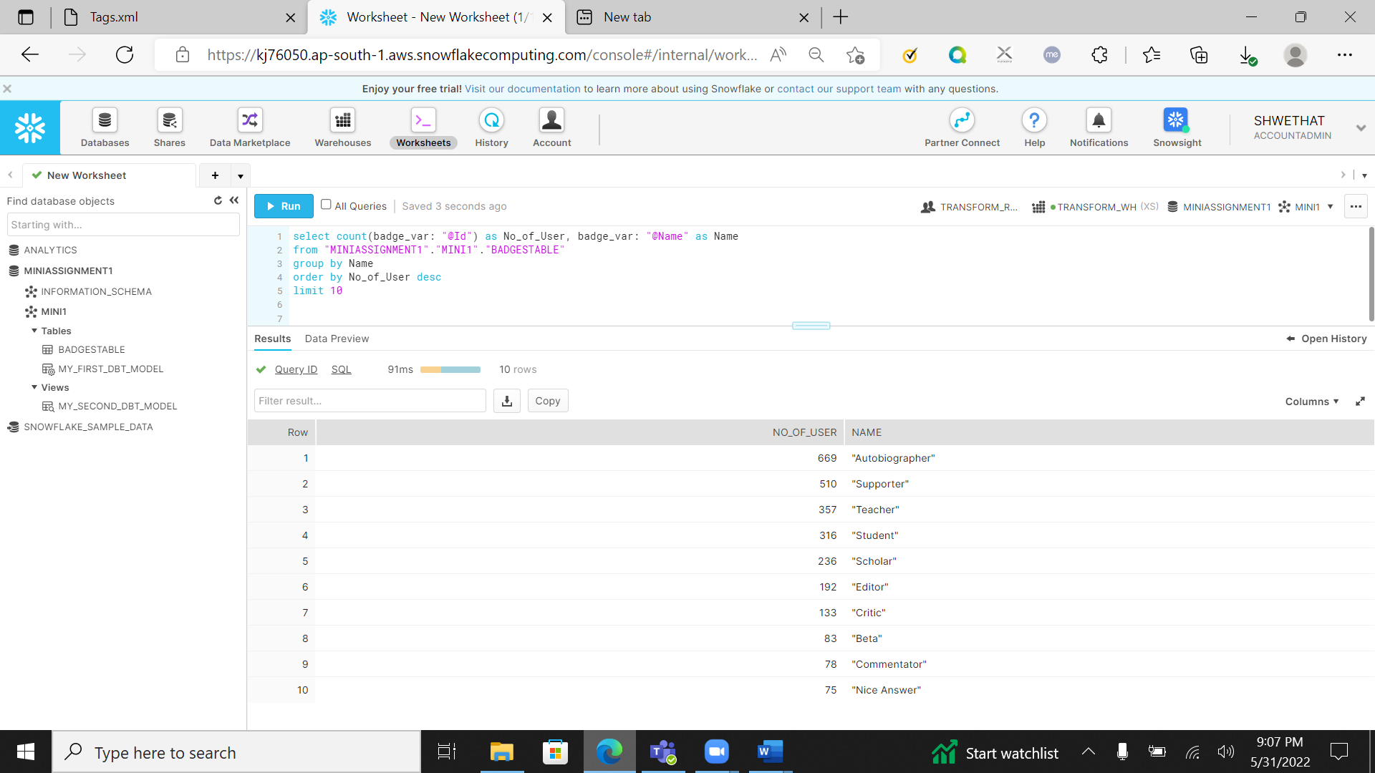

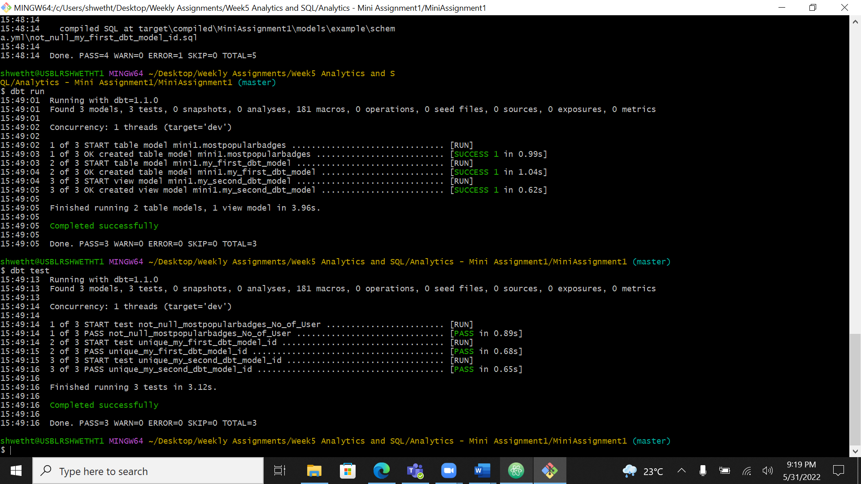

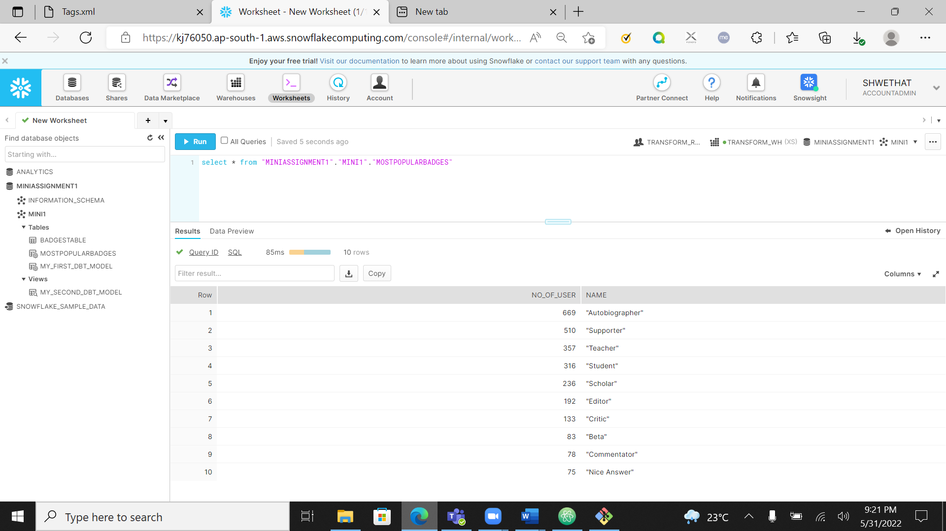

All test cases passed successfully

### #QUESTIONS_LIKE

Query:

select commentsvar: "@Text" as Text

from comments , userstable

where uservar:"@Id" = commentsvar:"@UserId" and

uservar:"@DisplayName" like any('%nau%');

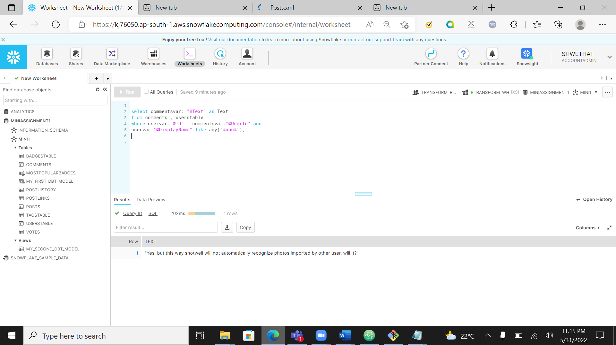

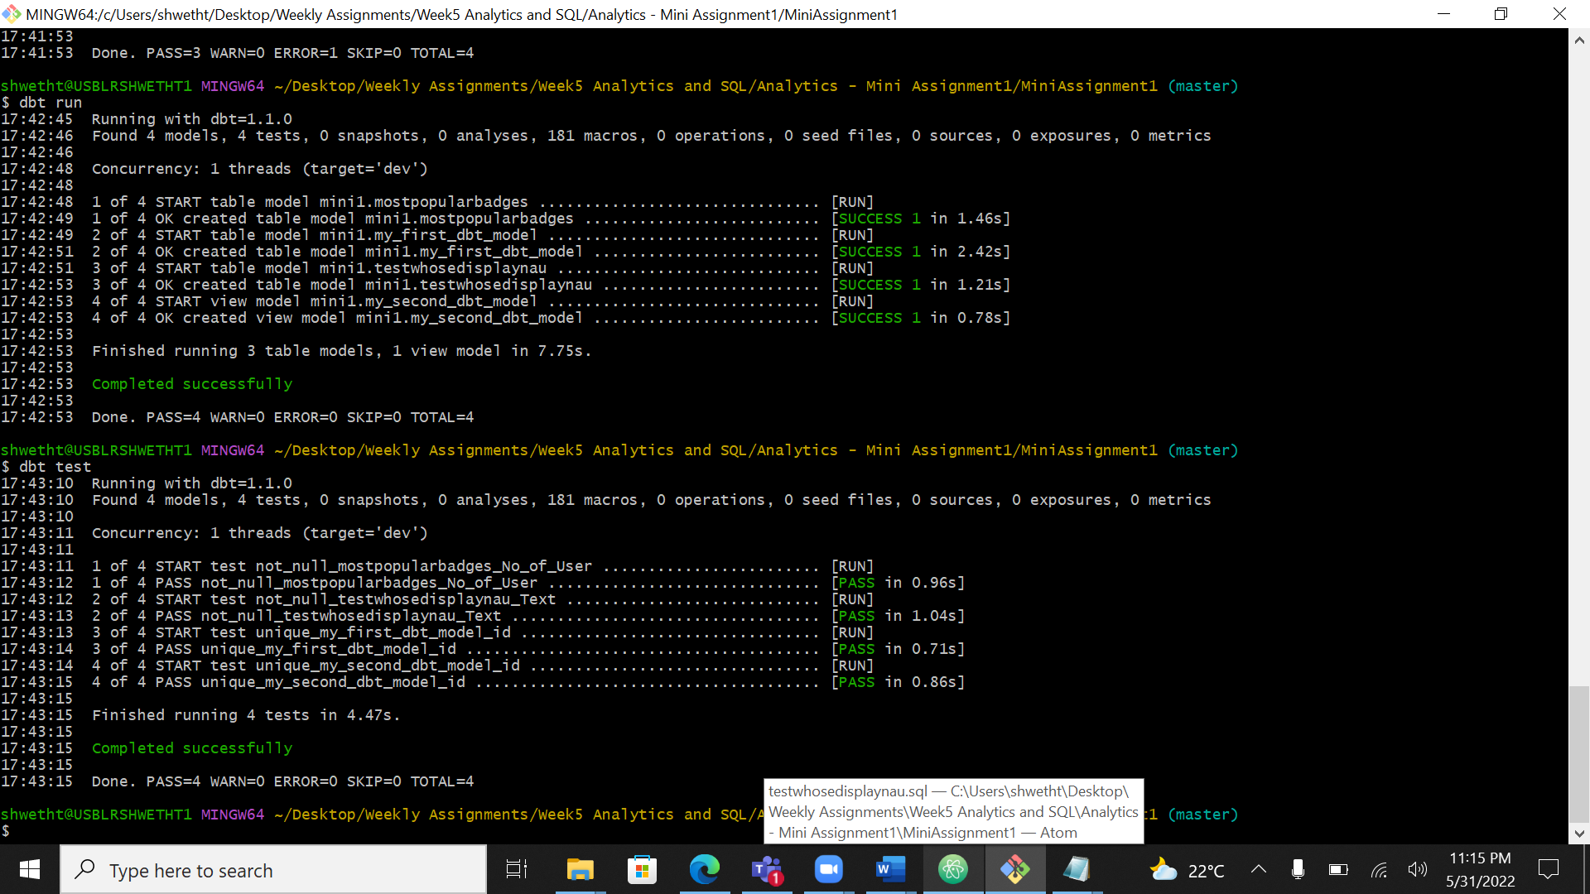

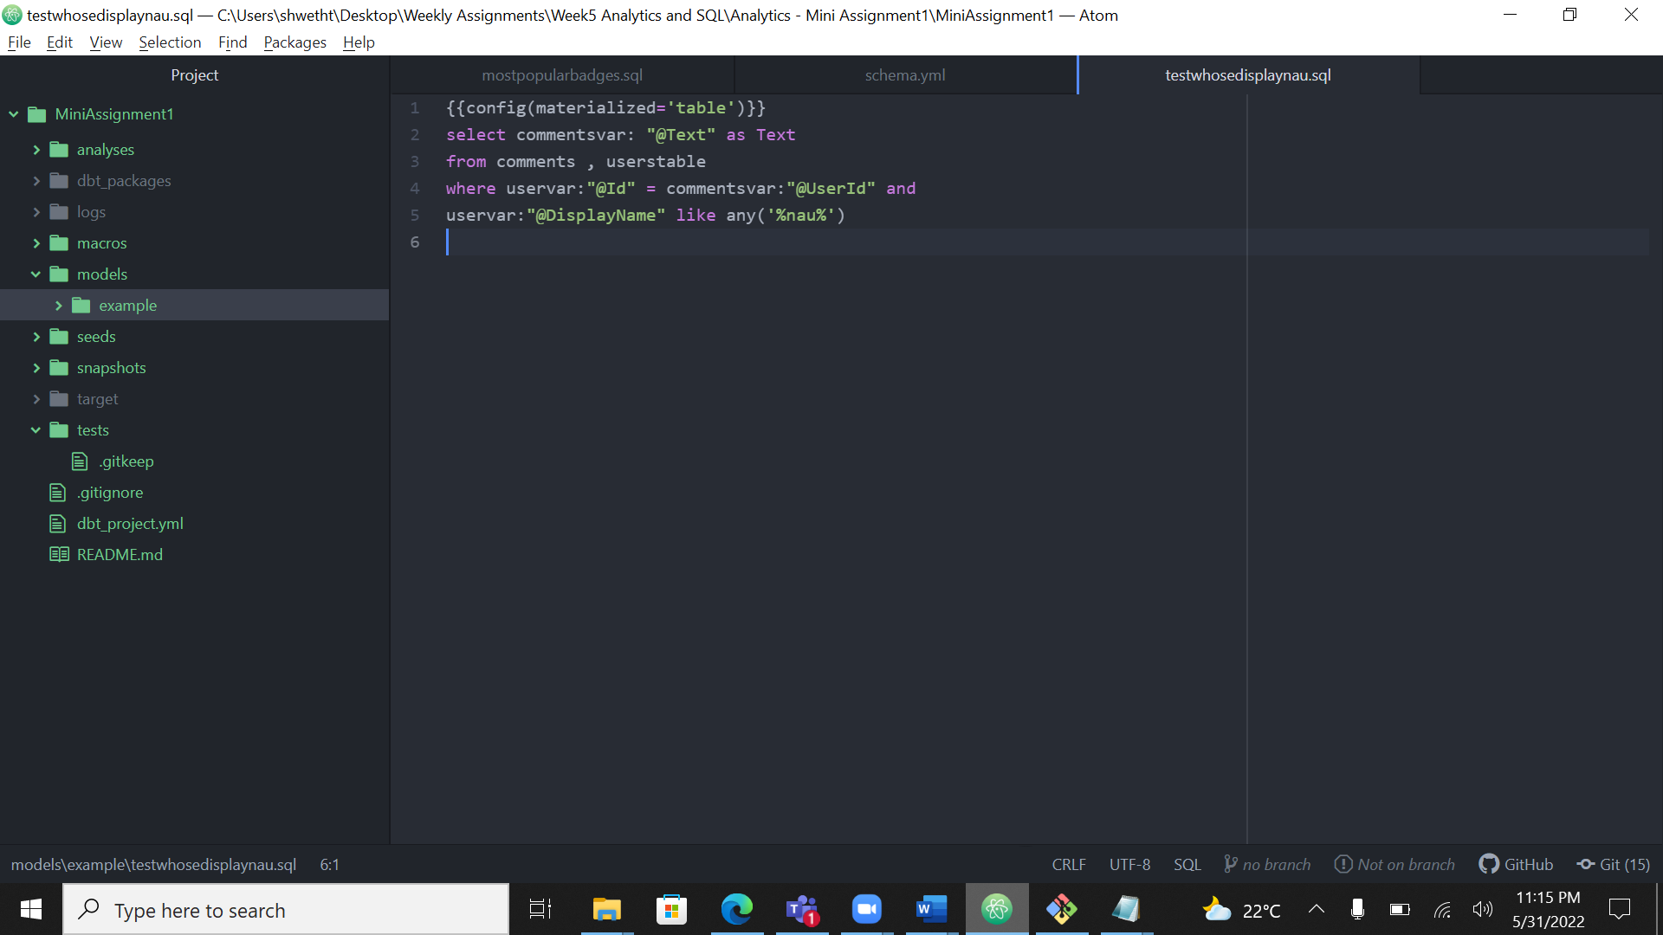

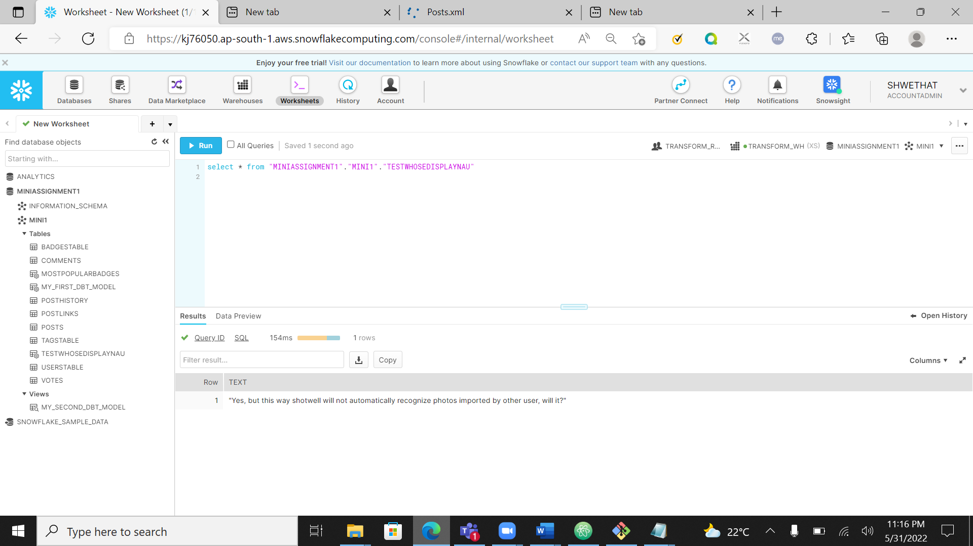

All Test successful

### #QUESTIONS

Query:

select postsvar:"@Body" as Text, uservar: "@DisplayName"

from posts, userstable

where postsvar:"@PostTypeId" = '1' and uservar:"@DisplayName" like any('alexandrul') and postsvar:"@AcceptedAnswerId" = uservar:"@Id";

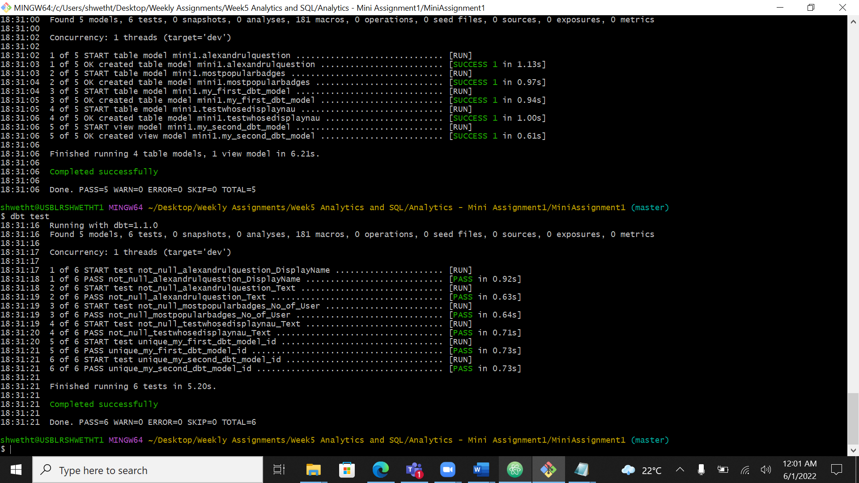

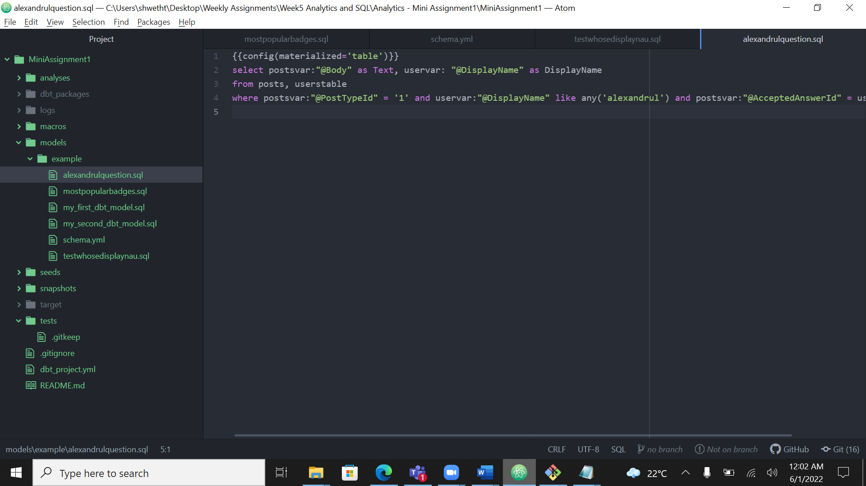

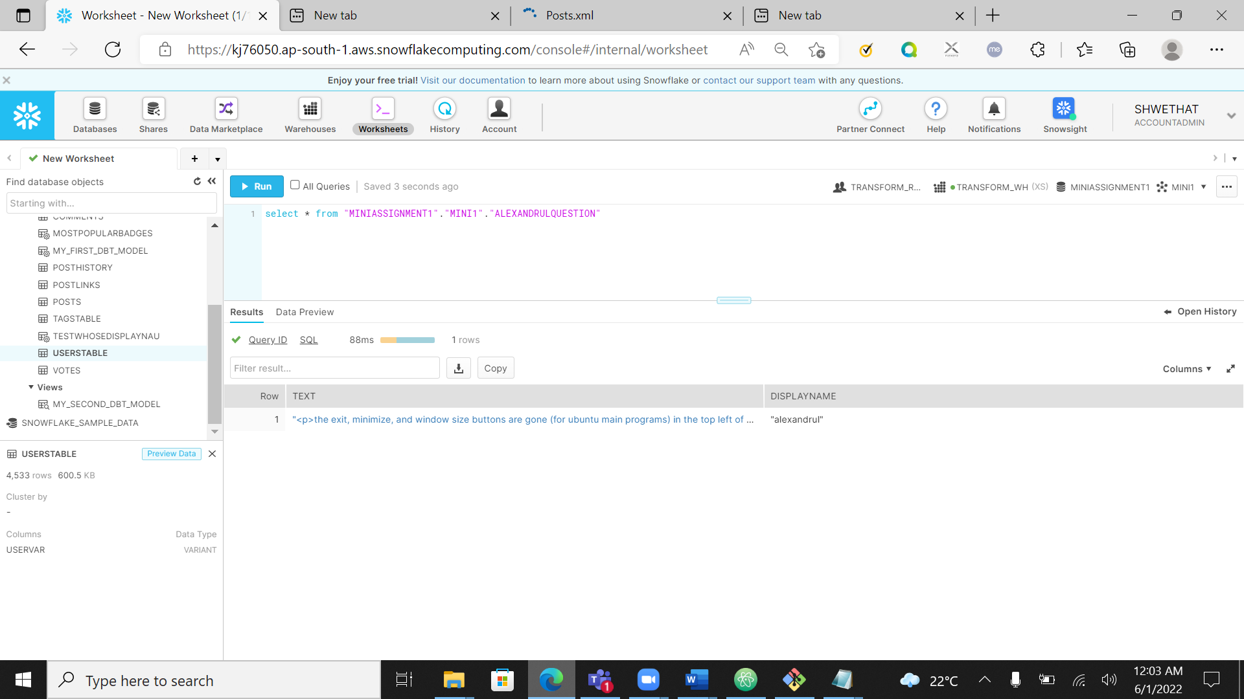

All test successful