**Dhanya M Hegde**

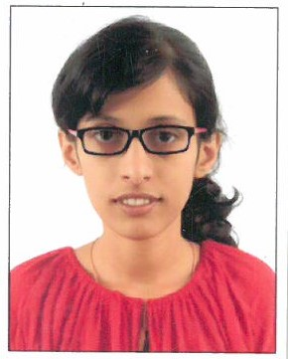

|  |  |
| --- | --- |
| **Title:** | Analyst |
| **Location:** | Bangalore, India |
| **Languages:** | Kannada (native),English (fluent),Hindi (fluent) |

# Experience Summary

**KEY SKILLS:**

* **Functional:** Project Management, Team Building, Communication and Interpretation skills.
* **Technical:** C and Data Structure (Intermediate), Java Core (Intermediate), HTML and CSS (Intermediate), Java Spring (Beginner), Java Microservices (Beginner).

# Training, Certifications & Affiliations

**TRAINING:**

* 6 Days Workshop conducted by Subhash Programming Classes on C Programming
* Java, Spring, Microservices offered by Capgemini Technology Services India Ltd.

**CERTIFICATION:**

* Virtualization for Beginners from VMware
* VMware Hands on Datacenter Virtualization using VSphere 6.0 with 75%
* Data Analytics from VTC Internshaala with 72.5%

# Higher Education

|  |  |  |
| --- | --- | --- |
| **Degree** | **University** | **Percentage** |
| B.E | Visvesvaraya Technological University | 69.1 |