**Shweta Srivastawa**

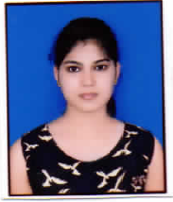

|  |  |
| --- | --- |
| **Title:** | Analyst |
| **Location:** | Bangalore, India |
| **Languages:** | Hindi (native),English (fluent) |

# Experience Summary

**KEY SKILLS:**

* **Functional:** Project Management, Team Building, Communication and Interpretation skills.
* **Technical:** C and Data Structure (Intermediate), C++ with OOPS (Intermediate), Java Core (Intermediate), HTML and CSS (Intermediate), Java Spring (Beginner), Java Microservices (Beginner).

# Training, Certifications & Affiliations

**TRAINING:**

* Raspberry-Pi and Applications of IOT offered by Enthu Technology Solutions India Pvt Ltd
* Android Application Development offered by Department of ISE, GAT Bangalore.
* Java, Spring, Microservices offered by Capgemini Technology Services India Ltd.

# Higher Education

|  |  |  |
| --- | --- | --- |
| **Degree** | **University** | **Percentage** |
| B.E. | Visvesvaraya Technological University | 73.09 |