AI Architect Solution - User Guide
This guide explains how to use AI Architect Solution.

1. Home Page
Click Start New Solution.
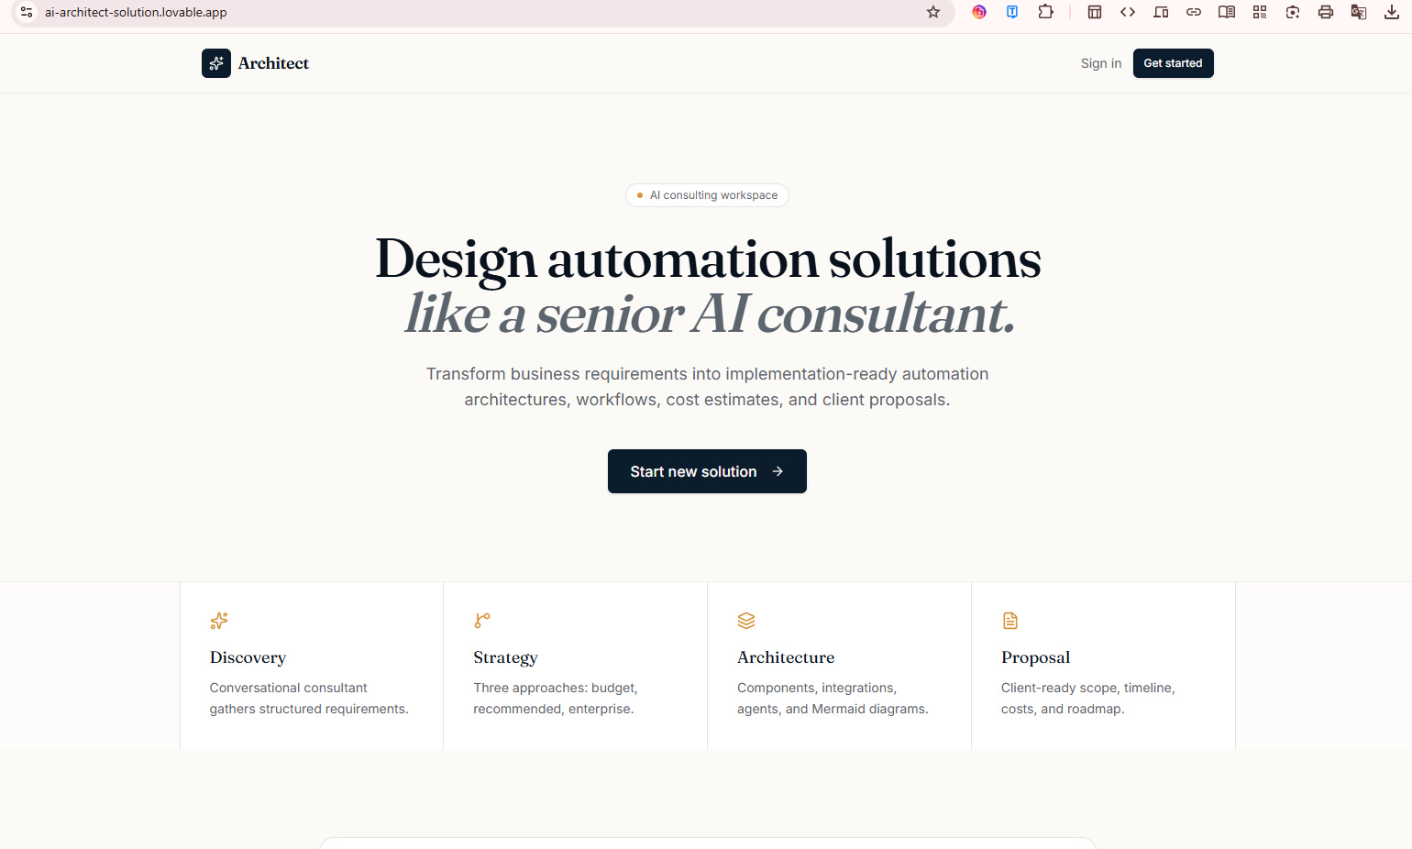

2. Sign In
Login or create an account.
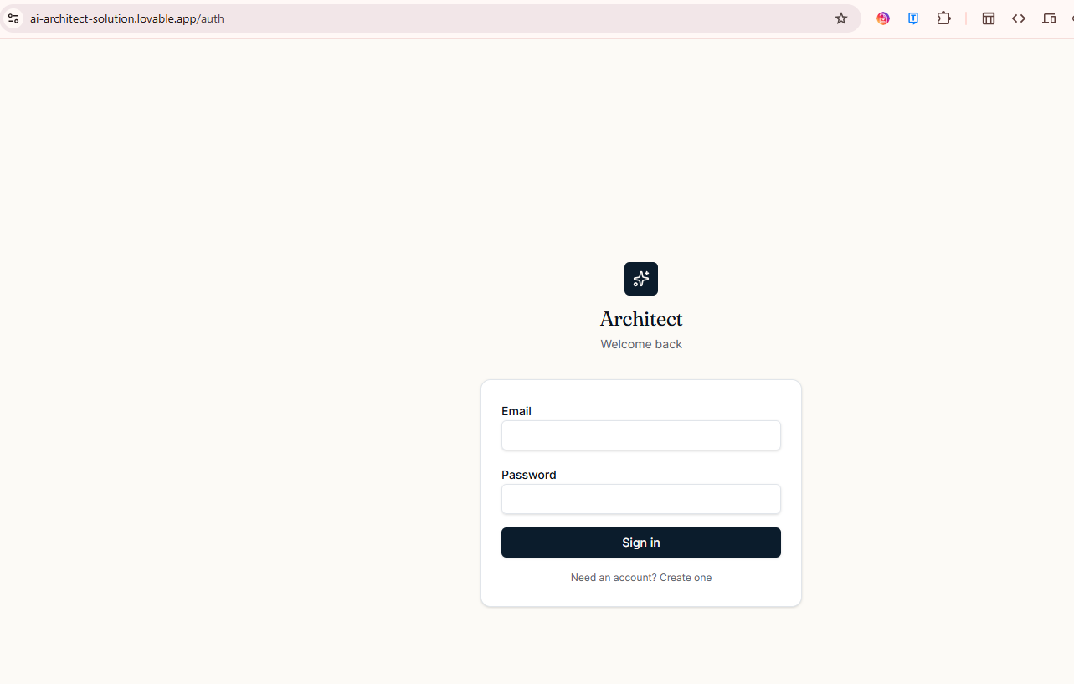

3. Dashboard
Manage projects or create a new one.
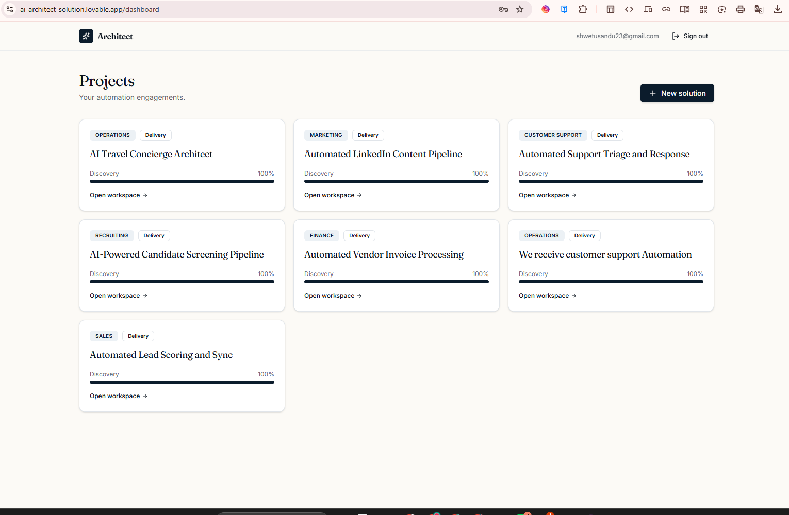

4. New Solution
Describe your business problem and begin discovery.
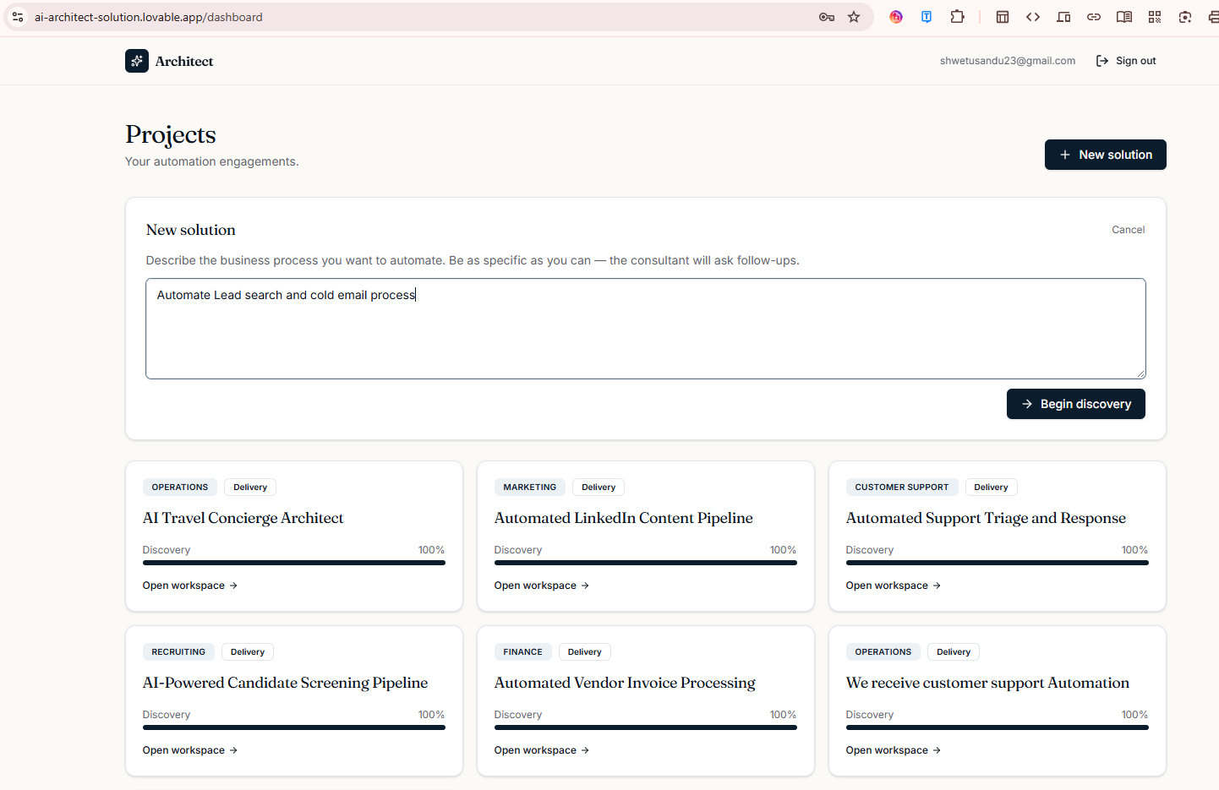

5. Discovery
Answer AI questions until discovery is complete.
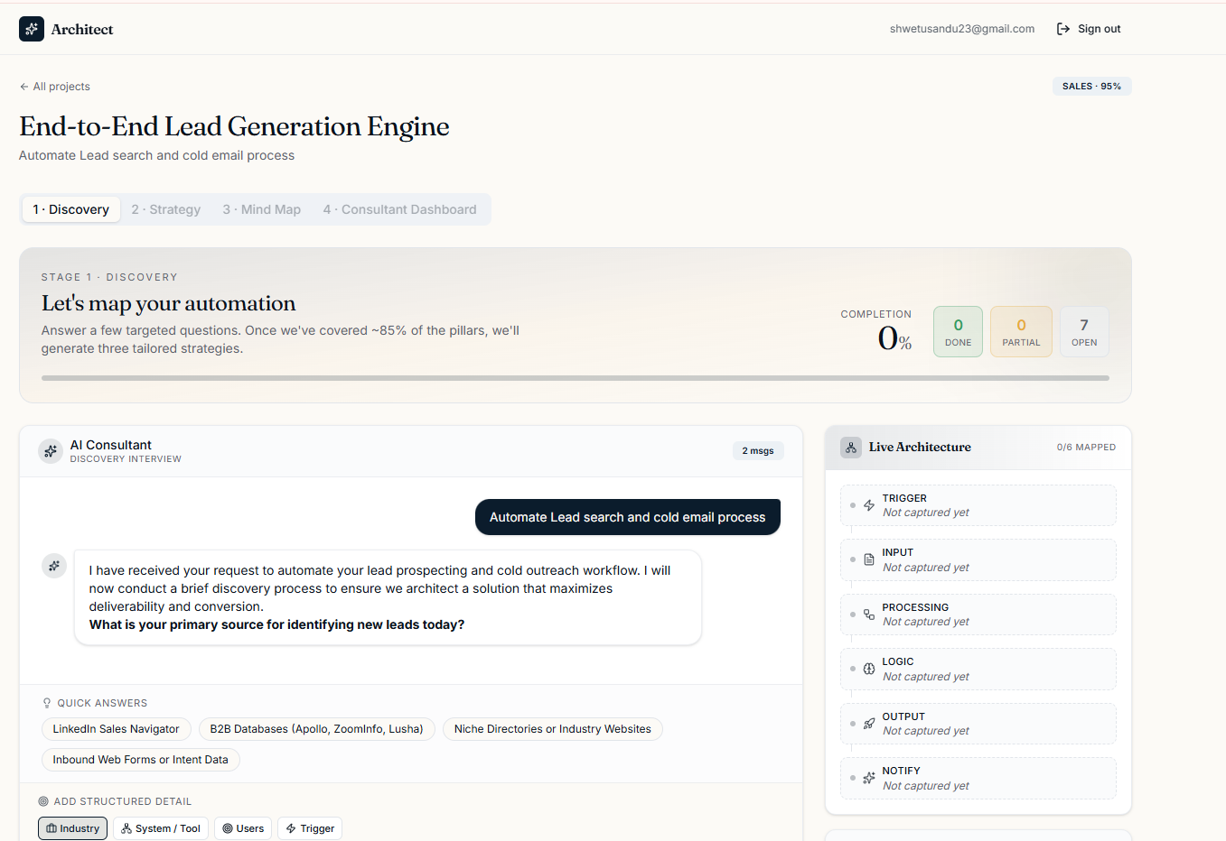

6. Strategy
Choose Budget, Recommended, or Enterprise.
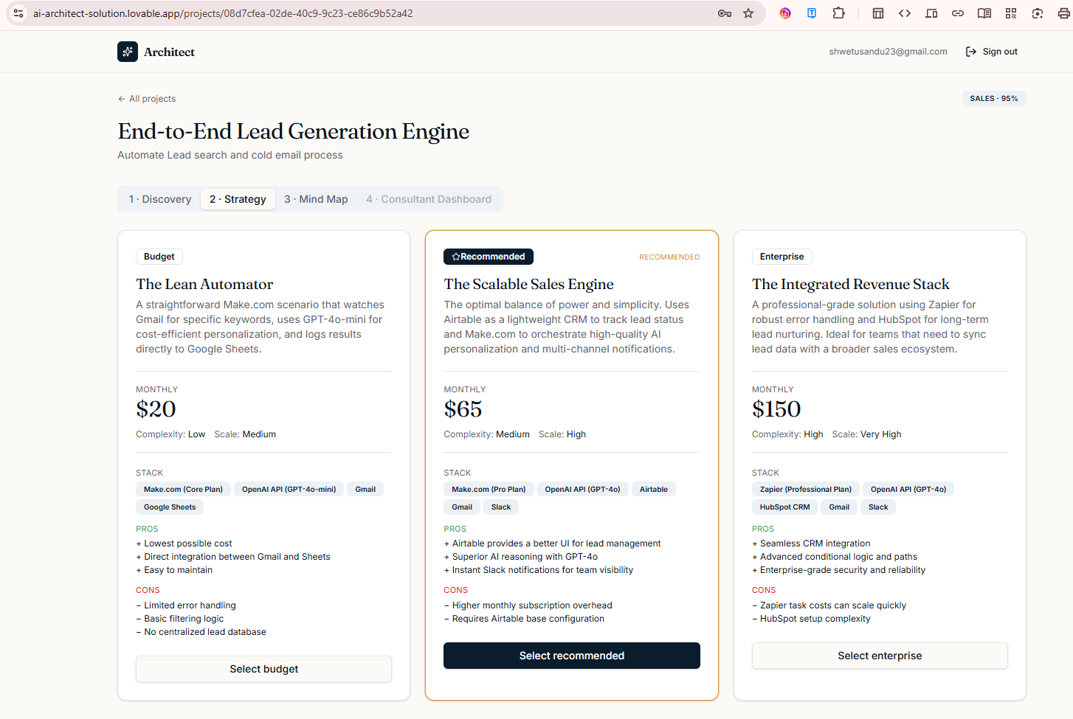

7. Consultant Dashboard
Generate all project documents.
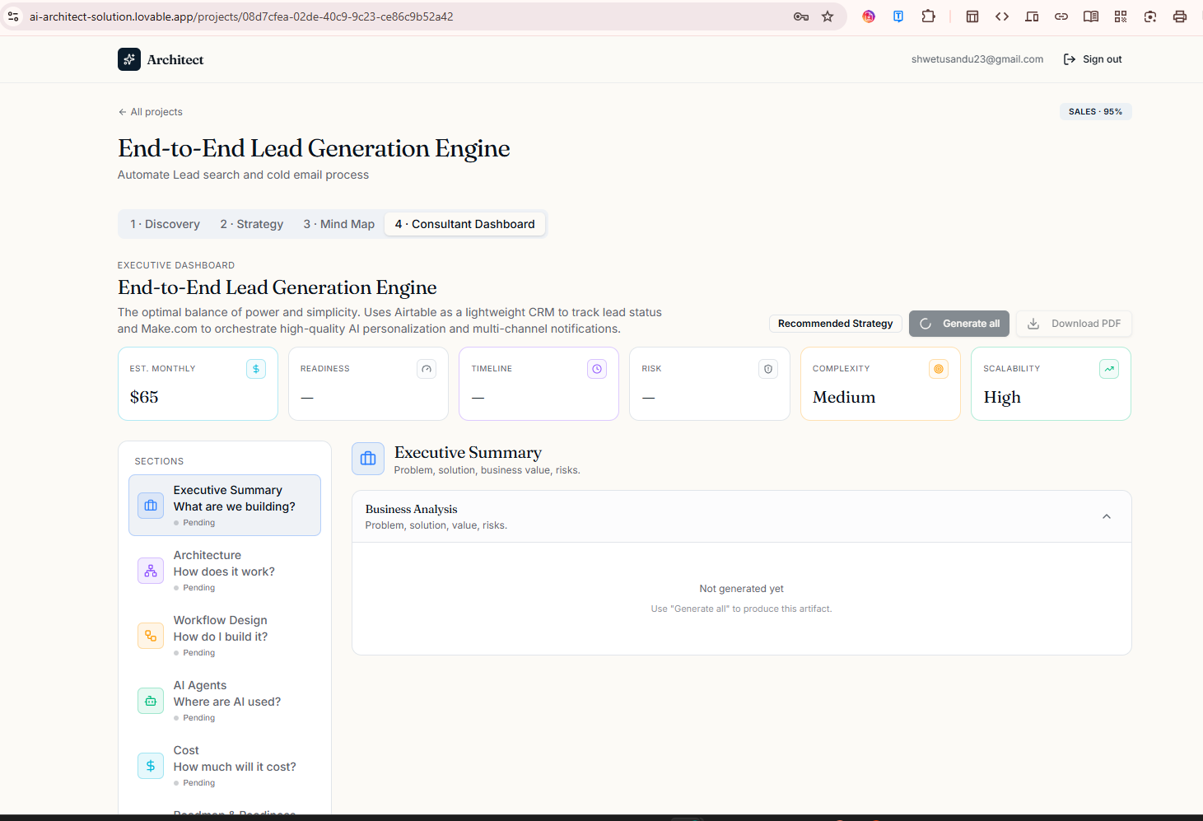
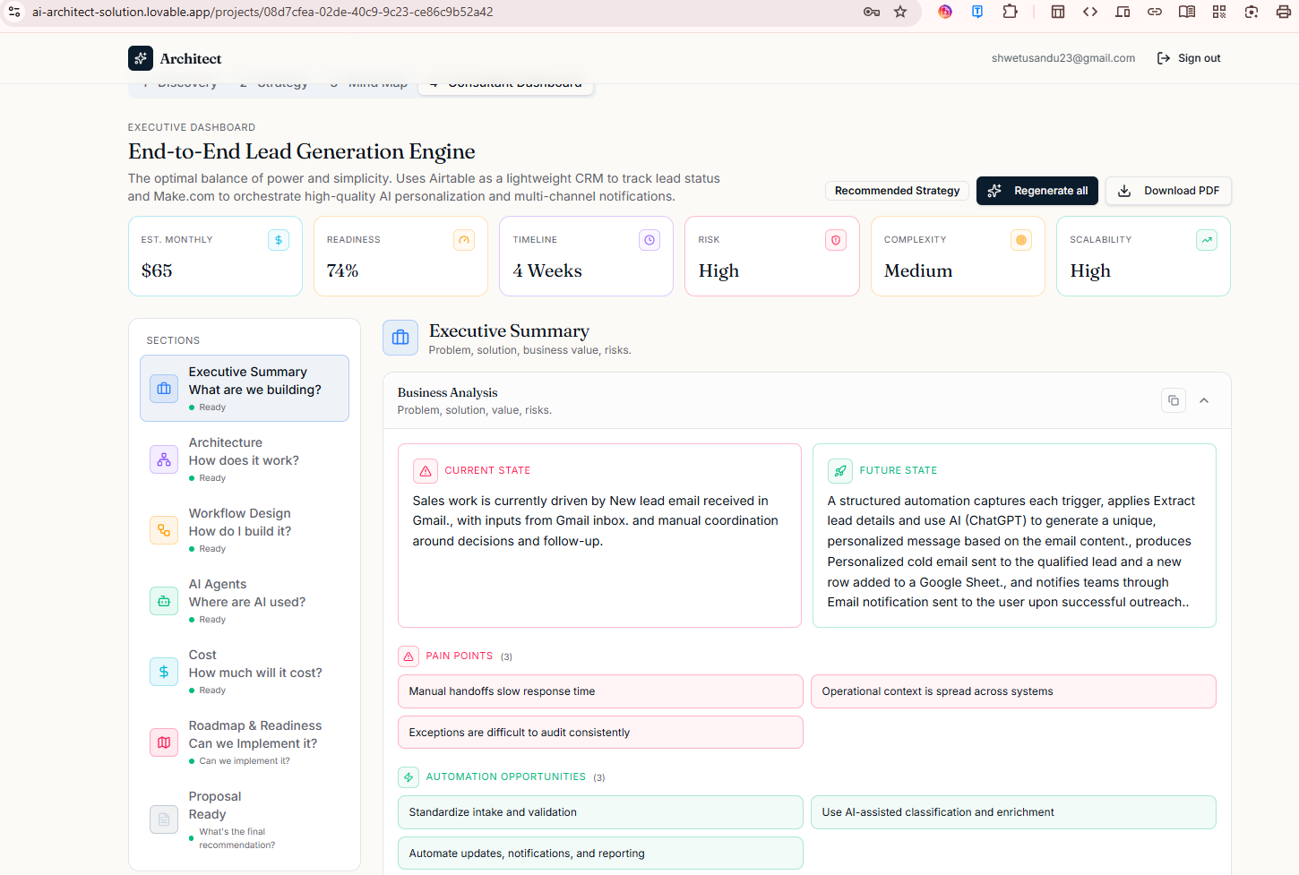

8. Download PDF
Export the final implementation document.

