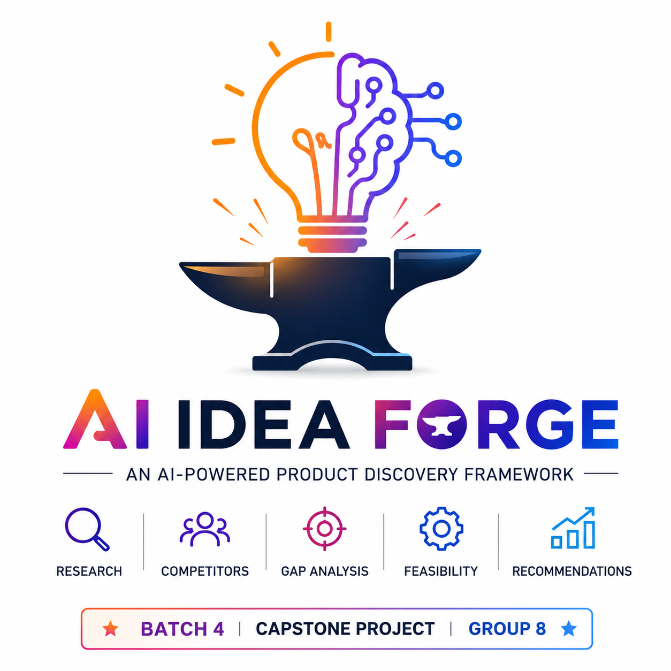

AI Idea Forge
An AI-Powered Product Discovery Framework
Tagline: Transform Ideas into Validated Products with AI

Problem Statement
Validating a product idea is often a manual, time-consuming, and inconsistent process. Teams typically use multiple tools to research competitors, analyze market trends, evaluate technical feasibility, and assess business potential. This fragmented approach increases research effort, delays decision-making, and can lead to costly mistakes.

Proposed Solution
AI Idea Forge provides a centralized AI-powered platform that accepts a product idea, business concept, or website URL and automatically performs comprehensive product discovery using specialized AI agents and live web research.
The platform delivers structured insights and actionable recommendations, enabling users to determine whether an idea is worth pursuing before development begins.

Features to Build
- AI Idea Analysis
- Live Market Research
- Competitor Discovery
- Competitor Benchmarking
- Market Gap Analysis
- Technical Feasibility
- Business Feasibility
- AI Recommendations
- Executive Report Generation
- Interactive Dashboard

Target Users
- Entrepreneurs
- Startup Founders
- Product Managers
- Innovation Teams
- Business Analysts
- Students and Capstone Teams

Technology Stack
Layer | Technology
Frontend | Lovable/Replit
Workflow Orchestration | n8n
AI Models | OpenAI GPT/Claude
Database | Supabase
Live Research | Web Search APIs
Backend | REST APIs
Documentation | GitHub
API Testing | Postman/Vercel

Impact
AI Idea Forge reduces the effort required to validate product ideas by automating research and analysis through a repeatable AI workflow. It enables faster, more informed product decisions while demonstrating AI orchestration, workflow automation, API integration, and modern software architecture.

