AI Idea Forge
AI Product Discovery Platform
Batch 4 – Group 8
CHAPTER
Database Design

1. Database Overview
The AI Idea Forge platform is backed by a Supabase PostgreSQL database, which serves as the single source of truth for every stage of the idea-validation workflow. The database is responsible for storing user accounts and profiles, submitted startup ideas, AI-generated analyses, the execution status of each analysis stage, confidence scores associated with AI output, generated reports, and a record of user activity across the platform.
The schema is organized around a single, clearly defined workflow: a user submits an idea, the platform's AI generates a consolidated understanding of that idea, and six specialist AI agents independently analyze it from different strategic angles. This design keeps each stage of analysis isolated in its own table while remaining traceable back to the original submission, which simplifies both the application logic and the process of reasoning about the system as a whole.

2. Entity Relationship Diagram (ERD)
The diagram below illustrates the core entity relationships of the platform, derived directly from the exported table schemas. The user submits an idea, which is stored in new_analysis_data; this record is the parent of both the AI-generated master record (ai_analysis_data) and the six specialist analysis tables.
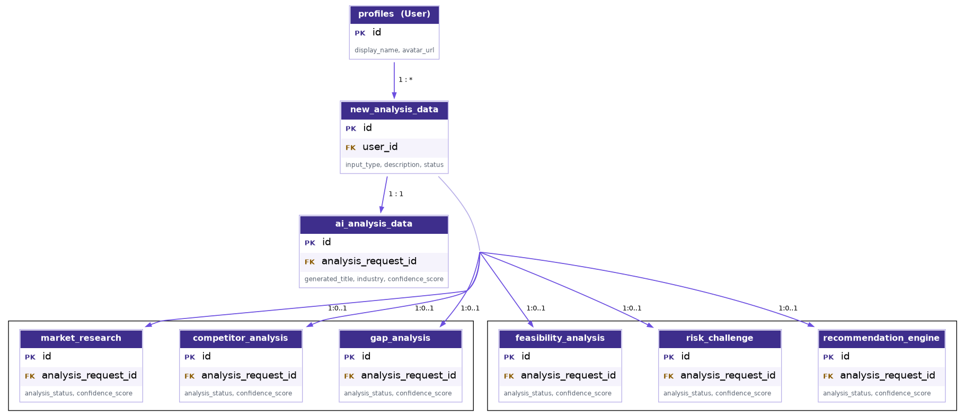
Figure 1. Entity Relationship Diagram – AI Idea Forge Core Analysis Workflow
A schema-level observation is worth noting for accuracy: while the platform's conceptual workflow presents ai_analysis_data as sitting “between” the idea submission and the six specialist agents, the exported data shows that all seven downstream tables (ai_analysis_data and the six specialist tables) store an analysis_request_id value that references new_analysis_data.id directly — confirmed by matching identical UUID values across these tables. Architecturally, ai_analysis_data and the six specialist tables are therefore parallel children of new_analysis_data rather than a strict linear chain. Conceptually, however, ai_analysis_data still functions as the consolidated “identity record” of the idea, since it is the first AI-generated artifact produced from the raw submission.

3. Database Relationship Summary
The table below summarizes every relationship identified from the exported schema data. All relationships listed are explicit, evidenced by matching foreign key values observed across the corresponding CSV exports.
Parent Table | Child Table | Relationship | Foreign Key
profiles (User) | new_analysis_data | One-to-Many | new_analysis_data.user_id → profiles.id
new_analysis_data | ai_analysis_data | One-to-One | ai_analysis_data.analysis_request_id → new_analysis_data.id
new_analysis_data | market_research | One-to-Zero/One | market_research.analysis_request_id → new_analysis_data.id
new_analysis_data | competitor_analysis | One-to-Zero/One | competitor_analysis.analysis_request_id → new_analysis_data.id
new_analysis_data | gap_analysis | One-to-Zero/One | gap_analysis.analysis_request_id → new_analysis_data.id
new_analysis_data | feasibility_analysis | One-to-Zero/One | feasibility_analysis.analysis_request_id → new_analysis_data.id
new_analysis_data | risk_challenge | One-to-Zero/One | risk_challenge.analysis_request_id → new_analysis_data.id
new_analysis_data | recommendation_engine | One-to-Zero/One | recommendation_engine.analysis_request_id → new_analysis_data.id

4. Database Table Documentation
This section documents the purpose, keys, relationships, and key attributes of each core table in the analysis workflow. Column-level detail has been intentionally limited to the attributes most relevant to understanding each table's role in the system.
new_analysis_data
Purpose | Acts as the entry point of the platform's core workflow. Every time a user submits a startup idea — whether typed as free text or supplied as a website URL — a new record is created here first. It represents the raw, unprocessed idea submission before any AI analysis takes place.
Primary Key | id (UUID)
Foreign Key(s) | - user_id: references profiles.id (the submitting user).
Relationship | One-to-Many with profiles (a user may submit many analyses). One-to-One with ai_analysis_data, and One-to-Zero/One with each of the six specialist analysis tables described below.
Key Attributes | - Submission Information: input_type, description  - Processing Status: status  - Ownership & Timestamps: user_id, created_at
Used By | New Analysis (idea submission form) and Dashboard (list of recent and pending analyses).

ai_analysis_data
Purpose | Stores the AI-generated master record for a submitted idea. When the platform's AI first processes a raw submission, it produces a refined title, description, and industry classification here, along with an overall matching score. This record acts as the consolidated identity of the idea that the rest of the application refers back to.
Primary Key | id (UUID)
Foreign Key(s) | - analysis_request_id: references new_analysis_data.id (the originating submission).
Relationship | One-to-One with new_analysis_data — every submitted idea produces exactly one AI-generated master record.
Key Attributes | - AI-Generated Identity: generated_title, generated_description, industry  - Scoring & Reanalysis: matching_score, is_reanalysis, reanalysis_count  - Processing Information: analysis_status, ai_model, processing_time_ms, confidence_score
Used By | Discovery Galaxy (idea header), Dashboard, and Resume Analysis (restoring a pending analysis).

market_research
Purpose | Stores the output of the Market Research agent — an independent, in-depth study of the idea's target market, sized opportunity, and competitive environment at a macro level.
Primary Key | id (UUID)
Foreign Key(s) | - analysis_request_id: references new_analysis_data.id — not ai_analysis_data.id. This was confirmed directly from the exported data, where identical UUID values are shared across new_analysis_data and this table's analysis_request_id column.
Relationship | One-to-Zero/One with new_analysis_data. Not every submitted idea has a completed Market Research record, since analysis is generated asynchronously and may still be in progress.
Key Attributes | - Market Definition: problem, market_size, target_customers  - Market Dynamics: market_trends, customer_pain_points, barriers_to_entry, market_growth_rate, market_maturity  - Compliance Context: regulatory_factors  - Processing Information: analysis_status, confidence_score
Used By | Discovery Galaxy (Market Research agent panel) and Reports.

competitor_analysis
Purpose | Stores the output of the Competitor Analysis agent, which identifies direct and indirect competitors and evaluates the idea's competitive positioning against them.
Primary Key | id (UUID)
Foreign Key(s) | - analysis_request_id: references new_analysis_data.id.
Relationship | One-to-Zero/One with new_analysis_data.
Key Attributes | - Competitor Landscape: direct_competitors, indirect_competitors  - Positioning: competitor_strengths, competitor_weaknesses, market_positioning, competitive_landscape_summary  - Processing Information: analysis_status, confidence_score
Used By | Discovery Galaxy (Competitor Analysis agent panel) and Reports.

gap_analysis
Purpose | Stores the output of the Gap Analysis agent, which identifies unmet needs in the market and highlights opportunities for the idea to differentiate itself.
Primary Key | id (UUID)
Foreign Key(s) | - analysis_request_id: references new_analysis_data.id.
Relationship | One-to-Zero/One with new_analysis_data.
Key Attributes | - Identified Gaps: identified_market_gaps, customer_unmet_needs  - Opportunity Areas: innovation_gaps, differentiation_opportunities  - Processing Information: gap_summary, analysis_status, confidence_score
Used By | Discovery Galaxy (Gap Analysis agent panel) and Reports.

feasibility_analysis
Purpose | Stores the output of the Feasibility Analysis agent, which assesses how realistic the idea is to build and commercialize from both a business and technical standpoint.
Primary Key | id (UUID)
Foreign Key(s) | - analysis_request_id: references new_analysis_data.id.
Relationship | One-to-Zero/One with new_analysis_data.
Key Attributes | - Feasibility Scores: business_feasibility_score, technical_feasibility_score, overall_feasibility_score  - Resourcing & Planning: required_resources, technology_stack, estimated_development_complexity, estimated_time_to_market, estimated_budget_range  - Processing Information: analysis_status, confidence_score
Used By | Discovery Galaxy (Feasibility Analysis agent panel) and Reports.

risk_challenge
Purpose | Stores the output of the Risk & Challenge agent, which evaluates the market, technical, business, financial, legal, and operational risks associated with pursuing the idea.
Primary Key | id (UUID)
Foreign Key(s) | - analysis_request_id: references new_analysis_data.id.
Relationship | One-to-Zero/One with new_analysis_data.
Key Attributes | - Risk Categories: market_risks, technical_risks, business_risks, financial_risks, legal_and_regulatory_risks  - Operational Assessment: operational_challenges, risk_mitigation_strategies, overall_risk_level  - Processing Information: risk_summary, analysis_status, confidence_score
Used By | Discovery Galaxy (Risk & Challenge agent panel) and Reports.

recommendation_engine
Purpose | Stores the output of the Recommendation Engine agent, which synthesizes the findings of the other agents into a final opportunity score and a set of actionable strategic recommendations.
Primary Key | id (UUID)
Foreign Key(s) | - analysis_request_id: references new_analysis_data.id.
Relationship | One-to-Zero/One with new_analysis_data.
Key Attributes | - Opportunity Scoring: overall_opportunity_score  - Strategic Guidance: priority_recommendations, recommended_next_steps, product_improvements, business_strategy, go_to_market_strategy  - Processing Information: recommendation_summary, analysis_status, confidence_score
Used By | Discovery Galaxy (Recommendation Engine agent panel), Dashboard (Ready/Avoid recommendation cards), and Reports.

5. Database Workflow
The database workflow is represented below as a use-case diagram, showing how the two primary actors in the system — the User and the AI Analysis Engine — interact with the platform's core data-driven processes, from idea submission through to consolidated reporting.
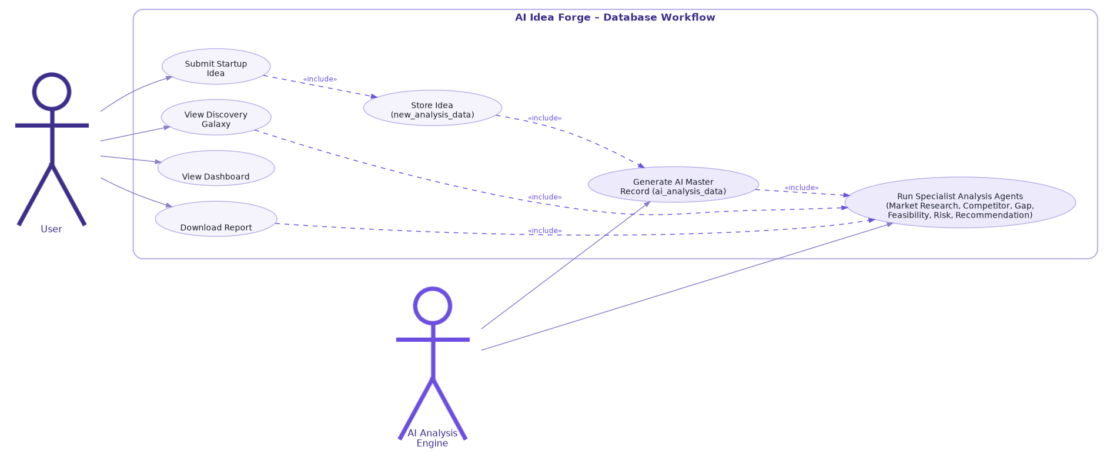
Figure 2. Use-Case Diagram – AI Idea Forge Database Workflow
Actors
- User: submits new ideas, and views the resulting analysis through the Discovery Galaxy, Dashboard, and downloadable reports.
- AI Analysis Engine: the backend AI process that generates the consolidated master record and runs the six specialist analysis agents on the user's behalf.
Use Case Flow
- Store Idea: The user's submission is stored as a new row in new_analysis_data — modeled as an included step of Submit Startup Idea.
- Generate AI Master Record: Once stored, the AI Analysis Engine generates the consolidated ai_analysis_data record from the raw submission.
- Run Specialist Analysis Agents: The AI Analysis Engine then runs all six specialist agents (Market Research, Competitor Analysis, Gap Analysis, Feasibility Analysis, Risk & Challenge, and Recommendation Engine), each writing its findings back to its own dedicated table.
- Downstream Use Cases: Viewing the Discovery Galaxy and downloading a report both include the specialist agent results, since both use cases read directly from the six analysis tables.

6. Database Design Considerations
The schema reflects a set of deliberate architectural choices intended to support a multi-agent AI system that will continue to grow in complexity over time.
Normalized, Modular Analysis Design
Rather than storing every agent's output in a single wide table, each specialist agent is given its own dedicated table. This modular separation keeps each agent's data model independent, so the schema for one agent (for example, Feasibility Analysis) can evolve without affecting the schema of another (for example, Risk & Challenge).
Separation of Concerns
The raw idea submission (new_analysis_data), the AI-consolidated identity of the idea (ai_analysis_data), and the specialist analyses are all kept in distinct tables. This separation means each table has a single, well-defined responsibility, which simplifies both querying and long-term maintenance.
Reduced Redundancy and Data Integrity
By having every specialist table reference the same originating new_analysis_data.id, the platform avoids duplicating idea-level information (such as the submission text) across seven different tables. Each agent table is only responsible for storing the output specific to its own analysis.
Scalability and Extensibility
Because each AI agent is backed by its own table with a consistent analysis_request_id foreign key pattern, adding a future AI agent to the platform is a matter of introducing a new table that follows the same convention, without requiring any structural change to new_analysis_data or the existing agent tables.
Query Performance
Isolating each agent's output into its own table keeps individual tables narrow and query patterns predictable — the Discovery Galaxy interface, for example, can query a single specialist table for its corresponding panel rather than filtering a single large, heavily overloaded table.

