Design Document

**Table of Contents**

1. Purpose 3

2. Use Case 3

3. Flow Chart 3

4. Database Design 5

5. Required Objects, Services, and Libraries 6

# Purpose

The document illustrates the low-level design details of user management. The document can be used by developers to implement the following functionalities,

* The administrator can add new user and user role and store it in the system.

# Use Case

The following are the use cases for which the use case diagram would be

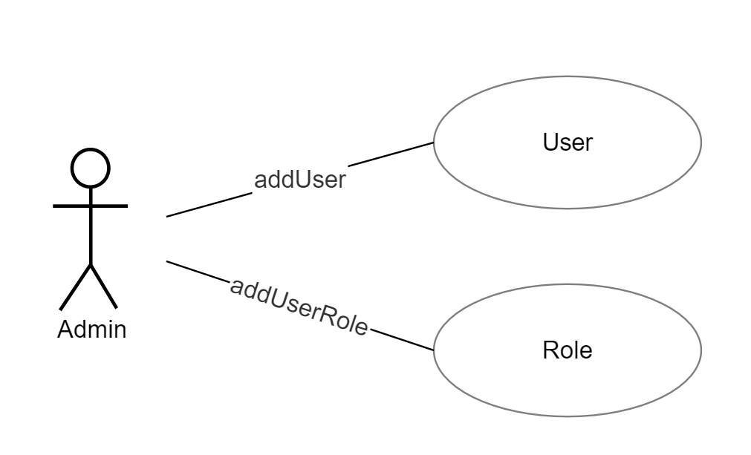

# Flow Chart

The following are flow charts illustrate the process flow of the two use cases.

* **Add User**
* **Add Role**

Start

Add User Details

Add Role Details

Validate the details

Stop

No

Yes

Display the appropriate error message.

Data added to User, Roles and User Roles tables

# Database Design

|  |  |  |  |  |  |  |
| --- | --- | --- | --- | --- | --- | --- |
| Table Name | Column Name | Column Discription | Data Type | Data Size | Primary Key | Foreign Key |
| user | user_id |  | number | 11 | Yes |  |
|  | user_code |  | number | 50 | No |  |
|  | user_phone |  | varchar | 50 | No |  |
|  | user_email |  | varchar | 200 | No |  |
|  | pan_no |  | varchar | 50 | No |  |
|  | user_password |  | varchar | 50 | No |  |
|  | is_active |  | boolean |  | No |  |

|  |  |  |  |  |  |  |
| --- | --- | --- | --- | --- | --- | --- |
| Table Name | Column Name | Column Discription | Data Type | Data Size | Primary Key | Foreign Key |
| role | role_id |  | number | 11 | Yes |  |
|  | role_description |  | varchar | 50 | No |  |
|  | is_active |  | varchar | 50 | No |  |
|  | created_by |  | varchar | 200 | No |  |
|  | updated_by |  | varchar | 50 | No |  |
|  | created_on |  | date |  | No |  |
|  | updated_on |  | date |  | No |  |

|  |  |  |  |  |  |  |
| --- | --- | --- | --- | --- | --- | --- |
| Table Name | Column Name | Column Discription | Data Type | Data Size | Primary Key | Foreign Key |
| user_role | user_role_id |  | number | 11 | Yes |  |
|  | user_id |  | number | 50 | No |  |
|  | role_id |  | varchar | 50 | No |  |
|  | is_active |  | varchar | 200 | No |  |
|  | created_by |  | varchar | 200 | No |  |
|  | updated_by |  | varchar | 50 | No |  |
|  | created_on |  | date |  | No |  |
|  | updated_on |  | date |  | No |  |

## Class Diagram:

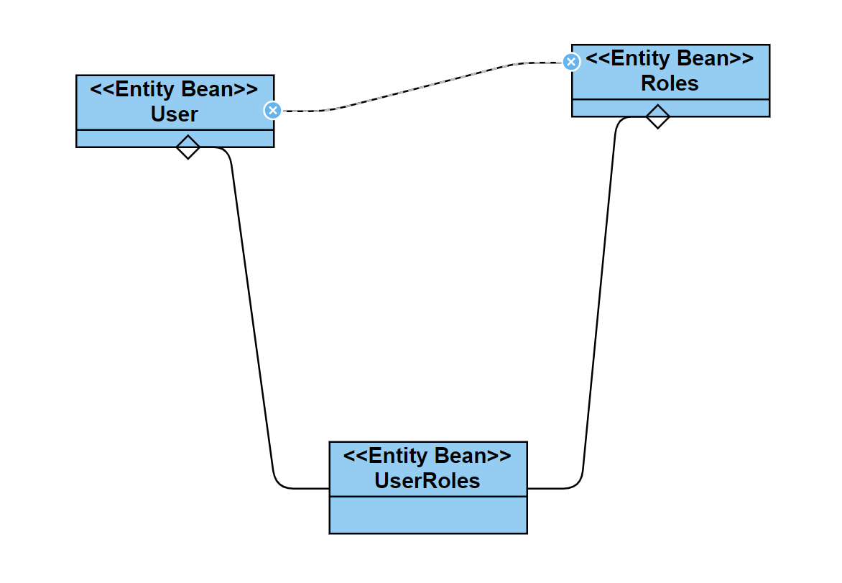

## Sequence Diagram:

### Create User and User Role:

