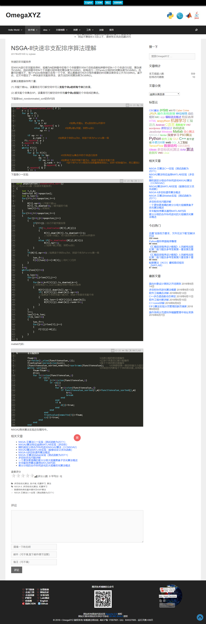

https://www.cnblogs.com/bnuvincent/p/5268786.html

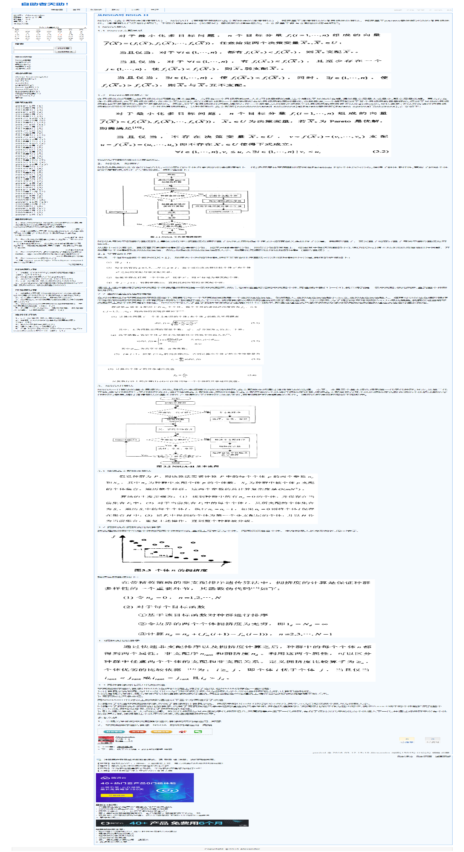

http://www.omegaxyz.com/2017/04/19/nsga2fastsort/