TBMI26 – Computer Assignment Reports  
Boosting

Deadline – March 14 2021

Shwetha Vandagadde Chandramouly

Suhani Ariga

In order to pass the assignment you will need to answer the following questions and upload the document to LISAM. Please upload the document in PDF format. **You will also need to upload all code in .m-file format**. We will correct the reports continuously so feel free to send them as soon as possible. If you meet the deadline you will have the lab part of the course reported in LADOK together with the exam. If not, you’ll get the lab part reported during the re-exam period.

1. **Plot how the classification accuracy on training data and test data depend on the number of weak classifiers (in the same plot). Be sure to include the number of training data (non-faces + faces), test-data (non-faces + faces), and the number of Haar-Features.**

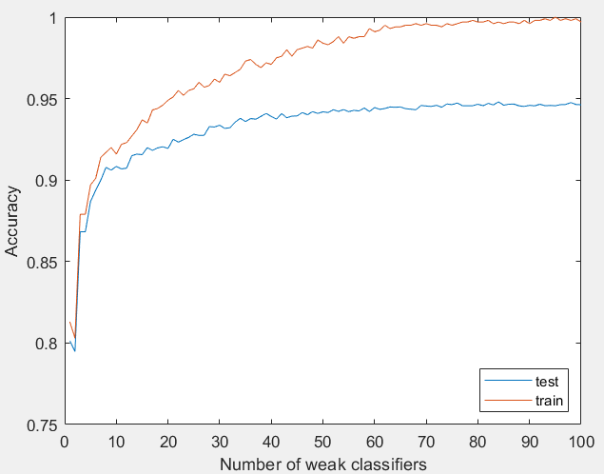

Number of faces for training data: 500

Number of non-faces for training data: 500

Number of faces for testing data: 4416

Number of non-faces for testing data: 7372

Number of Haar features: 100

1. **How many weak classifiers did you use when training? How many of them did you use for the final strong classifier? Motivate your choices.**

100 weak classifiers are used when training. From the plot above, we observe that accuracy of test data increases significantly till it reach around 40 classifiers. After that the accuracy of test data is not better with a greater number of weak classifiers.

That means there is a minimal increase in accuracy of test data for more that 40 weak classifiers. This also leads to computational waste.

1. **What is the accuracy on the training data and test data after applying the optimized strong classifier? Discuss your choice of hyperparameters and how they influence the accuracies.**

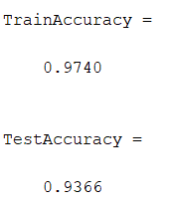

The increase in number of training images, increases accuracy but it takes high training time. The increase in number of haar features increase in finding the good feature for classifying the data which increases the training time. As mentioned in above question, the increase in number of weak classifiers will increase the computational time and the accuracy changes significantly for greater number of weak classifiers.

1. **Plot the Haar-features selected by your classifier (one for each weak classifier). If you have many weak classifiers, select some representative subset. Can you think of why they would be useful for classifying faces?**

Selected Haar-features

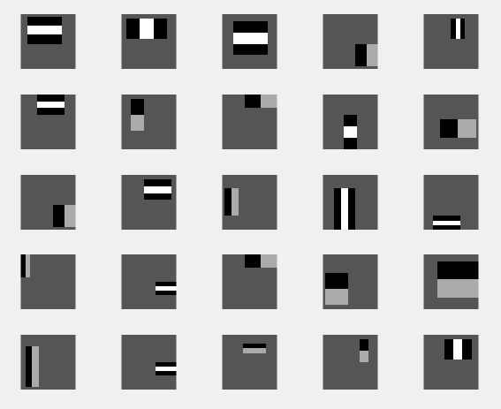

Haar features represent specific feature in the face. It is useful to identify features for the different shades in the face (nose, cheek, eyebrows etc.). For example: 2nd and 14th feature could check for bridge of the nose which is bright and sides of the nose is often in the shadow.

1. **Plot some of the misclassified faces and non-faces that seem hard to classify correctly. Why do you think they are difficult to classify?**

Misclassified faces

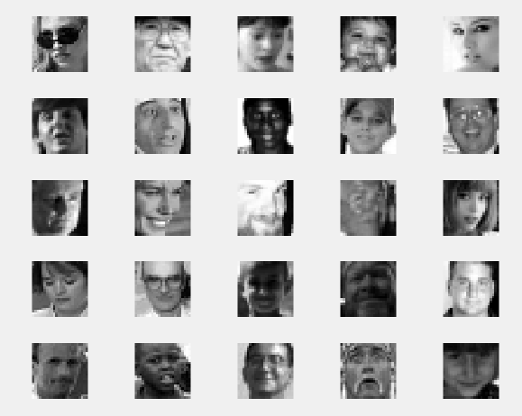

These are wrongly classified as non faces. It is reasonable due to some of the images contains glasses, some are taken from an odd angle, some are dark and blurry, some are shiny, some images are hair covering parts of the face or some images have shadows which differ from most of the images.

Misclassified non faces

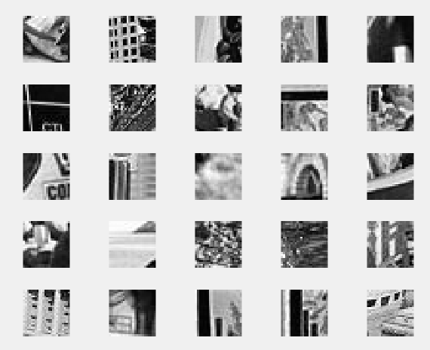

It is difficult to tell exactly why these are wrongly classified as faces. It could be the vertical lines in the image are mis constructed as the edges of the face. Perhaps they have contrasted edges in places where faces are often positioned in training data. There could be patterns which has features close to nose, eyes etc.

1. **Are your results reasonable? Can you think of any way to improve the results?**

We got accuracy of test data as 93.66 so yes, the results are reasonable. We trained data not only considering accuracy but also computational time. The model could train with more amount of data which increases accuracy rate but it takes more training time.

The faces that are wrongly classified are sensitive to many parameters such as it is sensitive to low/high exposure, poses, expressions or may not detect face with glasses or beard or it is effective if the face is in frontier view. If we consider the above parameters for training the face, then we can improve the results.

1. **Can we expect perfect results? Motivate your answer.**We cannot expect perfect results but can be better as mentioned in above question. Even though we consider those parameters its unreasonable to expect perfect results. Cameras with face recognition functionality today have almost perfect accuracy but are still dependent on light, angled away from the camera etc.