An artificial intelligence model for heart disease detection using machine learning algorithms

Literature Review

**1. Introduction**

The merger of Artificial Intelligence (AI) and Machine Learning (ML) into the healthcare field has immensely enhanced capabilities for disease prediction and diagnosis. Heart disease, one of the top killers worldwide, requires early identification to improve patient outcomes and decrease mortality. ML models have shown impressive performance for predicting cardiac condition. This research explores and implements various machine learning models—specifically K-Nearest Neighbors (KNN), Random Forest, and Logistic Regression—to build an efficient heart disease prediction system.

**2. Machine Learning in Heart Disease Detection**

Machine learning allows for the processing of large-scale medical data to identify patterns that are not apparent to human practitioners. Different algorithms like Logistic Regression, Decision Trees, K-Nearest Neighbors (KNN), and Support Vector Machines (SVM) have been used for this.

In our project, a machine learning system based on Python was created to forecast the occurrence of heart disease. Key operations involved data cleaning, missing value handling, and feature selection. The final model utilized several algorithms, and KNN and Random Forest provided competitive precision. The system was tested through cross-validation for reliability.

**3. Data Processing and Feature Selection**

Successful preprocessing of the data is instrumental in model performance. The original dataset was well-checked to manage missing or null values—particularly for features such as ca (major vessels) and thal—and usually held NaNs. Missing data were filled using mean or mode tactics for consistency.

Significant attributes were age, sex, resting blood pressure, cholesterol level, fasting blood sugar, exercise-induced angina, and maximum heart rate. Statistical summaries and correlation heatmaps were some of the methods used to measure feature importance. This ensured the input space of the model was optimized and the overall prediction quality was enhanced.

**4. Model Implementation and Evaluation**

Three models—Logistic Regression, K-Nearest Neighbors (KNN), and Random Forest Classifier—were trained and tested.

- Logistic Regression was used as a baseline model because it was interpretable and could be used to determine major risk factors.

- K-Nearest Neighbors (KNN), which is a distance-based algorithm, worked fine when there was appropriate feature scaling and registered better accuracy after fine-tuning the value of k.

- Random Forest, an ensemble learning algorithm, provided the best accuracy by combining the predictions of many decision trees, thus minimizing overfitting and enhancing generalization.

Cross-validation (10-fold) was employed to evaluate model performance objectively. Among all models, Random Forest performed the best, followed by KNN and Logistic Regression.

**5. Cybersecurity Considerations in AI-Based Healthcare Applications**

Since AI solutions manage sensitive information about patients, security is the primary concern. In order to minimize risks, this study considers strong cybersecurity to be necessary in the form of data encryption, secure authentication techniques, and protections at the network level. Also, adherence to healthcare regulations like the Health Insurance Portability and Accountability Act (HIPAA) must be made to maintain privacy in data as well as proper usage.

**6. Gaps in Existing Literature**

Despite notable advancements, several challenges remain:

- Limited access to large, diverse, and balanced datasets impairs model generalizability.

- Deep learning methods are underexploited for heart disease prediction because they have high data and computing demands.

- There is a requirement for solutions that enable real-time monitoring and integration with wearable technologies to constantly monitor health.

- Model transparency and explainability should be enhanced to enhance clinician confidence in AI-supported decisions.

**7. Conclusion**

This review highlights the imperative role of machine learning in heart disease detection, especially models such as Random Forest and KNN, whose high accuracy and reliability have been exemplified. Our instantiation confirms the merit of synergism between preprocessing strength and model selection and hyperparameter optimization. Future work should aim at increasing datasets, conducting deep learning platforms, and creating real-time user-friendly diagnostic tools to improve early detection and patient care.

Skeleton (Project Architecture)

**Data Collection/Acquisition**

* The dataset used in this project was acquired from a heart disease dataset (from Kaggle).
  + Key Features: age, sex, cholesterol, thalach, oldpeak, ca, num, etc.
  + Problem: The dataset initially contained missing values and categorical columns.
  + Action: Loaded using pandas, checked using .info() and .describe().

**Data Preprocessing**

* Handling missing values
  + Filled numeric missing values using .fillna(df.mean()).
  + Dropped irrelevant columns (like id) and encoded categorical columns.
* Encoding categorical features
  + Categorical values like sex, cp, thal, etc., were label encoded.
* Target Column
  + num was converted to a binary column called target (0 = No Disease, 1 = Disease).

**Exploratory Data Analysis (EDA)**

* Tools Used
  + Matplotlib
  + Seaborn
* Heatmap to visualize correlations
* Descriptive statistics
  + Features like thalach, ca, chol, and oldpeak had visible influence on heart disease likelihood.

**Model Training**

* K-Nearest Neighbors (KNN) classifier
* Random Forest classifier
* Cross-validation with 10-fold

**Evaluation**

* Accuracy score
* Cross-validation score
  + 10-fold Cross-Validation using cross_val_score()
* Visualization using confusion matrix
  + Heatmap of feature correlations
  + Target distribution
  + Accuracy from cross-validation

About the algorithm(s) used

K-Nearest Neighbors (KNN)

K-Nearest Neighbors (KNN) is a simple, non-parametric machine learning algorithm used for classification and regression. In the context of heart disease detection, it predicts the class (disease/no disease) of a new patient by checking the majority class among its 'K' nearest neighbors in the dataset.

Usage in our model:

* We tested values of K from 1 to 10.
* Used 10-fold cross-validation to ensure consistent and unbiased accuracy estimates.
* Scaled continuous variables to standardize distances using StandardScaler.
* Chose the best K based on the highest mean accuracy.

Pros:

* Easy to understand and implement.
* Performs well with well-separated classes and low noise.

Cons:

* Slow prediction on large datasets.
* Sensitive to irrelevant features and the scale of data.

Random Forest Classifier

Random Forest is an ensemble learning method based on constructing multiple decision trees during training. It outputs the class that is the mode of the classes of the individual trees.

Usage in our model:

* Used 100 decision trees (n_estimators=100).
* Applied 10-fold cross-validation to assess performance.
* Achieved high accuracy and stable results.

Pros:

* High accuracy and good generalization.
* Robust to overfitting and noisy data.
* Handles both numerical and categorical features well.

Cons:

* Model complexity and training time can be higher.
* Less interpretable than a single decision tree.

Graphs and Charts

Correlation Heatmap:

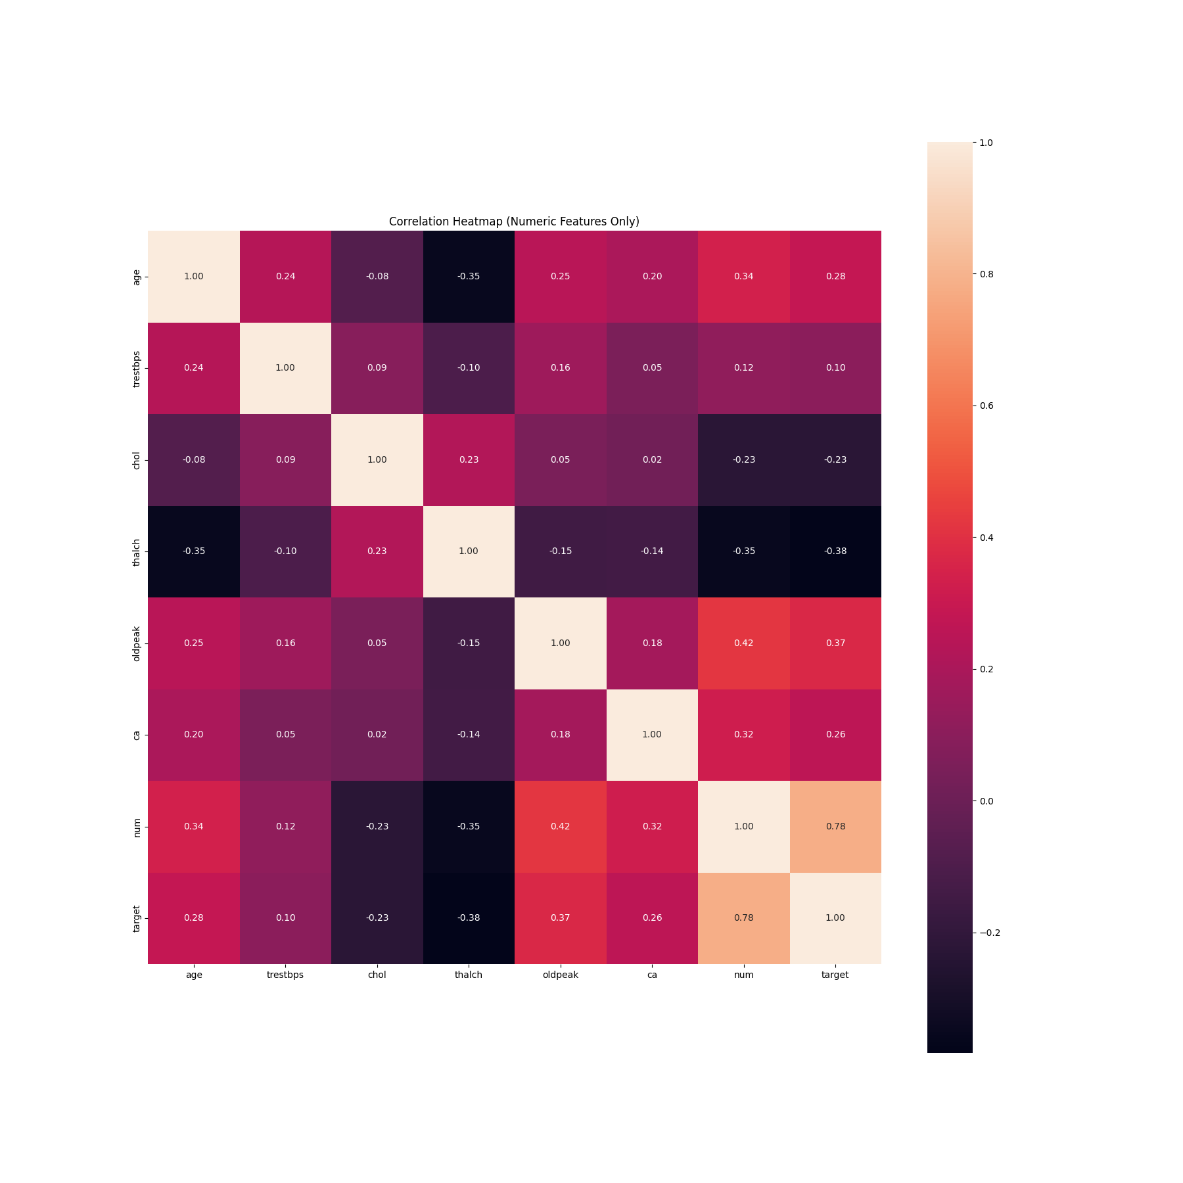

Feature Distributions: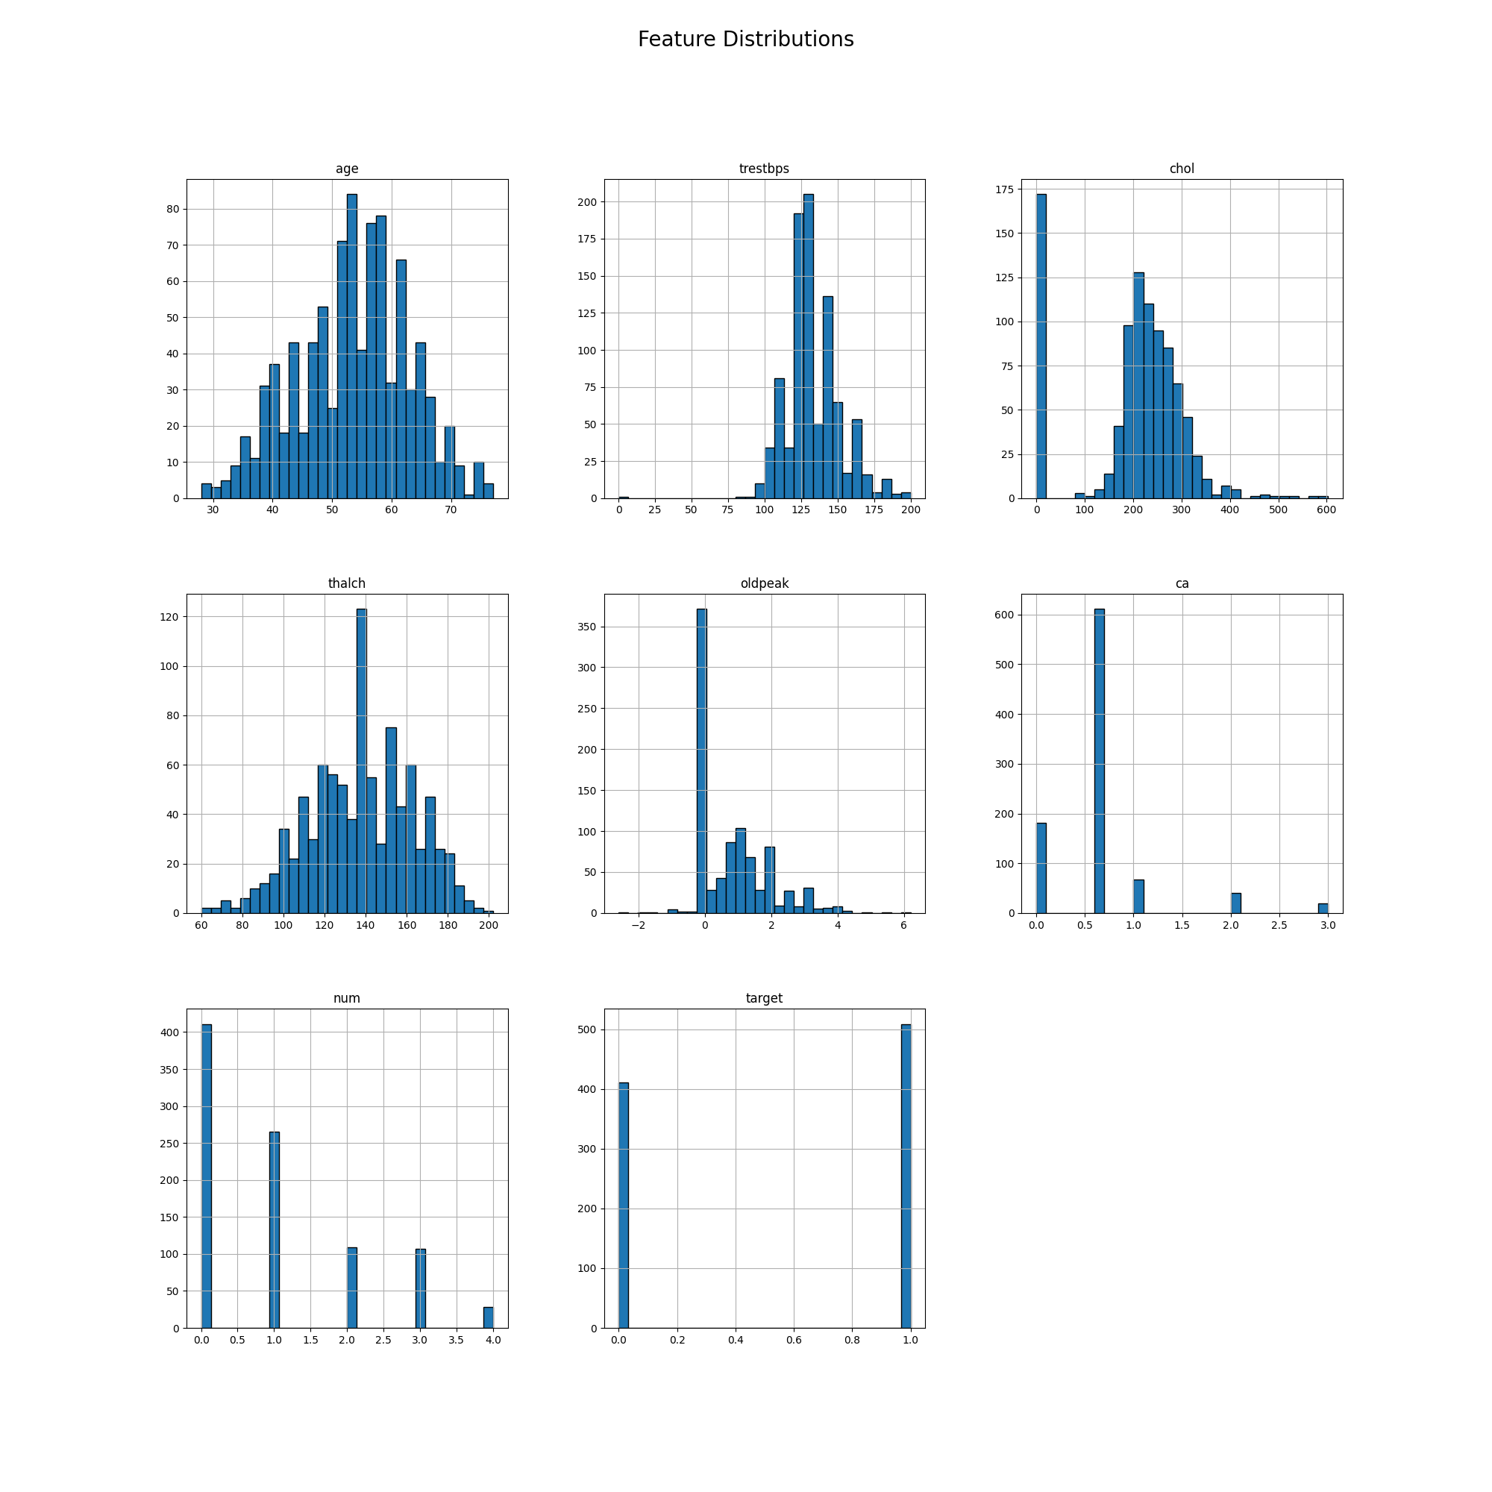

Target Distribution:

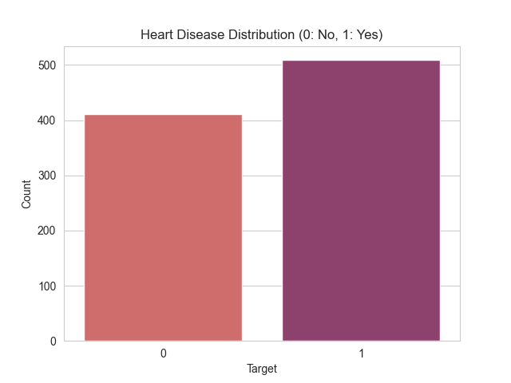

KNN Accuracy:

