
B.Tech in Computer Science and Business Systems
Department of Computer Science and Engineering
Faculty of Engineering & Technology
Jain Global Campus, Kanakapura Taluk - 562112
Ramanagara District, Karnataka, India

2026-2027
( III Semester)

A Mini Project Report on

Student Attendance Management System

Submitted in partial fulfilment for the award of the degree of

Bachelor of Technology
in
Computer Science and Business Systems
Submitted by

- Ekta Patel 25BTRCB020
- Shahan Samar 25BTRCB044
- Akanksha Poovaiah M 25BTRCB002
- Anany Mangal 25BTRCB004
- Varsha Vakati 25BTRCB055
Under the guidance of

Dr. Santhosh Kumar S
Assistant Professor-3 (CSBS)

Computer Science and Business Systems
Department of Computer Science and Engineering
Faculty of Engineering & Technology
JAIN (Deemed to-be University)

B.Tech in Computer Science and Business Systems
Department of Computer Science and Engineering
Faculty of Engineering & Technology
Jain Global Campus, Kanakapura Taluk - 562112
Ramanagara District, Karnataka, India
CERTIFICATE

This is to certify that the mini project work titled "Student Attendance Management System" is carried out by Ekta Patel (25BTRCB020), Shahan Samar (25BTRCB044), Akanksha Poovaiah M (25BTRCB002), Anany Mangal (25BTRCB004), Varsha Vakati (25BTRCB055), bonafide students of Bachelor of Technology in Computer Science and Business Systems, Faculty of Engineering & Technology, JAIN (Deemed-to-be University), Bengaluru, in partial fulfilment of the requirements of the OOP's using JAVA course (25PCCSBS301), III Semester, during the academic year 2026-2027.

Subject Teacher |  | Program Head,
Dr. Santhosh Kumar S  Asst. Professor-3  Computer Science and Business System  Faculty of Engineering & Technology  Date: |  | Dr. D. Ramya Dorai  Associate Professor,  Program Head,  Computer Science and Business System  Faculty of Engineering & Technology  Date:

DECLARATION
Ekta Patel  USN: 25BTRCB020 | Signature: __________________
Shahan Samar  USN: 25BTRCB044 | Signature: __________________
Akanksha Poovaiah M  USN: 25BTRCB002 | Signature: __________________
Anany Mangal  USN: 25BTRCB004 | Signature: __________________
Varsha Vakati  USN: 25BTRCB055 | Signature: __________________
Place : Bengaluru
Date :
We, Ekta Patel (25BTRCB020), Shahan Samar (25BTRCB044), Akanksha Poovaiah M (25BTRCB002), Anany Mangal (25BTRCB004), Varsha Vakati (25BTRCB055), students of B.Tech in Computer Science and Business Systems at JAIN (Deemed-to-be University), declare that this mini project report titled "Student Attendance Management System" is submitted for the course OOP's using JAVA (25PCCSBS301), III Semester, during the academic year 2026-2027. The report describes the application, its Java concepts, design, source code and test results. We take responsibility for reviewing the implementation and explaining it during evaluation. The sources consulted are acknowledged in the references.

ACKNOWLEDGEMENT
We thank the Faculty of Engineering & Technology, JAIN (Deemed-to-be University), for the opportunity to apply object-oriented programming through this Java mini project.
We express our gratitude to Dr. D. Ramya Dorai, Program Head, Computer Science and Business Systems, and Dr. Santhosh Kumar S, course instructor and project guide, for the academic framework and project requirements.
The Student Attendance Management System brings together the Java concepts studied in our course through a small desktop application. Preparing its design, implementation, tests and report gives us a concrete basis for understanding and demonstrating these concepts.
We also thank our classmates, families and friends for their encouragement. We acknowledge the official Java and Swing documentation used to understand the standard library components.
Signature of students
Ekta Patel (25BTRCB020) __________________
Shahan Samar (25BTRCB044) __________________
Akanksha Poovaiah M (25BTRCB002) __________________
Anany Mangal (25BTRCB004) __________________
Varsha Vakati (25BTRCB055) __________________

ABSTRACT
The Student Attendance Management System is a Java desktop application for maintaining a student register and recording date-wise attendance. It provides a simple Swing interface with six courses and four study years per course. A user selects a cohort, views or edits students, and marks attendance using Present checkboxes. Attendance is recorded for the day as a whole, without separate subject records.
Each new attendance operation creates a uniquely numbered session. Several sessions can therefore be recorded on the same date for demonstration. Existing sessions can be viewed or corrected, while each session retains its original roster. Changes to a student's name or roll number do not rewrite historical attendance. The first run creates 144 fictional students and 24 sample sessions so every course and year can be explored.
The implementation contains three application source files and uses only the Java standard library. It demonstrates classes, objects, constructors, encapsulation, inheritance, abstraction, interfaces, method overloading, overriding, runtime polymorphism, collections, string handling, exceptions, packages and file handling. Records are saved in a local UTF-8 text file and reloaded when the app starts.
Validation prevents duplicate USNs, duplicate roll numbers within a cohort and incomplete attendance records. Failed saves restore the previous in-memory state. Verification on Windows with JDK 26.0.2, targeting Java 17, completed 41 data checks and 15 desktop-interface checks with no failures. The result is a small, explainable attendance application suitable for demonstrating the OOP's using JAVA course concepts.

TABLE OF CONTENTS
1. Introduction 1
1.1 Background 1
1.2 About the Project 1
1.3 Why Java 1
1.4 Organization of the Report 1
2. Problem Statement 2
2.1 Existing System 2
2.2 Limitations of the Existing System 2
2.3 Proposed System 2
2.4 Problem Statement 2
3. Objectives 3
3.1 Main Objective 3
3.2 Specific Objectives 3
3.3 Learning Outcomes 3
4. Scope and Limitations 4
4.1 Scope 4
4.2 Limitations 4
5. System Requirements 5
5.1 Hardware Requirements 5
5.2 Software Requirements 5
5.3 Functional Requirements 5
5.4 Non Functional Requirements 5
6. System Design 6
6.1 System Architecture 6
6.2 Use Case Diagram 6
6.3 Class Diagram 7
6.4 Flowchart for Taking Attendance 8
6.5 Data Storage Design 8
6.6 Business Rules 8
7. Modules 9
7.1 Course and Year Navigation 9
7.2 Student Management 9
7.3 Attendance Capture 9
7.4 Attendance Review and Correction 9
7.5 File Handling and Error Recovery 9
8. Java Concepts Used 10
8.1 Inheritance and Polymorphism 11
8.2 Exception Handling 11
8.3 Collections and Object State 11
9. Source Code 12
9.1 Project Structure 12
9.2 How to Compile and Run 12
9.3 Source Files 12
10. Testing and Test Cases 22
10.1 Testing Strategy 22
10.2 Test Environment 22
10.3 Test Cases 22
10.4 Test Summary 23
10.5 Observations 23
11. Sample Application Output 24
11.1 Course and Year Selection 24
11.2 Cohort Menu 25
11.3 Student Register 26
11.4 Taking Attendance 27
11.5 Saved Sessions 28
11.6 Editing Existing Attendance 29
11.7 Restart Behaviour 29
12. Future Enhancements Conclusion and References 30
12.1 Future Enhancements 30
12.2 Conclusion 30
12.3 References 30

1. Introduction

1.1 Background
Attendance is a routine academic record. In a paper register, locating a class list, counting present students and correcting an earlier entry all require manual effort. A small desktop application can organize these records by course, study year and date while keeping the process familiar to a teacher.

1.2 About the Project
The Student Attendance Management System is a Java Swing application operated through buttons, forms and checkbox tables. It supports six fixed courses: CSE-CSBS, CSE-General, CSE - PWC, CSE - Cybersecurity, Aerospace and Mechanical. Each course contains Years 1 to 4. The selected cohort opens options to view students, edit students, take today's attendance, view attendance and edit existing attendance.
The application is intentionally limited to date-wise attendance. It does not split a day into subjects. Multiple independent sessions may be saved on the same day for demonstration. Students appear in numeric roll-number order, and checked Present boxes indicate attendance.

1.3 Why Java
Java provides object-oriented modelling and a standard desktop toolkit in one language. Swing supplies windows, tables and dialogs, while collections and file APIs support a small persistent data store. The project therefore needs only a JDK, without external Java libraries, a database or a server.

1.4 Organization of the Report
Chapters 2 to 5 define the problem, objectives, scope and requirements. Chapters 6 to 8 explain the design, modules and Java concepts. Chapter 9 presents the source listing, Chapter 10 records verification, Chapter 11 shows the working interface and Chapter 12 discusses improvements, conclusions and references.

2. Problem Statement

2.1 Existing System
A manual attendance register stores student details and date-wise presence on paper. Student lists may be maintained separately for each class, and totals are calculated by counting marks. Corrections depend on the clarity of handwritten notes and preservation of the original register.

2.2 Limitations of the Existing System
Searching a student, checking previous attendance and counting totals can be slow. Duplicate identifiers or roll numbers are not automatically detected. A correction can be difficult to distinguish from the original entry, and misplaced registers can make old records unavailable.

2.3 Proposed System
The proposed application keeps the student register and attendance sessions in one local file. Course and year selection limits each screen to the intended cohort. Input validation checks identifiers, checkbox tables simplify marking, and a live total shows present and absent counts before confirmation.

2.4 Problem Statement
Develop a simple Java desktop application that lets a user maintain students in fixed course/year cohorts, record today's attendance using checkboxes, create repeated same-day sessions, view or correct existing sessions, and retain all records after restarting the application.

3. Objectives

3.1 Main Objective
Build an understandable attendance application that demonstrates the object-oriented and core-Java concepts required by the mini project circular.

3.2 Specific Objectives
Provide six courses and four study years with clear navigation.
Allow adding, searching and editing students while validating USNs and roll numbers.
Record present or absent marks with checkboxes and show live totals.
Store separate attendance sessions for repeated attempts on one date.
Restrict attendance editing to existing sessions and preserve historical rosters.
Save records locally and restore them after restart.
Populate every cohort with fictional sample data for demonstration.
Keep the application in three source files with line-level explanations.

3.3 Learning Outcomes
The project connects Java classes to real objects, separates interface code from data rules, and demonstrates inheritance, polymorphism, collections, validation and file handling. The walkthrough and concept mapping help each team member explain the program flow and the reason for each design choice.

4. Scope and Limitations

4.1 Scope
The application supports one user on one computer. It manages names, immutable USNs, editable roll numbers and fixed course/year membership. Current students can be searched or edited. Attendance can be recorded today, viewed later and corrected using its existing session ID. All records persist locally.
First-run data contains 144 fictional students and 24 previous-day sample sessions. There are six students in each of 24 cohorts, with four present and two absent in the sample session. These records use DEMO identifiers and do not represent actual student attendance.

4.2 Limitations
The current version has no login, subject-wise records, database server, student deletion or transfer, automatic promotion, cloud synchronization or attendance-percentage report. Repeated sessions are independent records, so no claim is made about a daily attendance percentage. Saving rewrites the complete small text snapshot and is intended for demonstration-scale data. The date comes from the computer's local clock.

5. System Requirements

5.1 Hardware Requirements
Component | Requirement
Computer | A desktop or laptop capable of running JDK 17 or newer
Memory and storage | Enough available memory for the JDK and small local dataset; no large database is required
Display and input | Desktop display, keyboard and mouse; a window of at least 840 by 600 pixels

5.2 Software Requirements
Component | Requirement
Java | JDK 17 or newer, including java and javac on PATH
Operating system | Desktop Java environment; tested on Windows
Libraries | Java standard library only: Swing, AWT, collections, time and file APIs
Storage | Writable local data folder
Build tools | Provided batch or shell launchers; no Maven or Gradle required

5.3 Functional Requirements
ID | Requirement
FR1 | Navigate among six courses and four years.
FR2 | List and search students in roll-number order.
FR3 | Add students and edit names or rolls with validation.
FR4 | Take today's attendance and save a new unique session.
FR5 | Allow multiple sessions on the same date.
FR6 | View saved sessions without editing their checkboxes.
FR7 | Correct only an existing session's marks.
FR8 | Save and reload students and attendance.

5.4 Non Functional Requirements
The interface should be simple enough for a classroom demonstration. Validation errors must be understandable, and an unsuccessful write must not be reported as a successful save. Source files should have clear names and explanations. The application must preserve historical rosters and reject a second app instance using the same data folder.

6. System Design

6.1 System Architecture
The presentation layer is AttendanceApp. It calls AttendanceBook for queries and changes. Student and Session objects represent the current register and historical attendance. The data layer serializes these objects into a small, versioned UTF-8 text snapshot.
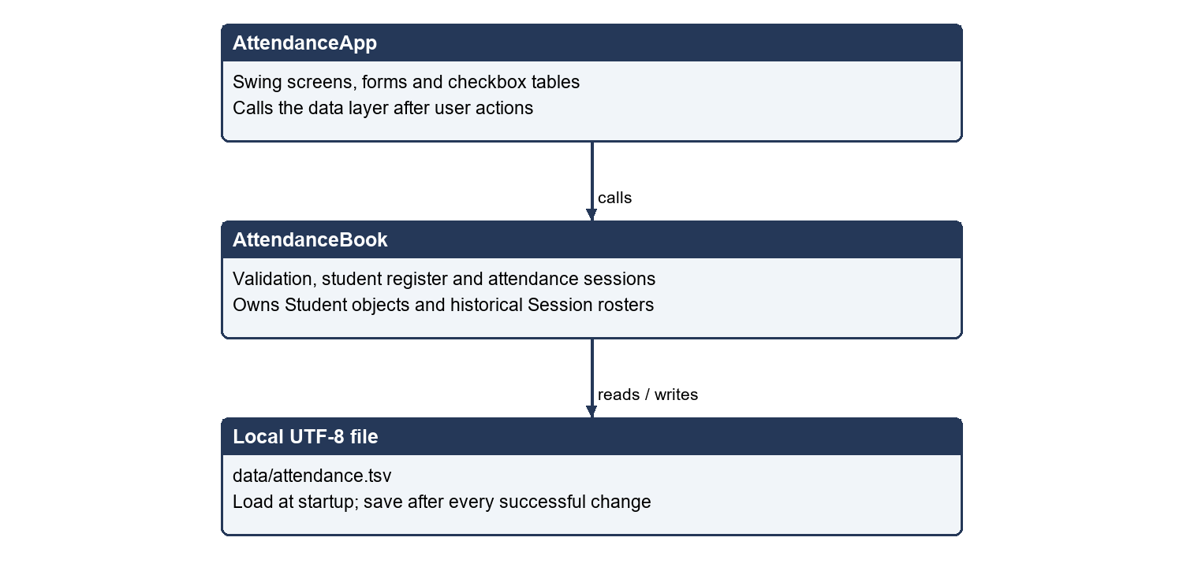
Figure 6.1 Application architecture

6.2 Use Case Diagram
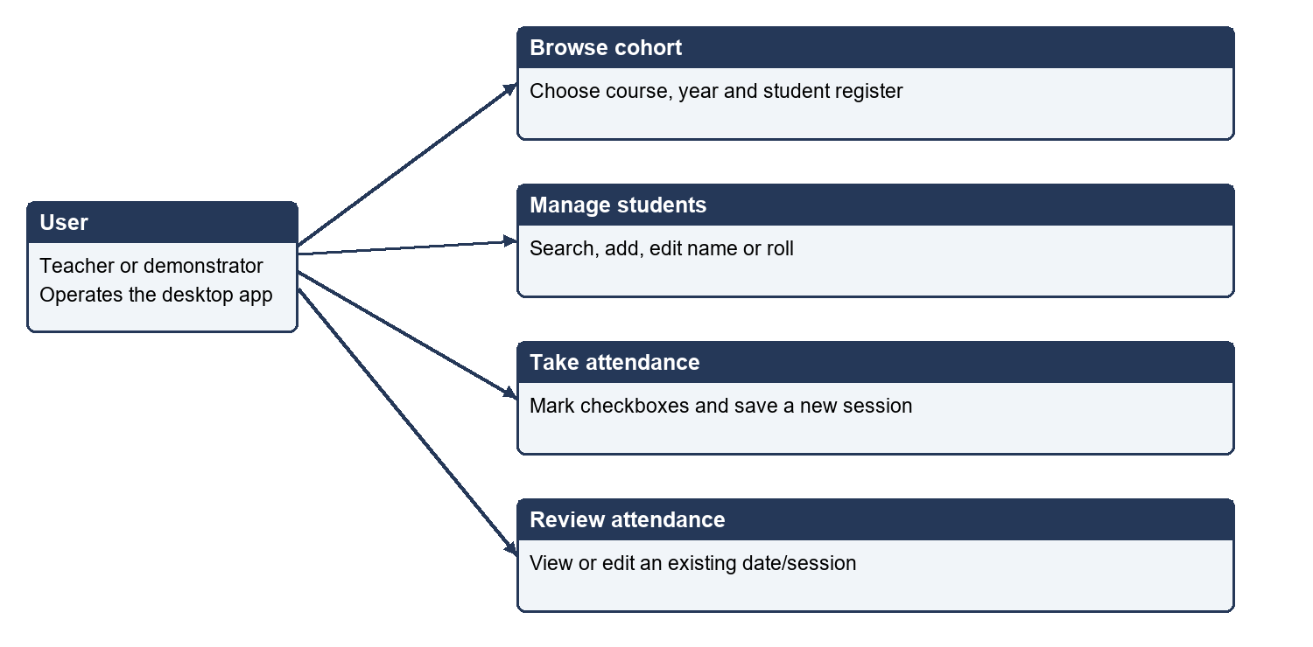
Figure 6.2 User actions supported by the desktop application

6.3 Class Diagram
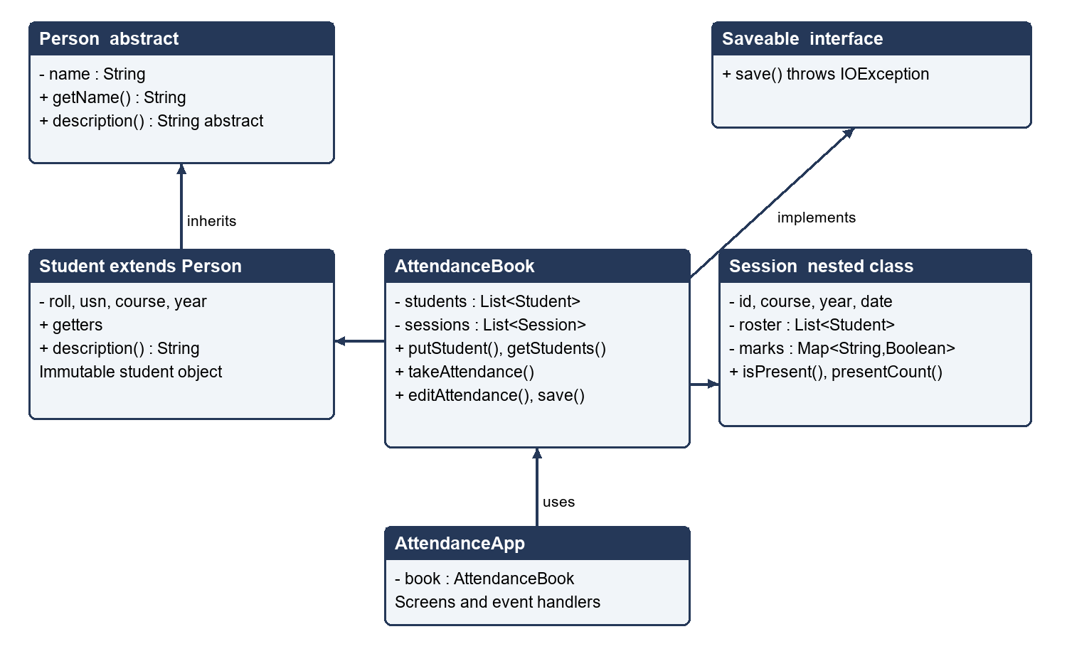
Figure 6.3 Main classes and their relationships
Student inherits from the abstract Person class. AttendanceBook implements Saveable and owns lists of Student and Session objects. Session is nested inside AttendanceBook to keep the application within three source files. AttendanceApp uses a book object to perform operations.

6.4 Flowchart for Taking Attendance
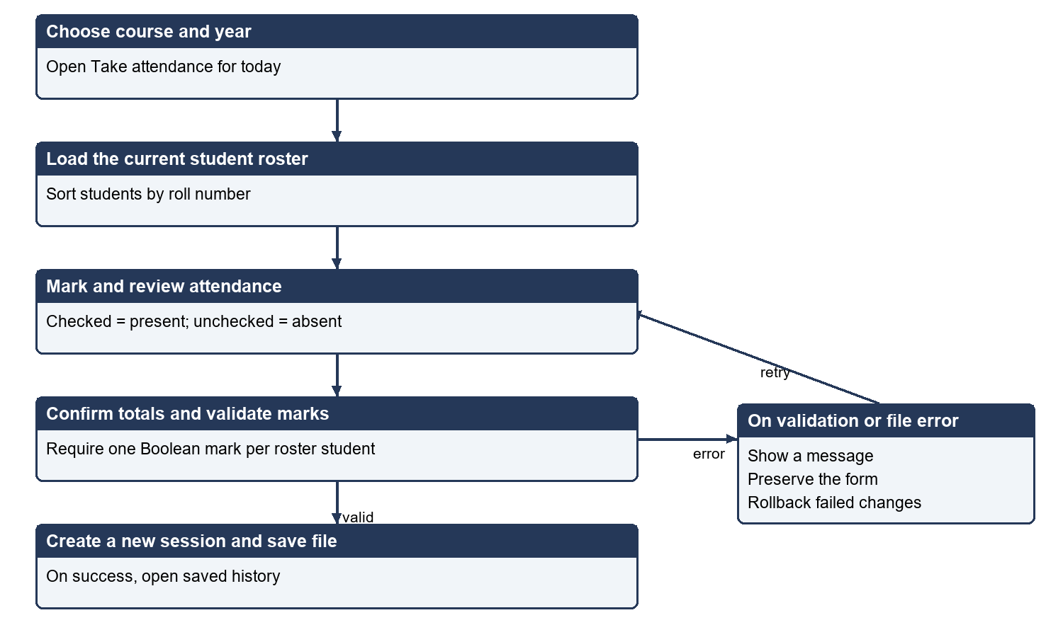
Figure 6.4 Taking and saving a new attendance session

6.5 Data Storage Design
The file data/attendance.tsv begins with ATTENDANCE followed by format version 1. Actual separators are tab characters. S rows store the current register. An A row introduces a session; following M rows store that session's historical students and marks. A complete snapshot is written to a temporary file before replacement of the saved file.
Record | Fields after the record type
S | roll, USN, name, course, year
A | session ID, course, year, ISO date
M | session ID, roll, USN, name, course, year, true or false

6.6 Business Rules
A USN is unique across the application and cannot be changed after creation. Roll numbers are integers from 1 to 9999 and must be unique within a cohort. Names contain 1 to 80 characters without control characters. Every attendance roster must be nonempty and every student must have a Boolean mark. New attendance uses today's date; correction requires an existing session ID. Historical roster snapshots do not change when students are later added or edited.

7. Modules

7.1 Course and Year Navigation
showCourses, showYears and showMenu create the navigation path. The shared page method provides a title, context and Back button. Selecting a course and year updates the current cohort used by subsequent screens.

7.2 Student Management
showStudents displays a read-only table in both browse and edit modes. Edit mode adds buttons for a validated dialog. putStudent checks the supplied data, constructs a new immutable Student object and saves it. Searching uses the overloaded getStudents method and a case-insensitive description containing the name and USN.

7.3 Attendance Capture
The attendance screen builds a Boolean Present column. A fresh session begins with every checkbox unchecked. All present and All absent shortcuts reduce repetitive clicking. A table listener updates present, absent and total counts. Saving commits the current cell editor, confirms the totals and calls takeAttendance.

7.4 Attendance Review and Correction
chooseSession lists saved dates and unique session numbers. Viewing disables checkbox editing. Editing reuses the same table with checkboxes enabled and calls editAttendance for the selected session. It preserves the session date and original roster, and does not affect other sessions.

7.5 File Handling and Error Recovery
AttendanceBook loads and validates its snapshot at startup and saves after every successful mutation. Invalid saved content stops startup without replacing the file. Mutating methods retain enough old state to undo changes when saving fails. The app holds a file lock while open, and unsaved checkbox changes require confirmation before leaving the screen.

8. Java Concepts Used
The following concepts correspond to the minimum technical requirements in the supplied course circular. Each example points to behaviour that actually appears in the implementation.
Concept | Use in this project
Classes and objects | Student, AttendanceBook, AttendanceApp and Session model records and behaviour.
Constructors | Student initializes fields and calls super(name); AttendanceBook loads or seeds its data.
Encapsulation | Private fields, getters and defensive collection copies protect internal state.
Inheritance and abstraction | Student extends abstract Person and supplies description().
Runtime polymorphism | A Person reference in the search method calls Student.description() at runtime.
Interfaces | AttendanceBook implements the Saveable.save() contract.
Overloading | getStudents(course, year) and getStudents(course, year, query) have different parameters.
Overriding | description(), toString(), save() and Swing table-model methods provide specialized behaviour.
Exception handling | IOException reports storage failures; IllegalArgumentException reports invalid data; finally cleans temporary files.
Arrays and collections | Arrays hold names and column labels; lists, maps and sets organize records and check duplicates.
String handling | trim, case normalization, contains, split and matches validate and search text.
File handling | Files.readAllLines, Files.write and Files.move load and save UTF-8 records.
Packages | Application classes use package attendance and import Java standard-library packages.
static and final | Shared course constants, static helpers, final fields and final classes express ownership and restrictions.

8.1 Inheritance and Polymorphism
Person person = student;
String text = person.description();
The declared reference type is Person, but the actual object is Student. Java therefore invokes Student's overridden description method. This is runtime polymorphism. Overloading is different: the compiler chooses between the two getStudents signatures based on the supplied arguments. The abstract parent cannot be instantiated directly.

8.2 Exception Handling
The data layer throws validation exceptions before accepting invalid input. File operations may throw IOException. The UI catches these errors and shows a dialog. A failed save restores the previous student or marks instead of leaving memory inconsistent with disk. A finally block removes unused temporary files.

8.3 Collections and Object State
ArrayList stores students and sessions. LinkedHashMap associates USNs with Boolean marks. HashSet detects repeated identifiers during loading. Student objects are immutable, and a session copies its roster and marks. This allows current student records to change while historical attendance remains stable.

9. Source Code

9.1 Project Structure
src/attendance/Student.java
src/attendance/AttendanceBook.java
src/attendance/AttendanceApp.java
tests/attendance/AttendanceBookTest.java
tests/attendance/AttendanceUiTest.java
run.bat run.sh test.bat test.sh test-ui.bat
docs/ report/
data/attendance.tsv (created on first run)

9.2 How to Compile and Run
Install JDK 17 or newer. On Windows, run run.bat from the project folder; on macOS or Linux, run sh run.sh in a desktop session. The equivalent manual commands are:
javac --release 17 -encoding UTF-8 -d build src/attendance/*.java
java -cp build attendance.AttendanceApp
Run test.bat for the data checks and test-ui.bat for the desktop checks. The README explains the alternate data directory option and a safe demonstration reset using a backup.

9.3 Source Files
The following listing contains the application source statements from all three files. Inline teaching comments are omitted here to keep the printed code readable; every nonblank line in the repository source includes an explanation. Long lines wrap visually on the page. The repository is the authoritative compilable source.

Student.java
package attendance;

abstract class Person {
private final String name;
Person(String name) {
this.name = name;
}
public String getName() { return name; }
public abstract String description();
}

public final class Student extends Person {
private final int roll;
private final String usn;
private final String course;
private final int year;
public Student(int roll, String usn, String name, String course, int year) {
super(name);
this.roll = roll;
this.usn = usn;
this.course = course;
this.year = year;
}
public int getRoll() { return roll; }
public String getUsn() { return usn; }
public String getCourse() { return course; }
public int getYear() { return year; }
@Override public String description() {
return getName() + " (" + usn + ")";
}
}

AttendanceBook.java
package attendance;

import java.io.IOException;
import java.nio.charset.StandardCharsets;
import java.nio.file.*;
import java.time.LocalDate;
import java.util.*;

interface Saveable {
void save() throws IOException;
}

@SuppressWarnings("auxiliaryclass")
public final class AttendanceBook implements Saveable {
public static final List<String> COURSES = List.of(
"CSE-CSBS", "CSE-General", "CSE - PWC",
"CSE - Cybersecurity", "Aerospace", "Mechanical");
private final List<Student> students = new ArrayList<>();
private final List<Session> sessions = new ArrayList<>();
private final Path file;

public static final class Session {
private final int id;
private final String course;
private final int year;
private final LocalDate date;
private final List<Student> roster;
private Map<String, Boolean> marks;
private Session(int id, String course, int year, LocalDate date, List<Student> roster, Map<String, Boolean> marks) {
this.id = id; this.course = course; this.year = year; this.date = date;
this.roster = List.copyOf(roster); this.marks = new LinkedHashMap<>(marks);
}
public int getId() { return id; }
public LocalDate getDate() { return date; }
public List<Student> getRoster() { return roster; }
public boolean isPresent(String usn) { return Boolean.TRUE.equals(marks.get(usn)); }
public long presentCount() { return marks.values().stream().filter(Boolean::booleanValue).count(); }
@Override public String toString() {
return date + " | Session #" + id + " | " + presentCount() + "/" + roster.size() + " present";
}
}

public AttendanceBook(Path file) throws IOException {
this.file = file.toAbsolutePath();
if (Files.exists(this.file)) { load(); }
else { seedDemo(); save(); }
}

public List<Student> getStudents(String course, int year) {
checkCohort(course, year);
List<Student> result = new ArrayList<>();
for (Student student : students) {
if (student.getCourse().equals(course) && student.getYear() == year) { result.add(student); }
}
result.sort(Comparator.comparingInt(Student::getRoll));
return List.copyOf(result);
}
public List<Student> getStudents(String course, int year, String query) {
String key = query.trim().toLowerCase(Locale.ROOT);
List<Student> result = new ArrayList<>();
for (Student student : getStudents(course, year)) {
Person person = student;
if (person.description().toLowerCase(Locale.ROOT).contains(key)) { result.add(student); }
}
return List.copyOf(result);
}
public List<Session> getSessions(String course, int year) {
checkCohort(course, year);
List<Session> result = new ArrayList<>();
for (Session session : sessions) {
if (session.course.equals(course) && session.year == year) { result.add(session); }
}
result.sort(Comparator.comparing(Session::getDate).thenComparingInt(Session::getId).reversed());
return List.copyOf(result);
}

public void putStudent(String originalUsn, int roll, String usn, String name, String course, int year) throws IOException {
checkCohort(course, year);
usn = usn.trim().toUpperCase(Locale.ROOT); name = name.trim();
require(roll > 0 && roll <= 9999, "Roll number must be between 1 and 9999.");
require(usn.matches("[A-Z0-9-]{3,24}"), "USN must contain 3-24 letters, digits or hyphens.");
require(!name.isEmpty() && name.length() <= 80 && name.chars().noneMatch(Character::isISOControl), "Name must contain 1-80 characters without control characters.");
int index = -1;
for (int i = 0; i < students.size(); i++) {
Student existing = students.get(i);
if (existing.getUsn().equals(originalUsn)) {
index = i;
require(existing.getCourse().equals(course) && existing.getYear() == year, "Student belongs to another cohort.");
continue;
}
require(!existing.getUsn().equals(usn), "That USN already exists.");
require(!(existing.getCourse().equals(course) && existing.getYear() == year && existing.getRoll() == roll), "That roll number is already used in this cohort.");
}
require(originalUsn == null || (index >= 0 && originalUsn.equals(usn)), "An existing student's USN cannot be changed.");
Student replacement = new Student(roll, usn, name, course, year);
Student previous = index < 0 ? null : students.get(index);
if (index < 0) { students.add(replacement); } else { students.set(index, replacement); }
try { save(); } catch (IOException error) {
if (index < 0) { students.remove(replacement); } else { students.set(index, previous); }
throw error;
}
}

public Session takeAttendance(String course, int year, Map<String, Boolean> marks) throws IOException {
List<Student> roster = getStudents(course, year);
validateMarks(roster, marks);
int id = sessions.stream().mapToInt(Session::getId).max().orElse(0) + 1;
Session session = new Session(id, course, year, LocalDate.now(), roster, marks);
sessions.add(session);
try { save(); } catch (IOException error) { sessions.remove(session); throw error; }
return session;
}
public void editAttendance(int id, Map<String, Boolean> marks) throws IOException {
Session session = sessions.stream().filter(item -> item.id == id).findFirst().orElseThrow(() -> new IllegalArgumentException("Select an existing session."));
validateMarks(session.roster, marks);
Map<String, Boolean> previous = session.marks;
session.marks = new LinkedHashMap<>(marks);
try { save(); } catch (IOException error) { session.marks = previous; throw error; }
}
private static void validateMarks(List<Student> roster, Map<String, Boolean> marks) {
require(!roster.isEmpty(), "Add students before taking attendance.");
require(marks != null && marks.size() == roster.size(), "Mark every student in this session.");
for (Student student : roster) { require(marks.get(student.getUsn()) != null, "Every student needs a present or absent value."); }
}
private static void checkCohort(String course, int year) {
require(COURSES.contains(course) && year >= 1 && year <= 4, "Choose a listed course and year 1-4.");
}
private static void require(boolean valid, String message) {
if (!valid) { throw new IllegalArgumentException(message); }
}

@Override public void save() throws IOException {
Files.createDirectories(file.getParent());
List<String> lines = new ArrayList<>();
lines.add("ATTENDANCE\t1");
for (Student student : students) { lines.add("S\t" + studentLine(student)); }
for (Session session : sessions) {
lines.add("A\t" + session.id + "\t" + session.course + "\t" + session.year + "\t" + session.date);
for (Student student : session.roster) {
lines.add("M\t" + session.id + "\t" + studentLine(student) + "\t" + session.isPresent(student.getUsn()));
}
}
Path temporary = Files.createTempFile(file.getParent(), "attendance-", ".tmp");
try {
Files.write(temporary, lines, StandardCharsets.UTF_8);
try { Files.move(temporary, file, StandardCopyOption.ATOMIC_MOVE, StandardCopyOption.REPLACE_EXISTING); }
catch (AtomicMoveNotSupportedException error) { Files.move(temporary, file, StandardCopyOption.REPLACE_EXISTING); }
} finally { Files.deleteIfExists(temporary); }
}
private static String studentLine(Student student) {
return student.getRoll() + "\t" + student.getUsn() + "\t" + student.getName() + "\t" + student.getCourse() + "\t" + student.getYear();
}
private static Student readStudent(String[] fields, int start) {
int roll = Integer.parseInt(fields[start]); int year = Integer.parseInt(fields[start + 4]);
String usn = fields[start + 1]; String name = fields[start + 2]; String course = fields[start + 3];
checkCohort(course, year);
require(roll > 0 && roll <= 9999 && usn.matches("[A-Z0-9-]{3,24}") && !name.isBlank() && name.length() <= 80 && name.chars().noneMatch(Character::isISOControl), "Invalid saved student.");
return new Student(roll, usn, name, course, year);
}
private void load() throws IOException {
List<String> lines = Files.readAllLines(file, StandardCharsets.UTF_8);
try {
require(!lines.isEmpty() && lines.get(0).equals("ATTENDANCE\t1"), "Unsupported or missing file header.");
Set<String> usns = new HashSet<>(); Set<String> rolls = new HashSet<>(); Set<Integer> ids = new HashSet<>();
int index = 1;
while (index < lines.size() && lines.get(index).startsWith("S\t")) {
String[] fields = lines.get(index++).split("\t", -1); require(fields.length == 6, "Malformed student row.");
Student student = readStudent(fields, 1);
require(usns.add(student.getUsn()) && rolls.add(student.getCourse() + "/" + student.getYear() + "/" + student.getRoll()), "Duplicate student or roll.");
students.add(student);
}
while (index < lines.size()) {
String[] fields = lines.get(index++).split("\t", -1);
require(fields.length == 5 && fields[0].equals("A"), "Malformed session header.");
int id = Integer.parseInt(fields[1]); int year = Integer.parseInt(fields[3]);
String course = fields[2]; LocalDate date = LocalDate.parse(fields[4]);
checkCohort(course, year); require(id > 0 && id < Integer.MAX_VALUE && ids.add(id), "Invalid or duplicate session number.");
List<Student> roster = new ArrayList<>(); Map<String, Boolean> marks = new LinkedHashMap<>(); Set<Integer> sessionRolls = new HashSet<>();
while (index < lines.size() && lines.get(index).startsWith("M\t")) {
String[] row = lines.get(index++).split("\t", -1);
require(row.length == 8 && Integer.parseInt(row[1]) == id, "Malformed attendance row.");
Student student = readStudent(row, 2);
require(student.getCourse().equals(course) && student.getYear() == year && usns.contains(student.getUsn()) && !marks.containsKey(student.getUsn()) && sessionRolls.add(student.getRoll()), "Invalid session roster.");
require(row[7].equals("true") || row[7].equals("false"), "Invalid attendance value.");
roster.add(student); marks.put(student.getUsn(), Boolean.parseBoolean(row[7]));
}
validateMarks(roster, marks); roster.sort(Comparator.comparingInt(Student::getRoll));
sessions.add(new Session(id, course, year, date, roster, marks));
}
} catch (RuntimeException error) {
throw new IOException("Cannot read " + file + ". Your file was not changed. " + error.getMessage(), error);
}
}
private void seedDemo() {
String[] names = {"Aarav Rao", "Diya Shah", "Ishaan Das", "Meera Nair", "Rohan Kumar", "Sara Ali"};
for (int course = 0; course < COURSES.size(); course++) {
for (int year = 1; year <= 4; year++) {
for (int roll = 1; roll <= names.length; roll++) {
students.add(new Student(roll, "DEMO" + (course + 1) + year + String.format(Locale.ROOT, "%03d", roll), names[roll - 1], COURSES.get(course), year));
}
List<Student> roster = getStudents(COURSES.get(course), year); Map<String, Boolean> marks = new LinkedHashMap<>();
for (Student student : roster) { marks.put(student.getUsn(), student.getRoll() % 3 != 0); }
sessions.add(new Session(sessions.size() + 1, COURSES.get(course), year, LocalDate.now().minusDays(1), roster, marks));
}
}
}
}

AttendanceApp.java
package attendance;

import javax.swing.*;
import javax.swing.table.DefaultTableModel;
import java.awt.*;
import java.awt.event.*;
import java.io.IOException;
import java.nio.channels.*;
import java.nio.file.*;
import java.time.LocalDate;
import java.util.LinkedHashMap;
import java.util.List;
import java.util.Map;

public final class AttendanceApp {
private final JFrame frame = new JFrame("Student Attendance Management System");
private final AttendanceBook book;
private String course;
private int year;
private boolean dirty;
private JPanel content;

public AttendanceApp(AttendanceBook book) {
this.book = book;
frame.setSize(1000, 700); frame.setMinimumSize(new Dimension(840, 600));
frame.setLocationRelativeTo(null);
frame.setDefaultCloseOperation(WindowConstants.DO_NOTHING_ON_CLOSE);
frame.addWindowListener(new WindowAdapter() {
@Override public void windowClosing(WindowEvent event) { if (mayLeave()) { frame.dispose(); } }
});
showCourses();
}
public void show() { frame.setVisible(true); }
private boolean mayLeave() {
return !dirty || JOptionPane.showConfirmDialog(frame, "Discard unsaved attendance changes?", "Unsaved attendance", JOptionPane.YES_NO_OPTION) == JOptionPane.YES_OPTION;
}
private void page(String title, String subtitle, Runnable back) {
dirty = false;
content = new JPanel(new BorderLayout(16, 16));
content.setBorder(BorderFactory.createEmptyBorder(24, 28, 24, 28));
JPanel heading = new JPanel(new GridLayout(0, 1, 0, 8));
if (back != null) { heading.add(button("Back", () -> { if (mayLeave()) { back.run(); } })); }
JLabel label = new JLabel(title); label.setFont(new Font("SansSerif", Font.BOLD, 24));
heading.add(label); heading.add(new JLabel(subtitle));
content.add(heading, BorderLayout.NORTH); frame.setContentPane(content);
}
private void refresh() { frame.revalidate(); frame.repaint(); }
private JButton button(String text, Runnable action) {
JButton button = new JButton(text);
button.setFont(new Font("SansSerif", Font.PLAIN, 16));
button.addActionListener(event -> {
try { action.run(); } catch (IllegalArgumentException error) { error(error.getMessage()); }
});
return button;
}
private void error(String message) { JOptionPane.showMessageDialog(frame, message, "Please check", JOptionPane.ERROR_MESSAGE); }
private String cohort() { return course + " / Year " + year; }
private JPanel actions() { return new JPanel(new FlowLayout(FlowLayout.LEFT, 10, 6)); }
private void showCourses() {
page("Student Attendance", "Choose a course to view students and manage date-wise attendance.", null);
JPanel grid = new JPanel(new GridLayout(3, 2, 18, 18));
for (String choice : AttendanceBook.COURSES) { grid.add(button(choice, () -> { course = choice; showYears(); })); }
content.add(grid, BorderLayout.CENTER);
content.add(new JLabel("First run includes fictional DEMO students and yesterday's sample attendance in every year."), BorderLayout.SOUTH);
refresh();
}
private void showYears() {
page(course, "Choose a study year.", this::showCourses);
JPanel grid = new JPanel(new GridLayout(2, 2, 18, 18));
for (int number = 1; number <= 4; number++) {
final int selectedYear = number;
grid.add(button("Year " + number, () -> { year = selectedYear; showMenu(); }));
}
content.add(grid, BorderLayout.CENTER); refresh();
}
private void showMenu() {
page(cohort(), book.getStudents(course, year).size() + " students | " + book.getSessions(course, year).size() + " saved sessions", this::showYears);
JPanel grid = new JPanel(new GridLayout(3, 2, 16, 16));
grid.add(button("View students", () -> showStudents(false)));
grid.add(button("Edit students", () -> showStudents(true)));
grid.add(button("Take attendance (today)", () -> attendance(null, true)));
grid.add(button("View attendance", () -> chooseSession(false)));
grid.add(button("Edit attendance", () -> chooseSession(true)));
content.add(grid, BorderLayout.CENTER);
content.add(new JLabel("Each new attendance creates a separate session, including repeated sessions on the same day."), BorderLayout.SOUTH);
refresh();
}
private JTable table(DefaultTableModel model) {
JTable table = new JTable(model); table.setRowHeight(34);
table.setFont(new Font("SansSerif", Font.PLAIN, 15));
table.getTableHeader().setFont(new Font("SansSerif", Font.BOLD, 15));
table.setSelectionMode(ListSelectionModel.SINGLE_SELECTION);
table.getTableHeader().setReorderingAllowed(false);
table.setFillsViewportHeight(true);
return table;
}
private DefaultTableModel model(boolean attendance, boolean editable) {
String[] columns = attendance ? new String[]{"Roll", "USN", "Name", "Present"} : new String[]{"Roll", "USN", "Name"};
return new DefaultTableModel(columns, 0) {
@Override public boolean isCellEditable(int row, int column) { return attendance && editable && column == 3; }
@Override public Class<?> getColumnClass(int column) { return column == 0 ? Integer.class : column == 3 ? Boolean.class : String.class; }
};
}
private void showStudents(boolean editable) {
page(cohort() + " / Students", editable ? "Add a student or select a row and edit its name or roll number. USNs stay fixed." : "Students are listed in roll-number order. Search by name or USN.", this::showMenu);
DefaultTableModel model = model(false, false); JTable table = table(model);
JPanel main = new JPanel(new BorderLayout(8, 8)); JPanel searchRow = actions(); JTextField query = new JTextField(24);
Runnable search = () -> {
model.setRowCount(0);
for (Student student : book.getStudents(course, year, query.getText())) { model.addRow(new Object[]{student.getRoll(), student.getUsn(), student.getName()}); }
};
searchRow.add(new JLabel("Name or USN")); searchRow.add(query); searchRow.add(button("Search", search));
query.addActionListener(event -> search.run());
main.add(searchRow, BorderLayout.NORTH); main.add(new JScrollPane(table), BorderLayout.CENTER);
content.add(main, BorderLayout.CENTER);
if (editable) {
JPanel controls = actions(); controls.add(button("Add student", () -> studentForm(null)));
controls.add(button("Edit selected student", () -> {
int row = table.getSelectedRow();
if (row < 0) { error("Select a student row first."); return; }
String usn = model.getValueAt(row, 1).toString();
Student selected = book.getStudents(course, year).stream().filter(student -> student.getUsn().equals(usn)).findFirst().orElseThrow();
studentForm(selected);
}));
content.add(controls, BorderLayout.SOUTH);
}
search.run(); refresh();
}
private void studentForm(Student student) {
JTextField roll = new JTextField(student == null ? "" : String.valueOf(student.getRoll()));
JTextField usn = new JTextField(student == null ? "" : student.getUsn());
JTextField name = new JTextField(student == null ? "" : student.getName());
usn.setEditable(student == null);
JPanel form = new JPanel(new GridLayout(0, 2, 12, 12));
form.add(new JLabel("Roll number")); form.add(roll); form.add(new JLabel("USN")); form.add(usn); form.add(new JLabel("Full name")); form.add(name);
while (JOptionPane.showConfirmDialog(frame, form, student == null ? "Add student" : "Edit student", JOptionPane.OK_CANCEL_OPTION, JOptionPane.PLAIN_MESSAGE) == JOptionPane.OK_OPTION) {
try {
book.putStudent(student == null ? null : student.getUsn(), Integer.parseInt(roll.getText().trim()), usn.getText(), name.getText(), course, year);
showStudents(true); return;
} catch (NumberFormatException error) { error("Roll number must be a whole number from 1 to 9999."); }
catch (IllegalArgumentException | IOException error) { error(error.getMessage()); }
}
}
private void chooseSession(boolean editable) {
page(cohort() + (editable ? " / Edit attendance" : " / View attendance"), "Choose a date and session. Historical rosters preserve names and rolls as originally recorded.", this::showMenu);
List<AttendanceBook.Session> sessions = book.getSessions(course, year); JPanel panel = new JPanel(new BorderLayout(12, 12));
if (sessions.isEmpty()) { panel.add(new JLabel("No attendance yet. Use Take attendance (today) to create a session.")); }
else {
JList<AttendanceBook.Session> list = new JList<>(sessions.toArray(new AttendanceBook.Session[0]));
list.setFont(new Font("SansSerif", Font.PLAIN, 18)); list.setFixedCellHeight(46); list.setSelectionMode(ListSelectionModel.SINGLE_SELECTION); list.setSelectedIndex(0);
panel.add(new JScrollPane(list), BorderLayout.CENTER);
panel.add(button(editable ? "Edit selected session" : "View selected session", () -> {
if (list.getSelectedValue() != null) { attendance(list.getSelectedValue(), editable); }
}), BorderLayout.SOUTH);
}
content.add(panel, BorderLayout.CENTER); refresh();
}
private void attendance(AttendanceBook.Session session, boolean editable) {
boolean fresh = session == null; List<Student> roster = fresh ? book.getStudents(course, year) : session.getRoster();
page(cohort() + " / " + (fresh ? LocalDate.now() : session.getDate()), fresh ? "New session - checked means Present, unchecked means Absent. All students start Absent." : "Session #" + session.getId() + " - " + (editable ? "edit the saved marks, then save changes." : "saved attendance, view only."), () -> { if (fresh) { showMenu(); } else { chooseSession(editable); } });
DefaultTableModel model = model(true, editable); JTable table = table(model);
for (Student student : roster) { model.addRow(new Object[]{student.getRoll(), student.getUsn(), student.getName(), !fresh && session.isPresent(student.getUsn())}); }
JPanel main = new JPanel(new BorderLayout(8, 8)); JLabel count = new JLabel();
Runnable totals = () -> {
int present = 0; for (int row = 0; row < model.getRowCount(); row++) { if (Boolean.TRUE.equals(model.getValueAt(row, 3))) { present++; } }
count.setText("Present: " + present + " Absent: " + (roster.size() - present) + " Total: " + roster.size());
};
model.addTableModelListener(event -> { dirty = true; totals.run(); });
main.add(new JScrollPane(table), BorderLayout.CENTER); main.add(count, BorderLayout.SOUTH);
content.add(main, BorderLayout.CENTER);
if (editable) {
JPanel controls = actions();
controls.add(button("All present", () -> { for (int row = 0; row < model.getRowCount(); row++) { model.setValueAt(true, row, 3); } }));
controls.add(button("All absent", () -> { for (int row = 0; row < model.getRowCount(); row++) { model.setValueAt(false, row, 3); } }));
JButton save = button(fresh ? "Save new session" : "Save changes", () -> {
if (table.isEditing() && !table.getCellEditor().stopCellEditing()) { return; }
if (fresh && !LocalDate.now().toString().equals(frame.getRootPane().getClientProperty("attendanceDate"))) { error("The date changed. Reopen Take attendance to record the new day."); return; }
Map<String, Boolean> marks = new LinkedHashMap<>();
for (int row = 0; row < roster.size(); row++) { marks.put(roster.get(row).getUsn(), (Boolean) model.getValueAt(row, 3)); }
if (JOptionPane.showConfirmDialog(frame, count.getText() + "\nSave this attendance?", "Confirm attendance", JOptionPane.OK_CANCEL_OPTION) != JOptionPane.OK_OPTION) { return; }
try {
if (fresh) { book.takeAttendance(course, year, marks); } else { book.editAttendance(session.getId(), marks); }
dirty = false; chooseSession(false);
} catch (IOException error) { error("Attendance was not saved. " + error.getMessage()); }
});
save.setEnabled(!roster.isEmpty()); controls.add(save); content.add(controls, BorderLayout.SOUTH);
}
frame.getRootPane().putClientProperty("attendanceDate", LocalDate.now().toString());
totals.run(); refresh();
}

public static void main(String[] args) {
SwingUtilities.invokeLater(() -> {
FileChannel channel = null;
try {
UIManager.setLookAndFeel(UIManager.getSystemLookAndFeelClassName());
Path directory = Path.of(System.getProperty("attendance.dataDir", "data")).toAbsolutePath();
Files.createDirectories(directory);
channel = FileChannel.open(directory.resolve("attendance.lock"), StandardOpenOption.CREATE, StandardOpenOption.WRITE);
FileLock lock = channel.tryLock();
if (lock == null) { throw new IOException("This data folder is already open in another app window."); }
AttendanceApp app = new AttendanceApp(new AttendanceBook(directory.resolve("attendance.tsv")));
FileChannel heldChannel = channel;
app.frame.addWindowListener(new WindowAdapter() {
@Override public void windowClosed(WindowEvent event) {
try { lock.release(); heldChannel.close(); } catch (IOException error) { System.err.println(error.getMessage()); }
}
});
app.show();
} catch (Exception error) {
if (channel != null) { try { channel.close(); } catch (IOException ignored) { /* The main startup error is reported below. */ } }
JOptionPane.showMessageDialog(null, "Could not start attendance app.\n" + error.getMessage(), "Startup error", JOptionPane.ERROR_MESSAGE);
}
});
}
}

10. Testing and Test Cases

10.1 Testing Strategy
Two standalone Java test programs verify the application without third-party dependencies. AttendanceBookTest checks data rules and persistence using an isolated temporary directory. AttendanceUiTest operates actual Swing components on the event dispatch thread, verifies button outcomes and captures the application screens. The user's data directory is not modified by these tests.

10.2 Test Environment
Tests were executed on 1 November 2026 on Windows using Oracle JDK 26.0.2. The compiler used --release 17 -Xlint:all and produced no warnings. Java 17 bytecode compatibility was checked by compilation; a separate JDK 17 runtime was not used.

10.3 Test Cases
Case group | Input or action | Observed result
DT01-03 | Load all cohorts; search with mixed case and no match | 24 populated cohorts; correct filtered or empty results
DT04-08 | Add students; repeat USN or roll; reuse roll in another course | Valid records saved; duplicates rejected in the required scope
DT09-15 | Invalid roll, blank/control name, USN, course or year | All invalid inputs rejected
DT16-20 | Take attendance twice today; edit one session | Distinct session IDs; correct counts; other session unchanged
DT21-24 | Missing session; incomplete, extra or null marks | Invalid operations rejected
DT25-30 | Edit/add students and restart | Historical roster preserved; students and marks reloaded
DT31-35 | Corrupt/empty files and empty attendance | Bad data preserved; no silent reseeding; empty session rejected
DT36-41 | Force student and attendance writes to fail | Errors surfaced and previous in-memory state restored
UI01-06 | Visit home screen | All six required course buttons present
UI07-10 | View register; edit checkboxes; cancel discard | Correct editability; unsaved attendance preserved
UI11-15 | Save, view, edit, repeat attendance; cancel Add | Correct persisted counts and independent sessions; cancel is safe

10.4 Test Summary
Suite | Passed | Failed
Data layer | 41 | 0
Desktop UI | 15 | 0
Total | 56 | 0

10.5 Observations
Forced storage failures used a nonempty directory at the test destination path, making file replacement fail. The checks confirmed that failure does not leave a newly added student or session in memory, and that an edited session retains its old marks. The file-lock and midnight date-guard implementations were not covered by these initial automated checks. Tests were run on Windows; other desktop platforms were not separately executed.

11. Sample Application Output
These screenshots were captured from the actual Swing application during the desktop test run on 1 November 2026. The records are fictional demonstration data. Screen dates change with the computer's local date.

11.1 Course and Year Selection
The home screen opens one of the six requested courses. The next screen offers Years 1 to 4.
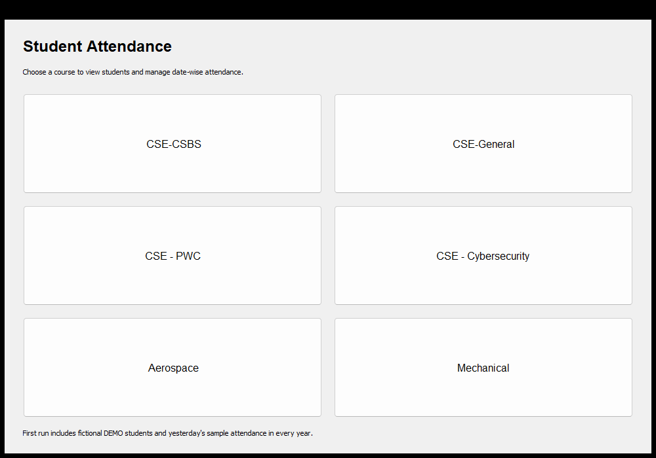
Figure 11.1 Six course choices

11.2 Cohort Menu
The cohort menu offers student viewing/editing and attendance creation, viewing and correction.
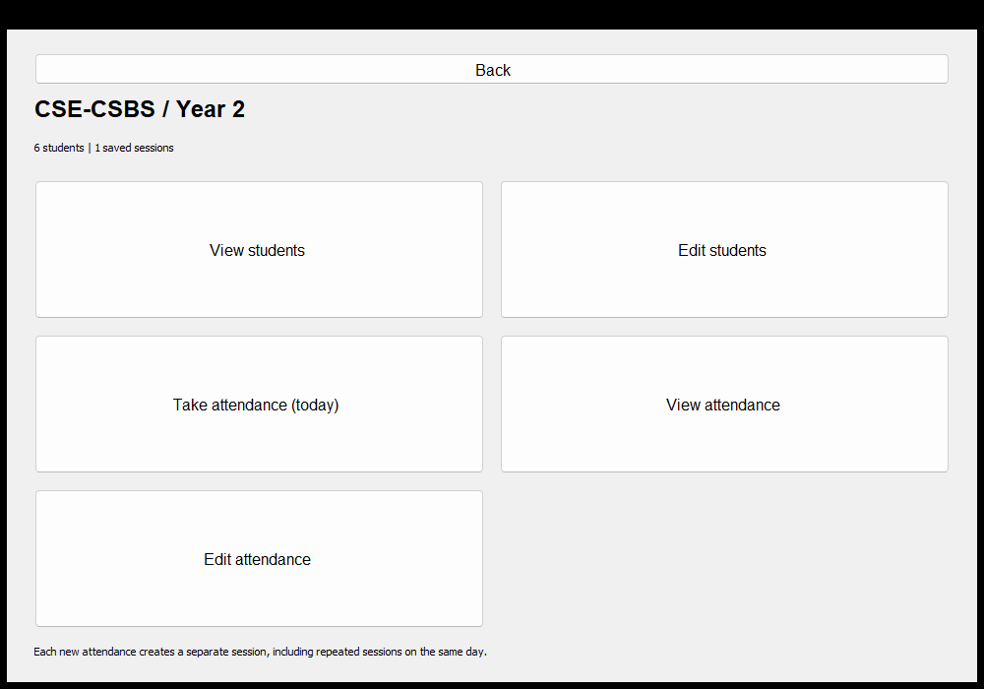
Figure 11.2 CSE-CSBS Year 2 operations

11.3 Student Register
The register displays roll, USN and name. Search matches a name or USN without requiring the same letter case.
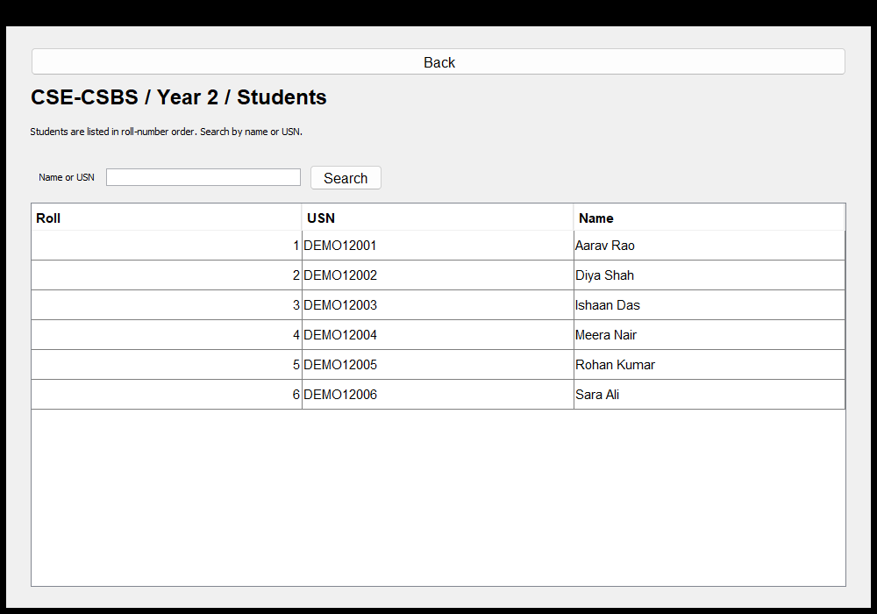
Figure 11.3 Students listed by roll number

11.4 Taking Attendance
In this example, Aarav, Diya, Meera and Rohan are checked. The totals show four present and two absent. Saving creates a new session.
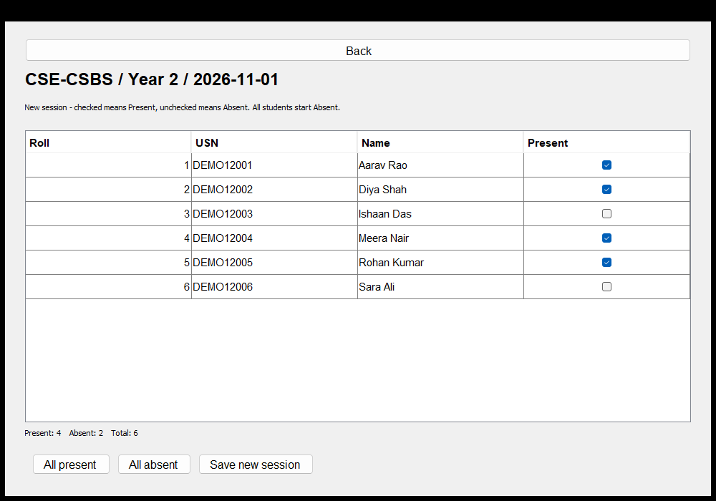
Figure 11.4 Present checkboxes and live totals

11.5 Saved Sessions
Each list entry includes its date, session number and present count. The selected session can be opened for viewing or correction.
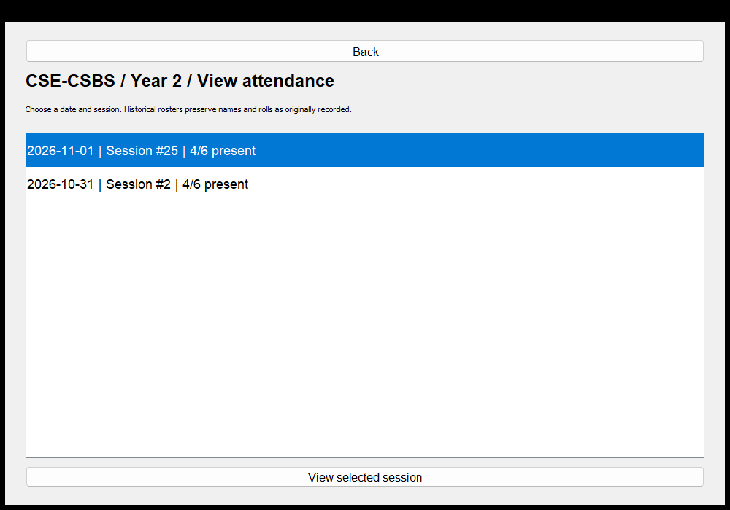
Figure 11.5 Attendance history by date and session

11.6 Editing Existing Attendance
The edit screen enables checkboxes for the original roster. The example marks all six present before saving changes. Other sessions remain unchanged.
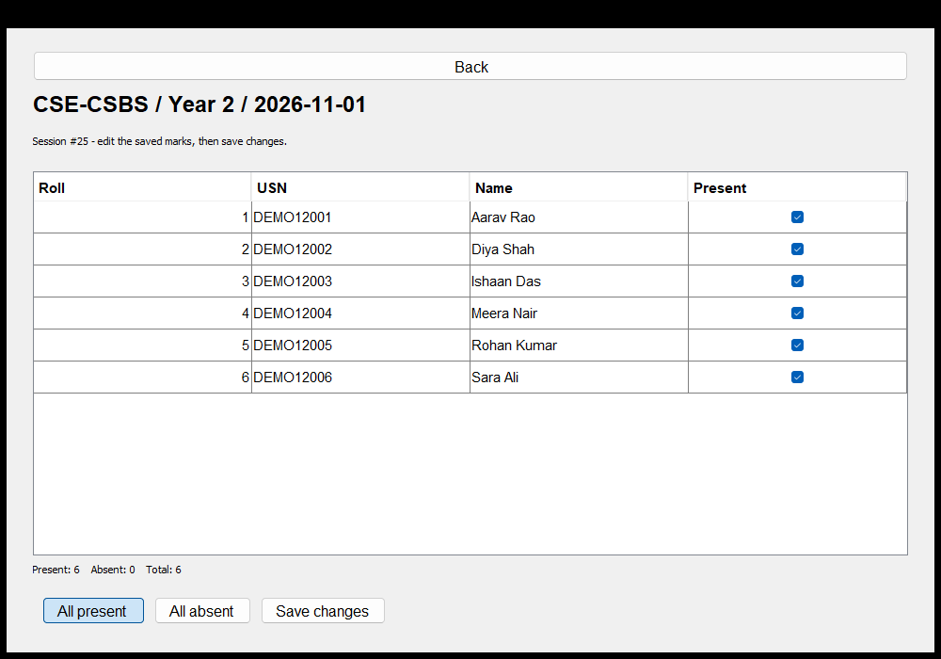
Figure 11.6 Correcting the selected saved session

11.7 Restart Behaviour
Closing and reopening the app reloads the student register and every saved attendance session from data/attendance.tsv. The regression tests verified both the number of records and corrected marks after reloading. No demonstration data is inserted again when a valid saved file already exists.

12. Future Enhancements Conclusion and References

12.1 Future Enhancements
Possible extensions include subject-wise attendance, user accounts and roles, a database through JDBC, student transfer and promotion, percentage reports with a clearly defined daily/session policy, spreadsheet export and automatic backups. These are future improvements and are not part of the current application.

12.2 Conclusion
The Student Attendance Management System implements a complete small workflow: choose a cohort, maintain its students, mark today's attendance, view or correct saved sessions and reload records after restart. Three application source files keep the design approachable, while historical rosters and validation preserve the meaning of saved attendance.
The implementation demonstrates the Java concepts identified in the circular through concrete examples rather than isolated syntax. The executed 41 data checks and 15 interface checks passed. The project is suitable for a classroom demonstration, with the documented limits of a local, single-user teaching application.

12.3 References
Department of Computer Science and Engineering, JAIN (Deemed-to-be University). Java Mini Project Circular. OOP's using JAVA, course code 25PCCSBS301, academic year 2026-27. Supplied course document.
Mini Project Report Templates. Cover, certificate, declaration, acknowledgement, abstract, contents and main report templates supplied for this project.
Oracle. The Swing Tutorial, TableRenderDemo source example. https://docs.oracle.com/javase/tutorial/uiswing/examples/components/TableRenderDemoProject/src/components/TableRenderDemo.java (consulted 1 November 2026).
Oracle. The Swing Tutorial, TableSelectionDemo source example. https://docs.oracle.com/javase/tutorial/uiswing/examples/components/TableSelectionDemoProject/src/components/TableSelectionDemo.java (consulted 1 November 2026).
Project source, annotated walkthrough, concept mapping and test programs. https://github.com/shxhxn/Java-Mini-Project

