SIMATS ENGINEERING
ASSESSMENT TOOL 1

COURSE NAME: Ethical Hacking COURSE CODE: ITA1411

COURSE OUTCOME COVERED

CO2: Execute footprinting in social engineering such as DNS analysis, competitive intelligence gathering, and attack simulations to collect relevant information for identifying potential security risks.

Assessment Tool Weightage: 30%

Duration: 90 min Total Marks: 50

Code of Conduct:

I __M . Shalini/1921260230_ (Name / Reg No) certify that this submission is my original work and that I have adhered to the guidelines specified for this assessment.
I understand that any violation of academic integrity rules will result in disciplinary action.

Signature of the student: M . Shalini

Report Analysis
Questions

1.A security analyst performed a network scan on the target 192.168.1.10 using the Nmap tool. The report identified several open ports, including HTTP (80), SSH (22), and MySQL (3306), along with the operating system and service versions. Analyze the report and explain the security risks associated with the identified services. Discuss how an attacker could exploit these services and recommend suitable security measures to protect the target system. (20 Marks)

1. Introduction
Nmap (Network Mapper) is a network scanning tool used to identify open ports, running services, operating systems, and possible security weaknesses in a target system. In this report, the target system is 192.168.1.10. The scan identified three open ports: HTTP (80), SSH (22), and MySQL (3306).

Analysis of the Report

Port | Service | Purpose
22 | SSH | Provides secure remote login to the system.
80 | HTTP | Hosts websites and web applications.
3306 | MySQL | Stores and manages database information.
The availability of these services is not automatically a vulnerability. However, weak configurations, outdated versions, and unnecessary network access can create security risks.

3. Security Risks Associated with the Services
A. SSH – Port 22
- SSH allows administrators to access the system remotely.
- Weak passwords may allow attackers to gain unauthorized access.
- Outdated SSH versions may contain known security vulnerabilities.
- Poor access controls may allow unauthorized users to attempt logins.
- Stolen SSH credentials or private keys may be used to access the system.
B. HTTP – Port 80
- HTTP traffic is not encrypted by default, so sensitive information may be exposed during transmission.
- Vulnerable web applications may allow SQL injection, cross-site scripting (XSS), or unauthorized access.
- Outdated web server software may contain known vulnerabilities.
- Incorrect file permissions or directory listing settings may expose sensitive information.
- Weak authentication and session management can increase the risk of account compromise.
C. MySQL – Port 3306
- If the database is accessible from untrusted networks, attackers may attempt unauthorized connections.
- Weak database passwords may allow unauthorized access.
- Excessive database privileges may permit users to read, modify, or delete sensitive information.
- Outdated MySQL versions may contain known vulnerabilities.
- Improper configuration may expose confidential business or customer data.

4. How an Attacker Could Exploit These Services
An attacker who can reach the target system might:
- Scan open ports to identify available services.
- Identify service versions and compare them with publicly known vulnerabilities.
- Attempt password-based attacks against SSH or MySQL.
- Test the web application for common security weaknesses.
- Try to access exposed database services using unauthorized credentials.
- Attempt to steal, modify, or delete data if a vulnerability or weak access control is successfully exploited.
These activities depend on the system's configuration, software versions, and security controls. An open port alone does not prove that the system is vulnerable.

5. Recommended Security Measures
Service | Security Measure
SSH (22) | Use strong authentication, disable direct root login, restrict access to trusted IP addresses, and prefer SSH keys or multifactor authentication where supported.
HTTP (80) | Redirect HTTP to HTTPS, use a valid TLS certificate, update web server software, and secure the application against common web attacks.
MySQL (3306) | Block public access, allow connections only from authorized application servers, use strong passwords, and apply least-privilege permissions.
All services | Install security updates, disable unnecessary services, monitor logs, and perform regular vulnerability assessments.

6. Additional Security Recommendations
- Configure a firewall to allow only necessary traffic.
- Keep the operating system and all services updated.
- Use an intrusion detection or prevention system where appropriate.
- Back up important files and databases regularly.
- Monitor failed login attempts and unusual network activity.
- Conduct periodic security audits and authorized penetration tests.

OUTPUT Screenshot:
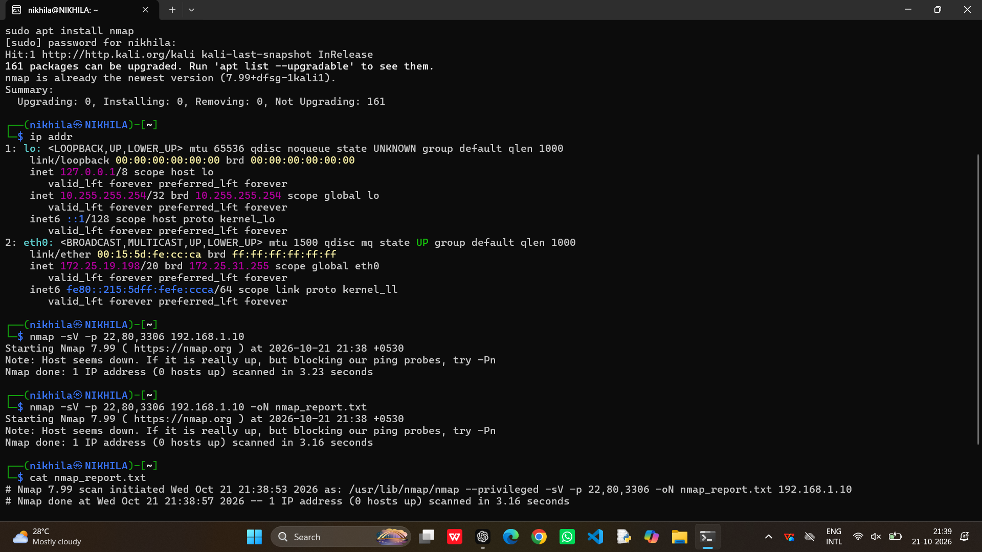

7. Conclusion
The Nmap report shows that SSH, HTTP, and MySQL are accessible on the target system. These services are useful but may introduce risks if they are outdated, improperly configured, or accessible to unauthorized users. Applying strong authentication, firewall restrictions, encryption, regular patching, and continuous monitoring can significantly improve the security of the target system.

2.A phishing awareness campaign was conducted for employees of ABC Technologies Pvt. Ltd. using the GoPhish tool. The report indicates that 40% of employees clicked the phishing link, 20% entered their login credentials, and several users downloaded a malicious attachment. Analyze the report and identify the security weaknesses demonstrated by the employees. Recommend suitable user awareness programs, email security controls, and organizational policies to reduce the risk of successful social engineering attacks.(20 Mark).

1. Introduction
GoPhish is an open-source phishing simulation tool used to conduct authorized phishing awareness campaigns. It helps organizations understand how employees respond to suspicious emails and identify weaknesses in security awareness.
In the given report, ABC Technologies Pvt. Ltd. conducted a phishing awareness campaign with the following results.

2. Analysis of the Report
Finding | Percentage / Observation | Security Concern
Employees who clicked the phishing link | 40% | Employees may not recognize suspicious links.
Employees who entered login credentials | 20% | Employees may disclose confidential login information.
Employees who downloaded a malicious attachment | Several users | Employees may expose systems to malware.
The report indicates that some employees are vulnerable to phishing attacks. The exact number of affected employees is not provided, so the percentages should not be converted into employee counts without additional information.

3. Security Weaknesses Demonstrated by Employees
A. Lack of phishing awareness
Employees clicked suspicious links without properly verifying the sender or the website.
B. Poor password security practices
Some employees entered their login credentials on a phishing page, increasing the risk of account compromise.
C. Unsafe attachment handling
Downloading suspicious attachments may introduce malware, ransomware, or spyware into the organization's systems.
D. Failure to verify email authenticity
Employees may have trusted emails that appeared to come from legitimate companies, managers, or colleagues.
E. Lack of incident reporting
Employees may not know how to report suspicious emails to the IT or security team.
F. Risk of further attacks
If an attacker compromises an employee's account, the account may be used to send additional phishing emails or access confidential company information.

4. Recommended User Awareness Programs
- Regular security training: Conduct training sessions to explain phishing, social engineering, and online security.
- Phishing simulation exercises: Use authorized GoPhish campaigns to measure employee awareness and identify areas for improvement.
- Suspicious email identification: Teach employees to check sender addresses, unexpected requests, spelling errors, and unusual links.
- Password protection training: Explain why passwords and one-time passwords (OTPs) must never be shared through suspicious links or messages.
- Attachment safety: Train employees not to open unexpected attachments without verification.
- Incident reporting awareness: Teach employees how to report suspicious emails immediately.

5. Recommended Email Security Controls
Security Control | Purpose
Spam filters | Detect and block unwanted or suspicious emails.
Email authentication | Use SPF, DKIM, and DMARC to help prevent email spoofing.
Anti-malware protection | Scan attachments and detect malicious files.
Safe link protection | Check suspicious URLs and block known malicious websites.
Multi-factor authentication (MFA) | Reduce the risk of unauthorized access when passwords are stolen.
Email monitoring | Identify suspicious email patterns and potential phishing campaigns.

6. Recommended Organizational Policies
- Establish a clear email and internet usage policy.
- Require employees to report suspicious emails immediately.
- Enforce strong passwords and multifactor authentication.
- Restrict unnecessary access to confidential information.
- Apply regular software updates and endpoint protection.
- Conduct periodic phishing simulations and awareness assessments.
- Define a clear procedure for responding to compromised accounts.
- Encourage employees to report mistakes without fear of unfair punishment, so incidents can be addressed quickly.

7. Steps to Reduce Future Phishing Attacks
The organization should follow these steps:
- Review the phishing campaign results.
- Identify employees who need additional training.
- Conduct targeted awareness sessions.
- Strengthen email filtering and attachment scanning.
- Enable multifactor authentication.
- Repeat authorized phishing simulations.
- Compare results to measure improvement.
Output Screenshot:
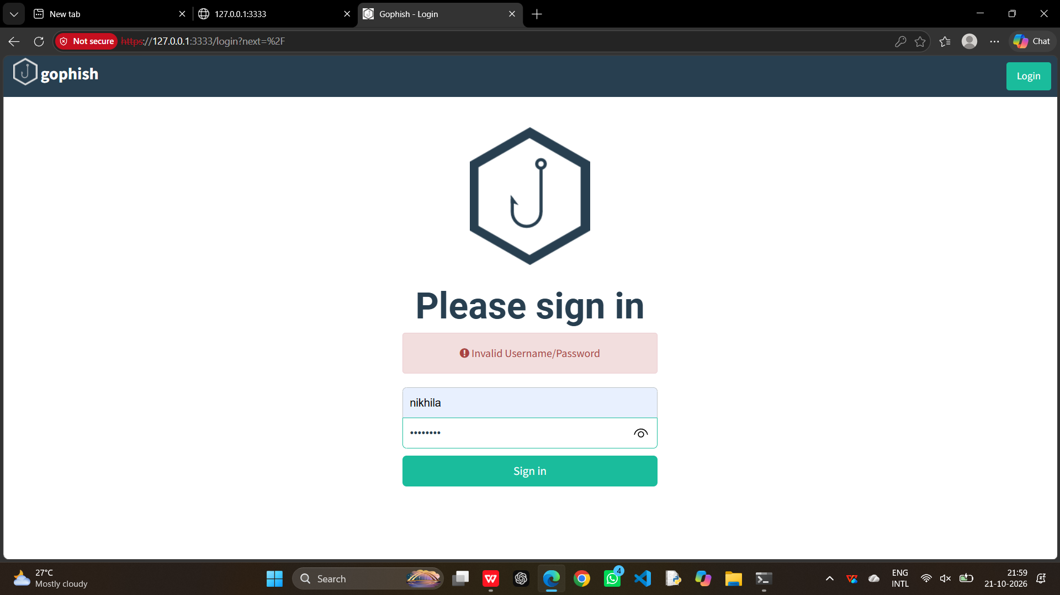

8. Conclusion
The GoPhish report shows that employees of ABC Technologies Pvt. Ltd. have weaknesses in identifying phishing links, protecting login credentials, and handling suspicious attachments. Regular awareness training, secure email systems, multifactor authentication, and effective reporting policies can reduce the risk of successful social engineering attacks.
3.A DNS assessment report generated using the Dig tool shows that the organization's DNS server permits a successful DNS Zone Transfer (AXFR), exposing internal hostnames, mail servers, and DNS records. Analyze the report and explain the security implications of the exposed information. Discuss how attackers could exploit these findings and recommend best practices to secure the DNS infrastructure..(10 Marks)

1. Introduction
DNS (Domain Name System) translates domain names into IP addresses. The dig tool is used to obtain DNS information and examine DNS records.
A DNS Zone Transfer (AXFR) is a process used to copy DNS zone information from one DNS server to another. It is normally required for legitimate synchronization between authorized DNS servers.
In the given report, the organization's DNS server permits a successful zone transfer, exposing internal hostnames, mail servers, and DNS records.

2. Analysis of the Report
The successful AXFR indicates that the DNS server may not be properly restricting which systems can request a complete copy of the DNS zone.
The exposed information may include:
- Internal hostnames and server names.
- Mail server details.
- DNS records and IP addresses.
- Names of important organizational systems.
- Information about the organization's network structure.
This information can help an attacker understand the organization's infrastructure.

3. Security Implications of Exposed Information
A. Information disclosure
Internal hostnames and DNS records may reveal details about servers, applications, and network resources.
B. Network mapping
Attackers may use the exposed records to build a map of the organization's infrastructure.
C. Identification of important systems
Hostnames may reveal systems used for email, databases, administration, or other important services.
D. Increased attack surface
The exposed information may help attackers identify potential targets for further investigation.
E. Targeted social engineering
Knowledge of employee-related hostnames, mail servers, or system names may help attackers prepare more convincing phishing messages.

4. How Attackers Could Exploit These Findings
An attacker might:
- Collect DNS records and hostnames exposed by the zone transfer.
- Identify important servers and their possible purposes.
- Correlate DNS information with other publicly available information.
- Investigate identified systems for security weaknesses.
- Use the information to support targeted phishing or other attacks.
A successful zone transfer does not automatically provide access to internal systems. It exposes information that may make further attacks easier.

5. Recommended Best Practices to Secure DNS Infrastructure
- Restrict zone transfers: Allow AXFR requests only from authorized secondary DNS servers.
- Configure access controls: Use appropriate server settings and firewall rules to block unauthorized zone-transfer requests.
- Review DNS records: Remove unnecessary or outdated records and avoid exposing internal hostnames publicly.
- Secure DNS servers: Keep DNS software updated and disable unnecessary services.
- Monitor DNS activity: Review DNS logs for unauthorized zone-transfer attempts and unusual requests.
- Use secure administration: Apply strong authentication and restrict administrative access.
- Conduct regular audits: Periodically test DNS configurations and verify that only authorized systems can transfer zones.

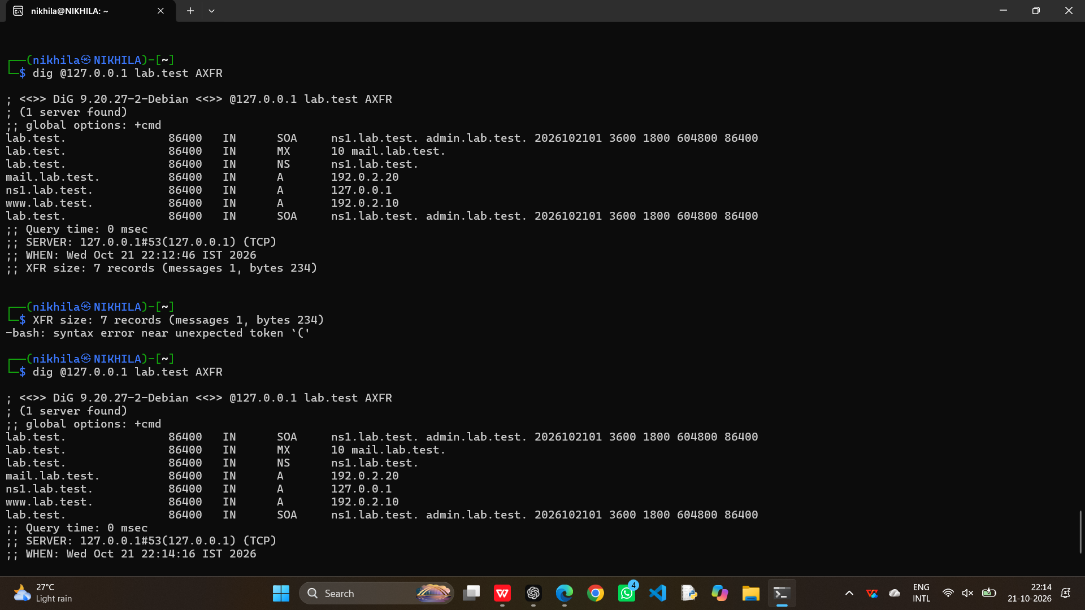

6. Conclusion
The DNS assessment report indicates that the organization's DNS server permits an unauthorized zone transfer, potentially exposing sensitive infrastructure information. Attackers could use this information to identify important systems and plan further attacks. Restricting AXFR requests, applying firewall rules, reviewing DNS records, monitoring logs, and conducting regular security audits can help protect the DNS infrastructure.

RUBRICS FOR CALCULATION

Report Analysis
Criteria | Weightage (%) | Level 4 (Exemplary) | Level 3 (Proficient) | Level 2 (Developing) | Level 1 (Beginning)
Report Analysis and Interpretation | 25% | Accurately interprets the security report, identifies all key findings, and explains their significance with excellent technical understanding. | Correctly interprets most findings with minor omissions or inaccuracies. | Identifies only some findings and provides limited interpretation. | Unable to interpret the report or identify key findings.
Identification of Security Risks and Vulnerabilities | 25% | Correctly identifies all security risks, vulnerabilities, and possible attack vectors with clear technical justification. | Identifies most risks and vulnerabilities with minor errors. | Identifies only a few risks with limited technical explanation. | Fails to identify major risks or vulnerabilities.
Application of Cybersecurity Concepts and Countermeasures | 30% | Applies appropriate ethical hacking concepts and recommends comprehensive, practical, and technically sound countermeasures. | Recommends suitable countermeasures with minor technical gaps. | Provides limited or partially appropriate recommendations. | Recommendations are inappropriate, incomplete, or missing.
Technical Communication and Documentation | 20% | Response is well-organized, technically accurate, clearly presented, and uses appropriate cybersecurity terminology throughout. | Response is organized and understandable with minor documentation or presentation issues. | Response lacks clarity, organization, or contains several technical inaccuracies. | Response is poorly organized, incomplete, and difficult to understand.

