**COMP 3133 – Full Stack Development – Lab 1**

* JavaScript Refresher Exercises

**Developer Note:**

* Answer any 4 of the JavaScript exercises below
* Try to solve the problems without using search engines or stack overflow for the solutions.

**Exercise 1:**

***Write a JavaScript program to capitalize the first letter of each word of a given string.***

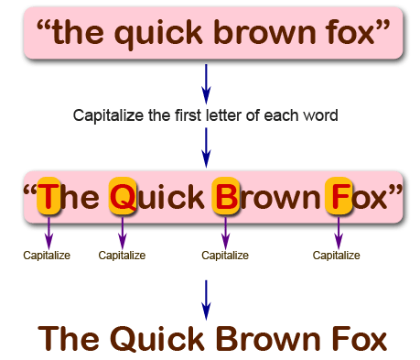

**function myFunction() {**

**var str = "the quick brown fox";**

**var res = str.split(" ");**

**var result='';**

**for (var i=0;i<res.length;i++){**

**res[i]=res[i].charAt(0).toUpperCase()+res[i].slice(1);**

**result=result+res[i]+ ' ';**

**}**

**result.trim;**

**return result;**

**}**

**myFunction();**

**Exercise 2:**

***Write a JavaScript program to find the largest of three given integers.***

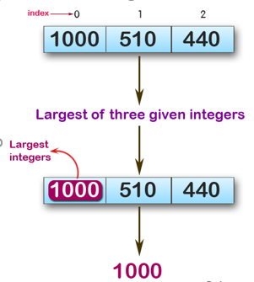

console.log(max (1,0,1));

console.log(max (0,-10,-20));

console.log(max (1000,510,440));

**Sample Output:**

1  
0  
100

**function** *max*(a,b,c) {  
 **var** max;  
 **if**(a>=b){  
 max=a;  
 **if**(a<c){  
 max=c;  
 }  
 }**else** {  
 max=b;  
 **if** (b<c){  
 max=c;  
 }  
 }  
 **return** max;  
  
}  
***console***.log(*max* (1,0,1));  
***console***.log(*max* (0,-10,-20));  
***console***.log(*max* (1000,510,440));

**Exercise 3:**

*Write a JavaScript program to move last three character to the start of a given string. The string length must be greater or equal to three****.***

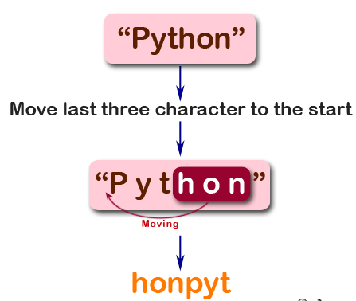

console.log(right("Python"));

console.log(right("JavaScript"));

console.log(right("Hi"));

**Sample Output:**

honPyt  
iptJavaScr  
Hi

**function** *right*(text){  
 **var** result=text.split(**''**);  
 **var** output=**''**;  
 **var** pointer;  
 **if**(result.**length**<=3){  
 **return** text;  
 }**else**{  
 **for**( **var** i=0;i<result.**length**;i++){  
 **if**(i>=result.**length**-3){  
 output+=result[i];  
 pointer=i;  
 }  
 }  
 **for**(i=0;i<result.**length**-3;i++){  
 output+=result[i];  
 }  
 **return** output.toString();  
 }  
}

**Exercise 4:**

*Write a JavaScript program to find the types of a given angle.*

Types of angles:  
• Acute angle: An angle between 0 and 90 degrees.  
• Right angle: An 90 degree angle.  
• Obtuse angle: An angle between 90 and 180 degrees.  
• Straight angle: A 180 degree angle.

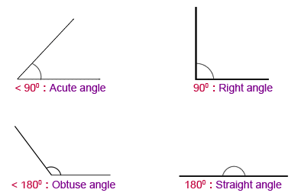

console.log(angle_Type(47))

console.log(angle_Type(90))

console.log(angle_Type(145))

console.log(angle_Type(180))

**Sample Output:**

Acute angle  
Right angle  
Obtuse angle  
Straight angle

**function** *angle_Type*(a){  
 **if**(a<90){  
 **return 'Acute angle'**;  
 }**else if**(a==90){  
 **return 'Right angle'**;  
 }**else if** (a<180){  
 **return 'Obtuse angle'**;  
 }**else if**(a==180){  
 **return 'Straight angle'**;  
 }  
}  
***console***.log(*angle_Type*(47))  
***console***.log(*angle_Type*(90))  
***console***.log(*angle_Type*(145))  
***console***.log(*angle_Type*(180))

**Exercise 5:**

*Write a JavaScript program to find the maximum possible sum of some of its k consecutive numbers (numbers that follow each other in order.) of a given array of positive integers.*

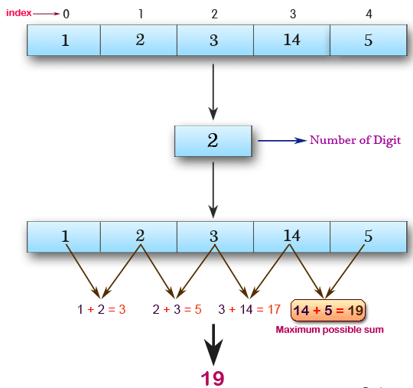

console.log(array_max_sum([1, 2, 3, 14, 5], 2))

console.log(array_max_sum([2, 3, 5, 1, 6], 3))

console.log(array_max_sum([9, 3, 5, 1, 7], 2))

**Sample Output:**

19  
12  
12