CASE STUDY

1.Advanced Matrix Library with Complete OOP
Problem: Create a comprehensive matrix computation library:
Program:
#include <iostream>
#include <vector>
#include <functional>
using namespace std;
class Matrix {
protected:
int rows, cols;
vector<vector<double>> data;
public:
Matrix(int r, int c) : rows(r), cols(c) {
data.assign(rows, vector<double>(cols, 0));
}
virtual void display() const {
cout << "Matrix (" << rows << "x" << cols << "):\n";
for (int i = 0; i < rows; i++) {
for (int j = 0; j < cols; j++)
cout << data[i][j] << " ";
cout << "\n";
}
}
virtual double determinant() const {
cout << "Determinant not defined for this matrix type.\n";
return 0;
}
virtual void apply(function<double(double)> f) {
for (int i = 0; i < rows; i++)
for (int j = 0; j < cols; j++)
data[i][j] = f(data[i][j]);
}
virtual ~Matrix() {}
};
class SquareMatrix : public Matrix {
public:
SquareMatrix(int n) : Matrix(n, n) {
for (int i = 0; i < n; i++)
for (int j = 0; j < n; j++)
data[i][j] = (i == j) ? 1 : 0;
}
double determinant() const override {
if (rows == 2) {
return (data[0][0] * data[1][1]) - (data[0][1] * data[1][0]);
}
if (rows == 3) {
return data[0][0]*(data[1][1]*data[2][2] - data[1][2]*data[2][1]) -
data[0][1]*(data[1][0]*data[2][2] - data[1][2]*data[2][0]) +
data[0][2]*(data[1][0]*data[2][1] - data[1][1]*data[2][0]);
}
cout << "Determinant calculation for larger size not implemented.\n";
return 0;
}
};
class IdentityMatrix : public SquareMatrix {
public:
IdentityMatrix(int n) : SquareMatrix(n) {
for (int i = 0; i < n; i++)
for (int j = 0; j < n; j++)
data[i][j] = (i == j) ? 1 : 0;
}
};
class DiagonalMatrix : public SquareMatrix {
public:
DiagonalMatrix(int n) : SquareMatrix(n) {
for (int i = 0; i < n; i++)
for (int j = 0; j < n; j++)
data[i][j] = (i == j) ? (i + 1) : 0;
}
};
class SparseMatrix : public Matrix {
public:
SparseMatrix(int r, int c) : Matrix(r, c) {
if (r > 0 && c > 0) {
data[0][0] = 5;
if (r > 1 && c > 1) data[r-1][c-1] = 10;
}
}

void display() const override {
cout << "Sparse Matrix (" << rows << "x" << cols << ") non-zero elements:\n";
for (int i = 0; i < rows; i++)
for (int j = 0; j < cols; j++)
if (data[i][j] != 0)
cout << "(" << i << "," << j << ") = " << data[i][j] << "\n";
}
};
int main() {
Matrix* matrices[3];
matrices[0] = new SquareMatrix(3);
matrices[1] = new DiagonalMatrix(3);
matrices[2] = new SparseMatrix(4, 4);
cout << "=== Matrix Demonstration ===\n";
for (int i = 0; i < 3; i++) {
matrices[i]->display();
cout << "Determinant: " << matrices[i]->determinant() << "\n\n";
}
auto doubleElements = [](double x) { return x * 2; };
SquareMatrix m(3);
cout << "Original Square Matrix:\n";
m.display();
m.apply(doubleElements);
cout << "After doubling each element:\n";
m.display();
for (int i = 0; i < 3; i++)
delete matrices[i];
return 0;
}

OUTPUT:
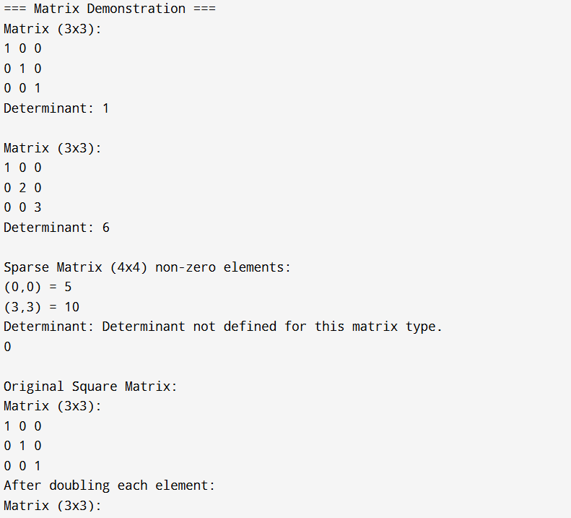
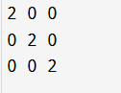
Defintion:
A Matrix Computation Library is a software module or collection of functions designed to perform various mathematical operations on matrices efficiently. It provides tools for matrix creation, manipulation, and computation, including operations such as addition, subtraction, multiplication, transposition, determinant calculation, and finding inverses or eigenvalues. The library serves as a foundation for solving complex mathematical, engineering, and scientific problems that involve linear algebra.

