GROUP TWO
Solutions to Selected Exercises
An Introduction to Statistical Learning (2nd Edition)
Chapters 2 and 3 | Computed in R using the ISLR2 package

These solutions follow James, Witten, Hastie, and Tibshirani, An Introduction to Statistical Learning with Applications in R, 2nd edition (corrected June 2023). Conceptual answers use the definitions of regression, classification, inference, and prediction from Chapter 2. Applied answers use the Auto data and the linear model functions in R. All numerical results below were produced with R 4.4 and ISLR2.
Chapter 2 | Statistical Learning
Exercise 2. Classification versus regression; inference versus prediction
Problem. For each scenario, state whether the problem is classification or regression, whether the main goal is inference or prediction, and give n and p.
(a) CEO salary of the top 500 U.S. firms
This is a regression problem. The response is CEO salary, which is a continuous quantitative variable, so we are modeling a real-valued outcome rather than a class label.
The main interest is inference. The wording is that we want to understand which factors affect CEO salary. That is a statement about the roles of the predictors (profit, number of employees, and industry), not a request for a forecast of a new CEO's pay. A flexible black-box predictor would be less useful here than an interpretable model whose coefficients can be discussed.
n = 500 (one observation per firm). p = 3 predictors: profit, number of employees, and industry. CEO salary is the response and is not counted in p.
(b) Success or failure of a new product
This is a classification problem. The response is binary (success or failure), which is a qualitative / categorical outcome.
The main interest is prediction. The practical question is whether a product that has not yet been launched will succeed or fail. We are not asked to explain the market mechanism; we are asked for an accurate call on a new case.
n = 20 previously launched products. p = 13 predictors: price charged, marketing budget, competition price, and ten other variables. Success/failure is the response. With n = 20 and p = 13 this is a small-sample, relatively high-dimensional setting, so a simple classifier is more realistic than a heavily parameterized one.
(c) Weekly percent change in the USD/Euro exchange rate
This is a regression problem. The response is the weekly percent change in the USD/Euro rate, which is continuous and quantitative.
The main interest is prediction. The problem states that we are interested in predicting the percent change in the exchange rate from weekly stock-market changes. The goal is a forecast, not an explanation of which market 'causes' the exchange rate to move.
n = 52 (weekly observations for all of 2012). p = 3 predictors: percent change in the U.S. market, the British market, and the German market. The USD/Euro percent change is the response. (2012 is a leap year, so a 52-week series is the natural weekly sample for the year.)
Scenario | Problem type | Goal | n | p | Response
(a) CEO salary | Regression | Inference | 500 | 3 | CEO salary (quantitative)
(b) Product launch | Classification | Prediction | 20 | 13 | Success / failure (binary)
(c) USD/Euro | Regression | Prediction | 52 | 3 | % change USD/Euro (quantitative)
Table 1. Summary of Exercise 2. n is the number of observations; p is the number of predictors.
Exercise 9. The Auto data set
The Auto data in ISLR2 already has missing horsepower values removed: 5 rows were omitted, leaving n = 392 complete observations and 9 variables. anyNA(Auto) is FALSE, so no further deletion is required. The analysis below uses that complete data frame.
library(ISLR2)
data(Auto)
dim(Auto) # 392 9
anyNA(Auto) # FALSE
(a) Quantitative versus qualitative predictors
The variables are mpg, cylinders, displacement, horsepower, weight, acceleration, year, origin, and name.
Quantitative (numeric measurements): mpg, cylinders, displacement, horsepower, weight, acceleration, and year. These are stored as numeric or integer and represent amounts or counts.
Qualitative (categorical): origin and name. Origin is coded as 1 = American, 2 = European, 3 = Japanese; the codes are not a numeric scale. Name is a factor with 304 manufacturer/model labels (301 distinct values appear in the 392 rows).
Two numeric variables are borderline. Cylinders takes only five values (3, 4, 5, 6, 8) and year takes thirteen values (70 through 82). They can be treated as quantitative, which we do for the range/mean/SD calculations requested in (b)–(d), or as qualitative factors in a regression. Origin should not be treated as a continuous predictor.
Variable | Storage | Unique values | Role
mpg | numeric | 127 | Quantitative (response in (f))
cylinders | integer | 5 | Quantitative (few levels; may be a factor)
displacement | numeric | 81 | Quantitative
horsepower | integer | 93 | Quantitative
weight | integer | 346 | Quantitative
acceleration | numeric | 95 | Quantitative
year | integer | 13 | Quantitative (few levels; may be a factor)
origin | integer (codes) | 3 | Qualitative (American / European / Japanese)
name | factor | 301 | Qualitative (car name)
Table 2. Variable types in Auto after missing values are removed.
(b) Range of each quantitative predictor
The range is max(x) − min(x). In R this is given by range() (the two endpoints) or by diff(range()).
quant <- c("mpg","cylinders","displacement","horsepower",
"weight","acceleration","year")
sapply(Auto[quant], range)
sapply(Auto[quant], function(x) diff(range(x)))
Predictor | Minimum | Maximum | Range
mpg | 9 | 46.6 | 37.6
cylinders | 3 | 8.0 | 5.0
displacement | 68 | 455.0 | 387.0
horsepower | 46 | 230.0 | 184.0
weight | 1,613 | 5,140.0 | 3,527.0
acceleration | 8 | 24.8 | 16.8
year | 70 | 82.0 | 12.0
Table 3. Range of each quantitative predictor in the full Auto data (n = 392).
mpg runs from 9.0 to 46.6 miles per gallon (range 37.6). Engine size and vehicle mass vary much more: displacement from 68 to 455 cubic inches (range 387) and weight from 1,613 to 5,140 pounds (range 3,527). Cylinders (3 to 8) and year (70 to 82) have short numeric ranges because they are discrete.
(c) Mean and standard deviation of each quantitative predictor
sapply(Auto[quant], mean)
sapply(Auto[quant], sd)
Predictor | Mean | SD
mpg | 23.45 | 7.81
cylinders | 5.47 | 1.71
displacement | 194.41 | 104.64
horsepower | 104.47 | 38.49
weight | 2,977.58 | 849.40
acceleration | 15.54 | 2.76
year | 75.98 | 3.68
Table 4. Mean and standard deviation, full Auto data (n = 392).
A typical car in the sample gets about 23.45 mpg (SD 7.81), has a 194 cubic-inch engine (SD 105), 104 horsepower (SD 38.5), and weighs about 2,978 pounds (SD 849). The large standard deviations for displacement, horsepower, and weight show that the data mix compact cars with heavy V8s.
(d) Range, mean, and SD after dropping observations 10 through 85
Rows 10 through 85 inclusive are 76 observations. Removing them leaves 392 − 76 = 316 rows. Those dropped rows are mostly early-year, high-cylinder cars, so the remaining sample is a little lighter, more efficient, and newer on average.
Auto_sub <- Auto[-c(10:85), ]
nrow(Auto_sub) # 316
sapply(Auto_sub[quant], range)
sapply(Auto_sub[quant], mean)
sapply(Auto_sub[quant], sd)
Predictor | Minimum | Maximum | Range | Mean | SD
mpg | 9 | 46.6 | 37.6 | 23.45 | 7.81
cylinders | 3 | 8.0 | 5.0 | 5.47 | 1.71
displacement | 68 | 455.0 | 387.0 | 194.41 | 104.64
horsepower | 46 | 230.0 | 184.0 | 104.47 | 38.49
weight | 1,613 | 5,140.0 | 3,527.0 | 2,977.58 | 849.40
acceleration | 8 | 24.8 | 16.8 | 15.54 | 2.76
year | 70 | 82.0 | 12.0 | 75.98 | 3.68
Table 5a. Full Auto data (n = 392).
Predictor | Minimum | Maximum | Range | Mean | SD
mpg | 11.0 | 46.6 | 35.6 | 24.40 | 7.87
cylinders | 3.0 | 8.0 | 5.0 | 5.37 | 1.65
displacement | 68.0 | 455.0 | 387.0 | 187.24 | 99.68
horsepower | 46.0 | 230.0 | 184.0 | 100.72 | 35.71
weight | 1,649.0 | 4,997.0 | 3,348.0 | 2,935.97 | 811.30
acceleration | 8.5 | 24.8 | 16.3 | 15.73 | 2.69
year | 70.0 | 82.0 | 12.0 | 77.15 | 3.11
Table 5b. After removing observations 10 through 85 (n = 316).
After the deletion, mean mpg rises from 23.45 to 24.40, mean horsepower falls from 104.47 to 100.72, and mean weight falls from 2,977.58 to 2,935.97. Mean year increases from 75.98 to 77.15, confirming that many of the removed cars were older. The mpg minimum increases from 9.0 to 11.0, and the heaviest remaining car is 4,997 lb rather than 5,140 lb. Standard deviations change only modestly. The numerical summaries are therefore somewhat sensitive to which slice of the data we keep, which is a reminder that descriptive statistics are sample-dependent.
(e) Graphical investigation of the predictors
We use a scatterplot matrix, mpg-versus-predictor panels with a LOESS smoother, boxplots by origin and cylinders, and a correlation heatmap. Together these show both the direction of each relationship and the collinearity among the engine/size variables.
pairs(Auto[quant], pch = 19, cex = 0.45)
cor(Auto[quant])
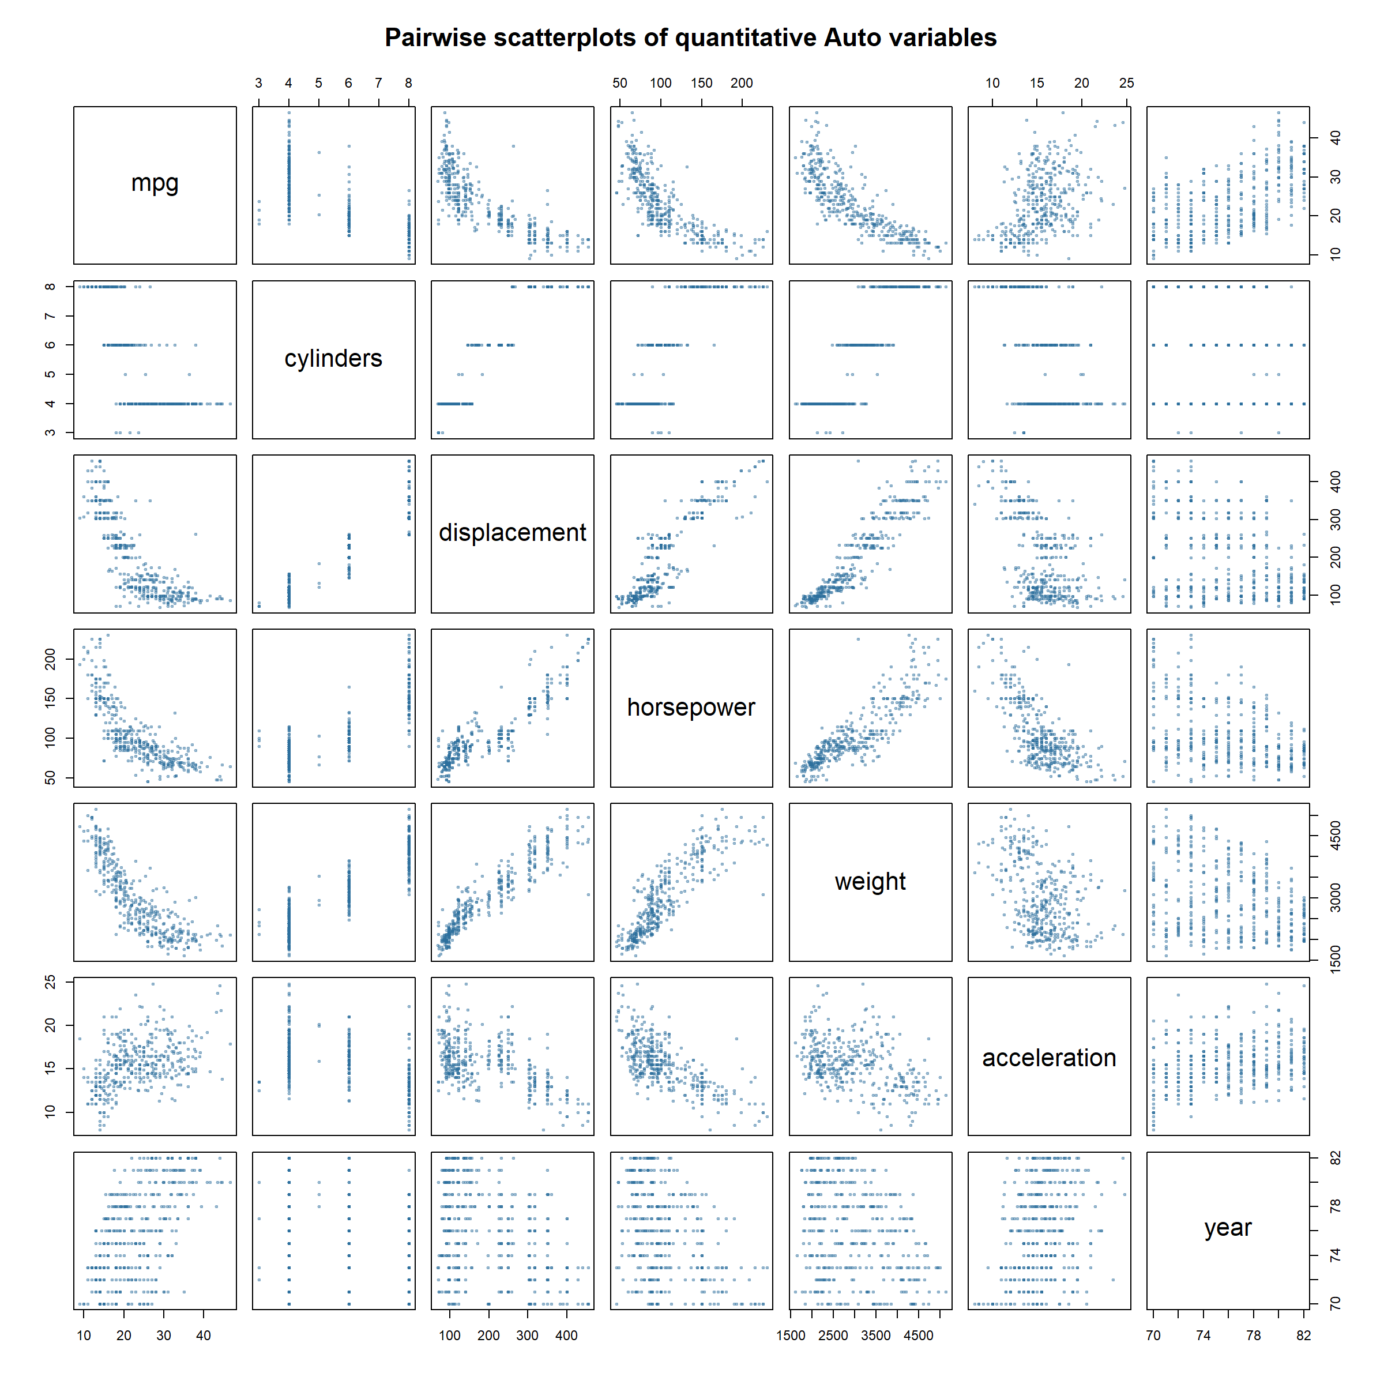
Figure 1. Scatterplot matrix of the quantitative Auto variables.
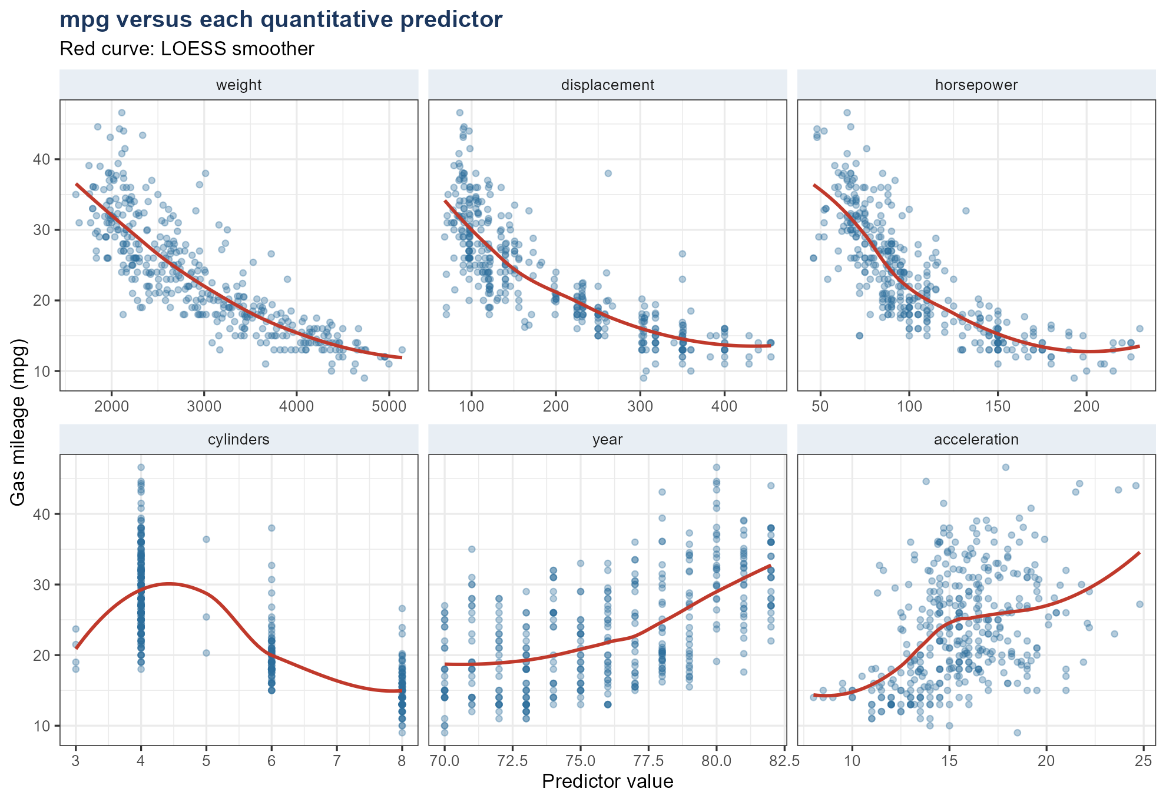
Figure 2. mpg against each quantitative predictor, with a LOESS smoother.
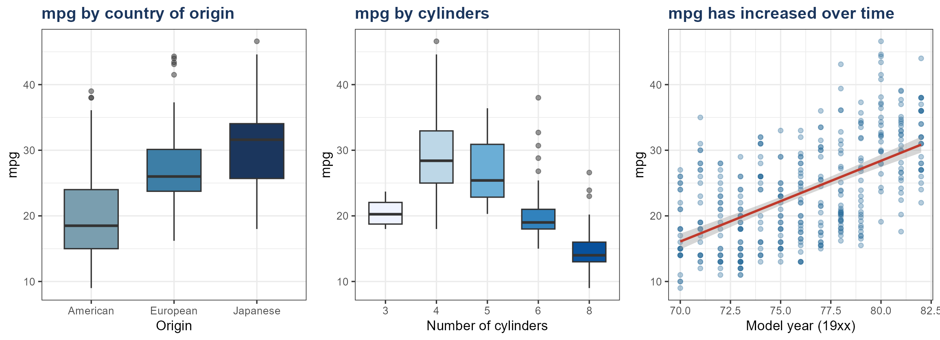
Figure 3. mpg by origin and cylinders, and the upward trend with model year.
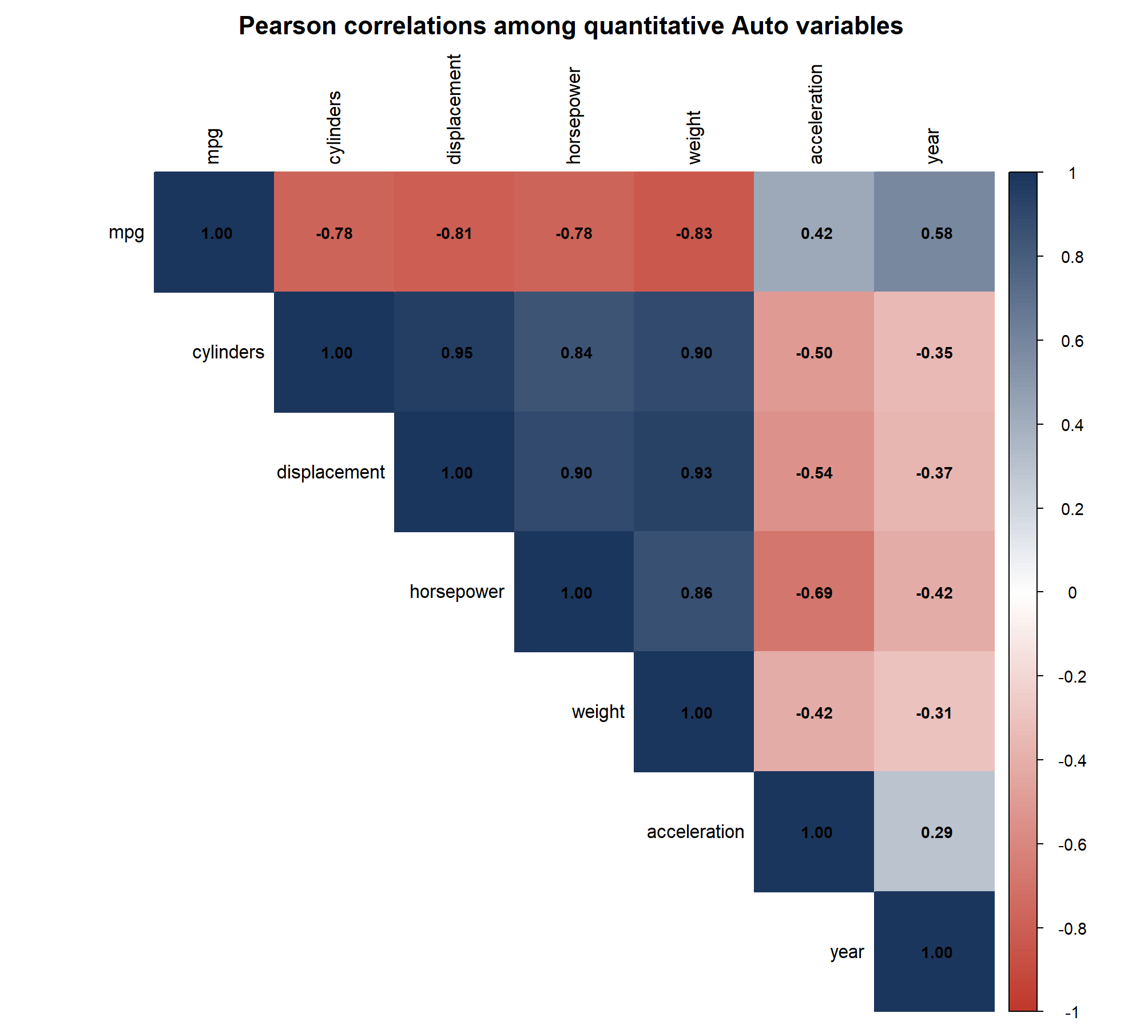
Figure 4. Pearson correlation matrix for the quantitative variables.
Findings from the plots:
1. Size and power travel together. Cylinders, displacement, horsepower, and weight are strongly positively correlated (all pairwise r between about 0.84 and 0.95). A heavier car almost always has a larger engine and more horsepower. These four variables are largely measuring the same 'big car' factor.
2. mpg falls as the car gets bigger and more powerful. The strongest linear association with mpg is weight (r = -0.832), then displacement (r = -0.805), then horsepower and cylinders (both r = -0.778). The scatterplots in Figure 2 are clearly decreasing, with some curvature at the high-mpg end (small, late-year cars).
3. Acceleration is only moderately related to mpg (r = 0.423). Faster 0–60 times (smaller acceleration values) belong to more powerful cars, which also get worse mileage, so the mpg–acceleration cloud is increasing but noisy.
4. Later model years get better mileage (r = 0.581). Figure 3 shows a clear upward drift from 1970 to 1982, consistent with fuel-economy standards and a shift toward smaller engines after the 1970s oil shocks.
5. Origin matters. American cars (origin = 1) have the lowest mean mpg (20.03), European cars are higher (27.60), and Japanese cars are highest (30.45). This partly overlaps with weight and engine size: U.S. cars in this era were heavier.
6. Cylinders behave like a step function. Four-cylinder cars dominate the high-mpg region; eight-cylinder cars cluster at low mpg. Five- and three-cylinder cars are rare, so those boxes are based on few points.
Origin | n | Mean mpg | SD mpg
American | 245 | 20.03 | 6.44
European | 68 | 27.60 | 6.58
Japanese | 79 | 30.45 | 6.09
Table 6. mpg by origin.
Cylinders | n | Mean mpg | SD mpg
3 | 4 | 20.55 | 2.56
4 | 199 | 29.28 | 5.67
5 | 3 | 27.37 | 8.23
6 | 83 | 19.97 | 3.83
8 | 103 | 14.96 | 2.84
Table 7. mpg by number of cylinders.
(f) Which variables look useful for predicting mpg?
Yes. Several predictors show a clear association with mpg and would be useful in a regression or nonparametric predictor of gas mileage.
The most informative quantitative variables are weight, displacement, horsepower, and cylinders: all have |r| with mpg of about 0.78 or larger, and the scatterplots are monotone. Because those four are highly collinear, a multiple regression that includes all of them will have unstable individual coefficients even if the overall fit is good. A sensible model might keep weight (the single strongest correlate) and perhaps horsepower or cylinders, but not the whole block without checking variance inflation.
Year is also useful (r = 0.581): later cars are more efficient after controlling, at least roughly, for size. Origin is useful as a factor: Japanese and European cars tend to have higher mpg than American cars. Acceleration is weaker and is partly a proxy for horsepower, so it is the least compelling of the numeric predictors. Name is not useful as a regression predictor: it is essentially an ID, with almost as many levels as observations.
Figure 2 also suggests mild nonlinearity (mpg flattens among the smallest cars). A linear model in weight or horsepower is a good start; a transformation (for example log(weight)) or a spline would likely improve prediction.
Chapter 3 | Linear Regression
Exercise 2. KNN classifier versus KNN regression
Problem. Carefully explain the differences between the KNN classifier and KNN regression methods.
K-nearest neighbors (KNN) is the same neighborhood rule in both cases. Given a query point x0, we find the K training observations whose predictors are closest to x0 (usually in Euclidean distance after scaling) and call that neighborhood N0. The two methods differ in the type of response they model and in how they turn the neighbors into a prediction.
KNN classifier (qualitative Y; Chapter 2).
The response is a class label. Among the K neighbors we compute the sample proportion of each class,
P̂(Y = j | X = x0) = (1/K) Σ_{i ∈ N0} 1(y_i = j)
and assign x0 to the class with the largest estimated probability (majority vote; ties broken by a rule). The method estimates a conditional class probability, then thresholds it. The natural loss is misclassification (0–1) error. The output is a label, optionally with class probabilities.
KNN regression (quantitative Y; Chapter 3).
The response is a real number. The same neighborhood is used, but the prediction is the average of the neighbors' y-values:
f̂(x0) = (1/K) Σ_{i ∈ N0} y_i
That is a local estimate of the regression function E(Y | X = x0). The natural loss is squared error. The output is a number, not a class.
What is shared, and what is not.
Both methods are nonparametric: they do not assume a linear (or any global) form for f. Both are determined by a distance metric and by K. Small K gives a flexible fit (low bias, high variance); large K gives a smoother fit (high bias, low variance). Both suffer in high dimension because 'nearest' neighbors become far apart (the curse of dimensionality).
The differences are therefore: (i) the response type (class versus number); (ii) the summary of the neighborhood (vote / class proportion versus mean); (iii) the output (label versus real-valued forecast); and (iv) the usual loss (misclassification versus squared error). KNN regression cannot be used unchanged for classification, and majority-vote KNN cannot produce a numeric mean. A hybrid exists only in the weak sense that a classifier's class probability is an average of 0–1 indicators, which is formally a KNN regression of those indicators.
Exercise 7. R² equals the square of Cor(X, Y) in simple linear regression
Problem. Show that in simple linear regression of Y onto X, the R² statistic (3.17) equals the square of the correlation (3.18). You may assume x̄ = ȳ = 0.
From the text, residual and total sums of squares, R², and the sample correlation are
RSS = Σ(y_i − ŷ_i)² , TSS = Σ(y_i − ȳ)² , R² = 1 − RSS/TSS
Cor(X, Y) = Σ(x_i − x̄)(y_i − ȳ) / √[Σ(x_i − x̄)² Σ(y_i − ȳ)²]
Assume x̄ = ȳ = 0. Then the intercept of the least-squares line is β̂0 = ȳ − β̂1 x̄ = 0, and the slope reduces to
β̂1 = Σ x_i y_i / Σ x_i² , ŷ_i = β̂1 x_i
Also TSS = Σ y_i². Expand the residual sum of squares:
RSS = Σ (y_i − β̂1 x_i)² = Σ y_i² − 2 β̂1 Σ x_i y_i + β̂1² Σ x_i²
Substitute β̂1 = (Σ x_i y_i) / (Σ x_i²):
RSS = Σ y_i² − 2 (Σ x_i y_i)² / Σ x_i² + (Σ x_i y_i)² / Σ x_i²
= Σ y_i² − (Σ x_i y_i)² / Σ x_i²
Therefore
R² = 1 − RSS/TSS = (Σ x_i y_i)² / ( Σ x_i² Σ y_i² )
Under the same centering, the correlation is
Cor(X, Y) = Σ x_i y_i / √(Σ x_i² Σ y_i²)
and squaring both sides gives
Cor(X, Y)² = (Σ x_i y_i)² / ( Σ x_i² Σ y_i² ) = R²
which is the claim. (If the means are not zero, the same algebra holds after replacing x_i and y_i by x_i − x̄ and y_i − ȳ, which is what ordinary simple linear regression does.)
A numerical check in R, after centering so that the means are zero, gives R² = 0.6680 and Cor(X,Y)² = 0.6680, which agree to machine precision.
set.seed(7)
x <- rnorm(200); y <- 1.5 * x + rnorm(200)
x <- x - mean(x); y <- y - mean(y) # so that xbar = ybar = 0
summary(lm(y ~ x))$r.squared
cor(x, y)^2
Exercise 12. Simple linear regression without an intercept
Problem. Compare the no-intercept slope of Y on X with the no-intercept slope of X on Y.
(a) When are the two coefficient estimates equal?
Equation (3.38) gives the least-squares slope for the no-intercept model Y = βX + ε:
β̂_{Y|X} = Σ x_i y_i / Σ x_i²
Reversing the roles of X and Y, the slope of X on Y with no intercept is
β̂_{X|Y} = Σ x_i y_i / Σ y_i²
The numerators are identical. The two estimates are therefore equal if and only if the denominators are equal, that is
Σ x_i² = Σ y_i²
(or the trivial case Σ x_i y_i = 0, which forces both slopes to be zero). Equivalently, the two vectors must have the same Euclidean length: ||x|| = ||y||. Special cases include y = x, y = −x, and y equal to any permutation of x (or of −x). In ordinary regression with an intercept this identity does not hold, because the two slopes are Cor(X,Y) times the two different SD ratios.
(b) An example in which the two estimates differ
If Y is roughly twice X, then ||y|| is about twice ||x||, so the denominators differ and the slopes cannot match. We simulate n = 100 observations from y = 2x + noise.
set.seed(12)
n <- 100
x <- rnorm(n)
y <- 2 * x + rnorm(n, sd = 0.8)
coef(lm(y ~ x + 0)) # regression of Y onto X, no intercept
coef(lm(x ~ y + 0)) # regression of X onto Y, no intercept
The fitted slopes are β̂_{Y|X} = 2.0144 and β̂_{X|Y} = 0.4103. They are not equal: the first is near 2, as expected from the simulation design, while the reverse regression is a much smaller number because Σ y_i² is much larger than Σ x_i². In R, a model without an intercept is specified by + 0 (or − 1) on the right-hand side of lm().
(c) An example in which the two estimates are the same
We keep the same x and set y to a random permutation of x. Then the two vectors contain the same numbers, so Σ x_i² = Σ y_i² automatically, and part (a) guarantees that the slopes match.
set.seed(12)
x <- rnorm(100)
y <- sample(x) # permutation: sum(x^2) == sum(y^2)
sum(x^2) == sum(y^2) # TRUE
coef(lm(y ~ x + 0))
coef(lm(x ~ y + 0))
Here Σ x_i² = Σ y_i² = 74.19. The two coefficient estimates are β̂_{Y|X} = -0.043949 and β̂_{X|Y} = -0.043949, which agree. (They are not equal to 1, because a permutation of x is not x itself; only the two slopes are forced to be equal, not to take any particular value.) Another simple construction is y = x or y = −x, which give slopes 1 and −1 respectively in both directions.
Example | Construction | sum(x^2) = sum(y^2)? | β̂ Y on X | β̂ X on Y
(b) Different slopes | y = 2x + noise | No | 2.0144 | 0.4103
(c) Equal slopes | y = permutation of x | Yes | -0.0439 | -0.0439
Table 8. No-intercept slopes from the two simulated examples (n = 100).
Notes on the R work
All applied calculations use the Auto data from ISLR2 (392 complete rows). Plots were drawn with graphics::pairs, ggplot2, and corrplot. No-intercept regressions use lm(y ~ x + 0). The script that produced this document is GroupTwo_ISLR_Ch2_Ch3_Solutions.R in the same folder.

