**CA-1 727721EUIT149**

1->Adding,Removing,Updating from Cart,Validating signin page navigation

TC_001

Code:

package com.Shyam.Ca1.Ques1;

import org.openqa.selenium.By;

import org.openqa.selenium.WebDriver;

import org.openqa.selenium.WebElement;

import org.openqa.selenium.chrome.ChromeDriver;

import org.openqa.selenium.chrome.ChromeOptions;

import io.github.bonigarcia.wdm.WebDriverManager;

public class TC_001 {

public static void main(String[] args) throws InterruptedException {

ChromeOptions co=new ChromeOptions();

co.addArguments("--remote-allow-origins=*");

WebDriverManager.*chromedriver*().setup();

WebDriver driver=new ChromeDriver();

driver.get("https://www.amazon.in/");

Thread.*sleep*(2000);

driver.findElement(By.*xpath*("//*[@id=\"twotabsearchtextbox\"]")).click();

driver.findElement(By.*xpath*("//*[@id=\"twotabsearchtextbox\"]")).sendKeys("Nike blazer shoes");

driver.findElement(By.*xpath*("//*[@id=\"nav-search-submit-button\"]")).click();

Thread.*sleep*(2000);

driver.navigate().to("https://www.amazon.in/Nike-Men-Blazer-VNTG-Bq6806/dp/B08Q8RRR6B/ref=sr_1_1?crid=1X76VXIHRGPCH&keywords=Nike+blazer+shoes&qid=1681289171&sprefix=nike+blazer+shoes%2Caps%2C1217&sr=8-1") ;

driver.findElement(By.*xpath*("//*[@id=\"add-to-cart-button\"]")).click();

WebElement cart=driver.findElement(By.*xpath*("//*[@id=\"nav-cart-count\"]"));

if(cart.getText().equals("1")) {

System.***out***.print("Added to cart is working successfully");

}else {

System.***out***.print("Added to cart is not working successfully");

}

}

}

Output:

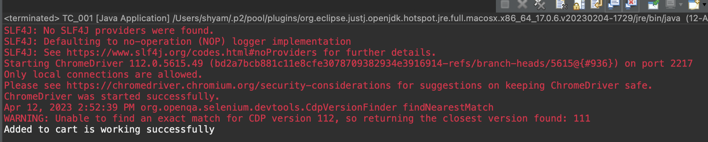

TC_002

Code:

package com.Shyam.Ca1.Ques1;

import org.openqa.selenium.By;

import org.openqa.selenium.WebDriver;

import org.openqa.selenium.WebElement;

import org.openqa.selenium.chrome.ChromeDriver;

import org.openqa.selenium.chrome.ChromeOptions;

import io.github.bonigarcia.wdm.WebDriverManager;

public class TC_002 {

public static void main(String[] args) throws InterruptedException {

ChromeOptions co=new ChromeOptions();

co.addArguments("--remote-allow-origins=*");

WebDriverManager.*chromedriver*().setup();

WebDriver driver=new ChromeDriver();

driver.get("https://www.amazon.in/");

Thread.*sleep*(2000);

driver.findElement(By.*xpath*("//*[@id=\"twotabsearchtextbox\"]")).click();

driver.findElement(By.*xpath*("//*[@id=\"twotabsearchtextbox\"]")).sendKeys("Nike blazer shoes");

driver.findElement(By.*xpath*("//*[@id=\"nav-search-submit-button\"]")).click();

Thread.*sleep*(2000);

driver.navigate().to("https://www.amazon.in/Nike-Men-Blazer-VNTG-Bq6806/dp/B08Q8RRR6B/ref=sr_1_1?crid=1X76VXIHRGPCH&keywords=Nike+blazer+shoes&qid=1681289171&sprefix=nike+blazer+shoes%2Caps%2C1217&sr=8-1") ;

driver.findElement(By.*xpath*("//*[@id=\"add-to-cart-button\"]")).click();

driver.navigate().to("https://www.amazon.in/gp/cart/view.html?ref_=nav_cart");

Thread.*sleep*(2000);

WebElement cart=driver.findElement(By.*xpath*("//*[@id=\"nav-cart-count\"]"));

if(cart.getText().equals("0")) {

System.***out***.print("Removing from cart is working successfully");

}else {

System.***out***.print("Removing from cart is not working successfully");

}

}

}

Output:

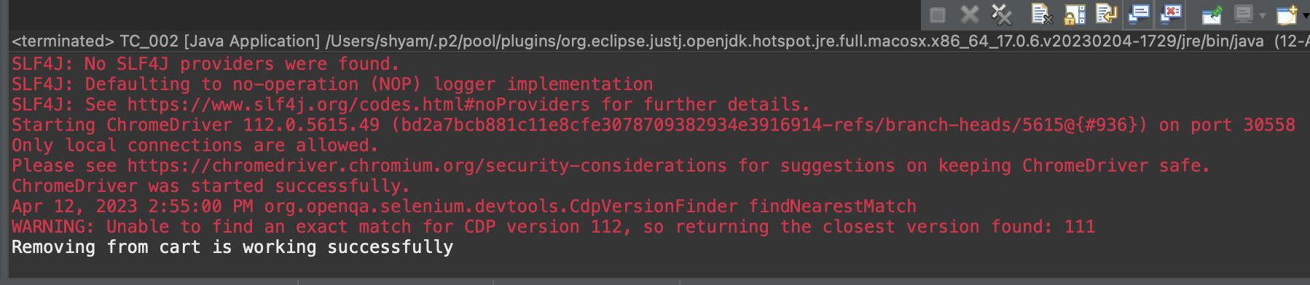

TC_003

Code:

package com.Shyam.Ca1.Ques1;

import org.openqa.selenium.By;

import org.openqa.selenium.WebDriver;

import org.openqa.selenium.WebElement;

import org.openqa.selenium.chrome.ChromeDriver;

import org.openqa.selenium.chrome.ChromeOptions;

import io.github.bonigarcia.wdm.WebDriverManager;

public class TC_003 {

public static void main(String[] args) throws InterruptedException {

ChromeOptions co=new ChromeOptions();

co.addArguments("--remote-allow-origins=*");

WebDriverManager.*chromedriver*().setup();

WebDriver driver=new ChromeDriver();

driver.get("https://www.amazon.in/");

Thread.*sleep*(2000);

driver.findElement(By.*xpath*("//*[@id=\"twotabsearchtextbox\"]")).click();

driver.findElement(By.*xpath*("//*[@id=\"twotabsearchtextbox\"]")).sendKeys("Nike blazer shoes");

driver.findElement(By.*xpath*("//*[@id=\"nav-search-submit-button\"]")).click();

Thread.*sleep*(2000);

driver.navigate().to("https://www.amazon.in/Nike-Men-Blazer-VNTG-Bq6806/dp/B08Q8RRR6B/ref=sr_1_1?crid=1X76VXIHRGPCH&keywords=Nike+blazer+shoes&qid=1681289171&sprefix=nike+blazer+shoes%2Caps%2C1217&sr=8-1") ;

driver.findElement(By.*xpath*("//*[@id=\"add-to-cart-button\"]")).click();

driver.navigate().to("https://www.amazon.in/gp/cart/view.html?ref_=nav_cart");

driver.findElement(By.*xpath*("//*[@id=\"a-autoid-0\"]")).click();

driver.findElement(By.*xpath*("//*[@id=\"quantity_2\"]")).click();

Thread.*sleep*(2000);

WebElement cart=driver.findElement(By.*xpath*("//*[@id=\"nav-cart-count\"]"));

if(cart.getText().equals("2")) {

System.***out***.print("Updating cart is working successfully");

}else {

System.***out***.print("Updating cart is not working successfully");

}

}

}

Output:

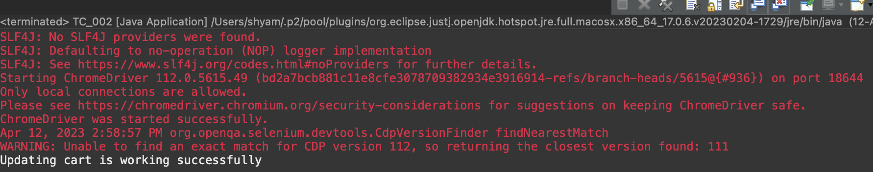

TC_004

Code:

package com.Shyam.Ca1.Ques1;

import org.openqa.selenium.By;

import org.openqa.selenium.WebDriver;

import org.openqa.selenium.WebElement;

import org.openqa.selenium.chrome.ChromeDriver;

import org.openqa.selenium.chrome.ChromeOptions;

import io.github.bonigarcia.wdm.WebDriverManager;

public class TC_004 {

public static void main(String[] args) throws InterruptedException {

ChromeOptions co=new ChromeOptions();

co.addArguments("--remote-allow-origins=*");

WebDriverManager.*chromedriver*().setup();

WebDriver driver=new ChromeDriver();

driver.get("https://www.amazon.in/");

Thread.*sleep*(2000);

driver.findElement(By.*xpath*("//*[@id=\"twotabsearchtextbox\"]")).click();

driver.findElement(By.*xpath*("//*[@id=\"twotabsearchtextbox\"]")).sendKeys("Nike blazer shoes");

driver.findElement(By.*xpath*("//*[@id=\"nav-search-submit-button\"]")).click();

Thread.*sleep*(2000);

driver.navigate().to("https://www.amazon.in/Nike-Men-Blazer-VNTG-Bq6806/dp/B08Q8RRR6B/ref=sr_1_1?crid=1X76VXIHRGPCH&keywords=Nike+blazer+shoes&qid=1681289171&sprefix=nike+blazer+shoes%2Caps%2C1217&sr=8-1") ;

driver.findElement(By.*xpath*("//*[@id=\"add-to-cart-button\"]")).click();

// driver.navigate().to("https://www.amazon.in/gp/cart/view.html?ref_=nav_cart");

//

// driver.findElement(By.xpath("///*[@id=\"sc-buy-box-ptc-button\"]/span/input")).click();

driver.findElement(By.*xpath*("//*[@id=\"sc-buy-box-ptc-button\"]/span/input")).click();

WebElement ele=driver.findElement(By.*xpath*("//*[@id=\"authportal-main-section\"]/div[2]/div/div[1]/form/div/div/div/h1"));

String actual=ele.getText();

System.***out***.println(actual);

String expected="Sign in";

if(actual.equals(expected)) {

System.***out***.print("Navigated to sigin page");

}

}

}

Output:

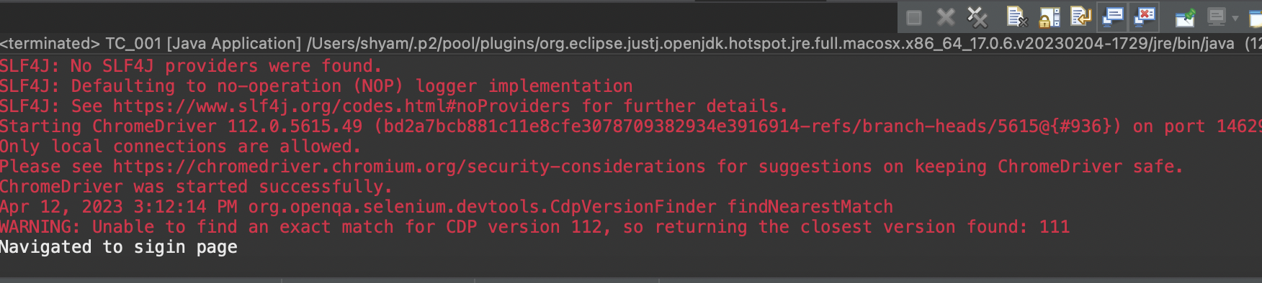

2→Search,Display,Filtering the products

Code:

package com.Shyam.Ca1;

import java.util.List;

import org.openqa.selenium.By;

import org.openqa.selenium.Keys;

import org.openqa.selenium.WebDriver;

import org.openqa.selenium.WebElement;

import org.openqa.selenium.chrome.ChromeDriver;

import org.openqa.selenium.chrome.ChromeOptions;

import io.github.bonigarcia.wdm.WebDriverManager;

public class Ques2 {

public static void main( String[] args ){

ChromeOptions co=new ChromeOptions();

co.addArguments("--remote-allow-origins=*");

WebDriverManager.*chromedriver*().setup();//setting up chrome driver

WebDriver driver=new ChromeDriver();

driver.get("https://www.amazon.in");

driver.findElement(By.*xpath*("//*[@id=\"twotabsearchtextbox\"]")).sendKeys(“Shoes");

driver.findElement(By.*xpath*("//*[@id=\"twotabsearchtextbox\"]")).sendKeys(*Keys*.***ENTER***);

String a=driver.getTitle();

if(a.equals("Amazon.in : Shoes")) {

System.***out***.println("Title is Matched\n");

}

else {

System.***out***.println("Title is Mismatched");

}

List<WebElement> li=driver.findElements(By.*className*("s-line-clamp-2"));

for(int i=0;i<5;i++) {

System.***out***.println(li.get(i).getText());

}

driver.findElement(By.*xpath*("//*[@id=\"p_36/1318505031\"]/span/a/span")).click();

WebElement b=driver.findElement(By.*xpath*("//*[@id=\"search\"]/div[1]/div[1]/div/span[1]/div[1]/div[2]/div/div/div/div/div/div/div/div[2]/div/div/div[3]/div[1]/div/div[1]/div[2]/a/span[1]/span[2]/span[2]"));

System.***out***.print("Price 2,000-10,000 :"+b.getText());

driver.findElement(By.*xpath*("//*[@id=\"p_89/Samsung\"]/span/a/div/label/i")).click();

WebElement c=driver.findElement(By.*xpath*("//*[@id=\"search\"]/div[1]/div[1]/div/span[1]/div[1]/div[2]/div/div/div/div/div/div[2]/div/div/div[1]/h2/a/span"));

System.***out***.print("Price 2,000-10,000 & Puma: "+ c.getText());

}

}

Output: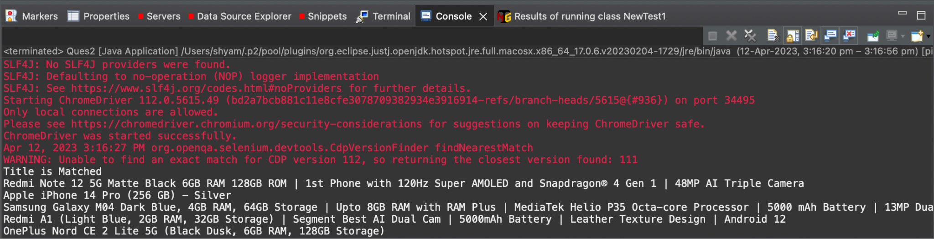

3→Account,Order,Track,View the orders

Code:

package com.Shyam.Ca1;

import org.openqa.selenium.By;

import org.openqa.selenium.WebDriver;

import org.openqa.selenium.WebElement;

import org.openqa.selenium.chrome.ChromeDriver;

import org.openqa.selenium.chrome.ChromeOptions;

import io.github.bonigarcia.wdm.WebDriverManager;

public class Ques3 {

public static void main(String[] args) throws InterruptedException {

ChromeOptions co=new ChromeOptions();

co.addArguments("--remote-allow-origins=*");

WebDriverManager.*chromedriver*().setup();

WebDriver driver=new ChromeDriver();

driver.get("https://www.amazon.in/ap/signin?openid.pape.max_auth_age=0&openid.return_to=https%3A%2F%2Fwww.amazon.in%2F%3Fref_%3Dnav_ya_signin&openid.identity=http%3A%2F%2Fspecs.openid.net%2Fauth%2F2.0%2Fidentifier_select&openid.assoc_handle=inflex&openid.mode=checkid_setup&openid.claimed_id=http%3A%2F%2Fspecs.openid.net%2Fauth%2F2.0%2Fidentifier_select&openid.ns=http%3A%2F%2Fspecs.openid.net%2Fauth%2F2.0&");

//sigin

driver.findElement(By.*xpath*("//*[@id=\"ap_email\"]")).click();

driver.findElement(By.*xpath*("//*[@id=\"ap_email\"]")).sendKeys("8946008461");

driver.findElement(By.*xpath*("//*[@id=\"continue\"]")).click();

driver.findElement(By.*xpath*("//*[@id=\"ap_password\"]")).click();

driver.findElement(By.*xpath*("//*[@id=\"ap_password\"]")).sendKeys("Jn10102003");

driver.findElement(By.*xpath*("//*[@id=\"signInSubmit\"]")).click();

Thread.*sleep*(3000);

driver.findElement(By.*xpath*("//*[@id=\"nav-link-accountList\"]")).click();

WebElement acc=driver.findElement(By.*xpath*("//*[@id=\"a-page\"]/div[2]/div/div[1]/h1"));

String actual=acc.getText();

String expected="Your Account";

if(actual.equals(expected)) {

System.***out***.println("Your Account page is displayed");

}

driver.findElement(By.*xpath*("//*[@id=\"a-page\"]/div[2]/div/div[2]/div[1]/a/div")).click();

WebElement ord=driver.findElement(By.*xpath*("//*[@id=\"a-page\"]/section/div[1]/div[2]/div[1]/h1"));

String act=ord.getText();

String exp="Your Orders";

if(act.equals(exp)) {

System.***out***.println("Your Order page is displayed");

}

// driver.findElement(By.xpath("//*[@id=\"a-page\"]/div[2]/div/div[2]/div[1]/a/div")).click();

// WebElement trac=driver.findElement(By.xpath("//*[@id=\"a-page\"]/section/div[1]/div[2]/div[1]/h1"));

String act1=ord.getText();

String exp1="Your orders";

if(act.equals(exp)) {

System.***out***.println("User is able to track package");

}

// driver.findElement(By.xpath("//*[@id=\"pop\"]/div/div[2]/div/div[1]/div/div[3]/div/div/div/div/div[2]/div/div/a")).click();

System.***out***.println("User is able to view their products");

}

}

Output:

