DAY-4

CLASS EXERCISES

TASK-1

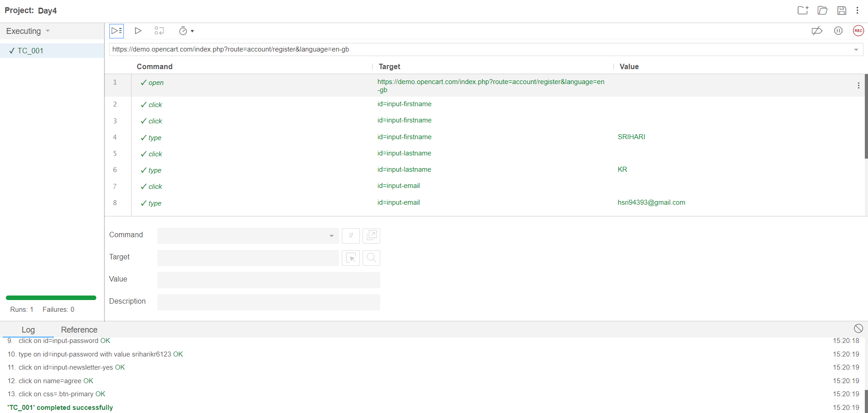

TASK-2

CODE:

**package** com.Test.Testing;

**import** org.openqa.selenium.By;

**import** org.openqa.selenium.WebDriver;

**import** org.openqa.selenium.chrome.ChromeDriver;

**import** org.openqa.selenium.chrome.ChromeOptions;

**import** io.github.bonigarcia.wdm.WebDriverManager;

/**

* Hello world!

*

*/

**public** **class** App

{

**public** **static** **void** main( String[] args ) **throws** InterruptedException

{

ChromeOptions co=**new** ChromeOptions();

co.addArguments("--remote-allow-origins=*");

WebDriverManager.*chromedriver*().setup();

WebDriver driver=**new** ChromeDriver(co);

driver.navigate().to("https://demo.opencart.com/index.php?route=account/register&language=en-gb");

driver.findElement(By.*id*("input-firstname")).sendKeys("Srihari");

Thread.*sleep*(5000);

driver.findElement(By.*id*("input-lastname")).sendKeys("KR");

Thread.*sleep*(5000);

driver.findElement(By.*id*("input-email")).sendKeys("srihari007@gmail.com");

Thread.*sleep*(5000);

driver.findElement(By.*cssSelector*("input#input-password")).sendKeys("sriharikr007");

Thread.*sleep*(5000);

driver.findElement(By.*id*("input-newsletter-yes")).click();

}

}

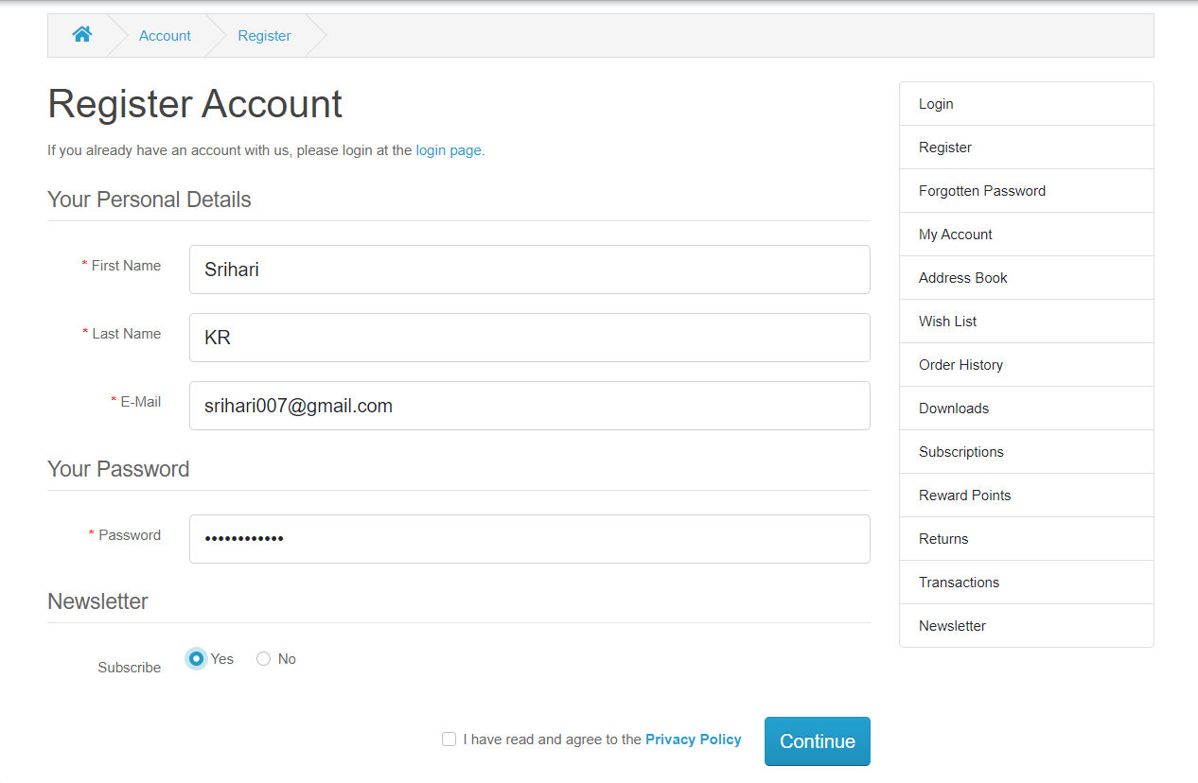

TASK-3

CODE:

**package** com.Test.Testing;

**import** org.openqa.selenium.By;

**import** org.openqa.selenium.JavascriptExecutor;

**import** org.openqa.selenium.WebDriver;

**import** org.openqa.selenium.chrome.ChromeDriver;

**import** org.openqa.selenium.chrome.ChromeOptions;

**import** io.github.bonigarcia.wdm.WebDriverManager;

**public** **class** Day4_3 {

**public** **static** **void** main( String[] args ) **throws** InterruptedException

{

ChromeOptions co=**new** ChromeOptions();

co.addArguments("--remote-allow-origins=*");

WebDriverManager.*chromedriver*().setup();//setting up chrome driver

WebDriver driver=**new** ChromeDriver();

driver.get("https://demo.opencart.com/index.php?route=checkout/voucher&language=en-gb");

driver.findElement(By.*xpath*("//input[@id=\"input-to-name\"]")).sendKeys("David");

driver.findElement(By.*xpath*("//input[@id=\"input-to-email\"]")).sendKeys("davidbilla@gmail.com");

driver.findElement(By.*xpath*("//input[@id=\"input-from-name\"]")).sendKeys("Srihari");

driver.findElement(By.*xpath*("//input[@id=\"input-from-email\"]")).sendKeys("hsri94393@gmail.com");

JavascriptExecutor js=(JavascriptExecutor) driver;

js.executeScript("window.scrollBy(0,500)","");

Thread.*sleep*(2000);

driver.findElement(By.*xpath*("//input[@id=\"input-theme-6\"]")).click();

driver.findElement(By.*xpath*("//textarea[@id=\"input-message\"]")).sendKeys("Gift Sent");

Thread.*sleep*(2000);

driver.findElement(By.*xpath*("//*[@id=\"form-voucher\"]/div[8]/div/div/input")).click();

Thread.*sleep*(2000);

driver.findElement(By.*xpath*("//*[@id=\"form-voucher\"]/div[8]/div/button")).click();

}

}

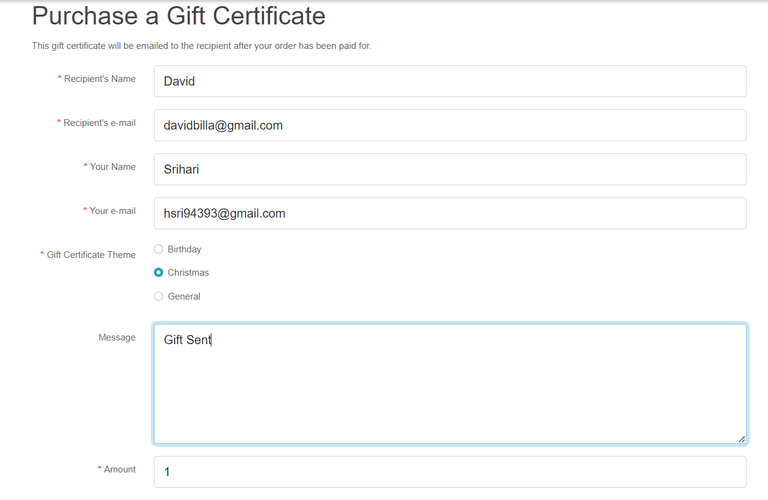

TASK-4

CODE:

**package** com.Test.Testing;

**import** org.openqa.selenium.By;

**import** org.openqa.selenium.JavascriptExecutor;

**import** org.openqa.selenium.WebDriver;

**import** org.openqa.selenium.chrome.ChromeDriver;

**import** org.openqa.selenium.chrome.ChromeOptions;

**import** io.github.bonigarcia.wdm.WebDriverManager;

**public** **class** Day4_4 {

**public** **static** **void** main(String[] args) {

ChromeOptions co=**new** ChromeOptions();

co.addArguments("--remote-allow-origins=*");

WebDriverManager.*chromedriver*().setup();

WebDriver driver=**new** ChromeDriver(co);

driver.navigate().to("https://j2store.net/free/");

driver.manage().window().maximize();

JavascriptExecutor js=(JavascriptExecutor) driver;

js.executeScript("window.scrollBy(0,1000)","");

driver.findElement(By.*xpath*("/html/body/div[2]/div/div[2]/div/div/div/div/ul/li[1]/h4/a")).click();

driver.navigate().back();

driver.navigate().forward();

driver.navigate().refresh();

driver.close();

}

}

TASK-5_ 1

CODE:

**package** com.Test.Testing;

**import** org.openqa.selenium.By;

**import** org.openqa.selenium.WebDriver;

**import** org.openqa.selenium.chrome.ChromeDriver;

**import** io.github.bonigarcia.wdm.WebDriverManager;

**public** **class** Day4_5_1 {

**public** **static** **void** main(String[] args) {

WebDriverManager.*chromedriver*().setup();

WebDriver driver=**new** ChromeDriver();

driver.get("https://j2store.net/free/");

String currentUrl1=driver.getCurrentUrl();

String expectedUrl1="https://j2store.net/free/";

**if**(currentUrl1.equals(expectedUrl1)) {

System.***out***.println("Matched");

}**else** {

System.***out***.println("Unmatched");

}

}

}

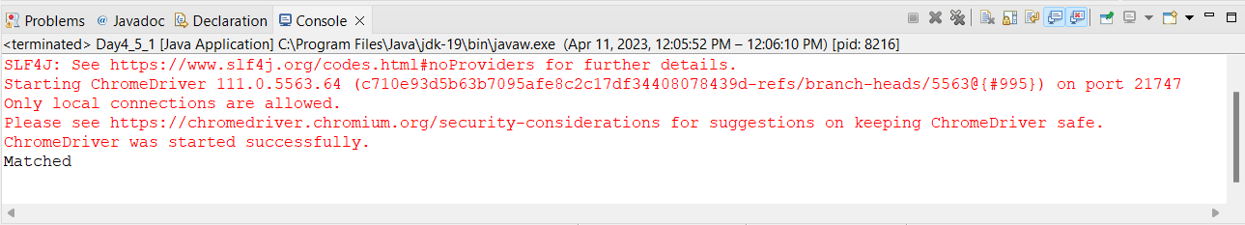

TASK-5_2

CODE:

**package** com.Test.Testing;

**import** java.util.List;

**import** org.openqa.selenium.By;

**import** org.openqa.selenium.WebDriver;

**import** org.openqa.selenium.WebElement;

**import** org.openqa.selenium.chrome.ChromeDriver;

**import** org.openqa.selenium.chrome.ChromeOptions;

**import** io.github.bonigarcia.wdm.WebDriverManager;

**public** **class** Day4_5_2 {

**public** **static** **void** main(String[] args) **throws** InterruptedException {

ChromeOptions co=**new** ChromeOptions();

co.addArguments("--remote-allow-origins=*");

WebDriverManager.*chromedriver*().setup();

WebDriver driver=**new** ChromeDriver();

driver.get("https://j2store.net/free/");

driver.findElement(By.*xpath*("//*[@id=\"Mod112\"]/div/div/ul/li[1]/a/img")).click();

Thread.*sleep*(5000);

List<WebElement> list=driver.findElements(By.*xpath*("//h2[@itemprop=\"name\"]"));

**for**(WebElement link:list) {

System.***out***.println(link.getText());

}

}

}

