Task A Screenshot:   
  
• Resource group rg-smartgear-dev • Storage account stsmartgear • Container raw with the CSV uploaded.

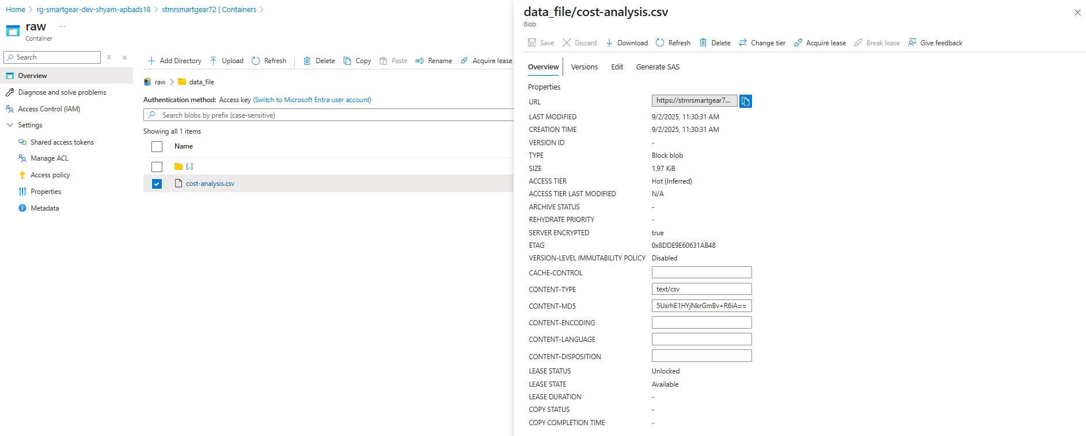

Task D Screenshot where to find success status :

