Guide to execute:

1. Download framework from git <https://github.com/shyam-nithyanandham/serenity-cucumber-bdd>
2. Unzip the zipped folders
3. Open command prompt
4. Goto the project folder (Using CD Command)
5. Type Maven command mvn verify or mvn verify clean

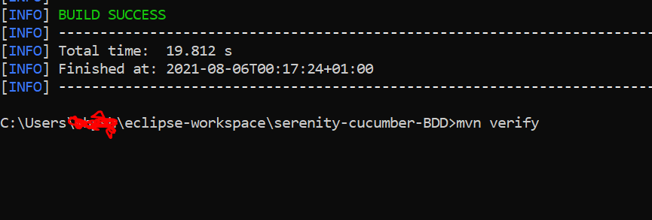

1. After the execution see, results path is given at the bottom.
2. Open the path through web browser.

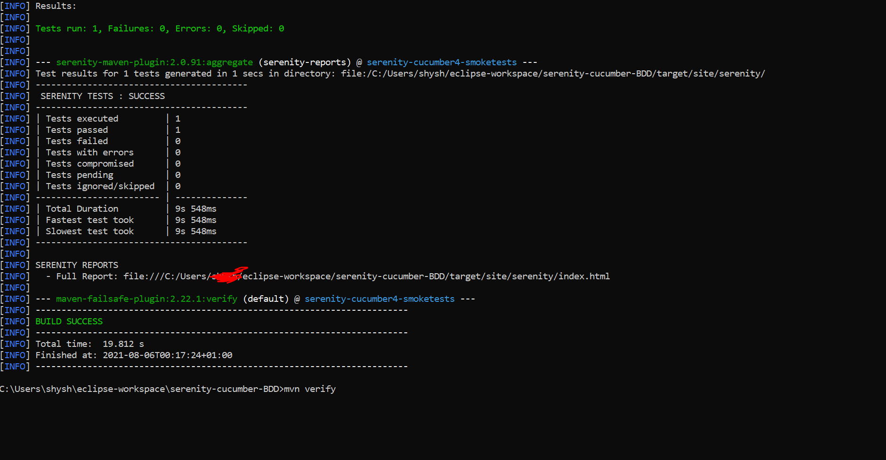

Results:

Serenity Report:

