DISTRIBUTED DATABASE

INTRODUCTION

Distributed databases bring the advantages of distributed computing to the database management domain. A distributed computing system consists of a number of processing elements, not necessarily homogeneous, that are interconnected by a computer network, and that cooperate in performing certain assigned tasks. As a general goal, distributed computing systems partition a big, unmanageable problem into smaller pieces and solve it efficiently in a coordinated manner. The economic viability of this approach stems from two reasons: (1) more computer power is harnessed to solve a complex task, and (2) each autonomous processing element can be managed independently and develop its own applications. A transaction can be executed by multiple networked computers in a unified manner.
Definition
- A distributed database (DDB) processes Unit of execution (a transaction) in a distributed manner. A distributed database (DDB) can be defined as
  - A distributed database (DDB) is a collection of multiple logically related database distributed over a computer network, and a distributed database management system as a software system that manages a distributed database while making the distribution transparent to the user.

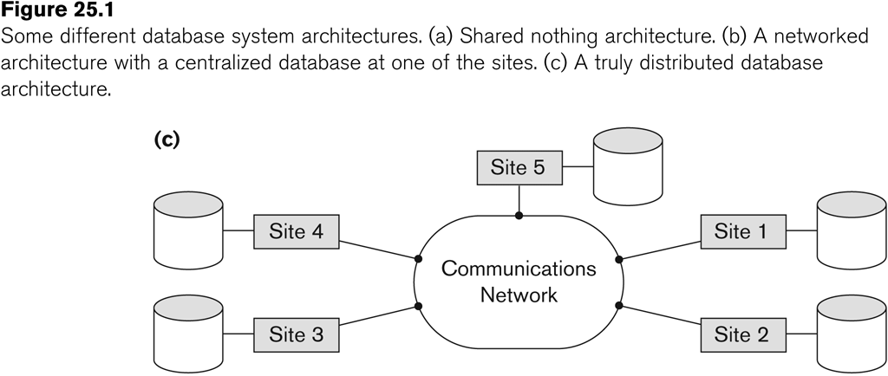

Parallel Versus Distributed Technology

Shared memory (tightly coupled) architecture: Multiple processors share secondary (disk) storage and also share primary memory

Shared disk (loosely coupled) architecture: Multiple processors share secondary (disk) storage but each has their own primary memory.
These architectures enable processors to communicate without the overhead of exchanging messages over a network (Note 3). Database management systems developed using the above types of architectures are termed parallel database management systems rather than DDBMS, since they utilize parallel processor technology.

Allocation of Fragments
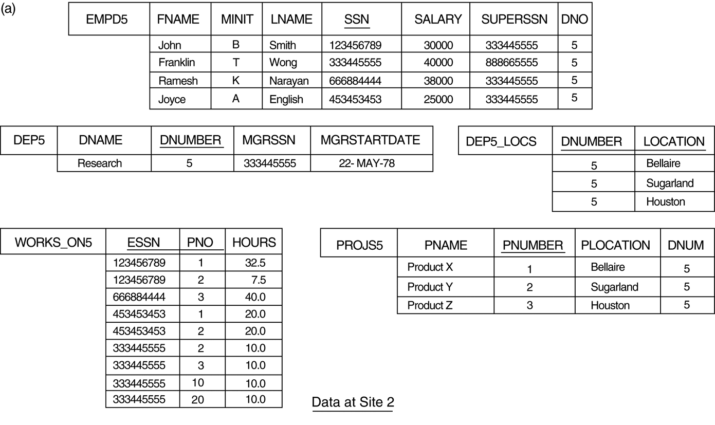

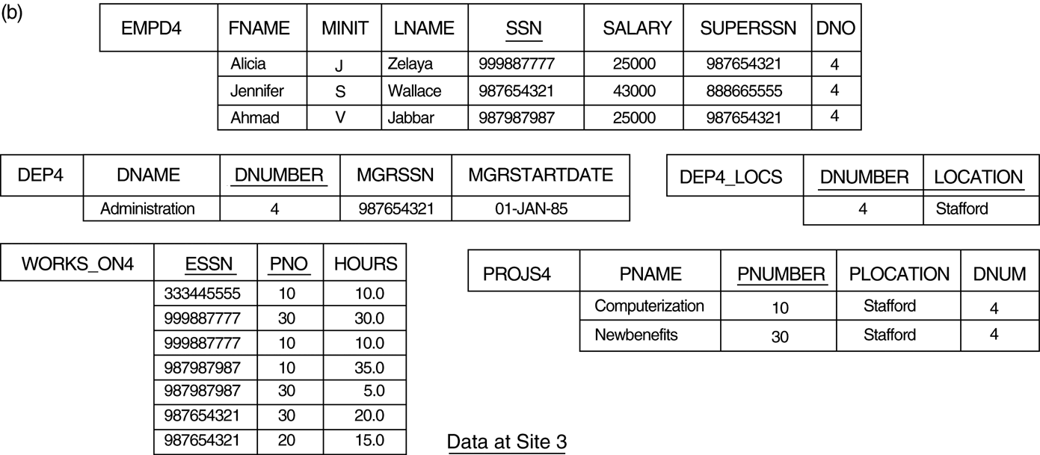

DDB Advantages

1. Distribution and Network transparency:
    - Users do not have to worry about operational details of the network.
      - There is Location transparency, which refers to freedom of issuing command from any location without affecting its working.
      - Then there is naming transparency, which allows access to any names object (files, relations, etc.) from any location.
2. Replication transparency:
    - It allows storing copies of a data at multiple sites as shown in the above diagram. This is done to minimize access time to the required data.

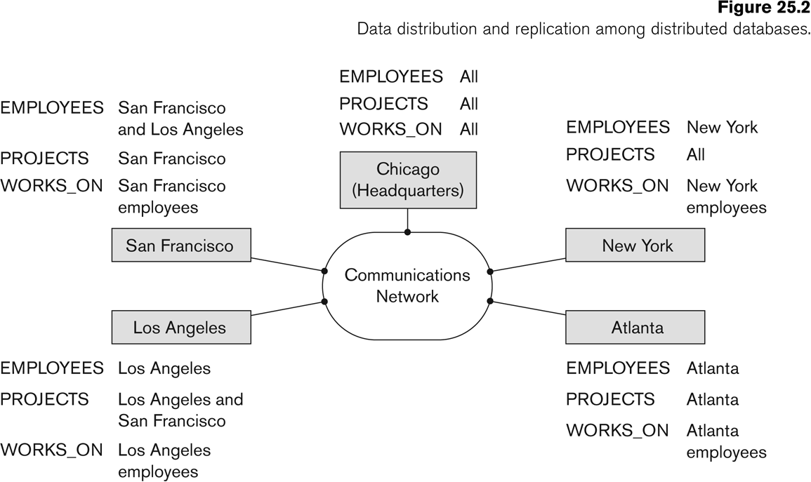

  - The EMPLOYEE, PROJECT, and WORKS_ON tables may be fragmented horizontally and stored with possible replication as shown below.

3.Fragmentation transparency:
    - Allows to fragment a relation horizontally (create a subset of tuples of a relation) or vertically (create a subset of columns of a relation).
4.Increased reliability and availability:
    - Reliability refers to system live time, that is, system is running efficiently most of the time. Availability is the probability that the system is continuously available (usable or accessible) during a time interval.
    - A distributed database system has multiple nodes (computers) and if one fails then others are available to do the job.
5.Improved performance:
    - A distributed DBMS fragments the database to keep data closer to where it is needed most.
    - This reduces data management (access and modification) time significantly.
6.Easier expansion (scalability):
    - Allows new nodes (computers) to be added anytime without chaining the entire configuration.
Data Fragmentation, Replication, And Allocation Techniques For Distributed Database Design

Data Fragmentation
  - Split a relation into logically related and correct parts. A relation can be fragmented in two ways:
    - Horizontal Fragmentation
    - Vertical Fragmentation
Horizontal fragmentation
  - It is a horizontal subset of a relation which contain those of tuples which satisfy selection conditions.
  - Consider the Employee relation with selection condition (DNO = 5). All tuples satisfy this condition will create a subset which will be a horizontal fragment of Employee relation.
  - A selection condition may be composed of several conditions connected by AND or OR.
Vertical fragmentation
  - It is a subset of a relation which is created by a subset of columns. Thus a vertical fragment of a relation will contain values of selected columns. There is no selection condition used in vertical fragmentation.
Consider the Employee relation. A vertical fragment of can be created by keeping the values of Name, Bdate, Sex, and Address.

Data Replication
  - Database is replicated to all sites.
  - In full replication the entire database is replicated and in partial replication some selected part is replicated to some of the sites.
  - Data replication is achieved through a replication schema.
Data Distribution (Data Allocation)
  - This is relevant only in the case of partial replication or partition.
The selected portion of the database is distributed to the database sites.

Types of Distributed Database Systems
Homogeneous
  - All sites of the database system have identical setup, i.e., same database system software.
  - The underlying operating system may be different.
    - For example, all sites run Oracle or DB2, or Sybase or some other database system.
    - 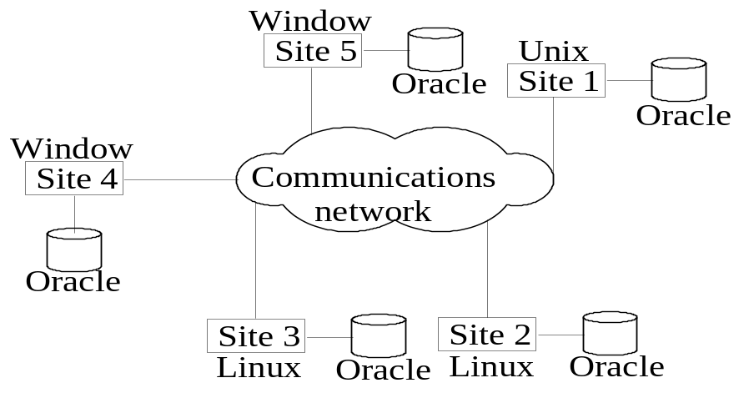The underlying operating systems can be a mixture of Linux, Window, Unix, etc.

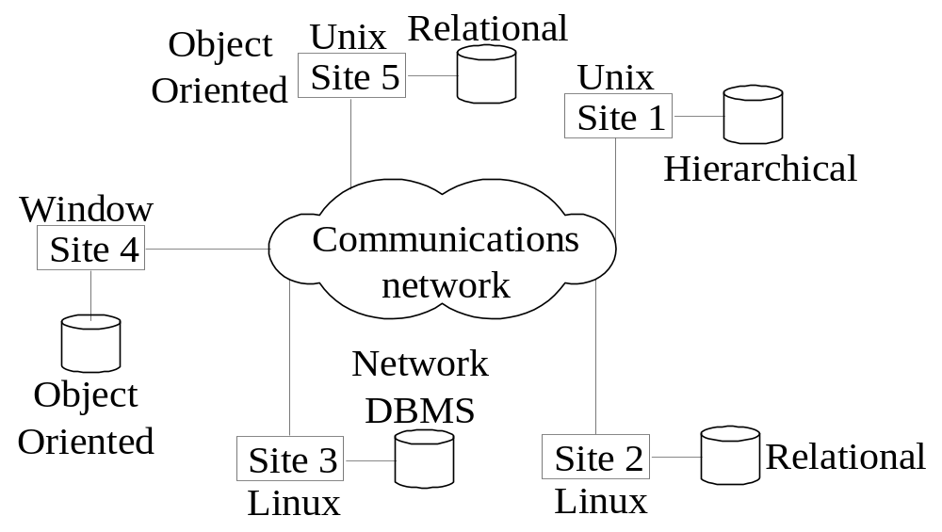Heterogeneous

Federated database management issues:
- Each site may run different database system but the data access is managed through a single conceptual schema. This implies that the degree of local autonomy is minimum. Each site must adhere to a centralized access policy. There may be a global schema.
- Federated Database Management Systems Issues
  - Differences in data models:
    - Relational, Objected oriented, hierarchical, network, etc.
  - Differences in constraints:
    - Each site may have their own data accessing and processing constraints.
  - Differences in query language:
    - Some site may use SQL, some may use SQL-89, some may use SQL-92, and so on.

Multidatabase: There is no one conceptual global schema. For data access a schema is constructed dynamically as needed by the application software.

CLIENT SERVER TECHNOLOGY

Client machines
  - Provide user with:
    - Appropriate interfaces to utilize these servers
    - Local processing power to run local applications
    - Provide appropriate interfaces and a client-version of the system to access and utilize the server resources.
    - Clients maybe diskless machines or PCs or Workstations with disks with only the client software installed.
    - Connected to the servers via some form of a network.
(LAN: local area network, wireless network, etc.)
  - 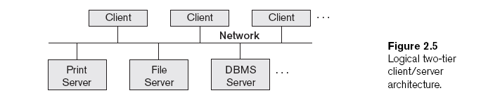
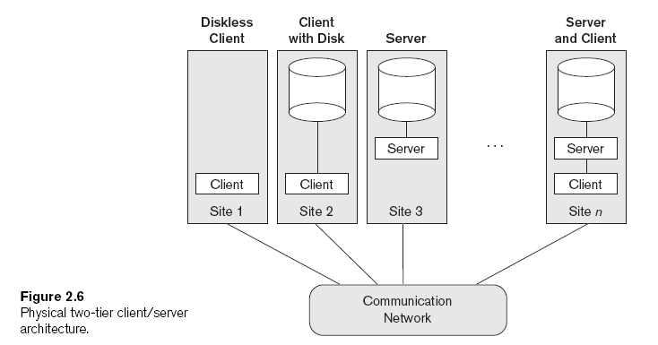
- Servers with specific functionalities
  - File server
    - Maintains the files of the client machines.
  - Printer server
    - Connected to various printers; all print requests by the clients are forwarded to this machine
Webservers or e-mailservers

Server
  - System containing both hardware and software
  - Provides services to the client machines
    - Such as file access, printing, archiving, or database access

Client Server Architecture
It consists of clients running client software, a set of servers which provide all database functionalities and a reliable communication infrastructure
- Clients reach server for desired service, but server does reach clients.
- The server software is responsible for local data management at a site, much like centralized DBMS software.
- The client software is responsible for most of the distribution function.
- The communication software manages communication among clients and servers.

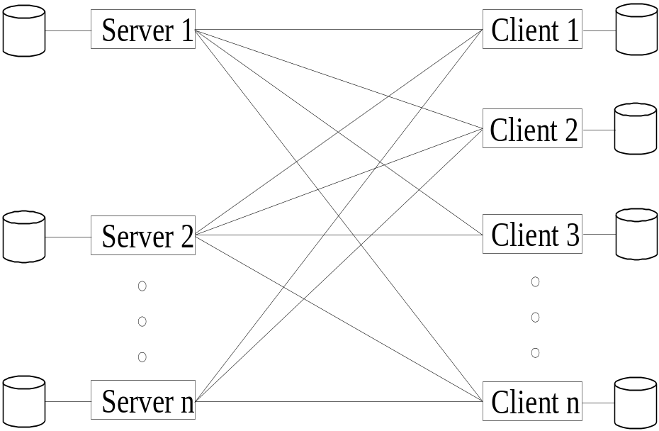

Client-Server Database Architecture
- The processing of a SQL queries goes as follows:
  - Client parses a user query and decomposes it into a number of independent sub-queries. Each subquery is sent to appropriate site for execution.
  - Each server processes its query and sends the result to the client.
  - The client combines the results of subqueries and produces the final result
Two-Tier Client/Server Architectures for DBMSs
- Server handles
  - Query and transaction functionality related to SQL processing
- Client handles
  - User interface programs and application programs
- Open Database Connectivity (ODBC)
  - Provides application programming interface (API)
  - Allows client-side programs to call the DBMS
    - Both client and server machines must have the necessary software installed
- JDBC
  - Allows Java client programs to access one or more DBMSs through a standard interface

Three-Tier and n-Tier Architectures for Web Applications
- Application server or Web server
  - Adds intermediate layer between client and the database server
  - Runs application programs and stores business rules
- N-tier
  - Divide the layers between the user and the stored data further into finer components

Three Tier Client-Server Architecture
- Common for Web applications
- Intermediate Layer called Application Server or Web Server:
  - stores the web connectivity software and the rules and business logic (constraints) part of the application used to access the right amount of data from the database server
  - acts like a conduit for sending partially processed data between the database server and the client.
- Additional Features- Security:
  - encrypt the data at the server before transmission
  - decrypt data at the client

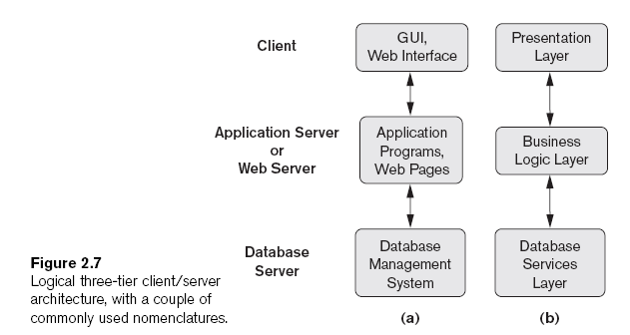

SPATIAL DATABASE

- Spatial databases provide concepts for databases that keep track of objects in a multi-dimensional space. For example, cartographic databases that store maps include two-dimensional spatial descriptions of their objects—from countries and states to rivers, cities, roads, seas, and so on. These applications are also known as Geographical Information Systems(GIS).
- These databases are used in many applications, such as environmental, emergency, and battle management. Other databases, such as meteorological databases for weather information, are three-dimensional, since temperatures and other meteorological information are related to three-dimensional spatial points.
- In general, a spatial database stores objects that have spatial characteristics that describe them. The spatial relationships among the objects are important, and they are often needed when querying the database.

- The main extensions that are needed for spatial databases are models that can interpret spatial characteristics. In addition, special indexing and storage structures are often needed to improve performance The basic extensions needed are to include two-dimensional geometric concepts, such as points, lines and line segments, circles, polygons, and arcs, in order to specify the spatial characteristics of objects. In addition, spatial operations are needed to operate on the objects’ spatial characteristics—for example, to compute the distance between two objects.

- consider a database that is used for emergency management applications. A description of the spatial positions of many types of objects would be needed. Some of these objects generally have static spatial characteristics, such as streets and highways, water pumps (for fire control), police stations, fire stations, and hospitals. Other objects have dynamic spatial characteristics that change over time, such as police vehicles, ambulances, or fire trucks.

- Three typical types of spatial queries:
Range query: Finds the objects of a particular type that are within a given spatial area or within a particular distance from a given location. (For example, finds all hospitals within the Dallas city area, or finds all ambulances within five miles of an accident location.)
• Nearest neighbor query: Finds an object of a particular type that is closest to a given location. (For example, finds the police car that is closest to a particular location.)
Spatial joins or overlays: Typically joins the objects of two types based on some spatial condition, such as the objects intersecting or overlapping spatially or being within a certain distance of one another. (For example, finds all cities that fall on a major highway or finds all homes that are within two miles of a lake.)
- For these and other types of spatial queries to be answered efficiently, special techniques for spatial indexing are needed. One of the best known techniques is the use of R-trees and their variations. R-trees group together objects that are in close spatial physical proximity on the same leaf nodes of a tree-structured index. The internal nodes of R-trees are associated with rectangles whose area covers all the rectangles in its subtree
- Other spatial storage structures include quadtrees and their variations. Quadtreesgenerally divide each space or subspace into equally sized areas, and proceed with the sub-divisions of each subspace to identify the positions of various objects.

MULTIMEDIA DATABASES

- Multimedia databases provide features that allow users to store and query different types of multimedia information, which includes images (such as pictures or drawings), video clips (such as movies, newsreels, or home videos), audio clips (such as songs, phone messages, or speeches), and documents (such as books or articles). The main types of database queries that are needed involve locating multimedia sources that contain certain objects of interest. For example, one may want to locate all video clips in a video database that include a certain person in them, say Bill Clinton.

- The above types of queries are referred to as content-based retrieval, because the multimedia source is being retrieved based on its containing certain objects or activities. Hence, a multimedia database must use some model to organize and index the multimedia sources based on their contents. Identifying the contents of multimedia sources is a difficult and time-consuming task. There are two main approaches. The first is based on automatic analysis of the multimedia sources to identify certain mathematical characteristics of their contents. This approach uses different techniques depending on the type of multimedia source (image, text, video, or audio). The second approach depends on manual identification of the objects and activities of interest in each multimedia source and on using this information to index the sources.

- Types of multimedia data are available in current systems and their characteristics
  - Text: May be formatted or unformatted. For ease of parsing structured documents, standards like SGML and variations such as HTML are being used.
  - Graphics: Examples include drawings and illustrations that are encoded using some descriptive standards (e.g. CGM, PICT, postscript).
  - Images: Includes drawings, photographs, and so forth, encoded in standard formats such as bitmap, JPEG, and MPEG. Compression is built into JPEG and MPEG.
    - These images are not subdivided into components. Hence querying them by content (e.g., find all images containing circles) is nontrivial.
  - Animations: Temporal sequences of image or graphic data.
  - Video: A set of temporally sequenced photographic data for presentation at specified rates– for example, 30 frames per second.
  - Structuredaudio: A sequence of audio components comprising note, tone, duration, and so forth.
  - Audio: Sample data generated from aural recordings in a string of bits in digitized form. Analog recordings are typically converted into digital form before storage
  - Composite or mixed multimedia data: A combination of multimedia data types such as audio and video which may be physically mixed to yield a new storage format or logically mixed while retaining original types and formats

Characterization of applications
Repository applications: A large amount of multimedia data as well as metadata is stored for retrieval purposes. Examples include repositories of satellite images, engineering drawings and designs, space photographs, and radiology scanned pictures.
Presentation applications: A large amount of applications involves delivery of multimedia data subject to temporal constraints; simple multimedia viewing of video data, for example, requires a system to simulate VCR-like functionality. Complex and interactive multimedia presentations involve orchestration directions to control the retrieval order of components in a series or in parallel. Interactive environments must support capabilities such as real-time editing analysis or annotating of video and audio data.
Collaborative work using multimedia information: This is a new category of applications in which engineers may execute a complex design task by merging drawings, fitting subjects to design constraints, and generating new documentation, change notifications, and so forth. Intelligent healthcare networks as well as telemedicine will involve doctors collaborating among themselves, analyzing multimedia patient data and information in real time as it is generated

WEB DATABASE
- The World Wide Web (WWW)—popularly known as "the Web"—originally developed in Switzerland at CERN (Note 1) in early 1990 as a large-scale hypermedia information service system for biological scientists to share information. Today this technology allows universal access to this shared information to anyone having access to the Internet and the Web contains hundreds of millions of Web pages within the reach of millions of users.
- In Web technology, a basic client-server architecture underlies all activities. Information is stored on computers designated as Web servers in publicly accessible shared files encoded using HyperText Markup Language (HTML).
- A number of tools enable users to create Web pages formatted with HTML tags, freely mixed with multimedia content—from graphics to audio and even to video. A page has many interspersed hyperlinks—literally a link that enables a user to "browse" or move from one page to another across the Internet. This ability has given a tremendous power to end users in searching and navigating related information—often across different continents.
- Information on the Web is organized according to a Uniform Resource Locator (URL)—something similar to an address that provides the complete pathname of a file. The pathname consists of a string of machine and directory names separated by slashes and ends in a filename.
- A URL always begins with a hypertext transport protocol (http), which is the protocol used by the Web browsers, a program that communicates with the Web server, and vice versa. Web browsers. interpret and present HTML documents to users. Popular Web browsers include the Internet Explorer of Microsoft and the Netscape Navigator. A collection of HTML documents and other files accessible via the URL on a Web server is called a Web site.

Providing Access to Databases on the World Wide Web

The Web server uses a standard interface called the Common Gateway Interface (CGI) to act as the middleware—the additional software layer between the user interface front-end and the DBMS back-end that facilitates access to heterogeneous databases. The CGI middleware executes external programs or scripts to obtain the dynamic information, and it returns the information to the server in HTML, which is given back to the browser.

There are two main ways to carry out dynamic real-time queries from the web:
- Using traditional HTML forms, information is passed to a CGI script that formats the query and submits it to the DBMS. Results are returned to the CGI script which then formats the output in HTML.
One needs: An HTTP (web) server, some language (e.g., Perl) that supports CGI, middleware to connect to the database, the DBMS.
Access using CGI scripts: The database server can be made to interact with the Web server via CGI. Figure below shows a schematic for the database access architecture on the Web using CGI scripts, which are written in languages like PERL, Tcl, or C. The main disadvantage of this approach is that for each user request, the Web server must start a new CGI process: each process makes a new connection with the DBMS and the Web server must wait until the results are delivered to it. No efficiency is achieved by any grouping of multiple users’ requests; moreover, the developer must keep the scripts in the CGI-bin subdirectories only, which opens it to a possible breach of security. The fact that CGI has no language associated with it but requires database developers to learn PERL or Tcl is also a drawback. Manageability of scripts is another problem if the scripts are scattered everywhere.
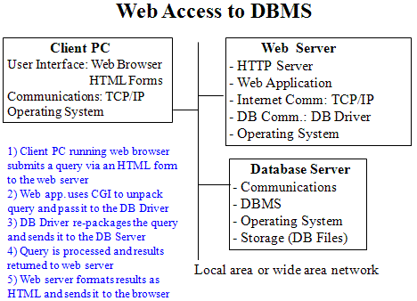
Access using JDBC: JDBC is a set of Java classes developed by Sun Microsystems to allow access to relational databases through the execution of SQL statements. It is a way of connecting with databases, without any additional processes for each client request. Note that JDBC is a name trademarked by Sun; it does not stand for Java Data Base connectivity as many believe. JDBC has the capabilities to connect to a database, send SQL statements to a database and to retrieve the results of a query using the Java classes Connection, Statement, and ResultSet respectively. With Java’s claimed platform independence, an application may run on any Java-capable browser, which loads the Java code from the server and runs it on the client’s browser. The Java code is DBMS transparent; the JDBC drivers for individual DBMSs on the server end carry the task of interacting with that DBMS. If the JDBC driver is on the client, the application runs on the client and its requests are communicated to the DBMS directly by the driver. For standard SQL requests, many RDBMSs can be accessed this way. The drawback of using JDBC is the prospect of executing Java through virtual machines with inherent efficiency. The JDBC bridge to Object Database Connectivity (ODBC) remains another way of getting to the RDBMSs.
The Web Integration Option of INFORMIX
- Informix has addressed the limitations of CGI and the incompatibilities of CGI, NSAPI, and ISAPI by creating the Web Integration Option (WIO). WIO eliminates the need for scripts. Developers use tools to create intelligent HTML pages called Application Pages (or App Pages) directly within the database. They execute SQL statements dynamically, format the results inside HTML, and return the resulting Web page to the end users.
- WIO uses the Web Driver, a lightweight CGI process that is invoked when a URL request is received by the Web server. A unique session identifier is generated for each request but the WIO application is persistent and does not terminate after each request.When the WIO application receives a request from the Web driver, it connects to the database and executes Web Explode, a function that executes queries within Web pages and formats results as a Web page that goes back to the browser via the Web driver.
- WIO supports applications developed in C, C++, and Java. This flexibility lets developers port existing applications to the Web or develop new applications in these languages. The WIO is integrated with Web server software and utilizes the native security mechanism of the Informix Dynamic Server. The open architecture of WIO allows the use of various Web browsers and servers.

The ORACLE WebServer
- ORACLE supports Web access to databases .The client requests files that are called "static" or "dynamic" files from the Web server. Static files have a fixed content whereas dynamic files may have content that includes results of queries to the database.
- There is an HTTP demon (a process that runs continuously) called Web Listener running on the server that listens for the requests originating in the clients. A static file (document) is retrieved from the file system of the server and displayed on the Web browser at the client. Request for a dynamic page is passed by the listener to a Web request broker (WRB), which is a multi-threaded dispatcher that adheres to cartridges.
- Cartridges are software modules that perform specific functions on specific types of data; they can communicate among themselves. Currently cartridges are provided for PL/SQL, Java, and Live HTML; customized cartridges may be provided as well.

MOBILE DATABASES
- Recent advances in portable and wireless technology led to mobile computing, a new dimension in data communication and processing.
- Portable computing devices coupled with wireless communications allow clients to access data from virtually anywhere and at any time.
- There are a number of hardware and software problems that must be resolved before the capabilities of mobile computing can be fully utilized.
- Some of the software problems – which may involve data management, transaction management, and database recovery – have their origins in distributed database systems.
- In mobile computing, the problems are more difficult, mainly:
  - The limited and intermittent connectivity afforded by wireless communications.
  - The limited life of the power supply(battery).
  - The changing topology of the network.
  - In addition, mobile computing introduces new architectural possibilities and challenges
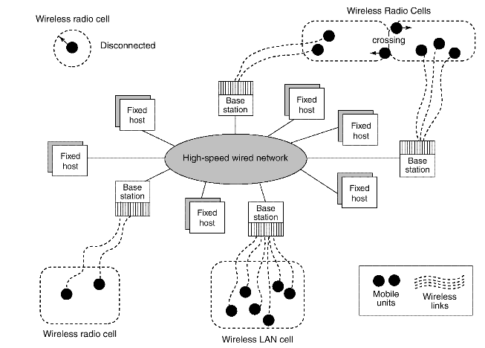

- It is distributed architecture where a number of computers, generally referred to as Fixed Hosts and Base Stations are interconnected through a high-speed wired network.
  - Fixed hosts are general purpose computers configured to manage mobile units.
  - Base stations function as gateways to the fixed network for the Mobile Units.
  - Wireless Communications
    - The wireless medium have bandwidth significantly lower than those of a wired network.
    - The current generation of wireless technology has data rates range from the tens to hundreds of kilobits per second (2G cellular telephony) to tens of megabits per second (wireless Ethernet, popularly known as WiFi).
    - Modern (wired) Ethernet, by comparison, provides data rates on the order of hundreds of megabits per second.
    - The other characteristics distinguish wireless connectivity options:
      - interference,
      - locality of access,
      - range,
      - support for packet switching,
      - seamless roaming throughout a geographical region.
    - Some wireless networks, such as WiFi and Bluetooth, use unlicensed areas of the frequency spectrum, which may cause interference with other appliances, such as cordless telephones.
    - Modern wireless networks can transfer data in units called packets, that are used in wired networks in order to conserve bandwidth
  - Client/Network Relationships
  - Mobile units can move freely in a geographic mobility domain, an area that is circumscribed by wireless network coverage.
  - To manage entire mobility domain is divided into one or more smaller domains, called cells, each of which is supported by at least one base station.
  - Mobile units be unrestricted throughout the cells of domain, while maintaining information access contiguity.
  - The communication architecture described earlier is designed to give the mobile unit the impression that it is attached to a fixed network, emulating a traditional client-server architecture.
  - Wireless communications, however, make other architectures possible. One alternative is a mobile ad-hoc network (MANET)
  - In a MANET, co-located mobile units do not need to communicate via a fixed network, but instead, form their own using cost-effective technologies such as Bluetooth.
  - In a MANET, mobile units are responsible for routing their own data, effectively acting as base stations as well as clients.
  - Moreover, they must be robust enough to handle changes in the network topology, such as the arrival or departure of other mobile units.
  - MANET applications can be considered as peer-to-peer, meaning that a mobile unit is simultaneously a client and a server.
    - Transaction processing and data consistency control become more difficult since there is no central control in this architecture.
    - Resource discovery and data routing by mobile units make computing in a MANET even more complicated.
    - Sample MANET applications are multi-user games, shared whiteboard, distributed calendars, and battle information sharing.
The characteristics of mobile computing include:
  - Communication latency
  - Intermittent connectivity
  - Limited battery life
  - Changing client location

- The server may not be able to reach a client.
  - A client may be unreachable because it is dozing – in an energy-conserving state in which many subsystems are shut down – or because it is out of range of a base station.
In either case, neither client nor server can reach the other, and modifications must be made to the architecture in order to compensate for this case
- Mobile computing poses challenges for servers as well as clients.
  - The latency involved in wireless communication makes scalability a problem.
    - Since latency due to wireless communications increases the time to service each client request, the server can handle fewer clients.
  - One way servers relieve this problem is by broadcasting data whenever possible.
  - A server can simply broadcast data periodically.
Broadcast also reduces the load on the server, as clients do not have to maintain active connections to it.
- Client mobility also poses many data management challenges.
  - Servers must keep track of client locations in order to efficiently route messages to them.
  - Client data should be stored in the network location that minimizes the traffic necessary to access it.
  - The act of moving between cells must be transparent to the client.
  - The server must be able to gracefully divert the shipment of data from one base to another, without the client noticing.
Client mobility also allows new applications that are location-based.

PARALLEL DATABASE

Need
- Parallel machines are becoming quite common and affordable
  - Prices of microprocessors, memory and disks have dropped sharply
  - Recent desktop computers feature multiple processors and this trend is projected to accelerate
- Databases are growing increasingly large
  - large volumes of transaction data are collected and stored for later analysis.
  - multimedia objects like images are increasingly stored in databases
- Large-scale parallel database systems increasingly used for:
  - storing large volumes of data
  - processing time-consuming decision-support queries
  - providing high throughput for transaction processing

Types of Parallel Database Architectures
- Shared memory –
  - processors share a common memory
  - Extremely efficient communication between processors
  - Downside –is not scalable beyond 32 or 64 processors Widely used for lower degrees of parallelism (4 to 8).

- Shared disk
- processors share a common disk
- Examples: IBM Sysplex and DEC clusters (now part of Compaq/HP) running Rdb (now Oracle Rdb) were early commercial users
- Downside: bottleneck at interconnection to the disk subsystem.
- Shared-disk systems can scale to a somewhat larger number of processors, but communication between processors is slower.

- Shared nothing
- processors share neither a common memory nor common disk
- Examples: Teradata, Tandem, Oracle-n CUBE
- Data accessed from local disks (and local memory accesses) do not pass through interconnection network, thereby minimizing the interference of resource sharing.
- Shared-nothing multiprocessors can be scaled up to thousands of processors without interference.
- Main drawback: cost of communication and non-local disk access; sending data involves software interaction at both ends.

- Hierarchical -- hybrid of the above architectures.Combines characteristics of shared-memory, shared-disk, and shared-nothing architectures.

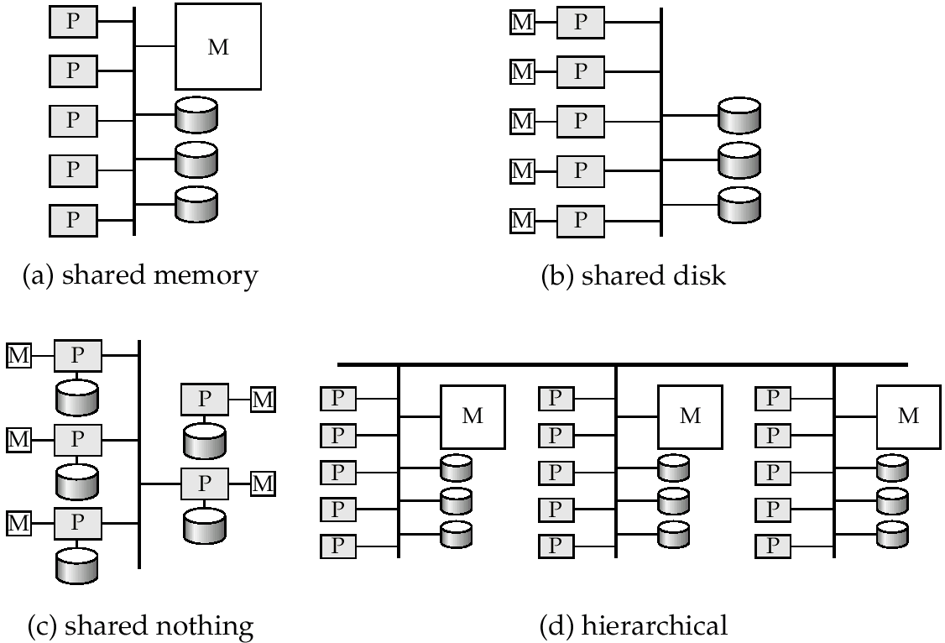

Parallelism in Databases
- Data can be partitioned across multiple disks for parallel I/O.
- Individual relational operations (e.g., sort, join, aggregation) can be executed in parallel
  - data can be partitioned and each processor can work independently on its own partition.
- Queries are expressed in high level language (SQL, translated to relational algebra)
  - makes parallelization easier.
- Different queries can be run in parallel with each other.
  - Concurrency control takes care of conflicts.
- Thus, databases naturally lend themselves to parallelism.
- Reduce the time required to retrieve relations from disk by partitioningthe relations on multiple disks.
I/O Parallelism
- Horizontal partitioning – tuples of a relation are divided among many disks such that each tuple resides on one disk.

- Partitioning techniques (number of disks = n):
- Round-robin:
Send the i^{th} tuple inserted in the relation to disk i mod n.
- Hash partitioning:
  - Choose one or more attributes as the partitioning attributes.
  - Choose hash function h with range 0…n - 1
  - Let i denote result of hash function h applied to the partitioning attribute value of a tuple. Send tuple to disk i.
- Range partitioning:
  - Choose an attribute as the partitioning attribute.
  - A partitioning vector [v_{o}, v₁, ...,v_{n-2}] is chosen.
  - Let v be the partitioning attribute value of a tuple. Tuples such that v_{i}≤v_{i+1} go to disk I + 1. Tuples with v<v₀ go to disk 0 and tuples with v≥v_{n-2} go to disk n-1.
E.g., with a partitioning vector [5,11], a tuple with partitioning attribute value of 2 will go to disk 0, a tuple with value 8 will go to disk 1, while a tuple with value 20 will go to disk2.

- The distribution of tuples to disks may be skewed — that is, some disks have many tuples, while others may have fewer tuples.
- Types of skew:
  - Attribute-value skew.
    - Some values appear in the partitioning attributes of many tuples; all the tuples with the same value for the partitioning attribute end up in the same partition.
    - Can occur with range-partitioning and hash-partitioning.
  - Partition skew.
    - With range-partitioning, badly chosen partition vector may assign too many tuples to some partitions and too few to others.
    - Less likely with hash-partitioning if a good hash-function is chosen.
Typical Database Query Types
- Sequential scan
- Point query
- Range query

Interquery Parallelism
- Queries/transactions execute in parallel with one another.
- Increases transaction throughput; used primarily to scale up a transaction processing system to support a larger number of transactions per second.
- Easiest form of parallelism to support, particularly in a shared-memory parallel database, because even sequential database systems support concurrent processing.
- More complicated to implement on shared-disk or shared-nothing architectures
  - Locking and logging must be coordinated by passing messages between processors.
  - Data in a local buffer may have been updated at another processor.
  - Cache-coherency has to be maintained — reads and writes of data in buffer must find latest version of data.

Intraquery Parallelism
- Execution of a single query in parallel on multiple processors/disks; important for speeding up long-running queries.
- Two complementary forms of intraquery parallelism :
  - Intraoperation Parallelism – parallelize the execution of each individual operation in the query.
  - Interoperation Parallelism – execute the different operations in a query expression in parallel.
- the first form scales better with increasing parallelism because the number of tuples processed by each operation is typically more than the number of operations in a query

Interoperator Parallelism
- Pipelined parallelism
  - Consider a join of four relations
  - Set up a pipeline that computes the three joins in parallel
    - Let P1 be assigned the computation of
    - And P2 be assigned the computation of
    - And P3 be assigned the computation of
  - Each of these operations can execute in parallel, sending result tuples it computes to the next operation even as it is computing further results
    - Provided a pipelineable join evaluation algorithm (e.g. indexed nested loops join) is used

- Pipeline parallelism is useful since it avoids writing intermediate results to disk
- Useful with small number of processors, but does not scale up well with more processors. One reason is that pipeline chains do not attain sufficient length.
- Cannot pipeline operators which do not produce output until all inputs have been accessed (e.g. aggregate and sort)
    - Little speedup is obtained for the frequent cases of skew in which one operator's execution cost is much higher than the others
- Query optimization in parallel databases is significantly more complex than query optimization in sequential databases.
- Cost models are more complicated, since we must take into account partitioning costs and issues such as skew and resource contention.
- When scheduling execution tree in parallel system, must decide:
  - How to parallelize each operation and how many processors to use for it.
  - What operations to pipeline, what operations to execute independently in parallel, and what operations to execute sequentially, one after the other.
- Determining the amount of resources to allocate for each operation is a problem.
  - E.g., allocating more processors than optimal can result in high communication overhead.
- Long pipelines should be avoided as the final operation may wait a lot for inputs, while holding precious resources

MULTIDIMENSIONAL DATABASE (MDB)
- A multidimensional database (MDB) is a type of database that is optimized for data warehouse and online analytical processing (OLAP) applications. Multidimensional databases are frequently created using input from existing relational databases. Whereas a relational database is typically accessed using a Structured Query Language (SQL) query, a multidimensional database allows a user to ask questions like "How many Aptivas have been sold in Nebraska so far this year?" and similar questions related to summarizing business operations and trends. An OLAP application that accesses data from a multidimensional database is known as a MOLAP (multidimensional OLAP) application.
- A multidimensional database - or a multidimensional database management system (MDDBMS) - implies the ability to rapidly process the data in the database so that answers can be generated quickly. A number of vendors provide products that use multidimensional databases. Approaches to how data is stored and the user interface vary.
- Conceptually, a multidimensional database uses the idea of a data cube to represent the dimensions of data available to a user. For example, "sales" could be viewed in the dimensions of product model, geography, time, or some additional dimension. In this case, "sales" is known as the measure attribute of the data cube and the other dimensions are seen as feature attributes. Additionally, a database creator can define hierarchies and levels within a dimension (for example, state and city levels within a regional hierarchy).

DATAWAREHOUSING(Multidimensional database)

Purpose of Data Warehousing
- Traditional databases are not optimized for data access only they have to balance the requirement of data access with the need to ensure integrity of data.
- Most of the times the data warehouse users need only read access but, need the access to be fast over a large volume of data.
- Most of the data required for data warehouse analysis comes from multiple databases and these analysis are recurrent and predictable to be able to design specific software to meet the requirements.
- There is a great need for tools that provide decision makers with information to make decisions quickly and reliably based on historical data.
- The above functionality is achieved by Data Warehousing and Online analytical processing (OLAP)
- W. H Inmon characterized a data warehouse as:
  - “A subject-oriented, integrated, nonvolatile, time-variant collection of data in support of management’s decisions.”
- Data warehouses have the distinguishing characteristic that they are mainly intended for decision support applications

- Applications that data warehouse supports are:
  - OLAP (Online Analytical Processing) is a term used to describe the analysis of complex data from the data warehouse.
  - DSS (Decision Support Systems) also known as EIS (Executive Information Systems) supports organization’s leading decision makers for making complex and important decisions.
  - DataMining is used for knowledge discovery, the process of searching data for unanticipated new knowledge.

- Conceptual Structure of Data Warehouse
- Data Warehouse processing involves
  - Cleaning and reformatting of data
  - OLAP
  - Data Mining
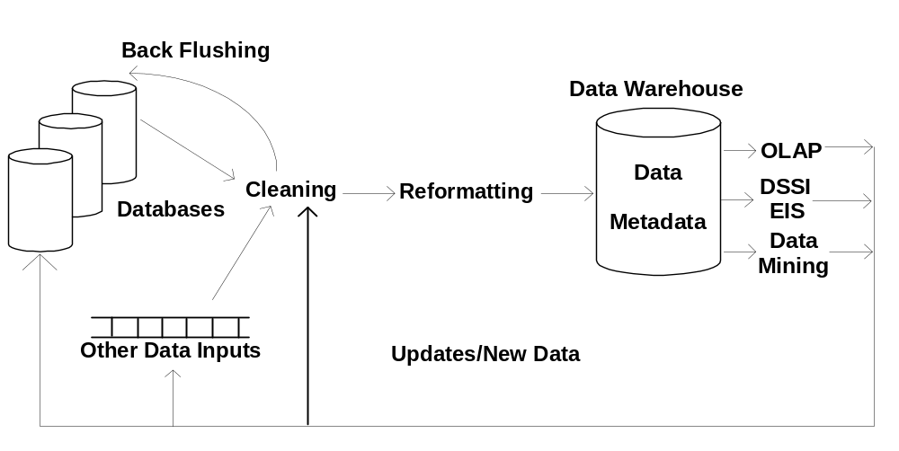

Comparison with Traditional Databases
- Data Warehouses are mainly optimized for appropriate data access.
  - Traditional databases are transactional and are optimized for both access mechanisms and integrity assurance measures.
- Data warehouses emphasize more on historical data as their main purpose is to support time-series and trend analysis.
- Compared with transactional databases, data warehouses are nonvolatile.
- In transactional databases transaction is the mechanism change to the database. By contrast information in data warehouse is relatively coarse grained and refresh policy is carefully chosen, usually incremental.
Characteristics of Data Warehouses
- Multidimensional conceptual view
- Generic dimensionality
- Unlimited dimensions and aggregation levels
- Unrestricted cross-dimensional operations
- Dynamic sparse matrix handling
- Client-server architecture
- Multi-user support
- Accessibility
- Transparency
- Intuitive data manipulation
- Consistent reporting performance
- Flexible reporting

Classification of Data Warehouses
- Generally, Data Warehouses are an order of magnitude larger than the source databases.
- The sheer volume of data is an issue, based on which Data Warehouses could be classified as follows.
  - Enterprise-wide data warehouses
    - They are huge projects requiring massive investment of time and resources.
  - Virtual data warehouses
    - They provide views of operational databases that are materialized for efficient access.
  - Data marts
    - These are generally targeted to a subset of organization, such as a department, and are more tightly focused.
- Data Modeling for Data Warehouses
- Traditional Databases generally deal with two-dimensional data (similar to a spread sheet).
  - However, querying performance in a multi-dimensional data storage model is much more efficient.
- Data warehouses can take advantage of this feature as generally these are
  - Non volatile
  - The degree of predictability of the analysis that will be performed on them is high.
- Example of Two- Dimensional vs. Multi- Dimensional
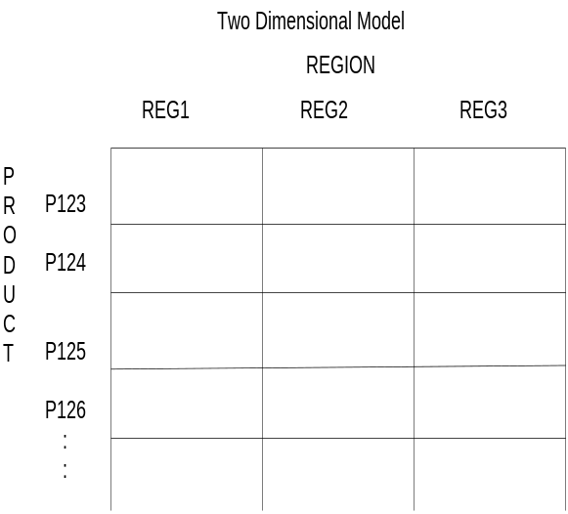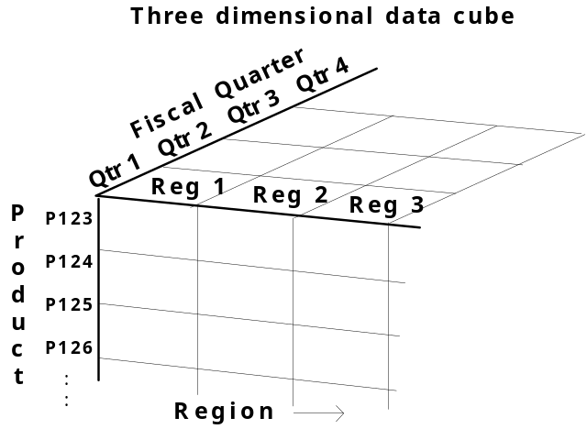

Advantages of a multi-dimensional model
  - Multi-dimensional models lend themselves readily to hierarchical views in what is known as roll-up display and drill-down display.
  - The data can be directly queried in any combination of dimensions, bypassing complex database queries.
- Multi-dimensional schemas are specified using:
  - Dimension table
    - It consists of tuples of attributes of the dimension.
  - Fact table
    - Each tuple is a recorded fact. This fact contains some measured or observed variable (s) and identifies it with pointers to dimension tables. The fact table contains the data, and the dimensions to identify each tuple in the data.
- Two common multi-dimensional schemas are
  - Star schema:
    - Consists of a fact table with a single table for each dimension
  - Snowflake Schema:
- It is a variation of star schema, in which the dimensional tables from a star schema are organized into a hierarchy by normalizing them

Star schema:
- Consists of a fact table with a single table for each dimension

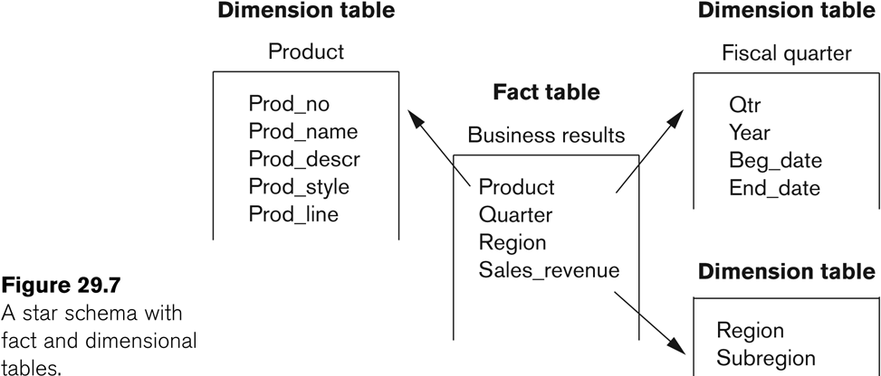

Snowflake Schema:
- It is a variation of star schema, in which the dimensional tables from a star schema are organized into a hierarchy by normalizing them

- 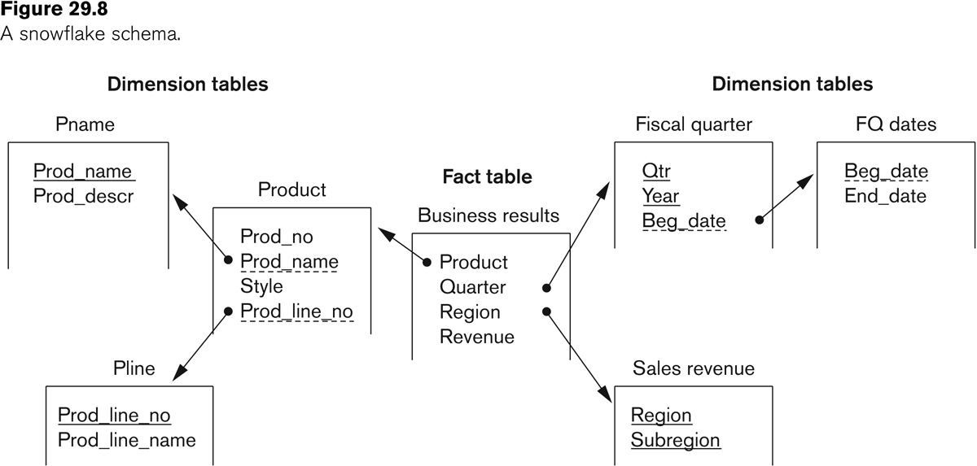

Fact Constellation
  - Fact constellation is a set of tables that share some dimension tables. However, fact constellations limit the possible queries for the warehouse.
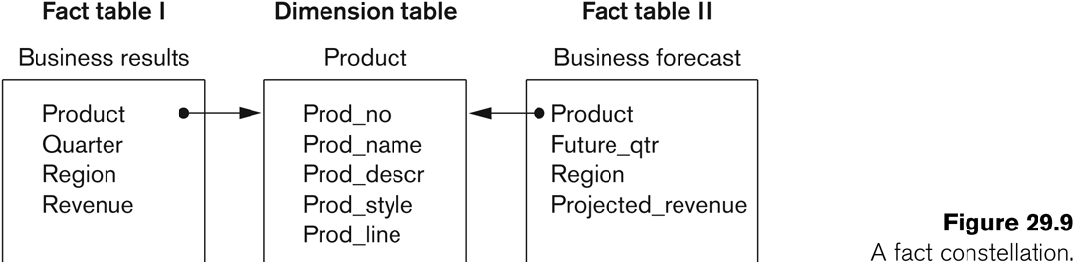

Indexing
  - Data warehouse also utilizes indexing to support high performance access.
  - A technique called bitmap indexing constructs a bit vector for each value in domain being indexed.
  - Indexing works very well for domains of low cardinality.

Building A Data Warehouse
- The builders of Data warehouse should take a broad view of the anticipated use of the warehouse.
  - The design should support ad-hoc querying
  - An appropriate schema should be chosen that reflects the anticipated usage.
- The Design of a Data Warehouse involves following steps.
  - Acquisition of data for the warehouse.
  - Ensuring that Data Storage meets the query requirements efficiently.
  - Giving full consideration to the environment in which the data warehouse resides.
- Acquisition of data for the warehouse
  - The data must be extracted from multiple, heterogeneous sources.
  - Data must be formatted for consistency within the warehouse.
  - The data must be cleaned to ensure validity.
    - Difficult to automate cleaning process.
    - Back flushing, upgrading the data with cleaned data.
  - The data must be fitted into the data model of the warehouse.
  - The data must be loaded into the warehouse.
    - Proper design for refresh policy should be considered.
- Storing the data according to the data model of the warehouse
- Creating and maintaining required data structures
- Creating and maintaining appropriate access paths
- Providing for time-variant data as new data are added
- Supporting the updating of warehouse data.
- Refreshing the data
- Purging data

Functionality of a Data Warehouse
- Functionality that can be expected:
  - Roll-up: Data is summarized with increasing generalization
  - Drill-Down: Increasing levels of detail are revealed
  - Pivot: Cross tabulation is performed
  - Slice and dice: Performing projection operations on the dimensions.
  - Sorting: Data is sorted by ordinal value.
  - Selection: Data is available by value or range.
  - Derivedattributes: Attributes are computed by operations on stored derived values.

Warehouse vs. Data Views
- Views and data warehouses are alike in that they both have read-only extracts from the databases.
- However, data warehouses are different from views in the following ways:
  - Data Warehouses exist as persistent storage instead of being materialized on demand.
  - Data Warehouses are not usually relational, but rather multi-dimensional.
  - Data Warehouses can be indexed for optimization.
  - Data Warehouses provide specific support of functionality.
  - Data Warehouses deals huge volumes of data that is contained generally in more than one database.

Difficulties of implementing Data Warehouses
- Lead time is huge in building a data warehouse
  - Potentially it takes years to build and efficiently maintain a data warehouse.
- Both quality and consistency of data are major concerns.
- Revising the usage projections regularly to meet the current requirements.
  - The data warehouse should be designed to accommodate addition and attrition of data sources without major redesign
- Administration of data warehouse would require far broader skills than are needed for a traditional database.

Open Issues in Data Warehousing
- Automation of
  - data acquisition
  - data quality management
  - selection and construction of access paths and structures
  - self-maintainability
  - functionality and performance optimization

DATA MINING
Definitions of Data Mining
- The discovery of new information in terms of patterns or rules from vast amounts of data.
- The process of finding interesting structure in data.
- The process of employing one or more computer learning techniques to automatically analyze and extract knowledge from data.

Data warehouse:
- The data warehouse is a historical database designed for decision support.
- Data mining can be applied to the data in a warehouse to help with certain types of decisions.
- Proper construction of a data warehouse is fundamental to the successful use of data mining.

Need for Data Mining
- The Explosive Growth of Data: from terabytes to petabytes
  - Data collection and data availability
    - Automated data collection tools, database systems, Web, computerized society
  - Major sources of abundant data
    - Business: Web, e-commerce, transactions, stocks, …
    - Science: Remote sensing, bioinformatics, scientific simulation, …
    - Society and everyone: news, digital cameras, YouTube
- We are drowning in data, but starving for knowledge!
- “Necessity is the mother of invention”—Data mining—Automated analysis of massive data sets

Applications of Data Mining
- E-commerce
- Marketing and retail
- Finance
- Telecoms
- Drug design
- Process control
- Space and earth sensing

Knowledge Discovery in Databases (KDD)
- Data mining is actually one step of a larger process known as knowledge discovery in databases (KDD).
- The KDD process model comprises six phases
  - Data selection
  - Data cleansing
  - Enrichment
  - Data transformation or encoding
  - Data mining
  - Reporting and displaying discovered knowledge
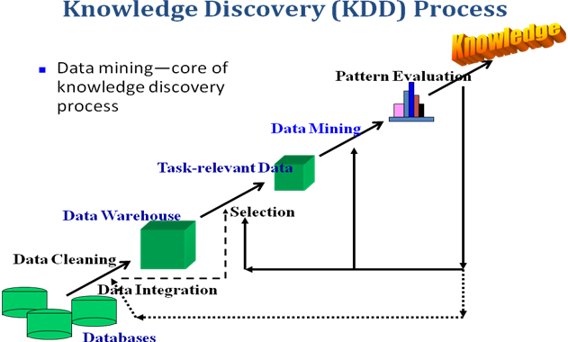

- As an example, consider a transaction database maintained by a specialty consumer goods retailer. Suppose the client data includes a customer name, ZIP Code, phone number, date of purchase, item code, price, quantity, and total amount.
- A variety of new knowledge can be discovered by KDD processing on this client database. During data selection, data about specific items or categories of items, or from storesin a specific region or area of the country, may be selected. The data cleansing process then may correct invalid ZIP Codes or eliminate records with incorrect phone prefixes. Enrichment typically enhances the data with additional sources of information. For example, given the client names and phone numbers, the store may purchase other data about age, income, and credit rating and append them to each record. Data transformation and encoding may be done to reduce the amount of data.
- For instance, item codes may be grouped in terms of product categories into audio, video, supplies, electronic gadgets, camera,accessories, and so on. ZIP Codes may be aggregated into geographic regions, incomes may be divided into ranges, and so on. In Figure 29.1, we will show a step called cleaning as a precursor to the data warehouse creation. If data mining is based on an existing warehouse for this retail store chain, we would expect that the cleaning has already been applied. It is only after such preprocessing that data mining techniques are used to mine different rules and patterns.

The result of mining may be to discover the following type of new information:
■ Association rules—for example, whenever a customer buys video equipment, he or she also buys another electronic gadget.
■ Sequential patterns—for example, suppose a customer buys a camera, and within three months he or she buys photographic supplies, then within six months he is likely to buy an accessory item. This defines a sequential pattern of transactions. A customer who buys more than twice in lean periods may be likely to buy at least once during the Christmas period.

■ Classification trees—for example, customers may be classified by frequency of visits, types of financing used, amount of purchase, or affinity for types of items; some revealing statistics may be generated for such classes.

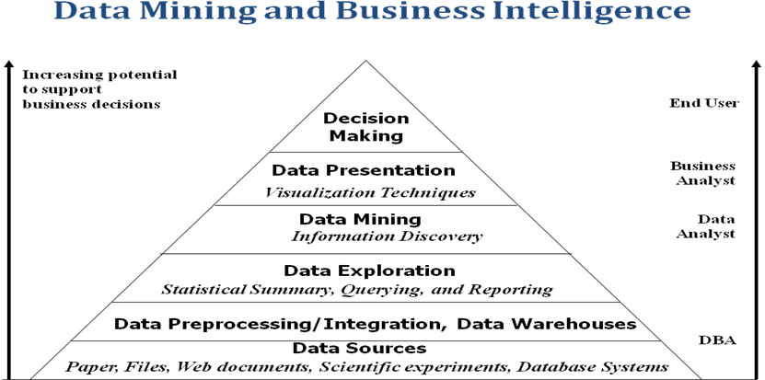

Why Not Traditional Data Analysis?
- Tremendous amount of data
  - Algorithms must be highly scalable to handle such as tera-bytes of data
- High-dimensionality of data
  - Micro-array may have tens of thousands of dimensions
- High complexity of data
  - Data streams and sensor data
  - Time-series data, temporal data, sequence data
  - Structure data, graphs, social networks and multi-linked data
  - Heterogeneous databases and legacy databases
  - Spatial, spatiotemporal, multimedia, text and Web data
  - Software programs, scientific simulations
- New and sophisticated applications
Goals of Data Mining and Knowledge Discovery (PICO)
- Prediction:
  - Determine how certain attributes will behave in the future.
- Identification:
  - Identify the existence of an item, event, or activity.
- Classification:
  - Partition data into classes or categories.
- Optimization:
- Optimize the use of limited resources.

Types of Knowledge Discovered during Data Mining
- Association Rules
- Classification Hierarchies
- Sequential Patterns
- Patterns Within Time Series
- Clustering

ASSOCIATION RULES
- Association rules are frequently used to generate rules from market-basket data.
  - A market basket corresponds to the sets of items a consumer purchases during one visit to a supermarket.
- An association rule is of the form X=>Y
  - X is called antecedent (left-hand-side or LHS) and Y is called consequent (right-hand-side or RHS) of the rule.

  - For an association rule to be of interest, it must satisfy a minimum support and confidence.
{bread} => {jam}

- Found in the sales data of a supermarket would indicate that if a customer buys bread he or she is likely to also buy jam
- Such information can be used as the basis for decisions about marketing activities such as, e.g., promotional pricing or product placements
- Let I={i1, i2, .., in} be a set of n binary attributes called items.
- Let D={t1, t2, .., tm} be a set of transactions called the database.
- Each transaction in D has a unique transaction ID and contains a subset of the items in I.
- A rule is defined as an implication of the form X(Y where X∩Y= ∅ and X,Y⊆ I.
- Itemset
  - A collection of one or more items
    - Example: {Milk, Bread, Bread}
  - k-itemset
    - An itemset that contains k items

- A rule has a left-hand set of items and a right-hand set of items. A rule ``LHS => RHS'' with a ‘support’ s and ‘confidence’ c.
- Support:
  - The minimum percentage of instances in the database that contain all items listed in a given association rule.
  - Support is the percentage of transactions that contain all of the items in both itemsets, LHS and RHS.
  - Confidence:
  - Given a rule of the form X ( Y, rule confidence is the conditional probability that Y is true when X is known to be true
  - P(Y=true/X=true) = P(Y=true ∩ X=true) / P(X=true)

Transaction ID | Milk | Bread | Butter | Beef
1 | 1 | 1 | 1 | 1
2 | 0 | 1 | 1 | 0
3 | 1 | 1 | 0 | 1
4 | 1 | 1 | 1 | 0
5 | 0 | 1 | 0 | 0

- Frequent Itemset
  - An itemset whose support is greater than or equal to a minsup threshold
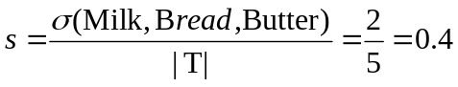
Supp({Milk, bread} → butter) :
Conf({Milk, bread} → butter:
66% of the transactions containing milk and bread the rule is correct

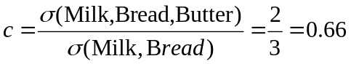

- {Milk, bread} -> butter
- Support is the percentage of transactions that contain all of the items in both itemset, LHS and RHS.
- Confidence: P(Y=true/X=true)= P(Y=true ∩ X=true) / P(X=true)

- Brute-force approach:
  - List all possible association rules
  - Compute the support and confidence for each rule
  - Discard rules that fail the minsup and minconf thresholds
Trans. ID | Milk | Bread | Butter | Beef
1 | 1 | 1 | 1 | 1
2 | 0 | 1 | 1 | 0
3 | 1 | 1 | 0 | 1
4 | 1 | 1 | 1 | 0
5 | 0 | 1 | 0 | 1

- Observations:
  - Rules originating from the same itemset have identical support but can have different confidence
Example of Rules:
{Milk,Bread}
→ {Beef} (s=0.4, c=0.66)
{Milk,Beef} → {Bread} (s=0.4, c=1)
{Bread,Beef} → {Milk} (s=0.4, c=0.66)
{Beef} → {Milk,Bread} (s=0.4, c=0.66)
{Bread} → {Milk,Beef} (s=0.4, c=0.4)
{Milk} → {Bread,Beef} (s=0.4, c=0.66)

Apriori principle:
  - If an itemset is frequent, then all of its subsets must also be frequent
- Apriori principle holds due to the following property of the support measure:
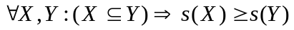

Support of an itemset never exceeds the support of its subsets
  - This is known as the anti-monotone property of support

CLASSIFICATION
- Classification is the process of learning a model that is able to describe different classes of data.
- Learning is supervised as the classes to be learned are predetermined.
- Learning is accomplished by using a training set of pre-classified data.
- The model produced is usually in the form of a decision tree or a set of rules.
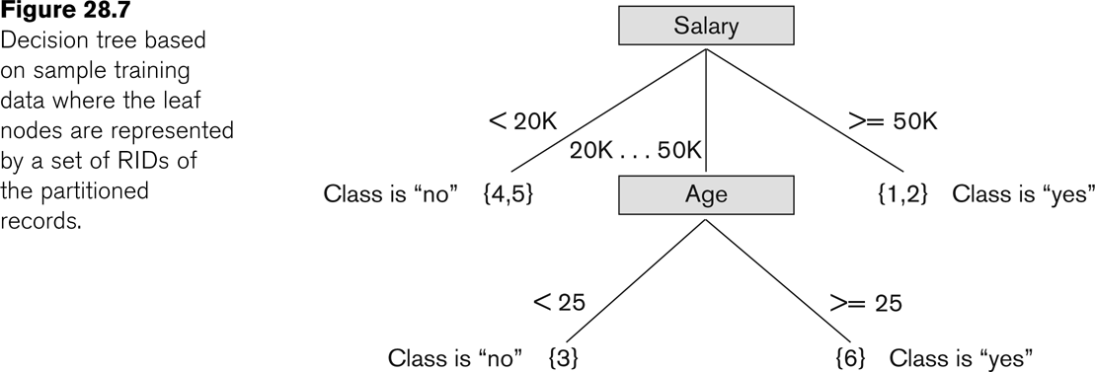

- Here is one of the rules extracted from the decision tree of Figure 28.7.
  - IF 50K > salary >= 20K
      - AND age >=25
  - THEN class is “yes”

Clustering
- Unsupervised learning or clustering builds models from data without predefined classes.
- The goal is to place records into groups where the records in a group are highly similar to each other and dissimilar to records in other groups.
- The k-Means algorithm is a simple yet effective clustering technique

Additional Data Mining Methods
- Sequential pattern analysis
- Time Series Analysis
- Regression
- Neural Networks
- Genetic Algorithms

